**Practice Exam – 01**

**50 points**

1. **Instructions to create the project.**

You will be creating **Air Quality Check (AQC)** application for this exam. Air quality means how clean or polluted the air is based on the levels of two common pollutants: PM2.5 and PM10.

* **PM₂.₅**: Fine particulate matter (≤2.5 µm) that can penetrate deep into the lungs and bloodstream, posing serious health risks.
* **PM₁₀**: Coarse particulate matter (≤10 µm) that can be inhaled and cause respiratory irritation and health issues.

Find the air quality check (AQC) value in the air giving the values of PM2.5 and PM10.

1. Create a project in XCode with the name “**LastName_Exam01**”.
2. While creating the app make sure to follow minimum deployment and project format as shown below:

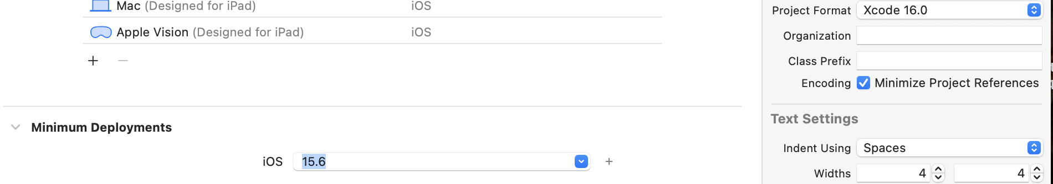

1. **Instructions to create the AQC App.**

The user interface (UI) of the app is shown in Figure 1. Design an Air Quality Check app that takes the values of PM2.5(positive values) and PM10(positive values) as input.

There is **no strict minimum or maximum** for PM₂.₅ and PM₁₀ in your code, but here are reasonable limits based on real-world air quality data:

• Minimumvalue: 0 (clean air, no pollution)

• Maximumvalue: 500+ (hazardous air quality, extreme pollution)

The app should be able to categorize the quality as per the below Table:

|  |  |
| --- | --- |
| **Category** | **AQC Range** |
| Best | <50 |
| Moderate | 50<AQC<100 |
| Poor | AQC>100 |

1. Your app should consist of the following UI components and you may use your own colors of choice.
   1. A header label shows ‘Air Quality Check’ in your choice of color
   2. Two text fields to enter
      1. The value of PM2.5.
      2. The value of PM10
   3. Two buttons
2. to calculate the AQC
3. to reset the contents to initial stage

Example:

*When the user enters the input*

*PM25 as 40*

*PM10 as 60*

AQC= (40+60) / 2 = 50.

The calculated AQC value must be rounded to one digit.

* 1. Three Labels

1. To name the PM2.5 Label
2. To name the PM10 Label
3. A label to print Message in two different lines:

**The AQC value is ______ .**

**This air quality is considered to be _____ quality air.**

* 1. A UIImage to display the image related to the category. [NOTE: images are provided to you]

**Test Cases:**

|  |  |  |  |
| --- | --- | --- | --- |
| **PM2.5 VALUE** | **PM10 VALUE** | **EXPECTED OUTPUT AQC** | **IMAGE DISPLAYED** |
| 20 | 30 | 25.0 | Best |
| 60.5 | 70.5 | 65.5 | Moderate |
| 120.3 | 130.7 | 125.5 | Poor |
| (No value given) | 30 | Please enter the input values for PM2.5 and PM10. | No image |
| (No value given) | (No value given) | Please enter the input values for PM2.5 and PM10. | No image |
| 30 | (No value given) | Please enter the input values for PM2.5 and PM10. | No image |
| (give some name or text)  For example: iOS | (give some name or text)  For example: Mobile computing | Please enter valid numeric values for PM2.5 and PM10. | No image |

**UI SCREEN:**

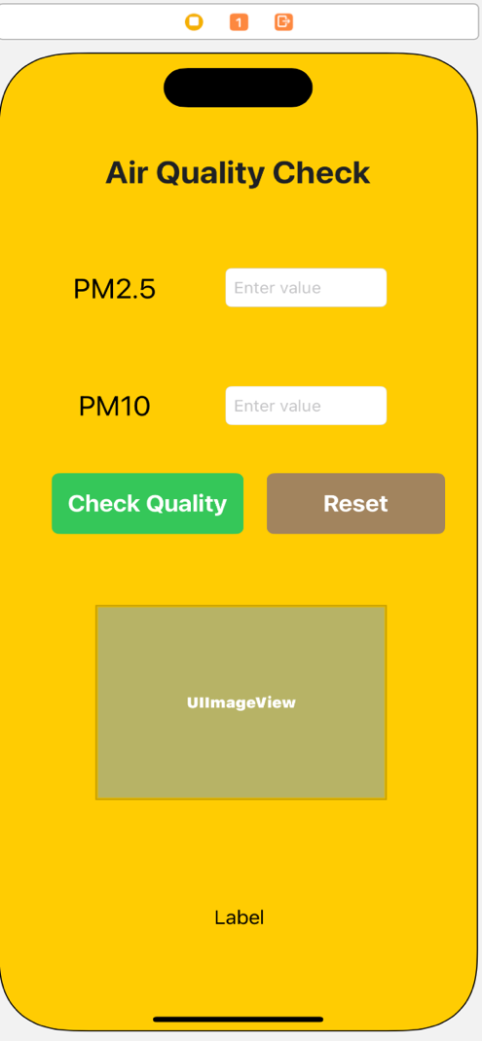

**Figure 1: App Design**

1. Refer below images for sample output

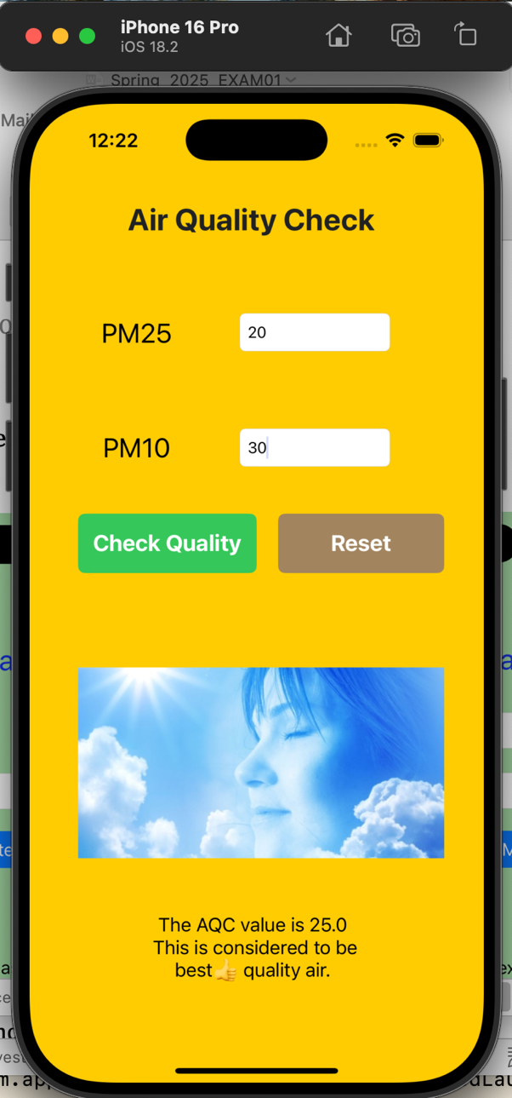 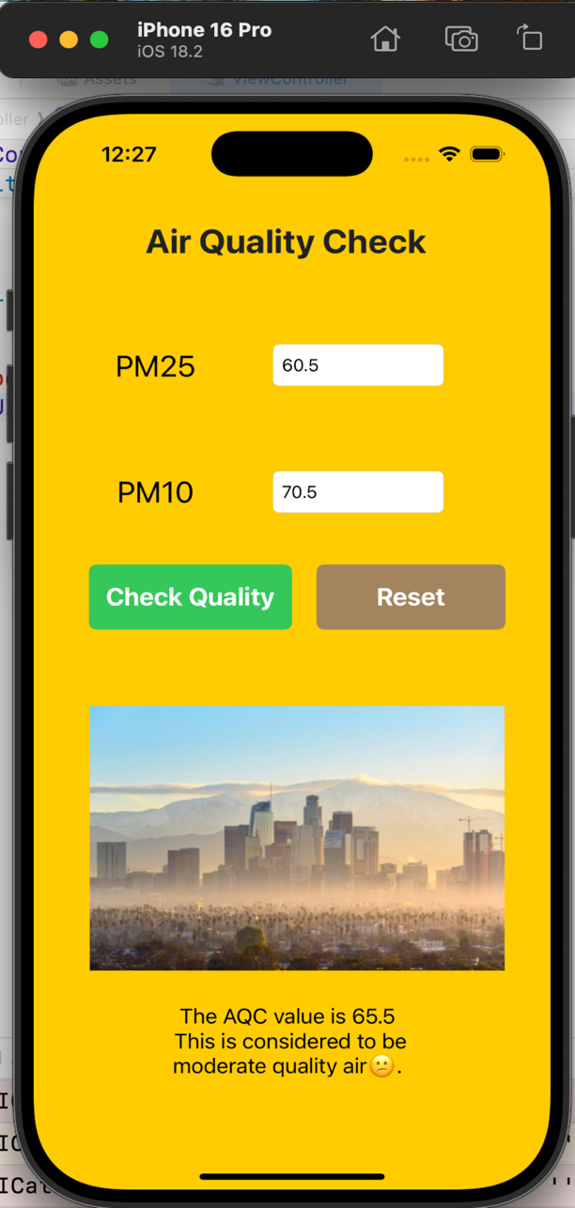

**Figure 2: View of Best air quality** **Figure 3: View of Moderate air quality**

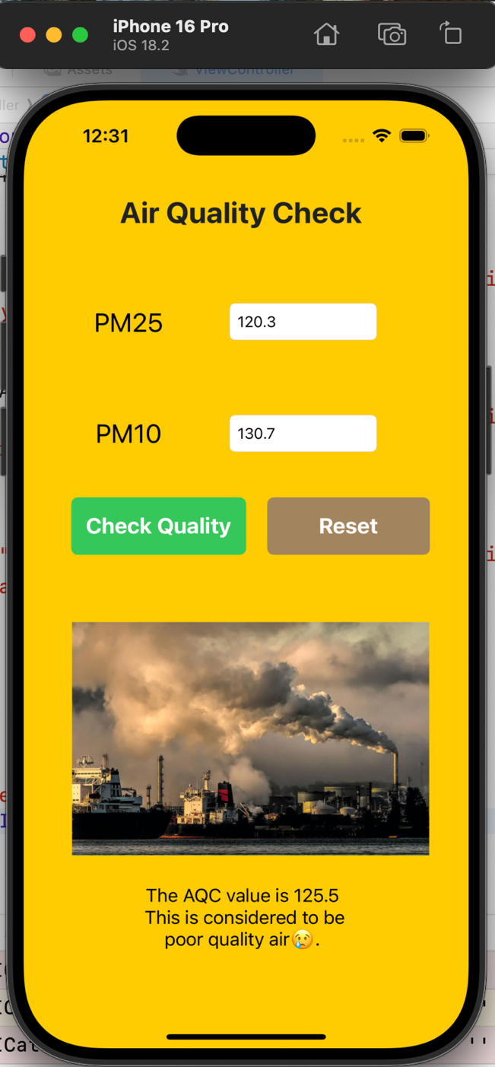 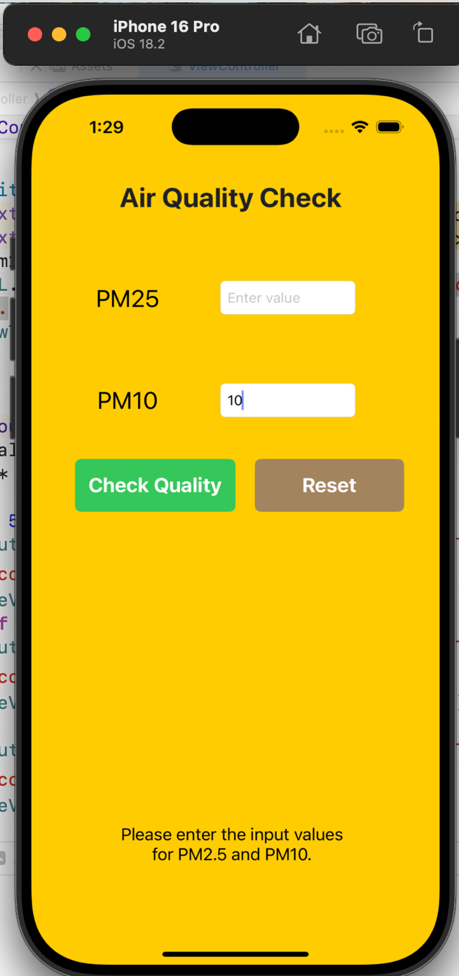

**Figure 4: View of Poor air quality** **Figure 5: When input values are not entered**

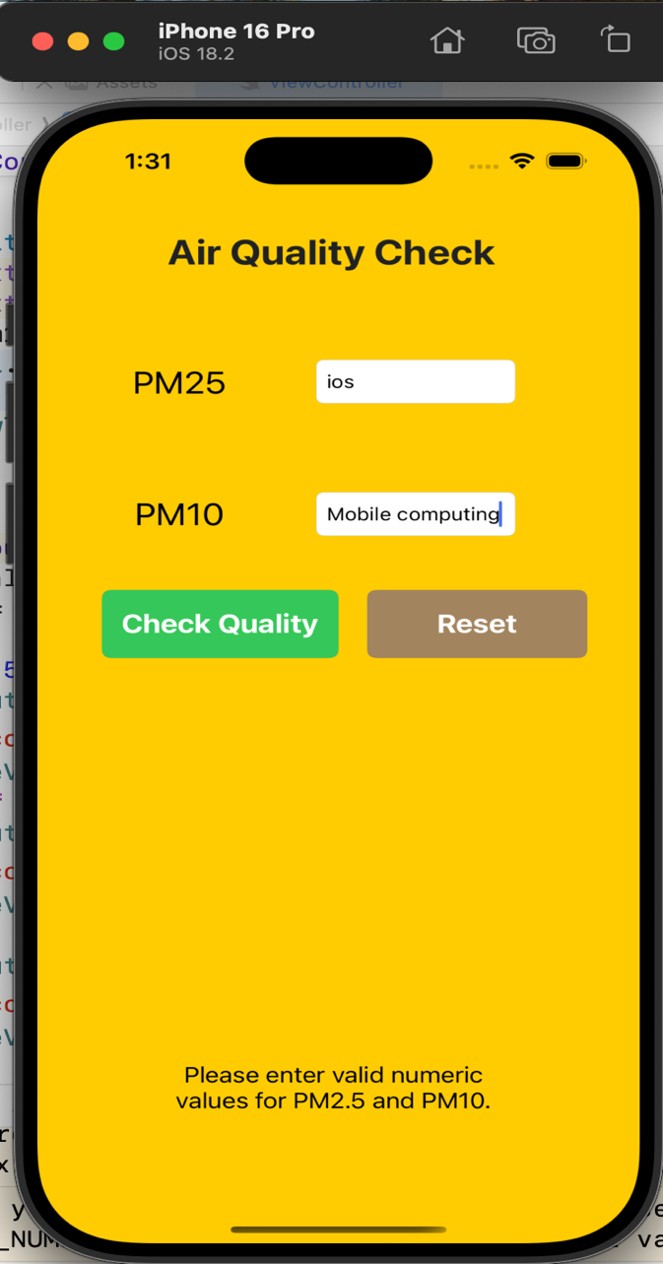 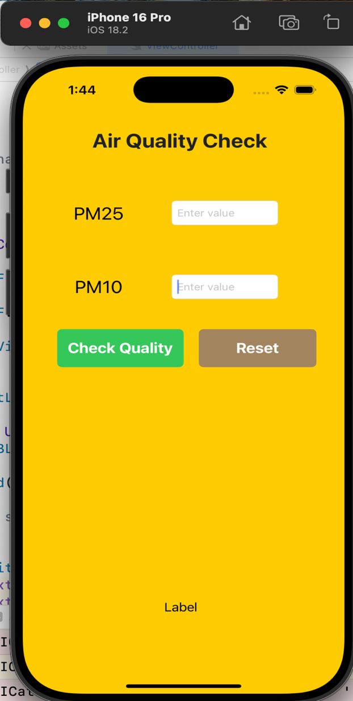

**Figure 6: When the input values are Fig 7: View when Reset Button is clicked**

**entered in string format**

1. **Submission Instructions:**
2. Save your XCode project of Air Quality Check App
3. Name it with your LastName_Exam01. Compress the folder to zip and submit it to this exam.