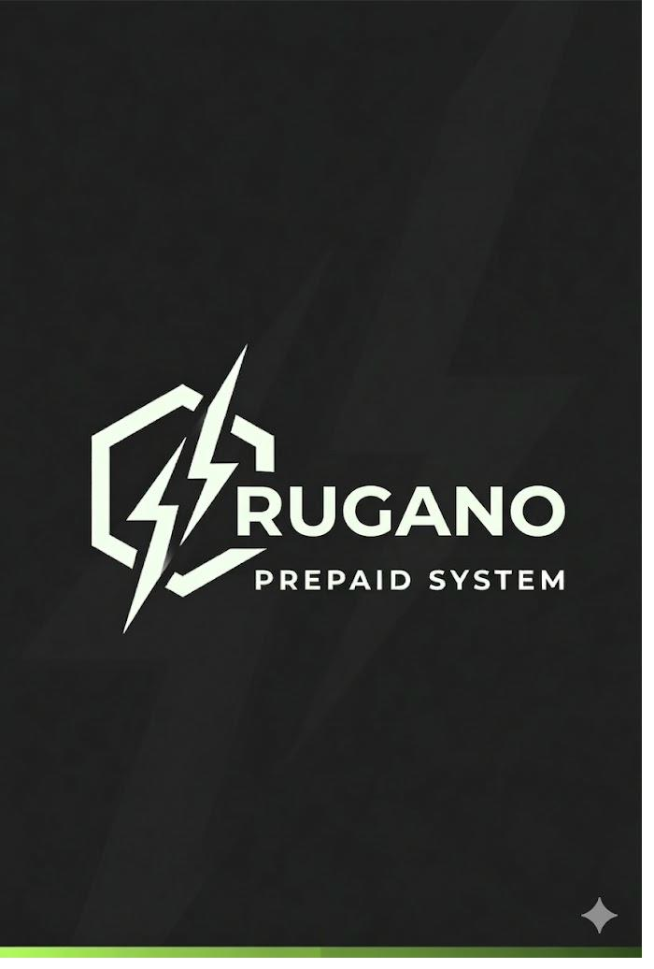
RUGANO
PREPAID SMART DOOR LOCK SYSTEM
Project Brief — Version 1.0
Project Name | Rugano Prepaid Smart Door Lock System
Version | V1 — Web Prototype
Brand | Rugano
Developer | Wycliff Kimani | Devcraft Technologies
Client | Rugano (Confidential)
Date | March 2025
Status | In Development
Deployment Target | Render.com (Free Tier)

1. Purpose & Problem Statement
Landlords in Kenya face a persistent challenge: tenants defaulting on rent while still having physical access to their units. Traditional lock-and-key systems provide no mechanism to enforce rent payment, and manual eviction processes are costly, confrontational, and legally complex.

Rugano solves this by turning the door itself into a rent enforcement mechanism. Access is prepaid — tenants buy time with every payment, and the door locks automatically when that time expires. Payment is via M-Pesa, the dominant mobile money platform in Kenya, making it frictionless for tenants.

2. System Overview
Rugano is a prepaid rent-based door access control system for Kenyan rental properties. It operates on the same principle as a prepaid electricity meter — pay for time, access is granted for that duration, access expires when balance runs out.

The V1 prototype is a fully functional web-based simulation of the system, built to demonstrate the complete payment-to-access flow before physical hardware integration.

3. How It Works

3.1 Payment Flow
- Tenant opens M-Pesa on their phone
- Navigates to Lipa Na M-Pesa → Pay Bill
- Enters Paybill: 174379 (Safaricom C2B Sandbox)
- Enters Account Number: Unit number (e.g. A1, B3)
- Enters any amount they can afford (lipa mdogo mdogo)
- Safaricom sends a payment callback to the Rugano API
- System identifies tenant by unit number, calculates access days, updates access_expires_at

3.2 Access Calculation
The core formula that drives all access decisions:

daily_cost = monthly_rent ÷ 30
days_granted = amount_paid ÷ daily_cost

Example: Tenant pays KES 1,000 for a KES 6,000/month unit:
- daily_cost = 6,000 ÷ 30 = KES 200/day
- days_granted = 1,000 ÷ 200 = 5 days access
- If tenant later pays KES 400 → 2 more days added to existing expiry

3.3 Door Access Logic
- Door entry is ALLOWED when: current_time < access_expires_at
- Door entry is DENIED when: access_expires_at is NULL or in the past
- Exit is ALWAYS free — system never blocks a tenant from leaving
- Partial payments extend access from current expiry (not from zero)

4. Key Features — V1
Feature | Description
M-Pesa C2B Payment | Tenant pays via real M-Pesa sandbox (paybill 174379). No simulated payments.
Lipa Mdogo Mdogo | Any payment amount accepted. Each payment extends access proportionally.
PIN-Based Door Access | Each tenant has a permanent 6-8 digit PIN. Correct PIN + active access = entry granted.
Auto-Lock on Expiry | Door denies entry automatically when access_expires_at is reached.
Landlord Dashboard | Full management interface: add tenants, set rents, view payments, change PINs.
PIN Management | Landlord or caretaker can change any tenant's PIN at any time from the dashboard.
Manual Unlock | Landlord can unlock a door remotely. Requires tenant authorization. Always logged.
Access Logs | Every entry attempt (granted, denied, manual unlock, expired) is recorded with timestamp.
Door Simulator | Web-based door interface simulating PIN entry and lock/unlock status for demo purposes.
Caretaker Access | Landlord can assign dashboard access to a caretaker with appropriate permissions.

5. Technology Stack
Backend Framework | FastAPI (Python)
Database | PostgreSQL via Supabase
Frontend | Jinja2 Templates + HTML/CSS/JS
Authentication | JWT (python-jose) + bcrypt password hashing
Payment Integration | M-Pesa Daraja C2B Sandbox (Paybill 174379)
Hosting | Render.com (Free Tier)
Environment Config | .env via python-dotenv
HTTP Client | httpx (async M-Pesa callbacks)

6. Database Schema Summary
Six tables power the Rugano system:

Table | Purpose
users | Landlords and caretakers who manage the system dashboard
properties | The rental property (V1: one property per account)
units | Individual rental units with unit number and monthly rent amount
tenants | Tenant records including PIN and access_expires_at timestamp
payments | All M-Pesa payments with amount, days granted, and M-Pesa reference
access_logs | Complete audit trail of every access event, PIN attempt, and manual unlock

7. Core System Rules
- Each tenant has one permanent PIN (6-8 digits). It does not change with payments.
- Only the landlord or caretaker can change a tenant's PIN from the dashboard.
- When a tenant moves out, their record is deactivated. New tenant gets new PIN.
- Access expires_at is extended on every payment — it never resets to zero.
- If access_expires_at is NULL, the tenant has never paid. Door denies entry.
- The door always allows exit. Only entry is controlled.
- Manual unlocks require the tenant's authorization and are always logged with who triggered it.
- Every payment stores: amount, days_granted, mpesa_ref, account_ref, timestamp.
- Account reference for M-Pesa is the unit number only (e.g. A1). Simple, no errors.
- V1 uses one property per landlord account. Multi-property support comes in V2.

8. M-Pesa Integration

8.1 Payment Method
Rugano uses M-Pesa C2B (Customer to Business) — the same flow tenants already use to pay KPLC electricity. No app installation or special setup required on the tenant's side.

8.2 Sandbox Details
Paybill Number | 174379 (Safaricom C2B Sandbox)
Account Number | Unit number (e.g. A1, B3)
Amount | Any amount — tenant chooses
Callback URL | POST /api/mpesa/callback
Environment | Sandbox — no real money moves

8.3 Callback Flow
- Safaricom sends POST request to /api/mpesa/callback
- System extracts: BillRefNumber (unit number), TransAmount, TransID
- Looks up unit by unit_number → finds active tenant
- Calculates days_granted = amount / (monthly_rent / 30)
- Updates tenant.access_expires_at += days_granted
- Logs payment to payments table
- Returns 200 OK to Safaricom

9. Management Dashboard
The Rugano dashboard is accessible via web browser by the landlord or assigned caretaker. It provides full control over the system.

9.1 Dashboard Sections
- Overview — current access status for all units at a glance
- Tenants — add, edit, deactivate tenants; change PINs
- Units — manage unit numbers and monthly rent amounts
- Payments — full payment history with M-Pesa references
- Access Logs — complete audit trail of all door events
- Manual Unlock — unlock a specific door with authorization log

10. Door Simulator (V1 Demo)
Since V1 is a web prototype before physical hardware, a door simulator page is included. This page simulates the tenant-facing keypad interface on the smart lock device.

- Tenant selects their unit from a dropdown
- Enters their PIN on the on-screen keypad
- System checks access_expires_at against current time
- Displays GRANTED (green) or DENIED (red) with reason
- Every attempt is logged to access_logs
This simulator is what the client uses to test the full flow end-to-end: pay via M-Pesa sandbox → enter PIN on simulator → see door status change.

11. V2 Roadmap (Future Revenue)
The following features are intentionally excluded from V1 but the system is architected to support them:

Feature | Revenue Model
Physical Hardware Integration | ESP32/Raspberry Pi device programming and supply
Multi-Property Support | Subscription per additional property
Remote Monitoring | Cloud dashboard subscription for landlords with 10+ units
SMS Notifications | Auto-SMS to tenants on payment confirmation and access expiry warning
Tenant Mobile App | Branded app for tenants to check balance and pay
Biometric Access | Fingerprint module integration — hardware upsell

12. Security Considerations
- All passwords hashed using bcrypt — never stored in plain text
- JWT tokens for session management with configurable expiry
- All secrets stored in .env — never hardcoded in source code
- .env excluded from version control via .gitignore
- M-Pesa callback endpoint validates payload before processing
- Manual unlocks require authorization and are permanently logged
- Tenant PINs are hashed in the database
- SQL queries use parameterized inputs — no raw string injection

13. Sign-Off
This brief serves as the agreed specification for Rugano V1. Any changes to scope, features, or timeline must be discussed and documented before implementation.

Developer  Wycliff Kimani | Devcraft Technologies  Signature: ___________________  Date: ________________________ | Client  Rugano  Signature: ___________________  Date: ________________________

