
NORTHERN EDUCATION DIVISION MOCK EXAMINATION
2026 JUNIOR CERTIFICATE EXAMINATION

BIOLOGY
(100 marks)
Thursday, 26th March, 2026 Subject Number: J022
Time Allowed: 2 hours
08:00 – 10:00 am

Instructions
- This paper contains 12 pages please check.
- This paper has three sections A, B and C
- Answer all questions in Section A by encircling the letter with the correct answer.
- Answer all questions in section B and C in the spaces provided
- In the table provided on this page, tick against the question number answered
- Write your full name and school on each and every page
- Hand in your paper to the invigilator when time is called to stop.
Question Number | Tick if answered | Do not write in these columns
1 – 5
6 – 10
11 – 15
16 – 20
21
22
23
24
25
26
27
28
29
30
31
32
33
 | Total

`SECTION A: MULTIPLE CHOICE (20 marks)
Answer all questions in this section by encircle the letter representing the correct answer.

- Figure 1 shows part of the ear.


Name the organ in Figure 1.
- Eustachian tube
- Cochlea
- Iris
- Millipede

- Identify the process represented by the word equation below
Water → Hydrogen atom + oxygen
- ATP formation
- Photolysis
- Transpiration
- Evaporation

- A report must have all the following except
- Hypothesis
- Title
- Histogram
- Conclusion

- Name the deficiency disease that occurs when the body of a child lacks enough calcium.
  - rickets
  - marasmus
  - kwashiorkor
  - anaemia
Figure 2 is a diagram of a cell. Use it to answer questions 5 and 6
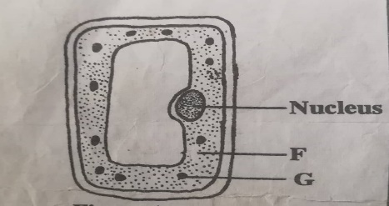
- Name the part marked F.
- Cell wall
- Cytoplasm
- Protoplasm
- Vacuole

- Which of the following is correct about the relationship between the structures marked F and G?
- Structure F receives oxygen produced in structure G.
- Structure G is made from structure F.
- Structure F receives glucose produced in structure G.
- Structure G obtains carbon dioxide from structure F.

- Which of the following minerals is important for the formation of red blood cells?
- iodine
- calcium
- iron
- fluorine
Figure 3 below is a food chain. Use it to answer question 8 and 9.

Ground nuts Mice XCat

- Which of the following represents organism X?
  - Goat
  - Snake
  - Ants
  - Chicken

- What would be the possible effect on the food chain if all mice were removed?
  - Ground nuts would decrease
  - Population of X would increase
  - Population of X would decrease
  - Population of cat would remain constant

- Which of the raw materials of photosynthesis is obtained by plant roots from the soil?
- Carbon dioxide
- Water
- Oxygen
- Mineral salts
- To which group of organisms does a bat belong?
- Bird
- Mammal
- Reptiles
- Crustaceans

- What term is given for a procedure where a needle is inserted into a vein to obtain blood?
  - Venipuncture
  - Blood transfusion
  - Blood donation
  - Needle insertion

- Oropharyngeal candidiasis occurs when the fungi attacks
  - Anus
  - Vagina
  - Penis
  - Mouth

- The taxonomic level after order is
  - Division
  - Species
  - Family
  - Class
- What is nutrient agar?
- A substance which kills bacteria
- A substance that feeds on a bacteria
- A substance with nutrients that encourage growth of bacteria for observation
- A chemical used to kill organisms in a lab

- To determine presence of moisture in air breathed out, cobalt chloride paper turns
  - Yellow
  - Pink
  - Blue – black
  - Green

- What anticoagulant is added to stored donated blood to prevent clotting?
  - Sodium citrate
  - Vitamin K
  - Iron
  - Calcium
Figure 4 shows a laboratory hazard symbol.



- What does the laboratory symbol represent?
- Harmful
- Corrosive
- Radioactive
- Flammable
- Why do Scientists repeat a scientific investigation?

- Rejecting hypothesis
- Reduce errors
- Comparing results
- Draw conclusion

- Chandler plucked an 8 cm leaf from a tree and made its drawing with magnification of X2.5. How long was the drawing?
  - 10.5 cm
  - 5.5 cm
  - 20 cm
  - 3.2 cm

SECTION B STRUCTURED QUESTIONS (50 marks)
Answer all questions in this section in the spaces provided.
- Figure 4 is a diagram showing an organism. Study it and answer questions that follow.
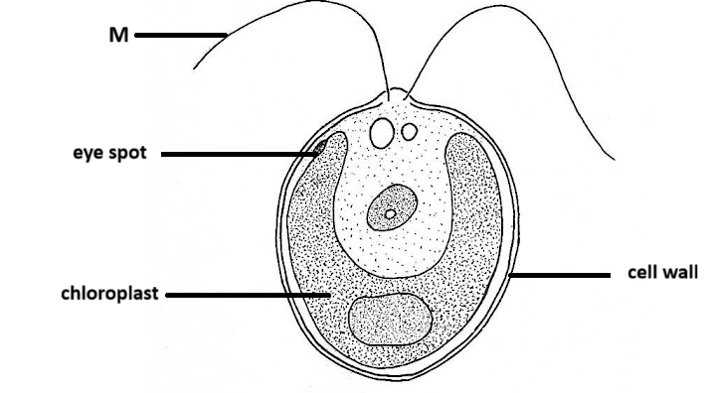
- Name the structure labelled M.
___________________________________________________________________
(1 mark)
- Give two observable features that make the organism in Figure 4 to be considered as a plant.
______________________________________________________________________________________________________________________________________
(2 marks)
- Give any two characteristics of liverworts.
______________________________________________________________________________________________________________________________________
(2 marks)

- A balanced has 55% carbohydrates, 15% lipids, 20% proteins and 10% water, vitamins and mineral salts.
- Present this information on a pie chart.

(5 marks)

- If the total mass of the diet weighed 2 700g, calculate mass of proteins.

(3 marks
- a. Explain the importance of the following modified leaves to a plant.
- Pitcher
__________________________________________________________________________________________________________________________________________
(2 marks)
- Spines
__________________________________________________________________________________________________________________________________________
- marks)
b. Explain the importance of rings of cartilage that line the trachea.
_______________________________________________________________________________________________________________________________________________________________________________________________________________
(2 marks)
- State any two involuntary responses controlled by medulla oblongata.
_______________________________________________________________________________________________________________________________________________________________________________________________________________
(3 marks)
- Explain how the following strategies help in preventing and controlling diarrhoeal disease.
- Sewage treatment
__________________________________________________________________________________________________________________________________________
(2 marks)
- Discouraging flying toilets
__________________________________________________________________________________________________________________________________________
(2 marks)
- Thorough cooking of food
__________________________________________________________________________________________________________________________________________
(2 marks)
- Figure 5 is a diagram showing the human skull. Study it and answer questions that follow.
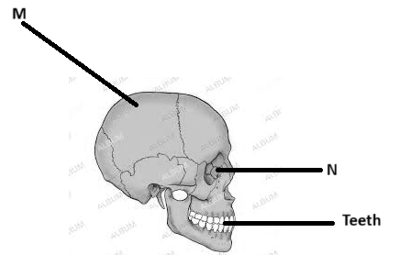
- Name part M
_____________________________________________________________________
(1 mark)
- What name is given to the joints in the skull?
_____________________________________________________________________
(1 mark)
- Give the sense organ found in part labelled N.
_____________________________________________________________________
(1 mark)
- Explain the structural adaptation of M in protecting the brain.
__________________________________________________________________________________________________________________________________________
(2 marks)
- a) Mention any two misconceptions associated with HIV and AIDS.
__________________________________________________________________________________________________________________________________________
(2 marks)
b) Differentiate Trichomoniasis and Syphilis in terms of causative agent.
__________________________________________________________________________________________________________________________________________
(2 marks)
c) Explain any two effects of HIV/AIDS on the nation.
____________________________________________________________________________________________________________________________________________________________________________________________________________________________________________________________________________________
(4 marks)
- Describe how the following ways are used in food preservation
- Pasteurisation
__________________________________________________________________________________________________________________________________________
(2 marks)
- Canning and bottling
__________________________________________________________________________________________________________________________________________
(2 marks)
- Salting
__________________________________________________________________________________________________________________________________________
(2 marks)
- Describe briefly how you can test lipids in food stuffs using ethanol emulsion test.
_________________________________________________________________________________________________________________________________________________________________________________________________________________________________________________________________________________________________________________________________________________________
(4 marks)
SECTION C ESSAY QUESTIONS (30 marks)
Answer all questions in this section in an essay form.
- Explain any five ways of caring for eyes.
___________________________________________________________________________________________________________________________________________________________________________________________________________________________________________________________________________________________________________________________________________________________________________________________________________________________________________________________________________________________________________________________________________________________________________________________________________________________________________________________________________________________________________________________________________________________________________________________________________________________________________________________________________________________________________________________________________________________________________________________________________________________________________________________________________________________________________________________________________________________________________________________________________________________________________________________________________________________________________________________________________________________________________________________________________________________________________________________________________________________________________________________________________________________________________________________________________________________________________________
(10 marks)

- Explain any five causes of deficiency diseases to an individual.
_____________________________________________________________________________________________________________________________________________________________________________________________________________________________________________________________________________________________________________________________________________________________________________________________________________________________________________________________________________________________________________________________________________________________________________________________________________________________________________________________________________________________________________________________________________________________________________________________________________________________________________________________________________________________________________________________________________________________________________________________________________________________________________________________________________________________________________________________________________________________________________________________________________________________________________________________________________________________________________________________________________________________________________________________________________________________________________________________________________________________________________________________________________________________________________________________________________________________________________________________________________________________________________________________________________________________________________________________
(10 marks)

- Describe an experiment that can be conducted to show that air breathed out contains moisture. In your essay include materials, procedure and expected results
______________________________________________________________________________________________________________________________________________________________________________________________________________________________________________________________________________________________________________________________________________________________________________________________________________________________________________________________________________________________________________________________________________________________________________________________________________________________________________________________________________________________________________________________________________________________________________________________________________________________________________________________________________________________________________________________________________________________________________________________________________________________________________________________________________________________________________________________________________________________________________________________________________________________________________________________________________________________________________________________________________________________________________________________________________________________________________________________________________________________________
(10 marks)
END OF QUESTION PAPERNB : This paper contains 12 printed pages.

