
NORTHERN EDUCATION DIVISION MOCK EXAMINATION
2026 JUNIOR CERTIFICATE EXAMINATION
CHEMISTRY
(100 Marks)
Subject Number: J038
Wednesday, 3 March, 2026 Time Allowed: 2 hours
8:00 – 10:00am

Question number | Tick if answered for Qs 21 to 30 | Do not write in these columns
1-20
21
22
23
24
25
26
27
28
29
30
31
32
33
TOTAL
Instructions

- This paper contains 12 printed pages. Please check.
- Write your Official Name in the spaces provided on top of each page of this question paper.
- This paper contains section A, B and C. Answer all questions in all sections.
- Use of scientific calculators is allowed.
- In the table provided on this page, tick against the question number you have answered.
- Hand in your paper to the invigilator when time is called to stop writing.

Turn over…
SECTION A (20 marks)
There are twenty questions in this section. Encircle the letter corresponding to the correct answer.

- Which branch of Chemistry involves study of techniques that are used to find out about composition of matter?
- Environmental Chemistry
- Physical Chemistry
- Analytical Chemistry
- Industrial Chemistry
- Which of the following is a chemical symbol of element called Lead?
- Ca
- L
- Hg
- Pb
- Express 302.43 in scientific notation.
- 302.43×10⁰
- 30.243×10²
- 3.0243×10²
- 3.0243×10⁻²
- Which of the following is general formula for alkanes?
- C_{n}H_{2n+2}
- C_{n}H_{2n+1}
- C_{n}H_{2n}
- C_{n}H_{2n}OH
- Which of the following bonds involves sharing of valence electrons?
- Electrostatic bond
- Covalent bond
- Metallic bond
- Ionic bond
- Which of the following gases support combustion?
- Oxygen
- Hydrogen
- Carbon dioxide
- Sulphur dioxide
Figure 1 is a diagram showing a technique used for separating mixtures.
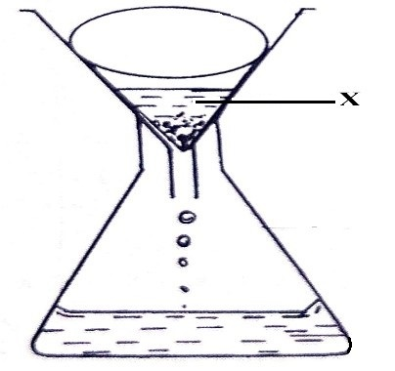
- State the method of separating mixtures indicated in the diagram
- Filtration
- Decantation
- Evaporation
- Distillation
- Which of the following is an example of mixtures that can be separated by the technique?
- Sand and petrol
- Oil and water
- Ink dye
- Iron fillings and sand
- Name the part labelled X
- Residues
- Distillate
- Water
- Filtrate
- What is percentage composition by mass of sodium in Na₂CO₃?
(RAM Na=23, C=12, O=16)
- 11.32%
- 15.09%
- 43.40%
- 45.28%
- Which pair has equal numbers of neutrons?
- ${}_{6}^{12}c∧{}_{12}^{24}{Mg}$
- ${}_{8}^{18}O∧{}_{9}^{19}F$
- ${}_{11}^{23}{Na}∧{}_{10}^{20}{Ne}$
- ${}_{8}^{17}O∧{}_{6}^{14}C$
- . Which of the following is not true about physical changes?
- difficult to reverse
- No new substance is formed
- The reactions are accompanied by great heat changes
- The reactants and products are in the same mass.
- Table 1 shows elements U, V, W and X found in the periodic table. Use the information to answer questions that follow.
Element | Atomic number | Mass number | Electron arrangement
U | 8 | 18 | 2,6
V | 18 | 40 | 2,8,8
W | 9 | 19 | 2,7
X | 3 | 7 | 2,1

- Which element is a halogen?
- X
- U
- W
- V
- Which two elements would form an ionic bond?
- U and V
- U and X
- W and X
- V and W
- Which element is stable from the table?
- U
- W
- V
- X
- Reactivity of Group VII elements decreases
- up the group
- down the group
- as the number of energy levels increases
- as the number of protons increases
- Which are the correct products for these reactants HCl + NaOH?
- NaOH + H₂O
- HCl + H₂O
- NaCl + H₂O
- H₂O + NaO
- Which of the following properties is common to both acids and bases?
- having a sour taste
- having a low pH
- facilitating corrosion
- turning red litmus paper to blue
- The higher the cation exchange capacity of the soil the:
- Lower the soil fertility
- higher the soil fertility
- higher the water content of the soil
- Higher the production of carbon dioxide when the soil is heated

SECTION B (50 marks)
Answer all questions in this section in spaces provided
- a. Define ‘precision’ as used in analytical Chemistry.
________________________________________________________________________________________________________________________________________ (1 mark)
b. Table 2 shows volume of hydrochloric acid used to be neutralized by sodium hydroxide. The student found the following results upon repeating the experiment 4 times

Run | Volume of HCl used (cm³)
1st reading | 20.87
2nd reading | 20.41
3rd reading | 20.89
4th reading | 21.0
- Which readings are precise?
________________________________________________________________________________________________________________________________________________________________________________________ (3 marks)
- Explain your answer in (i).
________________________________________________________________________________________________________________________ (2 marks)
- If the actual value is 20.3 cm³ which value is the most accurate?
_________________________________________________________ (1 mark)
- Figure 2 is an apparatus used in a chemistry laboratory
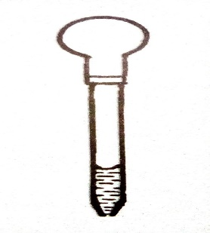
- Name the apparatus.
___________________________________________________________ (1 mark)
- State one use of the apparatus.
__________________________________________________________ (1 mark)
- Name instrument used to measure volume accurately in the laboratory
___________________________________________________________ (1 mark)
- a. Define the term electronegativity.
________________________________________________________________________________________________________________________________________ (1 mark)
b. Explain why atomic radius of elements increases down the group in the periodic table.
________________________________________________________________________________________________________________________________________________________________________________________________________________________________________________________________________________________ (3 marks)
c. How many atoms are in Cu(NO₃)₂?
________________________________________________________________ (1 mark)
- Figure 3 below shows a phenomena that happens in some states of matter.
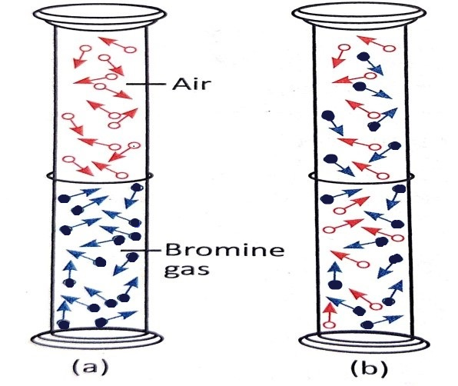
- Explain the phenomena illustrated by the diagram above.
_______________________________________________________________________________________________________________________________________________________________________________________________________ (2 marks)
- In which state of matter is the phenomenon possible?
___________________________________________________________________________________________________________________________________ (1 mark)
- Explain your answer in 10 a.(ii).
__________________________________________________________________________________________________________________________________ (2 marks)

- A certain element in the periodic table above is denoted as${}_{14}^{28}X$
- To which group of the periodic table does X belong? Give a reason for your answer.
__________________________________________________________________________________________________________________________________ (3 marks)
b. Identify element X in the periodic table.
________________________________________________________________ (1 mark)
c. Write the chemical formula of the compound between Al and O.
________________________________________________________________ (1 mark)
d. What type of bond exist between Al and O atoms? Give a reason for your answer?
________________________________________________________________________________________________________________________________________ (2 marks)
- a. State any one differences between physical and chemical changes.
________________________________________________________________________________________________________________________________________________________________________________________________________________ (2 marks)
b. The reaction between magnesium and chlorine is represented by the following equation:
Mg (s) + Cl₂ (g) MgCl₂ (aq)
(RAM: Mg = 24, Cl = 35.5)
- Calculate the total mass of reactants

(2 marks)
- Calculate the total mass of the product.

(2 marks)
- Establish the relationship between the total mass of reactants and that of the product.
________________________________________________________________________________________________________ (1 mark)
- What do you call the relationship established above?
_________________________________________________________ (1 mark)
- a. Define ‘Neutralization reactions’.
________________________________________________________________________________________________________________________________________ (1 mark)
b. Explain one application of neutralisation reaction.
________________________________________________________________________________________________________________________________________ (2 marks)
- An alkene has 10 hydrogen atoms.
- Find the total number of carbon atoms?

(2 marks)
- Write the molecular formula of the alkene.
___________________________________________________________ (1 mark)
- Draw the structure of the alkene in 28.(ii).

(1 mark)
- a. State one use of the following gases.
- Carbon dioxide
______________________________________________________________________________________________________________________________ (1 mark)
- Nitrogen gas
______________________________________________________________________________________________________________________________ (1 mark)
b. Give one natural sources of organic compounds.
________________________________________________________________________________________________________________________________________ (1 mark)
- a. Define the term soil salinity.
_________________________________________________________________________________________________________________________________________ (1mark)
b. Explain two causes of soil salinity.
________________________________________________________________________________________________________________________________________________________________________________________________________________________________________________________________________________________ (4marks)

SECTION C (30 marks)
Answer all the questions in this section in the spaces provided.
- With the aid of a well labelled diagram, describe changes that candle wax undergoes when heated.

_______________________________________________________________________________________________________________________________________________________________________________________________________________________________________________________________________________________________________________________________________________________________________________________________________________________________________________________________________________________________________________________________________________________________________________________________________________________________________________________________________________________________________________________________________________________________________________________________________________________________________________________________________________________________________________________________________________________________________________________________________________________________________________________________________________________________________________________________________________________________________________________ (10 marks)
- Describe an experiment that can be done to separate the mixture of iron nails, salt and sand.
______________________________________________________________________________________________________________________________________________________________________________________________________________________________________________________________________________________________________________________________________________________________________________________________________________________________________________________________________________________________________________________________________________________________________________________________________________________________________________________________________________________________________________________________________________________________________________________________________________________________________________________________________________________________________________________________________________________________________________________________________________________________________________________________________________________________________________________________________________________________________________________________________________________________________________________________________________________________________________________________________________________________________________________________________________________________________________________________________________________________________________________________________________________________________________________________________________________________________________________________________________________________________________________________________________________________________________________________________________________________________________________________ (10 marks)
- a. Describe how you would determine strength of an acid using universal indicator.
_______________________________________________________________________________________________________________________________________________________________________________________________________________________________________________________________________________________________________________________________________________________________________________________________________________________________________________________________________________________________________________________________________________________________________________________________________________________________________________________________________________________________________________________________________ (5 marks)
b. Describe an experiment that can be done to distinguish pentane from pentene.
________________________________________________________________________________________________________________________________________________________________________________________________________________________________________________________________________________________________________________________________________________________________________________________________________________________________________________________________________________________________________________________________________________________________________________________________________________________________________________________________________________________________________________________________________ (5 marks)
END OF QUESTION PAPER
This paper contains 12 printed pages.

