
NORTHERN EDUCATION DIVISION
2026 JUNIOR CERTIFICATE MOCK EXAMINATION
MATHEMATICS
(100 Marks)
Monday, 11 July 2026 Time allowed: 2 hours
08:00 – 10:00 am

Instructions
- This paper contains 15 pages printed. Please check.

- Write your Name and Examination number at the top of each page of the question paper in the spaces provided.

- Answer all the 20 questions in this paper.

- The maximum number of marks for each answer is indicated against each question.

- Write your answers in the spaces provided

- Show all your working.

- Scientific calculators may be used.

- Please make sure that you write your name on top of all pages in this paper before you start answering questions.

Questions answered | Tick if answered | Do not write in this column
1
2
3
4
5
6
7
8
9
10
11
12
13
14
15
16
17
18
19
20
Total

Turn over
- Evaluate $\frac{9}{g}$ + 2h + 5 when g = -3 and h = - 6 ( 3 marks)

- Find the difference between 20112₃ and 11121₃ and express your answer in base 10 (5 marks)

- Table 1 shows temperature readings in degrees Celsius of the four cities of Malawi in June:
Table 1
City | Temperature (℃)
Zomba | -2
Blantyre | 4
Lilongwe | 13
Mzuzu | -3

Calculate the mean temperature of the four cities on that day. (4 marks)

- Mr Mwale bought a plot at K2, 000,000 in 2024. If the value of the land appreciates at 3% per annum and he decides to sell the plot at the end of 2026, how much will this plot cost? (5 marks)

- A teacher wrote the numbers from 10 to 20 on number cards and asked Watipaso to select a card at random. Determine the probability that the number of the card picked is a prime number. (4 marks)

- Solve the following simultaneous equations:

$x-y=3$
$3x+y=1$ (5 marks)

- Figure 1 shows two isosceles triangles ABD and ACD with the same base, AD
Figure 1
Given that AB = DB, and AC = DC. Angle ABD = $32°$, and angle ACD = $64°$, calculate the value of angle marked $x$. (6 marks)

- Make $n$ the subject of the formula $d=\frac{t(n-1)}{n}$ (5 marks)

- Given that the point $\left(p,4\right)$lies on a straight whose equation is
$y=2x+3$. Find the value of $p$ (4 marks)

- Solve for $x$ in the equation $\frac{x-2}{5}-\frac{x+5}{6}=1$ (5 marks)

- Figure 2 is a venn diagram showing rivers in Kasungu and Mchinji.

Kasungu Mchinji

Mpasadzi Bua Tovi
Rusa Likase

Figure 2
- List down rivers in the union of sets Kasungu and Mchinji. (2 marks)

- How many rivers are in the set of Mchinji? (1 mark)

- Find the LCM of $5a^{2}$, $10ab^{2}$ and $15a^{3}b^{3}$ (4 marks)

- Solve the inequality $\frac{3}{4}x+12>6$ (4 marks)

- How many kilograms of soil supplement that cost K15, 000 per kg must be mixed with 20 kg of aluminium nitrate that costs K7, 000 per kg to make a fertilizer that cost K9,000.00 per kg? (Leave your answer correct to the nearest kg). (7 marks)

- A cyclist travelled from town A to town B at an average speed of 20 km/h and took 1.5 hours. On the return journey, due to traffic, she took 30 minutes more. What was her average speed on the return journey? (4 marks)

- Factorise completely $6x^{2}-6$ . (3 marks)

- Use logarithms to evaluate $\frac{5.4 X 0.0064}{0.086}$, give your answer correct to 2 decimal places. (5 marks)

- Figure 3 is a pie chart showing students who play different games.
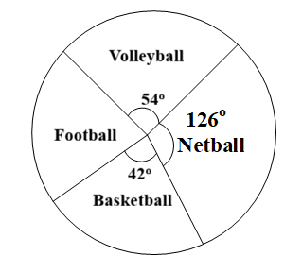
Figure 3
If the total number of students is 60, calculate the number of students who play football. (5 marks)

- Figure 4 is a diagram of a right pyramid.
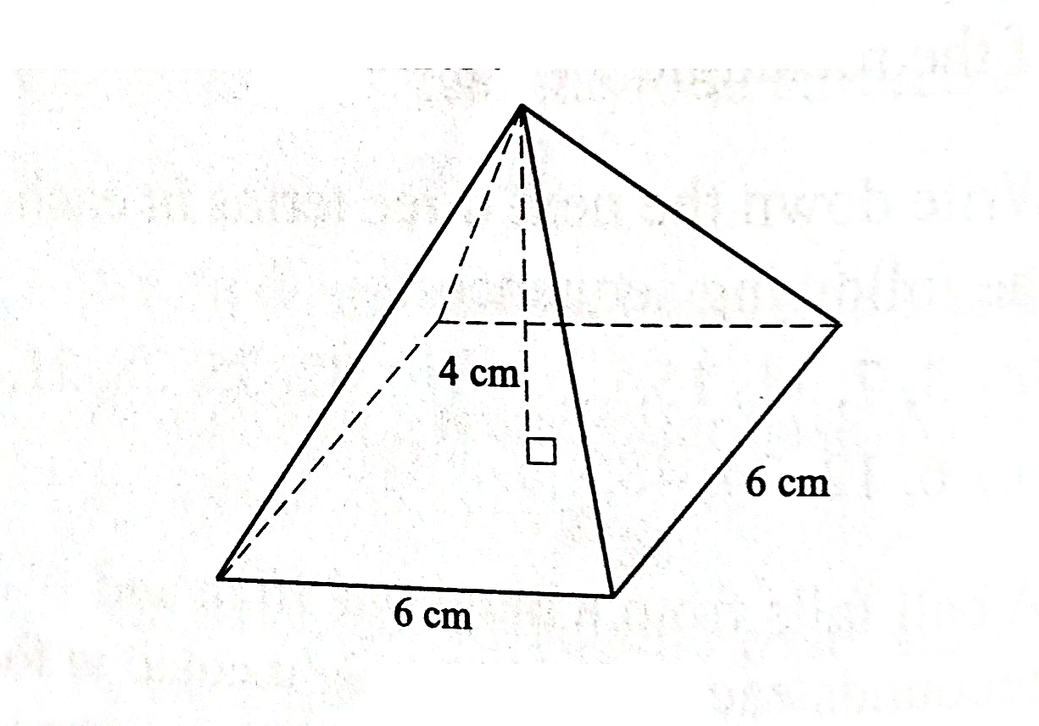
Figure 4
Calculate its total surface area. (10 marks)

20. Complete the tables of values for the equations $y=5-2x$
and $y=x-4$ (2 marks)

𝒚 = 𝟓 − 𝟐𝒙

 | −1 | 2 | 5
 | 7 |  | −5
$$x$$ | -1 | 2 | 5
$$y$$ | -5 | -2
$y=x-4$

b)
Using a scale of 2 cm to represent 1 unit on both axes, draw graphs of $y=5-2x$ and $y=x-4$ on the same graph paper provided on page 15.
(5 marks)
c) Use the graphs to solve the simultaneous equations $y=5-2x$ and $y=x-4$ (2 marks)



END OF QUESTION PAPER
NB: This paper contains 15 printed pages

