
CENTRAL WEST EDUCATION DIVISION
2026 MALAWI SCHOOL CERTIFICATE OF EDUCATION
MOCK EXAMINATIONS

Tuesday, 24 March Subject Number: M073/I
Time Allowed: 2 hrs. 30 min
08:00 - 10:30 am
GEOGRAPHY
PAPER I
(100 Marks)
MAP READING AND PHYSICAL GEOGRAPHY

Instructions
- This paper contains 11 printed pages. Please check.
- The paper has five questions.
- There are two sections, A and B. Follow the instructions for each section carefully.
- Write your CANDIDATE NUMBER and SCHOOL on top of each page of the question paper.
- In the table provided on this page, tick against the number of the question you have answered.
- Hand in the question paper to the invigilator when time is called to stop writing.

Question Number | Tick if answered | Do not write in these columns
1
2
3
4
5

SECTION A (75 marks)
Answer all three questions in this section in the space provided.
 |  | Study the 1: 50,000 map of Chirobwe sheet 1233C4 and use it to answer questions that follow.
 |  |  | Identify the human feature found on grid reference 723856.  ___________________________________________________________________ | (1 marks)
 |  |  | Give six-figure grid reference for the borehole BHFC 780.  ______________________________________________________________________________________________________________________________________ | (2 marks
 |  |  | Calculate the area of Bangwe Forest Reserve. | (5 marks)
 |  |  | In which direction is Lintete river flowing?  ___________________________________________________________________ | (2 marks)
 |  |  | Identify any two land uses on the map  ______________________________________________________________________________________________________________________________________ | (2 marks)
 |  |  | Mention the settlement pattern displayed by Fiso village.  ___________________________________________________________________ | (3 marks)
 |  |  | State whether or not Chikhamwazi school in grid reference 6585 and Kampanje school in grid reference 7085 are intervisible.  ___________________________________________________________________ | (1 mark)
 |  |  | Give a reason for your answer in d (i) above.  ______________________________________________________________________________________________________________________________________ | (1 mark)
 |  |  | Calculate the bearing of the trigonometric station 3533/MWS from borehole BHFC780  ___________________________________________________________________ | (2 marks)
 |  |  | Reduce the area on the map, north of northing 88, between easting 67 and easting 74 by half its original size. Use the graph paper provided on this page to answer this question.
 |  | 
 |  |  |  | (3 marks)
 |  |  | On the reduced map, insert the following:  - Bangwe Forest Reserve | (1 marks)
 |  |  | - Livulezi River | (1 marks)
 |  |  | - The new scale | (1 marks)
Figure 1 is an illustration of plate boundaries. Use it to answer the questions that follow.
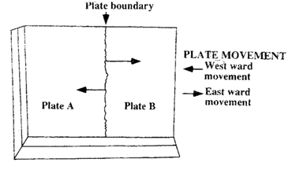
 |  |  | Identify the plate boundary.  ___________________________________________________________________ | (1 mark)
 |  |  | Mention any two geological features that form at plate boundary in (ii) above.  ______________________________________________________________________________________________________________________________________ | (2 marks)
 |  |  | Describe any two differences between basic and acidic lava.  ____________________________________________________________________________________________________________________________________________________________________________________________________________________________________________________________________________ | (4 marks)
 |  |  | Explain any two benefits of volcanism to human life.  ____________________________________________________________________________________________________________________________________________________________________________________________________________________________________________________________________________ | (4 marks)
Figure 2 is a riverine landform. Use it to answer questions that follow.
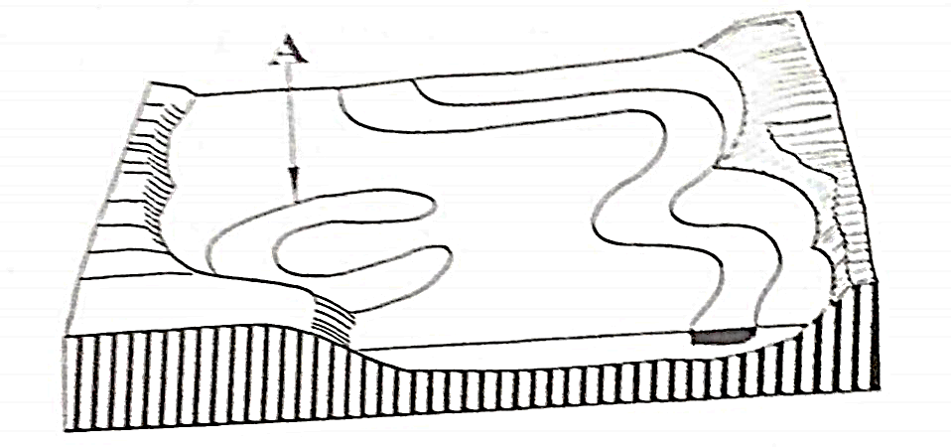
 |  |  | Identify the feature labelled A.  ___________________________________________________________________ | (1 mark)
 |  |  | Describe how the riverine landform in b (i) above develops.  ____________________________________________________________________________________________________________________________________________________________________________________________________________________________________________________________________________ | (4 marks)
 |  |  | With the aid of a well labelled diagram, explain how residual mountain is formed | (5 marks)
 |  |  | ________________________________________________________________________________________________________________________________________________________________________________________________________________________________________________________________________________________________________________________________________________________________________________________________________________________________________________________________________________________________________________________________________________________ | (4 marks)
 |  |  | What are ocean currents?  ______________________________________________________________________________________________________________________________________ | (1 mark)
 |  |  | Explain how each of the following factors affects the direction of ocean currents:
 |  |  | - shape of the continents  __________________________________________________________________________________________________________________________________ | (2 marks)
 |  |  | - prevailing winds  __________________________________________________________________________________________________________________________________ | (2 marks)
 |  |  | Explain any two positive effects of ocean currents on shipping.  ____________________________________________________________________________________________________________________________________________________________________________________________________________________________________________________________________________ | (4 marks)
Figure 3 shows main wetlands of Malawi. Use it to answer questions that follow.
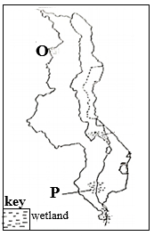
 |  |  | Name the wetlands marked O and P  O: _________________________________________________________________ | (1 mark)
 |  |  | P: _________________________________________________________________ | (1 mark)
 |  |  | Explain how wetlands help to:  - Reduce the emission of carbon dioxide.  ________________________________________________________________________________________________________________________________ | (2 marks)
 |  |  | - Maintain clean water in lakes and rivers.  ________________________________________________________________________________________________________________________________ | (2 marks)
 |  |  | Describe any two strategies for maintaining wetlands in Malawi.  ____________________________________________________________________________________________________________________________________________________________________________________________________________________________________________________________________________ | (4 marks)
 |  |  | Mention two causes of water pollution.  ______________________________________________________________________________________________________________________________________ | (2 marks)
 |  |  | Explain any one harmful effect of air pollution.  ___________________________________________________________________________________________________________________________________________________________________________________________________________________________________________________________________________ | (2 marks)
 |  |  | Explain how population growth influences désertification.  ____________________________________________________________________________________________________________________________________________________________________________________________________________________________________________________________________________ | (2 marks)
SECTION B (25 Marks)

Answer one question only from this section in the spaces provided

 |  |  | Name the instrument used to measure the following aspects of an earthquake.  - Magnitude  _________________________________________________________________ | (1 mark)
 |  |  | - Intensity  ________________________________________________________________ | (1 mark)
 |  |  | Explain any two effects of earthquakes on the environment.  ____________________________________________________________________________________________________________________________________________________________________________________________________________________________________________________________________________ | (4 marks)
 |  |  | Define the term “air pressure”.  ______________________________________________________________________________________________________________________________________ | (1 mark)
Table 1 shows the relationship between altitude, pressure and temperature. Use it to answer the questions that follow
Altitude | Pressure (mb) | Temperature (°C)
5000 | 606 | -15
3000 | 700 | 6
1500 | 852 | 18
0 | 1024 | 25

 |  |  | Calculate pressure difference between sea level and 5000m. | (3 marks)
 |  | (iii). | Explain how each of the following factors is influencing atmospheric pressure:  - Temperature  ________________________________________________________________________________________________________________________________________________________________________________________________ | (2 marks)
 |  |  | - Altiltude  ________________________________________________________________________________________________________________________________________________________________________________________________ | (2 marks)
 |  |  | Describe any two differences between local wind winds and prevailing winds.  ____________________________________________________________________________________________________________________________________________________________________________________________________________________________________________________________________________ | (4 marks)
 |  |  | Mention any one local wind experienced in the southern part of Malawi.  ___________________________________________________________________ | (1 mark)
 |  |  | Figure 4 shows a type of vegetation found in a certain climatic region of the world. Use it to answer questions that follow.
 |  |  | 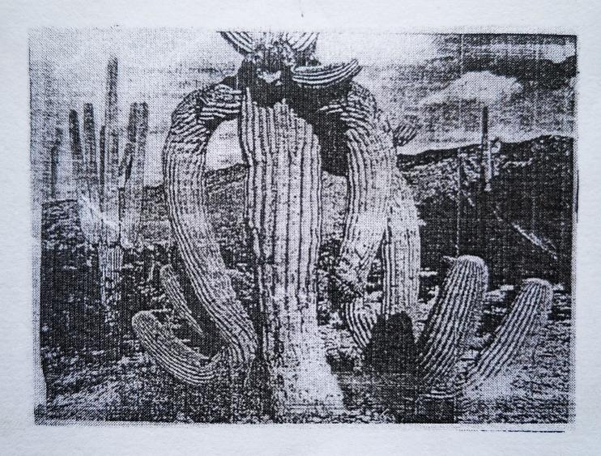
 |  |  | Name the plant shown in Figure 2.  ___________________________________________________________________ | (1 mark)
 |  |  | Which climatic region of the world has this vegetation?  ___________________________________________________________________ | (1 mark)
 |  |  | Explain any two ways in which vegetation in climatic region d (ii) above survives in extreme conditions.  ________________________________________________________________________________________________________________________________________________________________________________________________________________________________________________________________________________________________________ | (4 marks)

Figure 5 is a world map showing climatic regions. Use it to answer questions that follow.
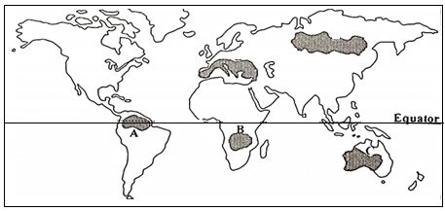
 |  |  | Identify the climates experienced in regions labelled A and C  A: _________________________________________________________________ | (1 mark)
 |  |  | C: _________________________________________________________________ | (1 mark)
 |  |  | Explain any two ways through which plants adapt to climatic conditions of the  region labelled B.  ____________________________________________________________________________________________________________________________________________________________________________________________________________________________________________________________________________ | (4 marks)
Table 2 shows climate for station X. Use it to answer questions that follow.

MONTH | J | F | M | A | M | J | J | A | S | O | N | D
Temp °C | 24 | 24 | 25 | 25 | 25 | 24 | 23 | 23 | 24 | 25 | 25 | 24
Rainfall (mm) | 215 | 210 | 205 | 220 | 210 | 205 | 200 | 195 | 210 | 220 | 215 | 210

 |  |  | Identify the hemisphere in which Station X is located?  ___________________________________________________________________ | (1 mark)
 |  |  | Describe any two unique rainfall attributes associated with the climatic region represented by the table.  ____________________________________________________________________________________________________________________________________________________________________________________________________________________________________________________________________________ | (4 marks)
 |  |  | Describe the relationship between temperature and rainfall as shown in the table above.  ______________________________________________________________________________________________________________________________________ | (2 marks)
 |  |  | Mention any two countries in Asia which experience the above type of climate.  ___________________________________________________________________ | (2 marks)
 |  |  | Mention the two types of cyclones.  ______________________________________________________________________________________________________________________________________ | (2 marks)
 |  |  | Describe any two weather patterns associated with the arrival of an eye of a cyclone.  ____________________________________________________________________________________________________________________________________________________________________________________________________________________________________________________________________________ | (4 marks)
 |  |  | Give two examples of anticyclones.  ______________________________________________________________________________________________________________________________________ | (2 marks)
 |  |  | Explain any one hazard of anticyclones.  ______________________________________________________________________________________________________________________________________ | (2 marks)

END OF QUESTION PAPER

