
CENTRAL WEST EDUCATION DIVISION
2026 MALAWI SCHOOL CERTIFICATE OF EDUCATION
MOCK EXAMINATIONS

Wednesday, 25 March Subject Number: M073/I
Time Allowed: 2 hrs. 00 min
02:00 - 04:00 pm
GEOGRAPHY
PAPER II
(100 Marks)
HUMAN AND ECONOMIC GEOGRAPHY

Instructions
- This paper contains 10 printed pages. Please check.
- The paper has five questions.
- There are two selections, A and B. Follow the instructions for each section carefully.
- Write your CANDIDATE NUMBER and SCHOOL on top of each page of the question paper.
- In the table provided on this page, tick against the number of the question you have answered.
- Hand in the question paper to the invigilator when time is called to stop writing.

Question Number | Tick if answered | Do not write in these columns
1
2
3
4
5

SECTION A (75 marks)
Answer all three questions in this section in the space provided.
 |  |  | Describe any two economic factors that influence agriculture.  ____________________________________________________________________________________________________________________________________________________________________________________________________________________________________________________________________________________ | (4 marks)
 |  |  | State any two characteristics of intensive farming systems.  ____________________________________________________________________________________________________________________________________________________________________________________________________________________________________________________________________________________ | (2 marks)
 |  |  | Mention any two sources of water for irrigation in Israel.  __________________________________________________________________________________________________________________________________________ | (2 marks)
 |  |  | Explain how the following factors affect irrigation farming in Israel.  - Relief  ______________________________________________________________________________________________________________________________________________________________________________________________________ | (2 marks)
 |  |  | - Salinity  ______________________________________________________________________________________________________________________________________________________________________________________________________ | (2 marks)
 |  |  | Explain any two advantages of sprinkler method of irrigation. | (4 marks)
 |  |  | ____________________________________________________________________________________________________________________________________________________________________________________________________________________________________________________________________________________
 |  |  | Mention any two districts where tea is grown in Malawi. | (2 marks)
 |  |  | __________________________________________________________________________________________________________________________________________
 |  |  | Describe two physical conditions which influence tea farming in Malawi. | (4 marks)
 |  |  | ____________________________________________________________________________________________________________________________________________________________________________________________________________________________________________________________________________________
 |  |  | What is the importance of each of the following in tea processing:
 |  |  | - Withering  ____________________________________________________________________________________________________________________________________ | (1 mark)
 |  |  | - Fermentation
 |  |  | ____________________________________________________________________________________________________________________________________ | (1 mark)
 |  |  | - Firing
 |  |  | ____________________________________________________________________________________________________________________________________ | (1 mark)
Figure 1 shows the fishing grounds of the world. Use it to answer the questions that follow.
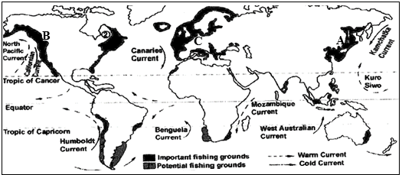
 |  |  | Identify the fishing grounds marked A and B.  A: _________________________________________________________________ | (1 mark)
 |  |  | B: _________________________________________________________________ | (1 mark)
 |  |  | Describe any two physical factors that have made fishing ground labelled C as one of the major fishing ground.  ____________________________________________________________________________________________________________________________________________________________________________________________________________________________________________________________________________________ | (4 marks)
 |  |  | Apart from fish, give any one resource from the sea.  __________________________________________________________________________________________________________________________________________ | (1 mark)
 |  |  | Mention any two challenges faced by the fishing in Malawi.  __________________________________________________________________________________________________________________________________________ | (2 marks)
 |  |  | Define the term “trade blocs”.
 |  |  | _______________________________________________________________________________________________________________________________________________________________________________________________________________ | (1 mark)
 |  |  | State any two challenges faced by “trade blocs” due to trade agreements.
 |  |  | ____________________________________________________________________________________________________________________________________________________________________________________________________________________________________________________________________________________ | (2 marks)
 |  |  | State any two challenges faced by trade blocs due to trade agreements.  ____________________________________________________________________________________________________________________________________________________________________________________________________________________________________________________________________________________ | (4 marks)
 |  |  | Explain any two ways in which Malawi benefit as a member state to regional trade blocs.  ____________________________________________________________________________________________________________________________________________________________________________________________________________________________________________________________________________________ | (4 marks)
 |  |  | Describe any two factors that influence tourism in Africa.  ____________________________________________________________________________________________________________________________________________________________________________________________________________________________________________________________________________________ | (2 marks)
 |  |  | State any one way in which ecotourism is important.  _______________________________________________________________________________________________________________________________________________________________________________________________________________ | (1 mark)
 |  |  | What is the main aim of the following international agreements on climate:
 |  |  | - Copenhagen Accord  ______________________________________________________________________________________________________________________________________ | (1 mark)
 |  |  | - Kyoto Protocol  ______________________________________________________________________________________________________________________________________ | (1 mark)
 |  |  | Define the term energy crisis.  __________________________________________________________________________________________________________________________________________ | (1 mark)
 |  |  | Outline any three possible solutions for energy crisis in Malawi.  _______________________________________________________________________________________________________________________________________________________________________________________________________________ | (3 marks)
Figure 2 shows a process of energy production. Use it to answer questions that follow.
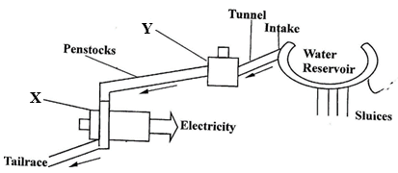

 |  |  | Name the parts labelled X and Y.  X. _________________________________________________  Y. _________________________________________________ | (2 marks)
 |  |  | Explain how the energy is produced in Figure 2.  _________________________________________________________________________________________________________________________________________________________________________________________________________________________________________________________________________________________________________________________________________________________ | (4 marks)
 |  |  | Explain any two factors that influence power generation in (i) above.  ____________________________________________________________________________________________________________________________________________________________________________________________________________________________________________________________________________________ | (4 marks)
 |  |  | Give any two examples of underground mining methods.  __________________________________________________________________________________________________________________________________________ | (2 marks)
 |  |  | Explain any two ways in which mining is important to the economy of Malawi.  _________________________________________________________________________________________________________________________________________________________________________________________________________________________________________________________________________________________________________________________________________________________ | (4 marks)
 |  |  | Describe any two negative effects of mining on the environment.  ____________________________________________________________________________________________________________________________________________________________________________________________________________________________________________________________________________________ | (4 marks)
 |  |  | State any one use of aluminium.  __________________________________________________________________________________________________________________________________________ | (1 mark)
SECTION B (25 Marks)

Answer one question only from this section in the spaces provided

 |  |  | State any two shapes of population pyramid.  __________________________________________________________________________________________________________________________________________ | (2 marks)

Figure 3 shows a population pyramid of country X. Use it to answer the questions that follow.
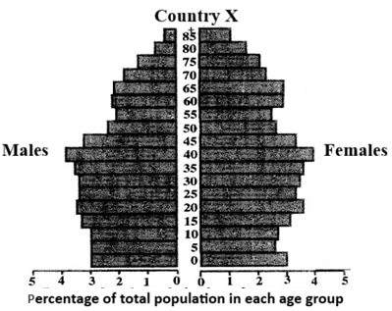

 |  |  | Give any two observations from the population pyramid in Figure 3.  ________________________________________________________________________________________________________________________________________ | (2 marks)
 |  |  | Describe any two implications of the population structure in (ii) above.  ________________________________________________________________________________________________________________________________________________________________________________________________________________________________________________________________________________ | (4 marks)
 |  |  | Name any two crops grown on dairy farms.  ________________________________________________________________________________________________________________________________________ | (2 marks)
 |  |  | Explain any two interventions to improve dairy industry in Malawi.  ________________________________________________________________________________________________________________________________________________________________________________________________________________________________________________________________________________ | (4 marks)
 |  |  | In what kind of rocks is petroleum found.  ____________________________________________________________________ | (1 mark)
 |  |  | Explain any two negative impacts of drilling oil in Lake Malawi.  ________________________________________________________________________________________________________________________________________________________________________________________________________________________________________________________________________________ | (4 marks)
 |  |  | Explain any two roles played by OPEC in the petroleum industry.  ________________________________________________________________________________________________________________________________________________________________________________________________________________________________________________________________________________ | (4 marks)
 |  |  | Give a reason why the following activities are done in rice fields:
 |  |  | - Controlling water level.  __________________________________________________________________________________________________________________________________ | (2 marks)
 |  |  | - Puddling of soil.  __________________________________________________________________________________________________________________________________ | (2 marks)
Figure 4 shows a settlement pattern. Use to answer questions that follow:
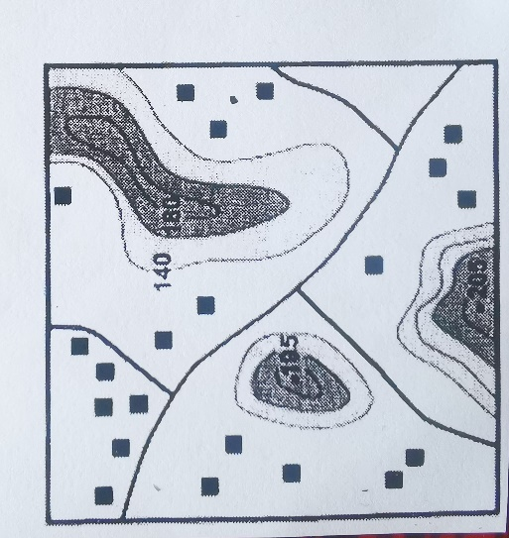
 |  |  | Identify the settlement pattern in the figure above.  ____________________________________________________________________ | (1 mark)

 |  |  | Describe any two factors that influence the development of the settlement pattern in a (i) above.  ________________________________________________________________________________________________________________________________________________________________________________________________________________________________________________________________________________ | (4 marks)
 |  |  | Give any two disadvantages of the settlement pattern shown in Figure 4 above.  ________________________________________________________________________________________________________________________________________________________________________________________________________________________________________________________________________________ | (2 marks)
 |  |  | Describe two factors that influence urbanization.  ________________________________________________________________________________________________________________________________________________________________________________________________________________________________________________________________________________ | (4 marks)
 |  |  | State any one solution for each of the following challenges associated with urbanization:  - Traffic congestion.  __________________________________________________________________________________________________________________________________ | (1 mark)
 |  |  | - Unemployment.  __________________________________________________________________________________________________________________________________ | (1 mark)
 |  |  | Mention any two ways of managing wastes.  ________________________________________________________________________________________________________________________________________ | (2 marks)
 |  |  | Describe any two economic effects of poor waste disposal.  ________________________________________________________________________________________________________________________________________________________________________________________________________________________________________________________________________________ | (4 Marks)
Figure 5 is the map of the world showing major industrial areas. Use it to answer questions that follow.
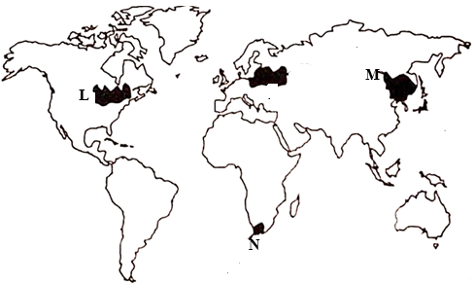

 |  |  | Name the industrial regions marked L and M.  L: _________________________________________________________________  M: _________________________________________________________________ | (2 marks)
 |  |  | Describe any two factors which have influenced the development of major industrial region marked N.  ________________________________________________________________________________________________________________________________________________________________________________________________________________________________________________________________________________ | (4 marks)

END OF QUESTION PAPER

