
2018 – 2019 FORM FOUR MOCK EXAMINATIONS
BIOLOGY
PAPER I
THEORY
100 marks
Time Allowed: 2 hours
Monday, 1st April, 2019.
Instructions
- This paper contains 13 pages. Please check.
- Write your name on every page.
- This paper contains two sections; A and B.
SECTION A (70 MARKS)
1. a. Name any two excretory organs in the human body.
____________________________________________________________________________________________________________________________
(2 marks)
b. Give any two differences in terms of composition between blood flowing in the dialysis tubing and the dialysis fluid.
Blood flowing in the dialysis tubing | Dialysis fluid
(2 marks)
c. Name any one excretory product from the human body.
______________________________________________________________
(1 mark)
d. State a permanent treatment that can be given to an individual with a kidney failure.
______________________________________________________________
(1 mark)
2. Figure 1 shows a capillary bed. Use it to answer questions that follow:
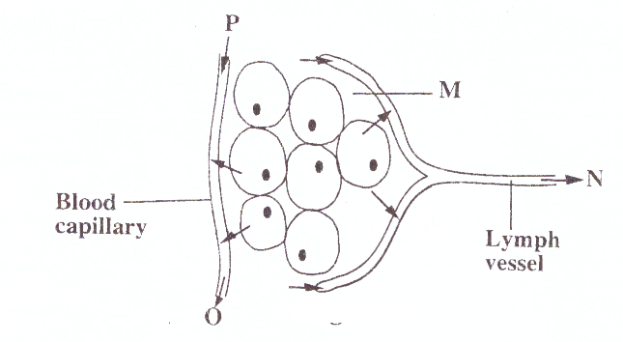
a. i. Name the fluid found in M.
________________________________________________________
(1 mark)
ii. Name any two substances found in M that are used by the body.
__________________________________________________________________________________________________________________
(2 marks)
b. Name two adaptations for each of the following to their functions:
i. blood capillaries
____________________________________________________________________________________________________________________________
(2 marks)

ii. lymph vessels
____________________________________________________________________________________________________________________________
(2 marks)
c. Which letter represents arterial end of the capillary bed?
______________________________________________________________
(1 mark)
3. a. i. Define the term “Organ transplant”
_____________________________________________________________
(1 mark)
ii. Name two organs in the human body that can be transplanted.
____________________________________________________________________________________________________________________________
(2 marks)
b. i. What problem is likely to occur if organ transplant is
carried out without considering blood groups?
_______________________________________________________
(1 mark)
ii. Explain one way in which the problem in b (i) would occur.
_______________________________________________________________________________________________________________________________________________________________________
(3 marks)
4. In a breeding experiment, a pure bread black mouse was crossed with
a pure-breed white mouse. All the F₁ offspring were black. Given that
the allele for black colour in mice is A and that for white colour is a
a. Write the genotypes of the parents:
i. Black mouse: __________________________________________
(1 mark)

ii. White mouse: __________________________________________
(1 mark)
b. i. Give the genotype of the F₁ generation.
______________________________________________________
(1 mark)
ii. State the genetic term that can be used to describe the F₁ offspring.
_______________________________________________________
(1 mark)
c. i. Using a well labelled genetic cross diagram, work out the phenotypic
ratio of the F₂ offspring.

(6 marks)
ii. If the number of mice produced in F₂ generation were 32. Calculate the number of white mice produced in the F₂ generation.

(4 marks)
5. Figure 2 shows muscles and joints of the human arm. Use it to answer the questions that follow:
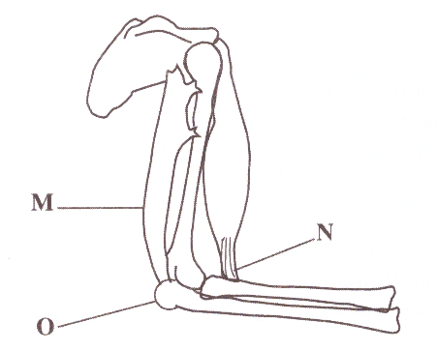
a. Name the parts marked M and N.
M: ___________________________ N:_________________________
(2 marks)
b. State one adaptation of the part marked N to its function.
________________________________________________________________
(1 mark)
c. What type of a joint is found at O?
_________________________________________________________________
(1 mark)
d. Explain how bending of the lower arm occurs.
___________________________________________________________________________________________________________________________________________________________________________________________________
(3 marks)
6. Figure 3 shows types of lymphocytes in a flow diagram. Use it to answer the questions that follow:
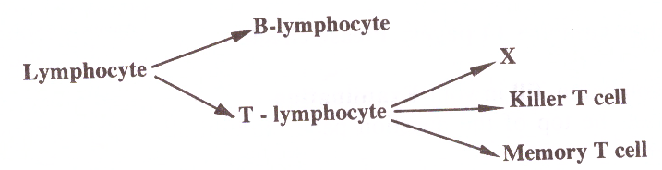
a. Name the T-lymphocyte X.
______________________________________________________________
(1 mark)
b. State the difference between “B-lymphocytes” and “T-lymphocytes”
______________________________________________________________
(1 mark)
c. Explain what happens if T-lymphocyte X has been weakened by HIV.
____________________________________________________________________________________________________________________________
(2 marks)
7. Figure 4 shows a plant tissue obtained from a stem. Use it to answer the questions that follow:
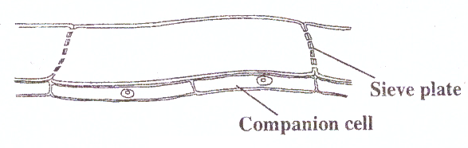
a. i. Identify the tissue.
______________________________________________________
(1 mark)
ii. Give two reasons to support your answer in a (i)
______________________________________________________
_____________________________________________________
(2 marks)
8. Table 1 shows the percentage volume composition of inhaled and exhaled air in the lungs.
Gas | Inhaled air (%) | Exhaled air (%)
Oxygen | 20.50 | 16.50
Carbondioxide | 0.04 | 4.00
Nitrogen | 79.46 | 79.46
a. From the table, what evidence suggests that the lung is very efficient in the excretion of carbondioxide?
_____________________________________________________________
(1 mark)
b. What percentage of total inhaled oxygen is used by the body? Show your working.

(2 marks)
9. a. i. Name one enzyme produced by the pancreas.
______________________________________________________
(1 mark)
ii. Give the food substance on which this enzyme acts.
______________________________________________________
(1 mark)
iii. What is the end-product of the digestion of the food named in a (ii)?
______________________________________________________
(1 mark)
10. Figure 5 shows a diagram of a section of an aquatic ecosystem.
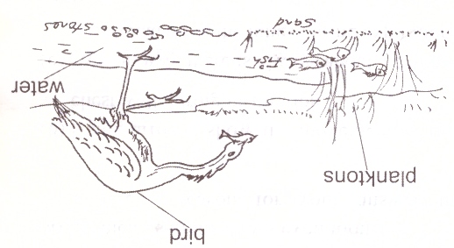
a. Construct a possible food chain from figure 5 above.

(1 mark)
b. Which organisms would be:
i. Part of a population having the greatest biomass?
______________________________________________________
(1 mark)
ii. On top of the pyramid of numbers?
______________________________________________________
(1 mark)
c. i. State two activities that the secondary consumer
should be able to do inorder to survive in this ecosystem.
ii. Using the diagram, describe the adaptations that the bird shows in order to accomplish activities mentioned in c (i)

(3 marks)

11. Rice field can be a good breeding ground for the worm that causes bilharzia.
a. Mention two features in rice fields that can encourage the breeding of this worm.
____________________________________________________________
______________________________________________________________
(2 marks)
b. Name the worm that causes bilharzia.
____________________________________________________________
(1 mark)
c. Describe one way of controlling the worm biologically.
______________________________________________________
(1 mark)
12. a. i. What is meant by external fertilization?
______________________________________________________
(1 mark)
ii. State one advantage of internal fertilization over external fertilization.
______________________________________________________
(1 mark)
b. Give a short biological explanation to refute the following claim
made by a certain mother: “My son Chisomo and my daughter
Chimwemwe are identical twins”
___________________________________________________________
(1 mark)

SECTION B (30 MARKS)
13. Discuss five adaptations of birds for flight. Your answer should be in an essay form.
_______________________________________________________________________________________________________________________________________________________________________________________________________________________________________________________________________________________________________________________________________________________________________________________________________________________________________________________________________________________________________________________________________________________________________________________________________________________________________________________________________________________________________________________________________________________________________________________________________________________________________________________________________________________________________________________________________________________________________________________________________________________________________________________________________________________________________________________________________________________________________________________________________________________________________________________________________________________________________________________________________________________________________________________________________________________________________________________________________________________________________________________________________________________________________________________________________________________________________________________________________________________________________________________
(10 marks)
14. Describe an experiment you would do to show that transpiration from leaves affects water uptake. Your answer should include procedure, expected results and conclusion in an essay form.
______________________________________________________________________________________________________________________________________________________________________________________________________________________________________________________________________________________________________________________________________________________________________________________________________________________________________________________________________________________________________________________________________________________________________________________________________________________________________________________________________________________________________________________________________________________________________________________________________________________________________________________________________________________________________________________________________________________________________________________________________________________________________________________________________________________________________________________________________________________________________________________________________________________________________________________________________________________________________________________________________________________________________________________________________________________________________________________________________________________________________________________________________________________________________________________________________________________________________________________________________________________________________________________
(10 marks)
15. Suppose you are a Health assistant in a community where there is high prevalence of malaria, what advice would you give to the community on prevention of malaria? Explain any five points in an essay form.
______________________________________________________________________________________________________________________________________________________________________________________________________________________________________________________________________________________________________________________________________________________________________________________________________________________________________________________________________________________________________________________________________________________________________________________________________________________________________________________________________________________________________________________________________________________________________________________________________________________________________________________________________________________________________________________________________________________________________________________________________________________________________________________________________________________________________________________________________________________________________________________________________________________________________________________________________________________________________________________________________________________________________________________________________________________________________________________________________________________________________________________________________________________________________________
(10 marks)
End of Question Paper

