Table of Contents

Part 1 – What is Symbolic Universal Notation?

Part 2 – Explanation of Characters and Extensions

Part 3 – How to Teach Characters and Extensions

Part 4 – Grammar

Part 5 – Words with Multiple Meanings

Part 6 – Changing a Symbol

Part 7 – How to Use the Dictionary

Part 8 – How to Prepare for Scripture

Part 9 – How to Teach Scripture

Part 10 – Error Correction Process

Part 11 – How to Capture Your Translation on Video

Part 12 – I’m Ready to Teach Someone. What do I do?

Note: It is advised that you read the entire manual. Then go to part 12 for the steps to take to begin teaching someone how to read and translate SUN.

Part 1 – What is Symbolic Universal Notation?

Symbolic Universal Notation (SUN) is a system of written communication that is based on symbols or pictographs. Each symbol represents one or more words in the reader’s language. Since SUN is based on pictures and symbols, it is a system that can be used universally. SUN was originally developed for individuals who are both deaf and blind. However, it has also proven helpful for the illiterate deaf who are not educated in a standard sign language.

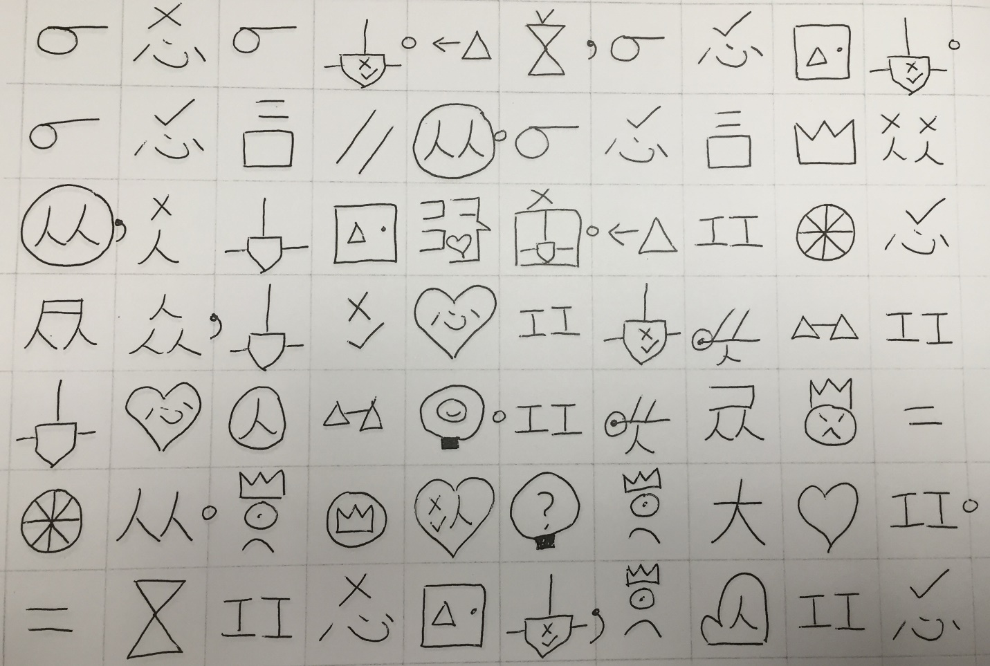

*Example of a page of Scripture in SUN.*

Part 2 – Explanation of Characters and Extensions

SUN consists of two types of symbols: characters and extensions. Characters are symbols that are the basic building blocks for other symbols. Characters can stand alone, but they can also be combined or altered to form new symbols. Characters are indicated in red in the SUN dictionary as well as the teaching cards. Characters are taught using illustrations to assist recognition and memorization. To effectively use SUN, it is advised to commit all the characters to memory as soon as possible.

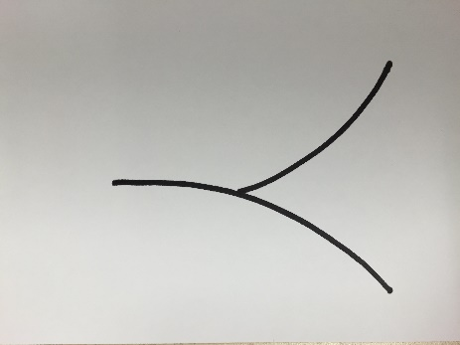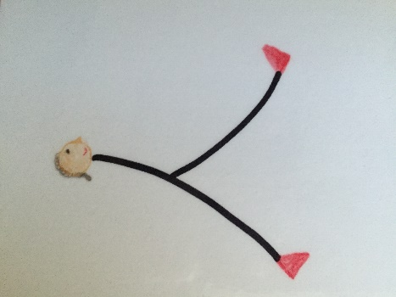

*On the left is the character for person. On the right is the illustration that is used to teach the character.*

Extensions are words that are formed by either combining or altering characters. There are three different types of extensions: combinations, alterations and proper nouns. Combinations are formed by combining two or more characters. Alterations are formed by changing a character or adding something to a character. Proper Nouns are combinations that are assigned to a name. Learning extensions rely more heavily on association rather than rote memorization. Extensions are indicated in green in both the dictionary and teaching cards.

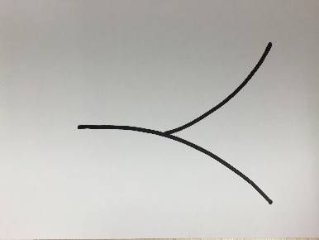 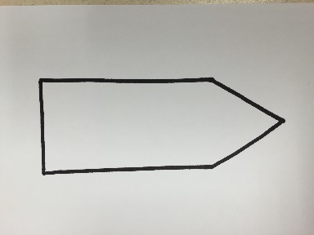 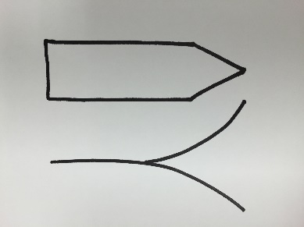

*Example of a combination: Combining the character person (left) and write (middle) makes writer (right).*

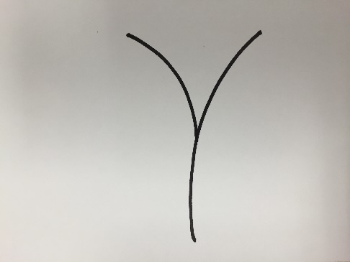 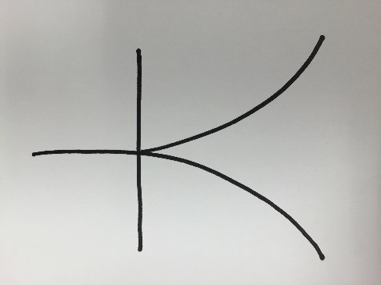

*Sleep Big*

The symbols “sleep” and “big” shown above are examples of alterations. In the word “sleep,” the character “person” is lying down on its side just as a person would be lying down when sleeping. In the word “big,” a straight line indicating arms stretched out is added to the character “person.” When a person stretches his arms out wide, he is often describing something big.

**Proper Nouns**

Proper nouns are indicated by assigning a symbol based on either the meaning of a name, or something significant about that person or place. Once the symbol is assigned, it is then placed inside the symbol for the common noun. Here’s an example.

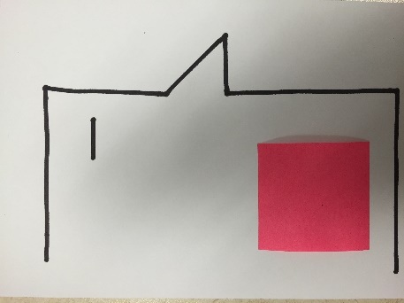

This word is man. There is pink box on the man’s cheek. If I come across the name of a man, like “Paul,” I would choose a symbol to put in the pink box based on either the meaning of the name or something significant in the person’s life. The name “Paul” means “little,” so I would use the character “small” and put it in that pink area. So the name Paul would look like this:

Here are some other types of proper nouns: (Note the pink area is where the symbol for each specific proper noun would be.)

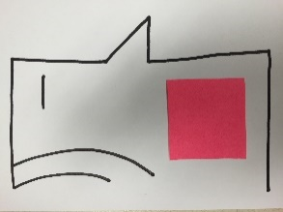 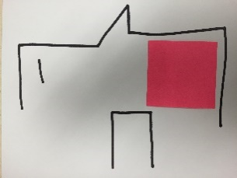 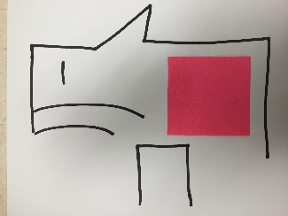 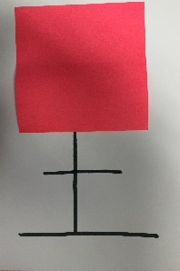 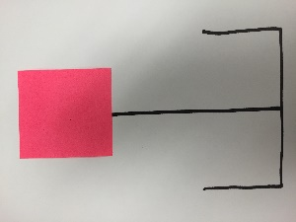

Woman Boy Girl Land (City, Country) Mountain

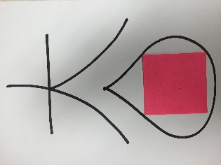 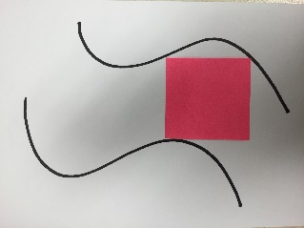

Sea River

In the translated text, proper nouns are indicated in blue.

In addition to character and extension cards, there are also yellow punctuation cards that explain the different types of punctuation used in SUN text. If the SUN text is printed on paper that has boxes or grids, the punctuation is placed on the vertical lines instead of in their own box. Quotation marks are printed at the top left and right corners of the box.

Part 3 – How to Teach Characters and Extensions.

**Teaching Characters**

**Step 1:** Take a teaching card for a character. Show the student the side with the illustration for the character.

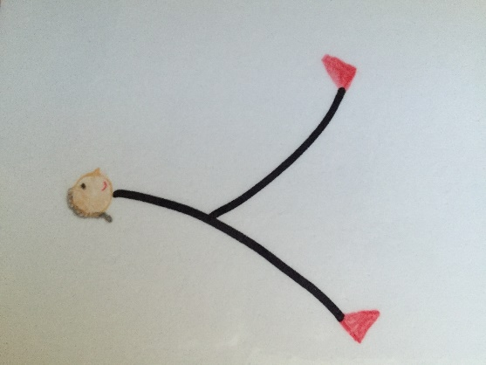

**Step 2:** Sign to the student what the character is. (Look in the following section *Meanings for the Characters* to find what each character is.) If more than one word is represented by the character, sign all the words.

**Step 3:** Trace the character with your fingers.

**Step 4:** Have the student trace the character with his fingers and sign the character. If more than one word is represented by the character, make sure the student signs all the words.

**Step 5:** Turn the teaching card over to the side without the illustration and repeat steps 2-4.

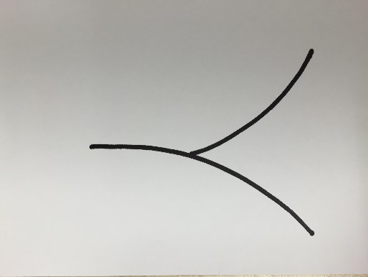

**Step 6:** After introducing 5 new characters, review by showing the student the side without the illustration and have the student sign the character to you.

**Step 7:** If the student forgets the character or makes a mistake, DO NOT sign the character. Flip the card over to the illustrated side and see if the student can remember or self-correct. (If the student cannot remember or self-correct even after seeing the illustration, repeat steps 2-4.)

**Teaching Extensions**

**Step 1:** If the extension is a combination, make sure you have taught all the characters in the combination. For example, before teaching the word “writer,” make sure the student knows the characters “person” and “write.”

**Step 2:** Show the student the extension card.

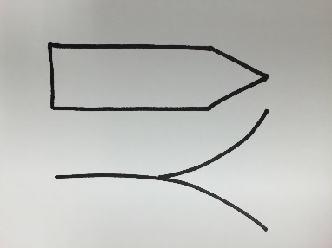

**Step 3:** Sign the word to the student. If more than one word is represented by the extension, sign all the words.

**Step 4:** Have the student sign the word to you. If more than one word is represented by the extension, make sure he signs all the words.

**Step 5:** Explain each extension using the explanation on the back of each extension card. Check for understanding.

**Step 6:** Have the student copy the extension in his own handwriting. After he writes the extension, have him sign the word or words for that extension.

**Step 7:** After each 5 extensions, review by showing the extension card and having the student sign the word or words.

**Step 8:** Review the same 5 extensions again, except this time have the student write the extension from memory.

Meanings for the Characters

Since the characters don’t have their meanings on the back, here is a list of all the characters and their meanings to use when teaching the characters. The numbers here correspond to the numbers on the upper right hand corner of the character cards

1.) Man / He / Him

2.) Love / Compassion

3.) King / Lord / Crown / Ruler

4.) Cross

5.) Mouth / Tell / Speak / Said

6.) Know / Knowledge

7.) You

8.) Hand

9.) Work / Do

10.) Heart

11.) Good

12.) Animal

13.) Thing

14.) Person

15.) Land / Place

16.) Sun / Day / Light

17.) Forward / To

18.) I / Me

19.) Time / When

20.) House

21.) No / Not

22.) Many / Much

23.) Small / Few

24.) Part / Some

25.) Face

26.) Very (showing emphasis)

27.) Chair / Sit

28.) Book / Read / Learn

29.) Start / Beginning

30.) Eye / See

31.) Pen / Write

32.) Road / Path / Way

33.) Ear / Hear

34.) Door

35.) Tree / Plant

36.) Straight

37.) Water

38.) Same / Equal

39.) Knife / Blade / Cut

40.) All / Whole / Every

41.) River / Stream

42.) Fabric / Clothing

43.) Camel

44.) Belt

45.) Insect

46.) Sweet

47.) Walk

48.) Near / Close by

49.) Tie / Knot

50.) Up

51.) From

52.) Fly

53.) Chains / Chain (verb) / Bondage

54.) Net

55.) Fish

56.) Boat

57.) Soft

58.) New

59.) Moon / Night

60.) Cup / Drink

61.) Hole

62.) Grain

63.) Stretch / Spread

64.) Mountain

65.) Storm

66.) Around / Surround

67.) Fire / Heat / Hot / Burn

68.) Measure / Measurement

69.) Fruit

70.) Table

71.) Air

72.) Pig

73.) Thousand

74.) Sword

75.) Box

76.) Color

77.) Whip

78.) Horse (picture of a horseshoe)

79.) Wall

80.) Nose / Smell

81.) Window

82.) Snake

83.) Tower

84.) Shield

85.) Dish

Part 4 – Grammar

**Filler Words**

A symbol-based writing system naturally takes up more room than regular words. For this reason, it is important to try to use the fewest number of symbols to convey a thought so that it doesn’t take up too much space. That is why some “filler words” such as prepositions, articles and conjunctions and certain adjectives are left out. Certainly, there are times when such words are necessary to convey the correct meaning. In those cases, the filler words are included. However, wherever possible, the filler words are left out and the reader is expected to fill them in when he reads the passage.

Here is an example:

A sentence in English may sound like this: ***I walked to the store to buy some bread.***

Here is what the sentence would look like in SUN:

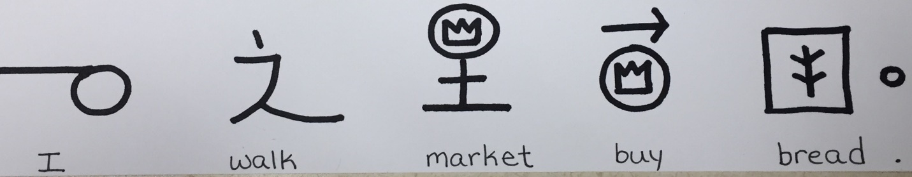

Notice the words that were left out in the sentence: (They are shown in red)

***I walked to the store to buy some bread.***

As the reader, the sentence still conveys the appropriate meaning even though the filler words are left out.

Here’s an example of times when filler words are not left out because they affect the meaning of the sentence. Look at the following sentences.

***I walked from the store to the house.***

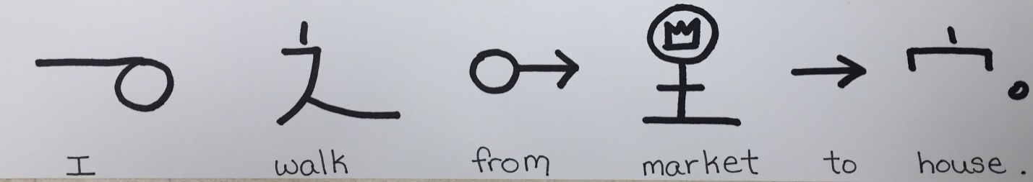

***I walked to the store and then to the house.***

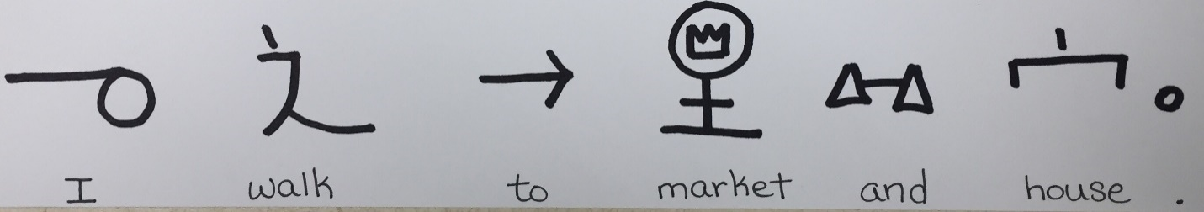

The words that are in red this time are included in the sentence because it makes a difference in the meaning. The first sentence suggests that I am starting at the store. The second sentence indicates that I went to both places. My starting point is not mentioned, but I definitely didn’t start at the store if I walked to the store.

**Pronouns**

There are no specific characters for pronouns such as “he,” “him,” “his,” “her,” “she,” “hers,” are not used. Instead, the name of the person (or the symbol for man, woman, or person) is repeated depending on the context of the sentence. This is to reduce the number of symbols each student must learn.

**Verb Tenses**

For the sake of simplicity, verb tenses are not used. In most cases, the context will dictate the tense of the verb, or there will be words in the sentence that will show what tense the verb is in.

Here’s an example: ***When I was small, I didn’t know how to walk.***

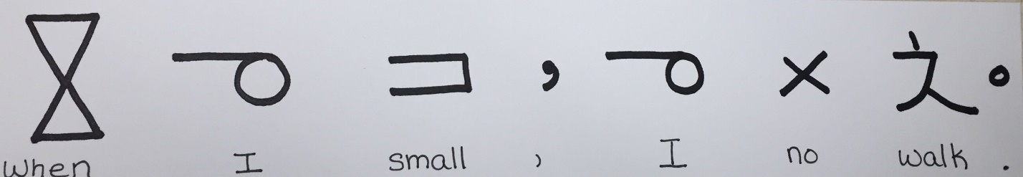

As you see, there are a lot of words left out including the past tense of the verb “do.” However, the reader can fill in the missing words just like we fill in missing words when children (or people learning our language) talk to us.

**Possessives**

Possessives are shown with a dot above the noun that is a possessive. The character that comes after the possessive belongs to the possessive. Here’s are a couple examples:

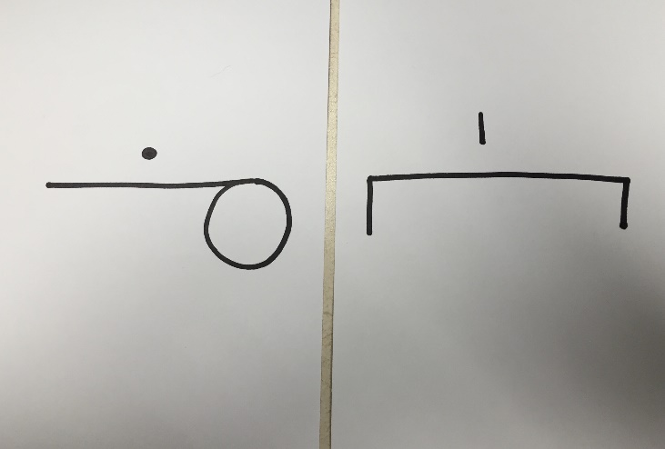

This is the phrase “my house.” The first symbol without the dot is “I” or “me.” Since it has a dot on it, that indicates a possessive noun, so the word becomes “my.” The word following the possessive is “house.” So the house belongs to me. It is “my house.”

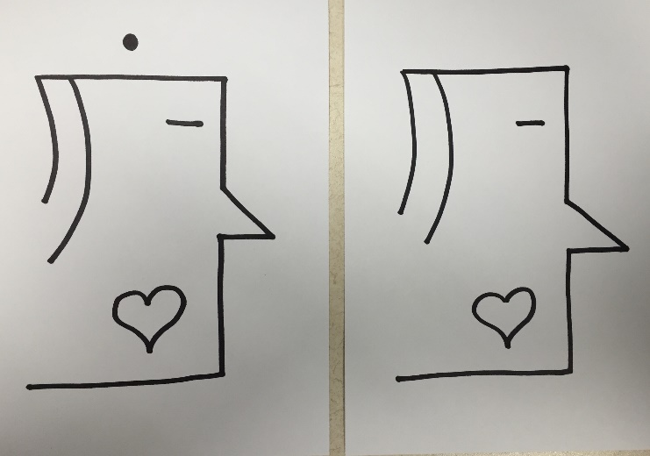

This is the phrase “Mother’s Mother” or “Grandmother.” To avoid creating another symbol for “grandmother,” the possessive noun is used. The second symbol belongs to the possessive noun that comes before it, so it is “mother’s mother.” If you are translating this and you say, “grandmother,” you would be correct.

Part 5 – Words with Multiple Meanings

The goal of SUN is that anyone can learn this system quickly and can get to Scripture as soon as possible. With that in mind, the fewer characters and extensions someone must learn, the better. That is why some words have multiple meanings. However, how does a reader decide which word to use? Here is where context plays a very important part in comprehension. Let’s try an example.

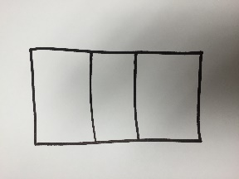

This is the word “eye.” It can also be the verb “see.” Now let’s look at the following sentence:

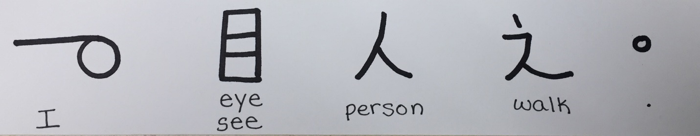

“I eye person walking” doesn’t make sense, but “I see a person walking” does. It is the reader’s responsibility to look at the context and pick the right word.

Part 6 – Changing a Symbol

Symbols may not be changed. This is to protect against confusion and delays that are caused by different opinions as to what the symbols should be. For example, what looks like house to me may not look like a house to someone else. If I want a house to be drawn a certain way, and someone else disagrees, we will waste a lot of time deciding what the symbols should be and never get to the important part of translating Scripture.

If you come across a word that is not in your language, find the closest word in your language and change the meaning, not the symbol. Here’s an example:

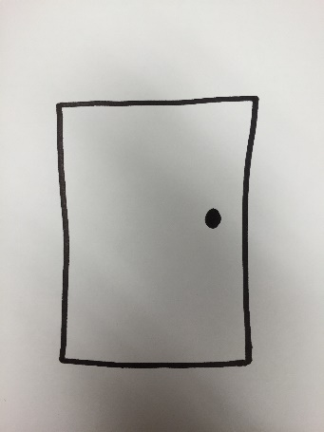

This is the symbol for door. Let’s pretend you don’t have doors where you live. You will then follow these steps to change the meaning.

1. Find out what the meaning of a door is – “A moveable solid barrier that opens or closes an entryway to a building.”
2. But then you think, “Our buildings don’t have a moveable solid barrier in the entryway, we only have an opening that serves as the entrance to the building.”
3. You may then decide that “entrance” is a better word than “door.”
4. In the dictionary, you will change **the meaning** of this symbol from “door” to “entrance.” You are not changing the symbol. You’re just changing the meaning of the symbol. That may mean that this symbol will require more effort to memorize than other symbols, but it will save the confusion of changing symbols.

Part 7 – Using the Dictionary

The kit includes a SUN dictionary. The SUN dictionary is a way to look up symbols that you or your student may not be familiar with. The dictionary is divided into sections with each section consisting of one character and the extensions that come from that character. To find a symbol, follow these steps:

Step 1: Is the symbol a character or extension?

Step 2a: If it is a character, look at the table of contents page (the very first page) and find your symbol. If the character is not listed in the table of contents, that means that the character has no extensions. In that case it will be listed under the “Other Characters” section.

Step 2b: If your character is an extension, look for the main character in the extension. Generally speaking, the main character is either the **character** **at the top** or the **biggest character**. Here are some examples.

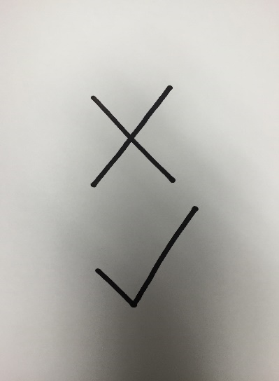

This is the word “bad.” It is an extension using the characters “no,” (x) and “good” (check mark). Since the “x” is on the top, you would look under the no section for this symbol.

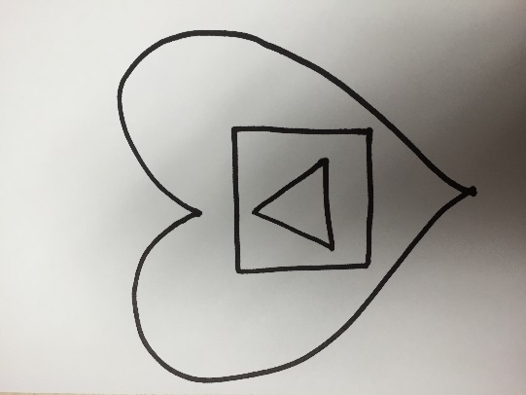This is the symbol for “hungry.” It is an extension using the characters “love,” (heart) “mouth,” (square) and “thing” (triangle). Since the heart is the biggest character, you would look under the love section for this symbol.

If you can’t find an extension under the character you think it should be listed, try looking under the other characters in the extension.

Numbers have their own section. To find the symbol for a number, look under the number section.

Symbols that have arrows in the top or biggest part are listed in the “arrows section.

If the symbol is in blue, it is a proper noun. Look in the proper nouns section for the word.

Part 8 – How to Prepare for Scripture

In many ways, SUN can be considered a unique language. Just like when learning any new language, the more you use it, the more familiar and comfortable you become. Since Scripture contains complex concepts that are not used in everyday conversations, (ex. resurrection, salvation, redemption, etc.) it is advised that you begin with everyday conversations to get used to the symbols. That way, when you see the symbols in Scripture, you’re already familiar with them. There are two parts to preparing for Scripture. The first part is conversational sentences (including some spiritual conversation to familiarize the student with spiritual terms.) The second part is a short story.

**Conversational Sentences**

Before you begin teaching these sentences, teach the characters and extensions needed for all 10 sentences. Here they are:

Characters: Man, Love, King, Cross, Mouth, Knowledge, Question Mark, You, Hand, Work, Heart, Good, Animal, Thing, Person, Land, Sun, Forward/To, Me, Time, House, No, Many, Period, Small, Face

|  |  |  |  |  |  |
| --- | --- | --- | --- | --- | --- |
|  |  |  |  |  |  |
|  |  |  |  |  |  |
|  |  |  |  |  |  |
|  |  |  |  |  |  |
|  |  |  |  |  |  |

Extensions: Boy, Boys, Father, Son, Sons, Brother, Brothers, Woman, Girl, Girls, Mother, Daughter, Daughters, Sister, Sisters, Money, Buy, Sell, Marketplace, Jesus, God, Church, Sad, Life, Sick, Have, Pray, Yes, Or, Go, Questioned, Who, What, How, About, Help

|  |  |  |  |  |  |  |
| --- | --- | --- | --- | --- | --- | --- |
|  |  |  |  |  |  |  |
|  |  |  |  |  |  |  |
|  |  |  |  |  |  |  |
|  |  |  |  |  |  |  |
|  |  |  |  |  |  |  |
|  |  |  |  |  |  |  |

Once you have taught all the needed words, follow these steps:

Step 1: Show the student the sentences in SUN (The sentences in parenthesis are the literal translation for the SUN sentences. The SUN sentences are drawn out on the following pages.)

Step 2: Have the student read it and sign it back to you.

Step 3: If he signs it correctly, let him know that his translation is correct and then ask him to write the answer to the question using SUN.

Step 4: Read his sentence and sign to him what you think he said.

Step 5: Let him tell you if you got it right.

1. Do you have any brothers or sisters?

(You have brother or sister? )

1. What does your mother do for a living?

(What you mother work?)

1. What does your father do for a living?

(What you father work?)

1. Do you have any animals at home?

(You have animal inside your house?)

1. Who helps you when you are sick?

(Who help you time you sick?)

1. When you go to the market, what do you buy?

(Time you to market, what you buy?)

1. Do you pray to God? When do you pray?

(You pray to God? When you pray?)

1. Tell me what you know about Jesus.

(Tell me what you know about Jesus.)

9.) Do you go to church?

(You go church?)

When your student answers, and they need a word that you have not taught, look in the dictionary to see if you can find the word. This will help you both get familiar with the dictionary. If you cannot find a symbol, try creating a symbol for the word.

**Children’s Book – *I Can Help***

After you have taught the conversational sentences, you are ready to teach a simple children’s book. Go through the same process by teaching all the new words that you will need for the book first. The new words are listed below.

New Characters: Part, Very, Sit, Book, Comma

|  |  |  |  |  |  |
| --- | --- | --- | --- | --- | --- |
|  |  |  |  |  |  |

New Extensions: But, And, After, Ability, Big, People, Gift, Give, School, Prepare, Evening, Thank, Now

|  |  |  |  |  |
| --- | --- | --- | --- | --- |
|  |  |  |  |  |
|  |  |  |  |  |
|  |  |  |  |  |

After all the words are learned you can teach the story. Here are the steps for teaching the story.

Step 1: Show the student the sentences in SUN (The sentences in parenthesis are the literal translation for the SUN sentences. The SUN sentences are drawn out on the following pages.)

Step 2: Have the student read it and sign it back to you.

Step 3: Sign the correct sentence and show them the picture from the book. (The book is in the back of this manual.)

**I am a big girl.**

(I big girl)

**I can help other people.**

(I ability help people.)

**After school, I like to feed my brother.**

(After school, I like give food to my brother.)

**He loves it.**

(Brother very happy.)

**When I have a holiday,**

(Time I no have school,)

**I help my mother to get ready to go to the office.**

(I help my mother prepare for work.)

**In the evening, I help my father in his shop.**

(Time evening, I help my father in father’s store.)

**But sometimes my mother says, “Please, do not help me!”**

(But part time mother says, “No help me.”)

**And sometimes my father says,**

(Part time father says,)

**“Thank you, but please do not help me today.”**

(“Thank you, no help me now.”)

**Sometimes they both tell me to sit in one place.**

(Part time my mom and dad tell me sit one place.)

**I like to read a book then!**

(When they tell me sit, I like read.)

**I like to help my grandmother.**

(I like help my grandmother.)

**She tells me stories.**

(She tell me story.)

**My brother is still small.**

(Brother small.)

**He cannot help at all.**

(Brother no ability help.)

**But I am a big girl.**

(I big girl)

**I can help other people.**

(I ability help people.)

Part 9 – How to Teach Scripture

After you have done everything in part 8, you are ready to tackle Scripture. When you teach Scripture, you are generally going to teach one chapter at a time. Some books of the Bible (like Mark) have very long chapters. In that case, break up the chapter into smaller chunks. As a rule, if a chunk requires learning more than 50 new symbols, (including both characters and extensions) it is too long. Pick a chunk that requires learning no more than 50 symbols.

Here’s how you would go about teaching someone Scripture, when the Scripture has already been translated into SUN.

**Step 1:** Go through every sentence of the chapter and list the characters and extensions that the sentence uses (just like I did for the conversational sentences and the children’s book). If there is an extension that uses characters that have not yet been taught, make sure to include those characters on the list and teach those characters before you teach the extensions. Note: It is strongly advised that as the teacher, you are familiar with all the characters, and at best, have them memorized before beginning to teach Scripture to save you time, confusion and frustration.

**Step 2:** Teach the characters first, then teach the extensions. Use the steps listed in part 3.

**Step 3:** Give the student the chunk of Scripture and have the student read each sentence and sign it back to you.

**Step 4:** Correct any errors using the error correction process listed in part 10.

**Step 5:** Optional step: Have the student capture his translation on video through the process listed in part 11.

**Step 6:** Repeat steps 1-5 through the rest of the book.

Part 10 – Error Correction Process

When the student signs the sentence back to you, if you think there are errors in his translation, follow these steps to correct the error.

Step 1: Your first goal is to understand the error that is being made (if there even is an error). So make sure you understand what the student is signing. If needed, ask the student to sign the sentence again.

Step 2: Next, read the sentence in the source text.

Step 3: Determine if the meaning in the source text is captured in the student’s translation.

Step 4a: If the answer to step 3 is yes, there is no error. Move on with the next sentence.

Step 4b: If the answer to step 3 is no, determine where the error is. Point to the symbol that caused the error, then sign the correct meaning for that symbol.

Step 5: Sign the correct translation of the symbols to him.

Step 6: Ask him to repeat the correct sentence back to you.

Part 11 – Capturing the Translation

You and your student may find that it is beneficial to capture the student’s translation on video so that the student can watch it in the way that the student communicates most naturally. Since SUN is like a second language, we want the Scriptures to be in the student’s “heart language,” (the language that he dreams in, prays in, and thinks in) so it may be more natural for the student to watch his signed translation on video when he’s “reading” it later. So here are the steps to capture it on video.

Step 1: Have the student practice the sentence correctly a couple times.

Step 2: Use a cell phone (or other video recording device) to record the translation.

Step 3: Check the translation against the source text for accuracy.

Part 12 – I’m Ready to Teach Someone.

What Do I Do?

After you have read everything in this manual, you are ready to sit the student down in front of you and teach them God’s Word. Where do you begin? Here’s the steps to follow.

Step 1: Pray and ask God for guidance. He is the author of the Bible, and it is His job to communicate His Word to you and your student. Our job is to be good receivers of His Word.

Step 2: Teach the numbers 1-10 as a warm up.

Step 3: Turn to Part 8. Gather the characters and extensions you need to teach the conversational sentences.

Step 4: Follow Part 8 all the way through.

Step 5: Continue working through Part 9.

Note: The colored stars on each teaching card indicated the sequence they are to be taught. Use the following sequence to teach the symbols.

Red Stars – Group 1 – Conversational Sentences

Blue Stars – Group 2 – Children’s Book

Yellow Stars – Group 3 – First chunk of Mark 1 (vs. 1-5)

Green Stars – Group 4 – Second chunk of Mark 1

Silver Stars – Group 5 – Third chunk of Mark 1

After you finish teaching Mark 1, go through each of the following chapters and create new chunks with no more than 50 new symbols and continue following part 9 through the rest of the book.