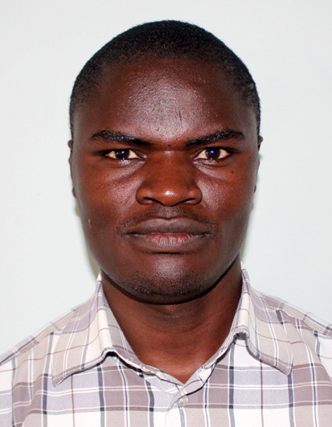

Wyclife Agumba Oluoch | +254729371248 | wyclifeoluoch@gmail.com

# 1. About me

Ecologist with passionate about coding in Python and R.

# 2. Work experience

**Bonn University, Center for Development Research, Germany** *2019-Present* Ecology and Natural Resource Management using Python and R.

**KALRO - Tea Research Institute** *2015-2019*Effects of Climate Change on Tea Production.

# 3. Skills

* Ecological Niche Modeling
* Data Analysis using Python and R.
* Data Visualization using ggplot2(R) and seaborn (Python) packages.
* Spatial Analysis using QGIS and R.