Stats practical 1

Wyeth Blumberg

2024-01-16

# Practical 1

**penguins**

penguins

library(palmerpenguins)  
library(tidyverse)  
library(tinytex)

penguins %>%  
 slice(1:10) %>%   
 knitr::kable()

| species | island | bill_length_mm | bill_depth_mm | flipper_length_mm | body_mass_g | sex | year |
| --- | --- | --- | --- | --- | --- | --- | --- |
| Adelie | Torgersen | 39.1 | 18.7 | 181 | 3750 | male | 2007 |
| Adelie | Torgersen | 39.5 | 17.4 | 186 | 3800 | female | 2007 |
| Adelie | Torgersen | 40.3 | 18.0 | 195 | 3250 | female | 2007 |
| Adelie | Torgersen | NA | NA | NA | NA | NA | 2007 |
| Adelie | Torgersen | 36.7 | 19.3 | 193 | 3450 | female | 2007 |
| Adelie | Torgersen | 39.3 | 20.6 | 190 | 3650 | male | 2007 |
| Adelie | Torgersen | 38.9 | 17.8 | 181 | 3625 | female | 2007 |
| Adelie | Torgersen | 39.2 | 19.6 | 195 | 4675 | male | 2007 |
| Adelie | Torgersen | 34.1 | 18.1 | 193 | 3475 | NA | 2007 |
| Adelie | Torgersen | 42.0 | 20.2 | 190 | 4250 | NA | 2007 |

# Descriptive

We have 344 penguins

we have 3 species

we have 3 islands

mean length 43.9219298, mean depth 17.1511696

mean flipper 200.9152047, mean mass 4201.754386

# Graphical exploration

Histogram of body mass of penguin species

ggplot(data = penguins) +  
 aes(x = body_mass_g) +  
 geom_histogram(aes(fill = species),  
 alpha = 0.5,  
 position = "identity") +  
 theme_minimal() +  
 labs(x = "Body mass (g)",  
 y = "frequency",  
 title = "Penguin body mass")

## Warning: Removed 2 rows containing non-finite values (`stat_bin()`).

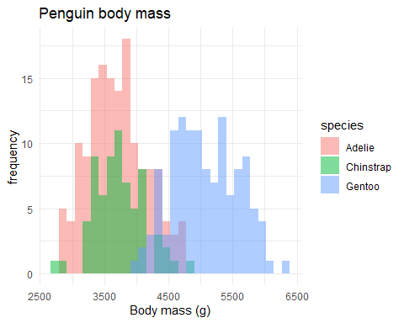

Distribution of body mass by species of penguins

#linear regression

model <- lm(bill_length_mm ~ flipper_length_mm + body_mass_g + sex, data = penguins )   
summary(model)

##   
## Call:  
## lm(formula = bill_length_mm ~ flipper_length_mm + body_mass_g +   
## sex, data = penguins)  
##   
## Residuals:  
## Min 1Q Median 3Q Max   
## -9.6131 -2.8005 -0.6307 2.1699 20.1682   
##   
## Coefficients:  
## Estimate Std. Error t value Pr(>|t|)   
## (Intercept) -8.0754117 4.6732129 -1.728 0.0849 .   
## flipper_length_mm 0.2672650 0.0335203 7.973 2.57e-14 ***  
## body_mass_g -0.0006670 0.0006232 -1.070 0.2853   
## sexmale 2.3047154 0.5055670 4.559 7.27e-06 ***  
## ---  
## Signif. codes: 0 '***' 0.001 '**' 0.01 '*' 0.05 '.' 0.1 ' ' 1  
##   
## Residual standard error: 4.029 on 329 degrees of freedom  
## (11 observations deleted due to missingness)  
## Multiple R-squared: 0.4621, Adjusted R-squared: 0.4572   
## F-statistic: 94.2 on 3 and 329 DF, p-value: < 2.2e-16

par(mfrow= c(2,2))  
plot(model)

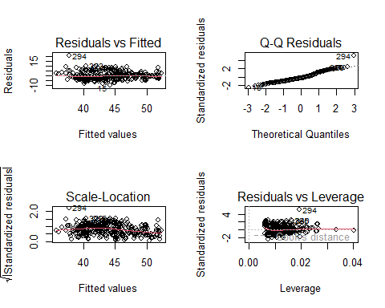

Checking assumptions of the model

(Gorman et al. 2021)

Gorman, K. B., K. E. Ruck, T. D. Williams, and W. R. Fraser. 2021. [Advancing the Sea Ice Hypothesis: Trophic Interactions Among Breeding Pygoscelis Penguins With Divergent Population Trends Throughout the Western Antarctic Peninsula](https://www.frontiersin.org/articles/10.3389/fmars.2021.526092). Frontiers in Marine Science 8.