Pokemon Trading card game

GUI DESIGN

Index:

The design language

- Introduction

- Text

- Colors

- UI Components

- TUIBUTTON

- other Components

- UI Layouts

- Listed layout

- Info layout

- Game layout 45 degrees

- Card assets

- Other Assets

The NAVIGATION

The design language

Introduction

The design language of this game is made to feel like an old Gameboy game, while still being modern. The game’s graphics are inspired by Minecraft’s assets, being usable on a 3D object while still remaining pixel art like.

Text

The main font used for the game is Early Gameboy available for download here: <https://www.dafont.com/early-gameboy.font>

This font is used as it has fixed character dimensions which goes well with the card textures as it is pixel art style.

Lucida Console, a built-in windows font is used for longer text such as chat messages and descriptions or help content.

Text in buttons are aligned to the left and scaled to the size of the window.

Headings are centered in the top of the views.

Colors

To make the game feel more like a Pokémon game, the color pallet of the original Gameboy Color games is used. These pallets are found at this website: <http://pokepalettes.com/>

UI Components

The UI components are to be kept simple and clean to create a better UX and logically and clearly marked navigation and flow.

TUIBUTTON

The UI button is the main way for users to navigate different views within the program. The button text should be concise and clearly state what its purpose is within the layout.

The button uses color pallets from Charizard.

The button has two states, default and hover. Hover state is used to give the user a visual indicator of the purpose of the component and passively tells then that it should be clicked to perform the action printed on it.

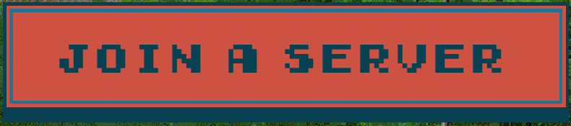 

The button has 3 parts, the two caps and the body. The body can stretch while the caps are of fixed width as to not distort on stretching. This allow the button to be scalable in height and width independantly.

  

Other Components

Other components should be designed to conform to the general design pattern of the rest of the UI it is in. That means: Be pixelated, Use Pokémon color pallets and be clear in function.

UI layouts

Listed Layout

The listed layout is used when an array of data is displayed. This layout uses TUIContainer with TUIButtons and TScrollBox to display the list.

Each listed layout has a centered heading in Early Gameboy and bottom / footer action buttons or navigation buttons.

Example: 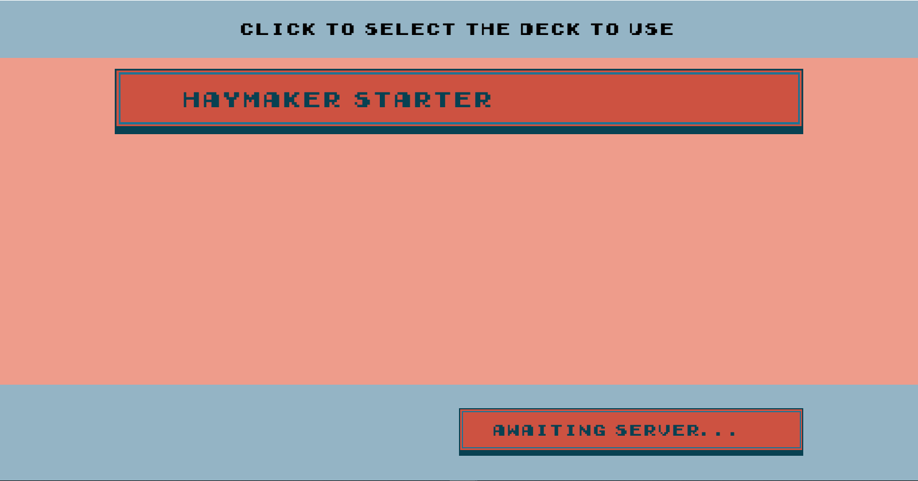

The color of the UIContainer should contrast with the Scrollbox to create a clear distinction between the two parts of the interface.

Notice the margins. Margins are floor(ClientWidth / 8) left and right and should be centered in width.

Info Layout

The info layout is simple and to the point. There is only one centered message inside. Optionally a back button or other action buttons can be added to the footer to allow the user to react to the info and an edit can be added under the centered message for user input.

The info layout is used as a dialog (for info OR input).

Example of a simple buttonless info page:

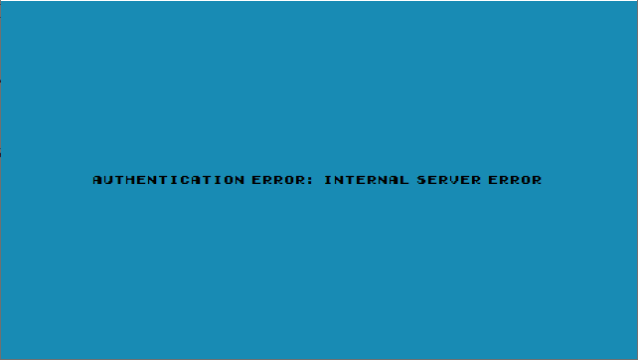

Game Layout

The game layout is the main layout that players will interact with. All components are rotated to 45 Degrees if not active (Clicked or hovered).

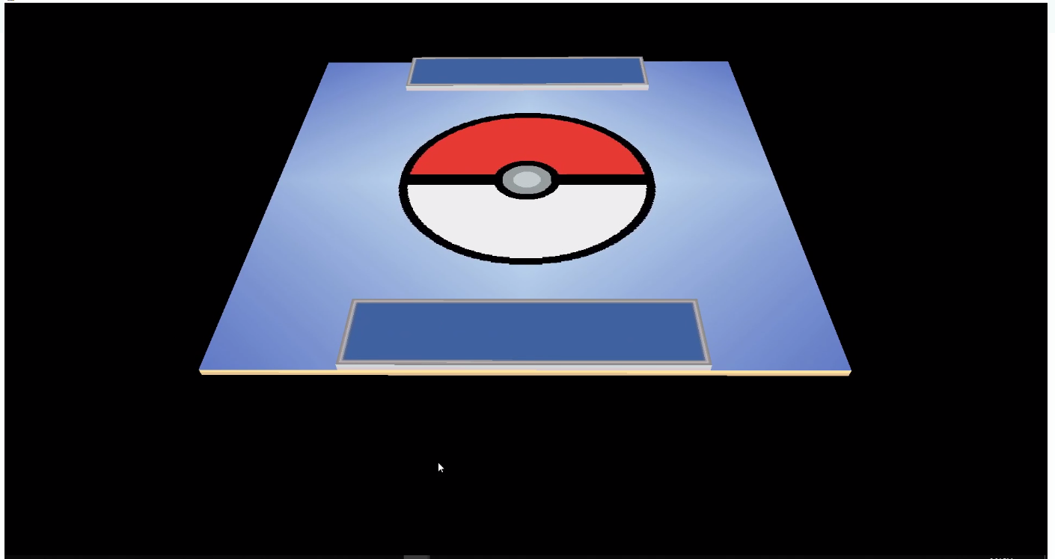

Card assets

The card assets are one of the most important parts of the game UI as it is the piece used to play the game.

The card assets are generated dynamically from 4 pieces of data, 3 images and 1 JSON object containing the data of the card.

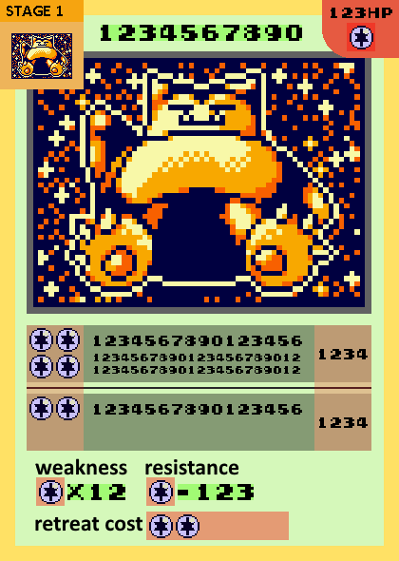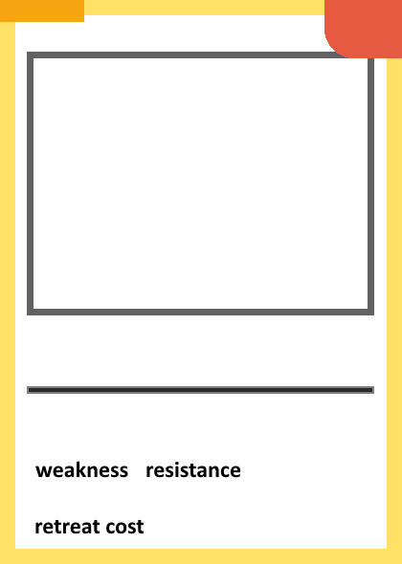

Figure 1 Design with guides

Figure 2 Stage

Figure 3 Back



Figure 4 Pokemon asset

Other Assets The board

 Blank asset

THE NAVIGATION

Zoom in to view the navigation closer.

Some of the ui is incomplete and temporary wireframes are made to show how the layout will look once inplimented.

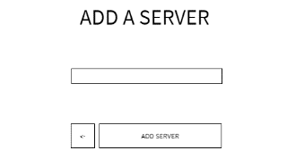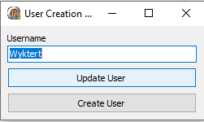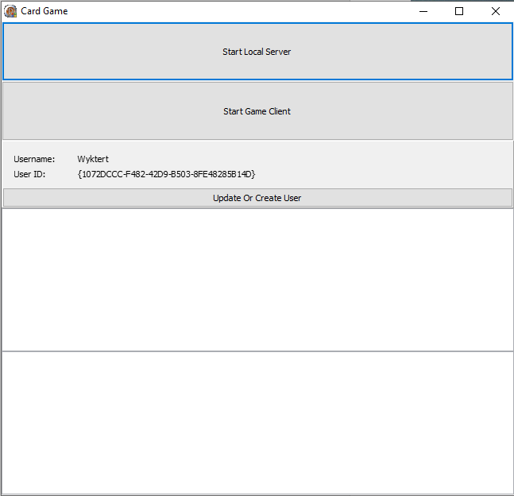

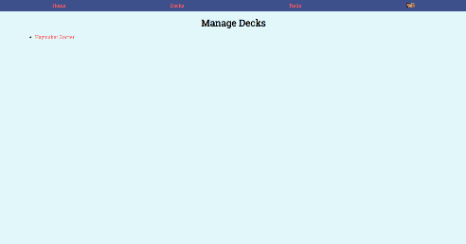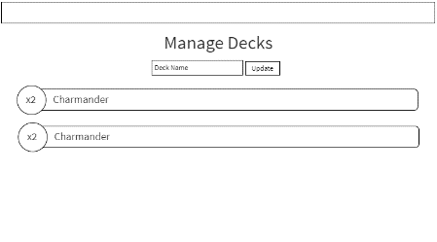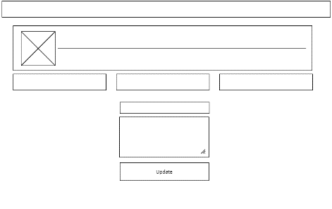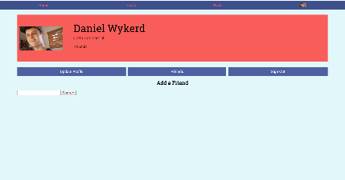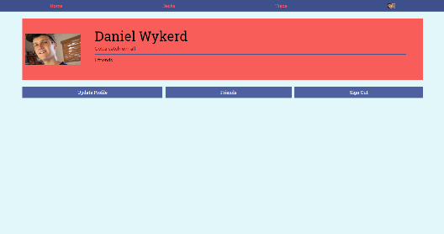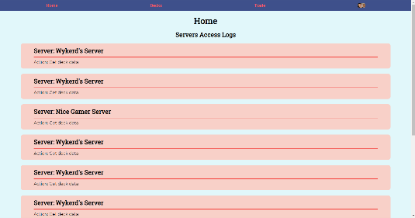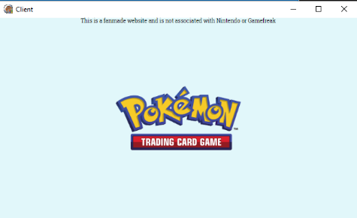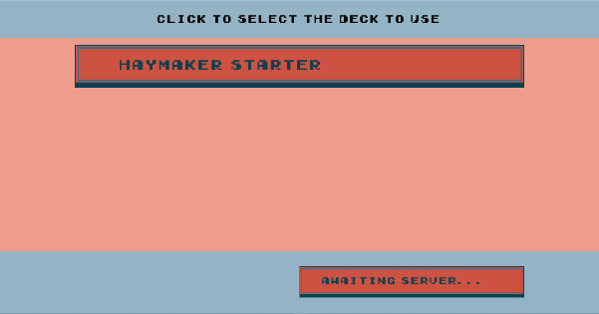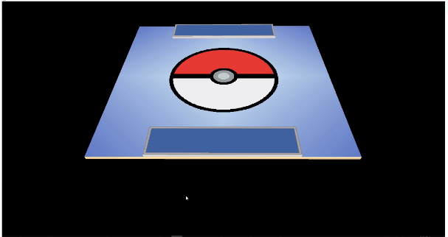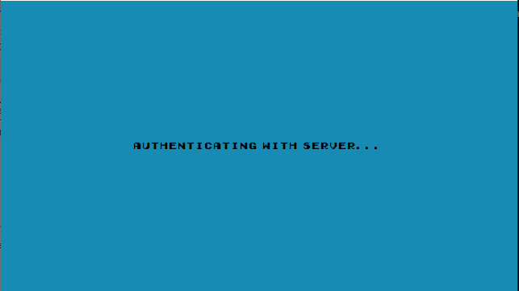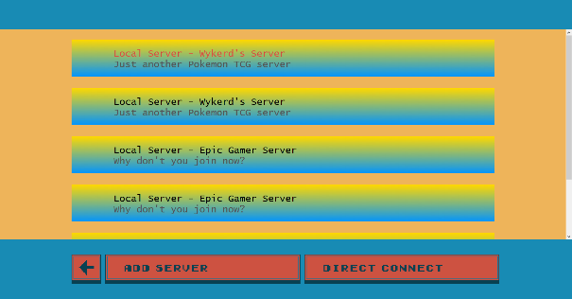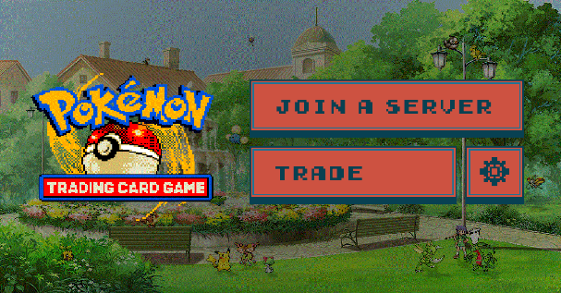

OpenGL Instance

Chromium Instance