MODULAR

GSM GPS

TRACKER

**INTRODUCTION**

Governmental Statistics show that there are high levels of theft in South Africa. Therefore, there is a need for a way to retrieve stolen goods like vehicles as well as personal property.

Although there are already GPS Tracking devices on the market, most of them are expensive and can only be used for one purpose.

**ENGINEERING GOAL**

The goal of this project is to design and manufacture a modular GPS tracking device that can accurately track stolen objects from anywhere in the country. The device will be modular allowing the user to add additional functionality to the core tracking module. The device should be mass producible and use pre-existing communication infrastructure to locate the device. There should be no third party involved in locating the device.

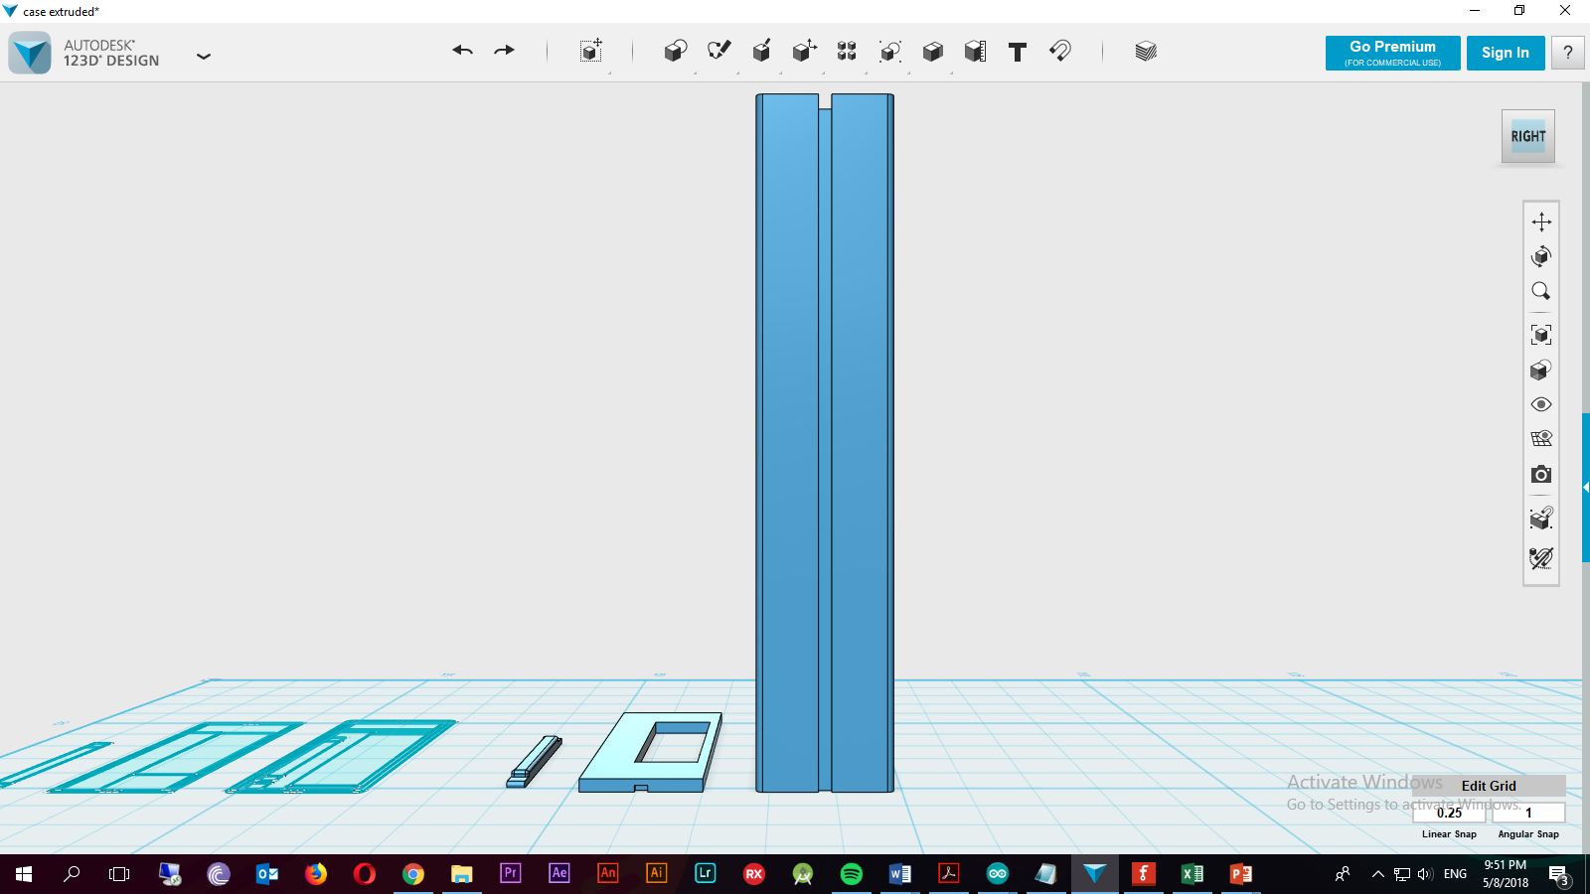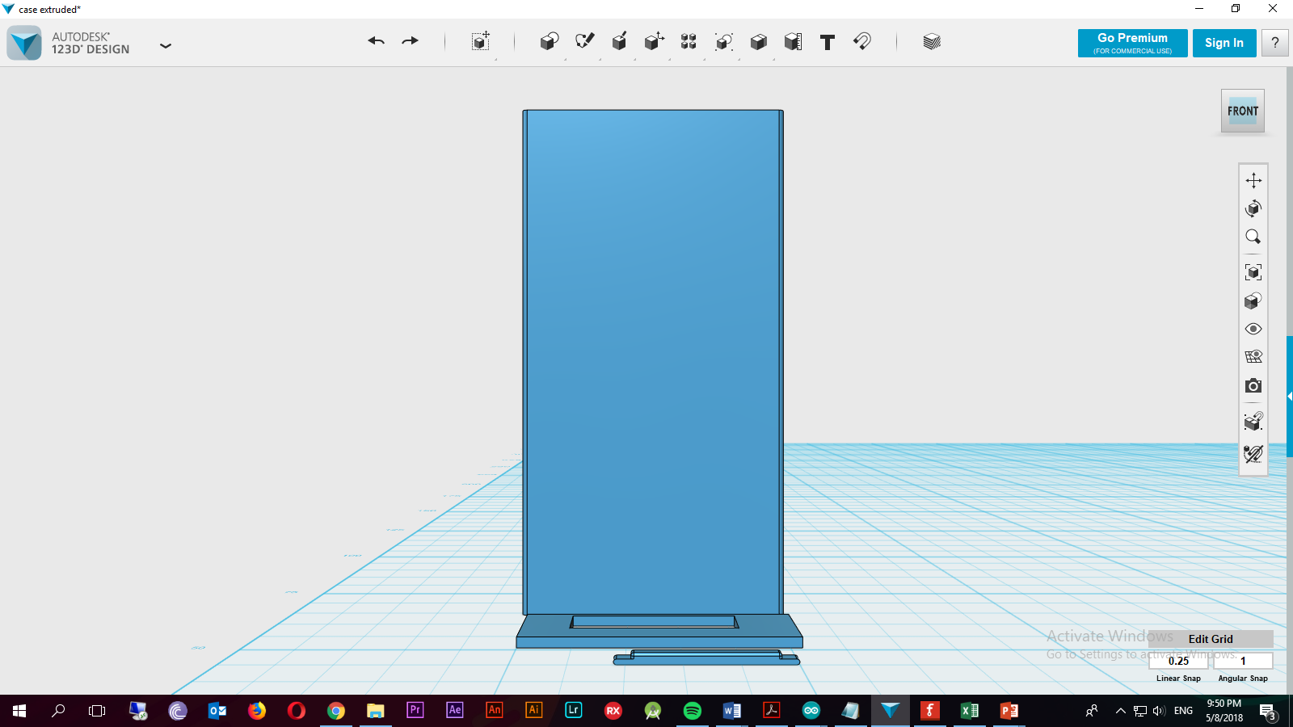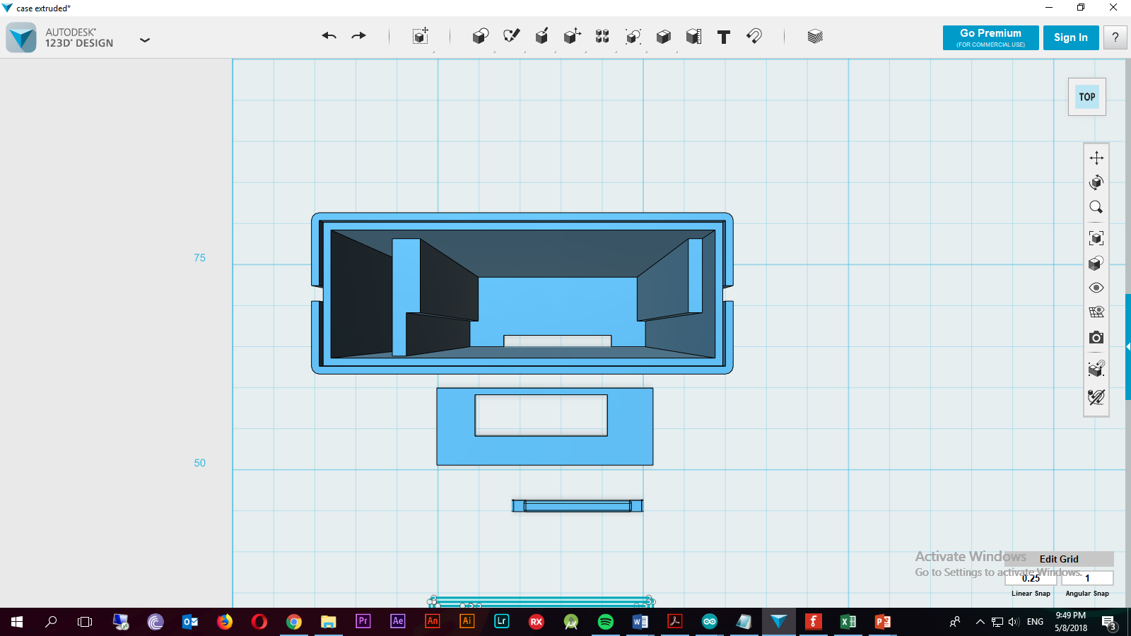CASE DESIGN

THE CASE WAS DESIGNED BY DANIEL WYKERD IN 123D Design

**FAILED**

**PROTOTYPE**

**SUCCESSFUL**

**PROTOTYPE**

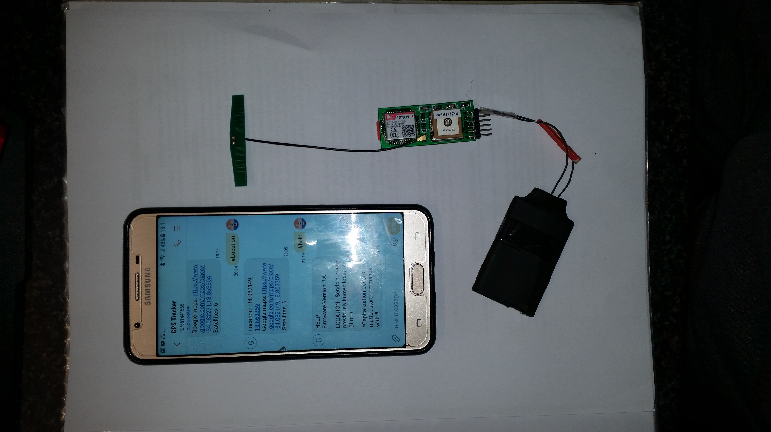

**APPLICATIONS**

Since the device is modular, it can be used for a variety of applications.

It can be used in a vehicle, put inside a wallet or bag or it can be given to a child to monitor his/her whereabouts.

The device works the best outdoors, which narrows the uses of the device if a highly accurate location is required.