Mechanical And Electrical Description With Software
Flow Chart
1 Hardware Structure

The new robots of our team is 50cm×50cm with 40 kilograms.
The original robot was made manually in 2004. The first two wheels robot was made manually by the team in 2006. Then in 2007 we made a large-scale transformation to it, and advanced the visual parts and motor driver parts of the robot. So the effect of the image and the speed of robot were upgraded. (Fig. 1 and 2)
In 2008, our first Omni-directional three wheels robot was finished which was also made manually. (Fig. 3) This robot was more flexible. In 2009, our robot was advanced and new robot was born. In 2010, We use advanced vision system and electronic system.(Fig. 4)

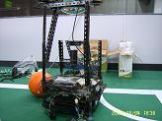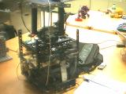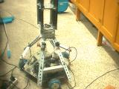
Fig.1 Fig.2 Fig.3

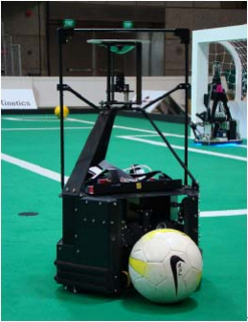

Fig.4

The structure of hardware system (Fig.5)
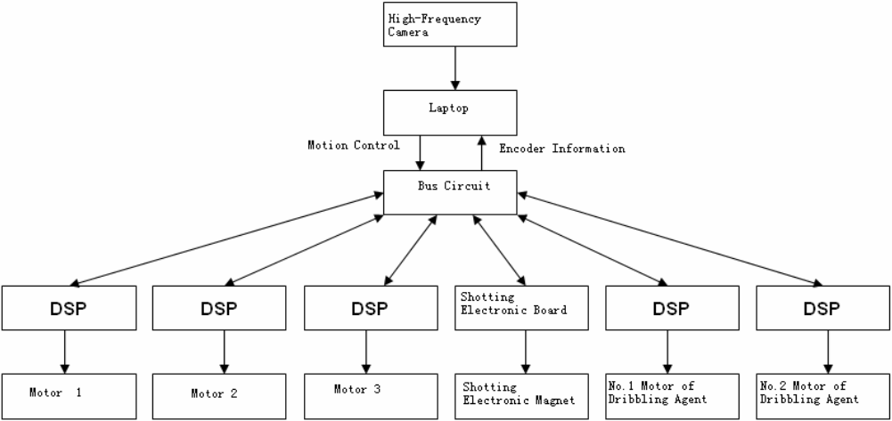

Fig.5

When we made the robot, we put an Omni-directional wheel, a 160w DC electric machinery and a pro-Motion BDMC3606SH Servo Driver together to make a Machinery Servo Driver. And placed them on the evenly Equilateral triangle robot machine chassis. The angle of the adjacent motor axis is 120 degrees. So the connection between the Machinery Servo Driver is simpler and easier to replace, remove or fix. (Fig. 6 and 7)

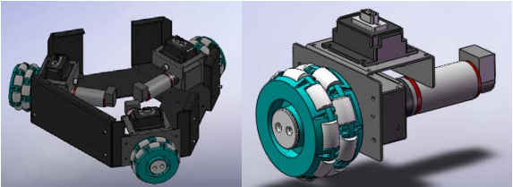
Fig.6 Fig.7

2 Electrical Structure

In our new robot, we used the Electromagnetic drive mode and the Leverage to make the shooting Agencies (Fig.8). In order to improve the driving force of Electromagnet, we designed a series of Step-up circuits, set the 24V to 380V, and stored the power in a Capacitor array.

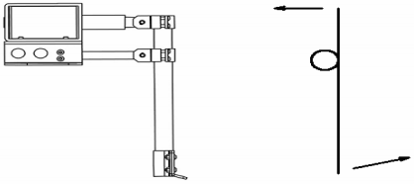
Fig. 8
According to the data of the experiment, when the Shooting Agencies hit the ball, the height of the ball is about 2 meters and the maximum distance is about 10 meters. We tried use the IGBT technology to control the energy and achieve the purpose of hitting the ball.
The camera of the robot is Point Grey, which interface:1394, image resolution: 640*480, frame rate: 60 fps.(Fig.9)

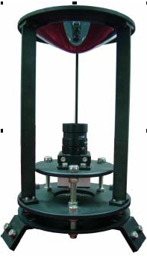
Fig.9

3 Software System

3.1 Vision

In the part of robot vision, we use HSV to describe the frame. With the distribution pixels of H, it judges the color of objects. The computer give the result of the binary. The football is red, the field is green, the field line is light blue and the obstacles are purple. (Fig.10, Fig. 11)

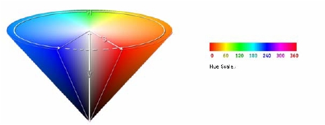
Fig. 10 (HIS Color Space)
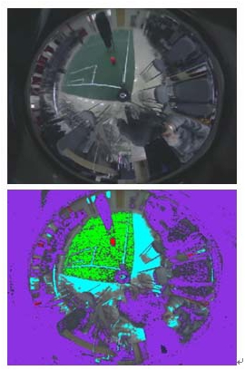
Fig. 11 (The objects color in Omni-directional Vision System)

The flow chart of vision system in software: (Fig. 11)
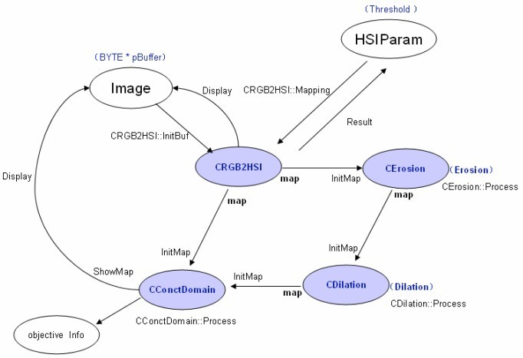
Fig. 12

3.2 Self Positioning

Our robot self-locates by the white lines of the field relative to the position and angel of the robot.
We will make correction to the omni-image first and recovery the shape of field line. (Fig. 13) The picture is Omni-image before correction and after correction.
Through the white line in the image and template of field line, we get the location relative to the field line. From Fig 14, the color of template field line is blue. The white field line was expressed by pink matrix. The software will match the pink matrix with the blue lines until they get together. We calculate absolute coordinate in the field with the turning of matrix angel and distance.

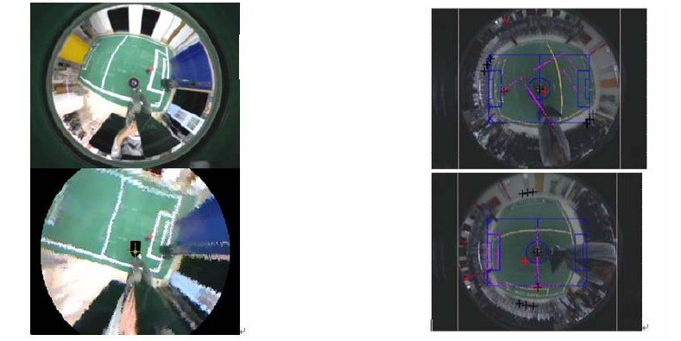
Fig.13 Fig.14

The matching flow chat is: (Fig 15)

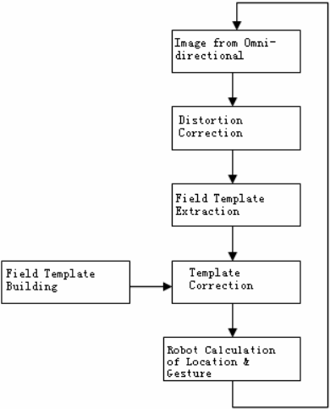
Fig. 15

3.3 Path-Planning

The effect (Fig. 16)
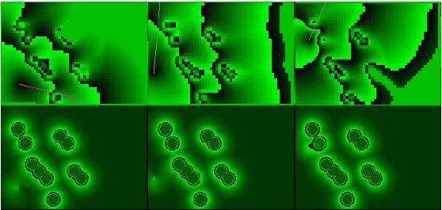
Fig. 16

3.4 Multi-Cooperation

We use global planning and self decision to make robot cooperation. The Coach programming will analysis the match and give the direction from the referee-box. (Fig.17)

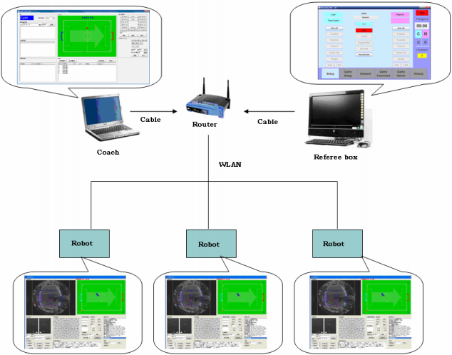
Fig.17

The flow chart of the rule distribution: (Fig.18)

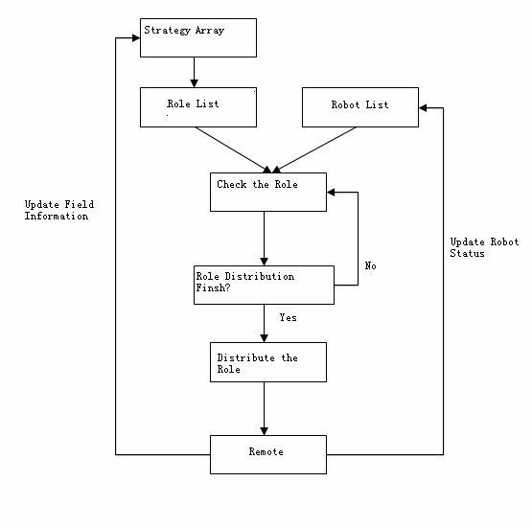
Fig. 18

