Cian’s Notes

Terms **31/1**

*Information system*: An information system is software that helps you organize and analyze data. Processes input and produces output.

*Information process*: Information processing is the change (processing) of information in any manner detectable by an observer. Basically viewing the information changed by the information system. The information processes involve computer systems.

Systems **1/2**

*Collection:* The process by which data is entered into or captured by a computer system.

Inputs: Camera, microphone, keyboard, mouse or touchpad.

*Organising:* The process by which data is structured into a form appropriate for the use of

information processes - such as the format in which data will be represented.

*Storing and retrieving:* The process by which data and information is saved and accessed later.

*Analysing:* The process by which data is interpreted transforming it into information.

*Processing:* A procedure that manipulates data and information to produce anew value or result.

*Displaying:* The information process by which information is output from the system.

Information systems make use of all these processes together to create and have function.

Definitions  **5/2**

* **Environment** - everything that influences and is influenced by the information system.
* **Purpose** - A statement identifying who the information system is for and what it needs to achieve.
* **Information system** - a set of information processes requiring participants, data/information  and information technology built to satisfy the purpose.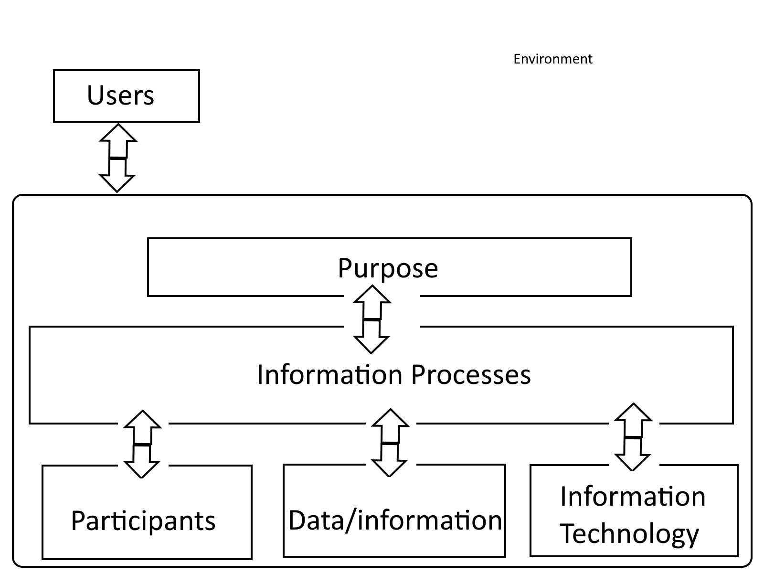
* **Information processes** - computer based and non-computer based activities.
* **Information technology** - hardware and software used in information processes
* **Data** - the raw material used by information processes
* **Information** - the output displayed by an information system
* **User** - A person who views or uses the information output from an information system
* **Participants** - a special class of user who carries out the information processes within an information system.

Scenario

* A factory employs approximately 50 workers.
* There is also an attached office where the payroll officer has a computer attached to the company’s local area network.
* Her secretary, in the adjoining office, enters each employee’s hours worked into the payroll system each day.
* On Thursday mornings the payroll officer calculates the gross pay, tax and net pay for each employee. She then generates pay slips for each employee together with a summary page for the factory manager.
* The factory manager must sign the bottom of the summary before the transfer of any money is permitted.
* Given that the summary sheet is approved the payroll officer then checks for sufficient funds in the company’s accounts, electronically transfers each employee’s pay into their individual accounts and generates a cheque for the taxation office.
* The secretary then distributes the pay slips and posts the tax cheque to the taxation office.

**Task**

Your task is to describe the above scenario in terms of the Information Systems Diagram.

Factors:

* USERS - Secretary, payroll officer.
* ENVIRONMENT - Factory / Payroll office.
* PURPOSE - To generate paychecks based on entered time worked for each worker.
* INFORMATION PROCESSES - Take hours worked for each employee, multiply by wage, calculate gross pay, tax and net pay. Provide sheet to be signed by factory manager,  electronically transfer pay and generate tax cheque for taxation office.
* PARTICIPANTS - Secretary, payroll officer, factory manager, workers.
* DATA INFORMATION - Hours worked, tax %, wages.
* INFORMATION / TECHNOLOGY - Database, computer, local network / system.

|  |  |
| --- | --- |
| Environment | Payroll office in a factory |
| Users | Manager, employees |
| Purpose | * Track / record employee work hours * Calculate pay & tax * Produce manager summary * Approve payment of wages * Create payslips, transfer money and generate tax cheque. |

Information Processes **8/2**

An information process requires a participant, data/info and information technology.

* The participant is the human element.
* Data/info is the raw points of data that go into the system, which outputs information.
* Information technology includes hardware and software used to complete the processes.

**Complete** <<https://drive.google.com/file/d/0BwzvXeA1LcQuMFFWWENTbkFheFE/view>>

Databases **27/2**

Child tables of parent tables have foreign keys that relate to the parental primary key.  
“*An organised collection of related data, which can be grouped together due to their similar characteristics*.”

**DBMS -** Database management system, builds, maintains and provides access to a database.

**Data Dictionary -** It is a plan/definition of any database. It is created before the database is built.

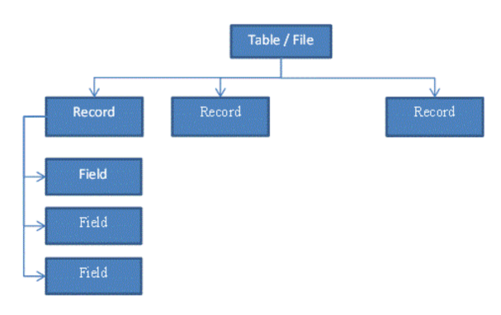

**Query Language**

The data in a Database is accessed using a Query Language.

Query Language includes the following types of commands or instructions:

* SELECT - get information
* UPDATE - update information
* INSERT - insert new information
* DELETE - delete information

The SELECT & UPDATE can be for many records, but we sometimes need to be more specific, we can use CONDITIONS to filter the records

A Filter is usually for a Field or group of Fields on a Record.  These fields are compare against a value (number or letters or boolean, etc.) or another field.

Will’s Notes

**31/1 - Information System and Process**

* Information system: An information system is software that helps you organize and analyze data. This is linked to Information process. Processes input and creates an output.
* Information process: Information processing is the change (processing) of information in any manner detectable by an observer. Basically viewing the information changed by the information system.

**1/2 - Important terms**

* ***Collecting:*** The process by which data is entered into or captured by a computer system, including:
  + Deciding what data is required
  + How it is sourced
  + How it is encoded for entry into the system
  + A charge-coupled device (**CCD**) is a device for the movement of electrical charge, usually from within the device to an area where the charge can be manipulated, for example conversion into a digital value. ← This is used in cameras to capture.

|  |  |
| --- | --- |
| Input | System |
| Image capture | Camera |
| Text | Keyboard |
| Sound Capture | Microphone |
| Position | Mouse/Touchpad |

* ***Organising****:* The process by which data is structured into a form appropriate for the use of information processes - such as the format in which data will be represented.
  + The format of the data determines the most appropriate software application and the processing that can be carried out.
  + For example, if a text document is scanned and represented as an image, the text cannot then be processed using a word processor.
* ***Analysing:*** The process by which data is interpreted, transforming it into information.
  + It interprets the data, so it makes sense to people and they can understand it.
  + Analysing is the process of methodically examining the data to study its contents and interrelationship
  + It includes such processes as; searching, selecting, sorting, and comparing data; some possible aims being to identify trends, model or simulate a scenario or to study the effects of change.
  + The resulting information is then displayed in such a way that it can be understood and used to increase knowledge.
* ***Displaying:*** The information process by which information is output from the system to meet a purpose.
  + It controls the format of the information presented to the participant or user.
  + Examples include; motion through a monitor, sound through a speaker etc.
* ***Storing and Retrieving:*** The process by which data and information is saved and accessed later.
  + Without this ability it would not be possible to reuse data without it continually needing to be re-entered.
  + Before data can be stored it must be organised into a suitable format, similarly any processes that will later retrieve the data must understand this format.
* ***Processing***: A procedure that manipulates a new value or result.
  + Processing is the only information process that alters the actual data present in the system.
* ***Transmitting and Receiving***: The process that sends and receives data and information within and between information systems.
  + Transmitting is the process of sending data or information and receiving is the process of acquiring data or information.
  + Both these processes allow for communication between different devices, these devices may be components within a single computer or the devices themselves maybe different computers.

**5/2 - Environment/Factor Table**

* **Environment:** Everything that influences and is influenced by the information system
* **Purpose:** A statement identifying who the information system is for and what it needs to achieve
* **Information system:** A set of information processes requiring participants, data/information and information technology built to satisfy the purpose
* **Information processes:** Computer based and non-computer based activities
* **Information technology:** Hardware and software used in information processes
* **Data:** The raw material used by information processes
* **Information:** The output displayed by an information system
* **User:** A person who views or uses the information output from an information system
* **Participant:** A special class of user who carries out the information processes within an information system

**Similar Scenario to what could be in the assignment**

* A factory employs approximately 50 workers
* There is also an attached office where the payroll officer has a computer attached to the company’s local area network
* Her secretary, in the adjoining office, enters each employee’s hours worked into the payroll system each day
* On  Thursday mornings the payroll officer calculates the gross pay, tax and net pay for each employee. She then generates pay slips for each employee together with a summary page for the factory manager
* The factory manager must sign the bottom of the summary before the transfer of any money is permitted
* Given that the summary sheet is approved the payroll officer then checks for sufficient funds in the company’s accounts, electronically transfers each employee’s pay into their individual accounts and generates a cheque for the taxation office
* The secretary then distributes the pay slips and posts the tax cheque to the taxation office.

The Factor’s:

* **Users:** Manager, Employees
* **Environment:** Payroll office in a Factory
* **Purpose:**
  + To record for when workers clock in and out,
  + Calculate pay and tax
  + Produce manager summary
  + Approve payment
  + Generate tax cheque, create payslips and transfer money

**Information purpose:**

|  |  |  |  |
| --- | --- | --- | --- |
| Process Description | Participant | Data/info | Information Technology |
| Enter Employee Hours | PO Secretary | Emp #, Hrs worked, Emp Name | Computer, Lan, Database |
| Calculate Gross Pay and Tax | Payroll Officer | Emp #, Emp Name, Hrs Worked, Gross Pay, Tax, Net pay | Printer Computer/Lan Database |
| Produce Manager Summary | Payroll Officer | Emp #, Emp Name, Hrs Worked, Gross Pay, Tax, Net pay | Printer Computer/Lan Database |
| Approve Payment | Manager | Approval Flag | Computer LAN, Database |
| Create Payslips | Payroll Officer |  | Printer, Computer / LAN, Database |
| Transfer Money to Emp | Payroll Officer | Emp#, Emp Bank, Details, Net Pay, Date paid | LAN, Money Transfer system (Externally), File |
| Generate Tax cheque | Payroll officer | Company details (ABN), Tax Amount Payable, Date | Cheque Printer |

**8/2 - Chapter review questions**

1. The circumstances and conditions that surround a system but are not part of the system are known as the?
   1. The Environment
2. Data entry primarily involved in which information process?
   1. Collecting
3. “I’m going to be late for school” is an example of A “The time is 9:25 AM” would be an example of B and “0925” would be C. A, B and C respectively could best be?

(A) data, information, knowledge.

(B) information, knowledge, data.

(C) knowledge, information, data. (x)

(D) knowledge, data, information

1. Information technology is a term used to describe?
   1. The hardware and software resources of the system
2. Participants in an information system commonly include all of the following:
   1. Direct users, indirect users, managers and data entry operators.
3. A system can be described as:
   1. An organised assembly of resources and processes that interact to achieve a common purpose.
4. The purpose of an information system:
   1. Is to fulfill some need or needs
5. Activities that coordinate resources to achieve the system’s purpose are known as:
   1. Information processes
6. The main difference between data and information is:
   1. Data is the raw material that is processed by information systems to create information.
7. Which term defines the line between what is what is not part of the system:
   1. Boundary
8. Define each:
   1. Environment:
      1. Everything that influences and is influenced by the information system
   2. Purpose:
      1. A statement identifying who the information system is for and what it needs to achieve
   3. Information system:
      1. A set of information processes requiring participants, data/information and information technology built to satisfy the purpose
   4. Information Processes:
      1. Computer based and non-computer based activities
   5. Participants:
      1. A special class of user who carries out the information processes within an information system
   6. Information Technology:
      1. Hardware and software used in information processes

**13/2 - Security of Data and Information**

Security of most resources is about guarding against theft or destruction. For example, an alarm on your car aims to deter thieves and vandals. PIN and PUK codes on mobile phones are deterrents to theft. Similar techniques are used to protect data and information, however there is an additional problem; most data and information can easily be edited or copied without any noticeable change to the original. We therefore require additional techniques and strategies for dealing with the security of data and information. Generally the larger the information system becomes the more crucial effective security of the data and information becomes. If your home computer crashes then the consequences are annoying but if a bank’s computer system fails, even for an hour, the consequences are enormous.

Some possible security issues that all information system designers need to consider include:

* **Virus attacks** – Viruses are software programs that deliberately produce some undesired or unwanted result. Most viruses are spread via attachments to emails but also by infected media such as flash drives and CDs.
* **Hackers** – These are people, often with extensive technical knowledge and skill,who aim to overcome or get around any security mechanisms used by a computer system. This allows them to view, utilize and even edit data and information.
* **Theft** – Unauthorised copying of data and information onto another system. Also physical theft of hardware, and as a consequence, the data and information it contains.
* **Unauthorised access by past and present employees** – Past and present employees may maliciously tamper with data or they may view and use data of a private nature inappropriately.
* **Hardware faults** – Failure of hardware, and in particular storage devices, can result in loss of data. It is inevitable that hardware will eventually fail at some time.
* **Software faults** – Errors in programs can cause data to become corrupted. No software is completely free of errors.

Some strategies commonly used to address the above issues include:

* **Passwords** – Passwords are used to confirm that a user is who they say they are. Once verified the user name is then used by the system to assign particular access rights to the user.
* **Backup copies** – A copy of important files is made on a regular basis. Should the original file fail or be lost then the backup copy can be used. It is important to keep backup copies in a secure location.
* **Physical barriers** – Machines storing important data and information, or performing critical tasks are physically locked away.
* **Anti-virus software** – All files are scanned to look for possible viruses. The antivirus software then either removes the virus or quarantines the file. The widespread use of networks, and in particular the Internet, has made anti-virus software a virtual necessity.
* **Firewalls** – A firewall provides protection from outside penetration by hackers. It monitors the transfer of information to and from the network. Most firewalls are used to provide a barrier between a local area network and the Internet.
* **Data encryption** – Data is encrypted in such a way that it is unreadable by those who do not possess the decryption code.
* **Audit trails** – The information system maintains records of the details of all transactions. The aim is to make it possible to work backwards and trace the origin of any problem that may occur.

To implement the above strategies requires that procedures be put in place to ensure their correct operation. For example: if an employee leaves, their username and password needs to be removed, anti-virus software needs to updated regularly to take account of any new viruses and backup copies need to be checked to ensure they are occuring correctly.

31.01.18

**Introduction to Information Skills and Systems**

|  |
| --- |
| An information system has a **purpose** in that it addresses the need(s) of a group or an individual.   * It performs the information processes of collecting, organising, analysing, storing/retrieving, processing, transmitting/receiving and displaying. * **Information processes** involve computer and non-computer activities. * For the processes to occur,   + **participants** (people),   + **data/information** and   + **information technologies** (hardware and software) are required. * The **purpose** for an information system defines who it is for and what they need. * Information systems give rise to ethical issues for people directly and indirectly involved with them. * They have a social impact on the environment in which they operate. |

1.02.18

**Input -> Systems**

To **capture**  and collect information on computer we can use:

* image capture -> camera, Sound capture -> microphone, text  -> keyboard, position -> mouse, trackpad and touchscreen

**Information Processes**

**COAST PD**

* **Collecting** is the process by which data is collected, introduced or captured by a computer system. This Includes..
  + Deciding what data is required
  + How it is sourced
  + How it is entered into the system
  + A charge-coupled device (**CCD**) is a device for the movement of electrical charge, usually from within the device to an area where the charge can be manipulated, for example conversion into a digital value. ← This is used in cameras to capture.
* **Organising** the process by which data is structured into a form appropriate for the use of other information processes - such as the format in which data will be represented.
  + The format of the data determines the most appropriate software application and the processing that can be carried out.
  + For example, if a text document is scanned and represented as an image, the text cannot then be processed using a word processor.
* **Analysing** is the process by which data is interpreted, transforming it into information.
  + It interprets the data, so it makes sense to people and they can understand it.
  + Analysing is the process of methodically examining the data to study its contents and interrelationship
  + It includes such processes as; searching, selecting, sorting, and comparing data; some possible aims being to identify trends, model or simulate a scenario or to study the effects of change.
  + The resulting information is then displayed in such a way that it can be understood and used to increase knowledge.
* **Storing and Retrieving** the process by which data and information is saved and accessed later
  + Without this ability it would not be possible to reuse data without it continually needing to be re-entered.
  + Before data can be stored it must be organised into a suitable format, similarly any processes that will later retrieve the data must understand this format.
* **Transmitting and Receiving** the process that sends and receives data and information within and between information and systems.
  + Transmitting is the process of sending data or information and receiving is the process of acquiring data or information.
  + Both these processes allow for communication between different devices, these devices may be components within a single computer or the devices themselves maybe different computers.
* **Processing** a procedure that manipulates data and information to produce a new value or result
  + Processing is the only information process that alters the actual data present in the system.
* **Displaying** the information process by which information is output from the system to meet a purpose.
  + It controls the format of the information presented to the participant or user.
  + Examples include; motion through a monitor, sound through a speaker etc.

5.2.18



* **Environment-** everything that influences and is influenced by the
  + Information system
* **Purpose-** a statement identifying who the information system is for and what it needs to achieve
  + The information system is for includes, individuals and organisations.
* **The information process**- requiring participants, data/information and information technology built to satisfy a purpose.
* **Information process** - computer based and non-computer based activities.
* **Information technology** - hardware and software used in information processes.
* **Data-** the raw material used by information processes
* **Information-** the output displayed by an information system
* **User-** a person who views or uses the information output from an information system
* **Participant-** a special class of user who carries out the information processes within the information system.

**The environment is everything outside the system e.g. if system was ATM the environment is the street around it**.

**Similar Scenario to what could be in the assignment**

* A factory employs approximately 50 workers.
* There is also an attached office where the **payroll officer** has a computer attached to the company’s local area network.
* Her **secretary,** in the adjoining office, enters each employee’s hours worked into the payroll system each day.
* On Thursday mornings the payroll officer calculates the gross pay, tax and net pay for each employee. She then generates pay slips for each employee together with a summary page for the factory manager.
* The **factory manager** must sign the bottom of the summary before the transfer of any money is permitted.
* Given that the summary sheet is approved the payroll officer then checks for sufficient funds in the company’s accounts, electronically transfers each employee’s pay into their individual accounts and generates a cheque for the taxation office.
* The secretary then distributes the pay slips and posts the tax cheque to the taxation office.

The Factor’s:

**Users:** Manager, Employees

**Environment:** Factory and the payroll office

**Purpose:**

1. track / record employee work hours

2. Calculate pay and tax

3. Produce manager summary

4. Approve payment

5. Create payslips, transfer money, and generate tax cheque

**Information Processes**

|  |  |  |  |
| --- | --- | --- | --- |
| Process Description | Participant | Data/info | Information Technology |
| 1.1 Enter Employee Hours | PO Secretary | Emp #, Hrs worked, Emp Name | Computer, Lan, Database |
| 2.1 Calculate Gross Pay and Tax | Payroll Officer | Emp #, Emp Name, Hrs Worked, Gross Pay, Tax, Net pay | Printer Computer/Lan Database |
| 3.1 Produce Manager Summary | Payroll Officer | Emp #, Emp Name, Hrs Worked, Gross Pay, Tax, Net pay | Printer Computer/Lan Database |
| 4.1 Approve Payment | Manager | Approval Flag | Computer, lan, database |
| 5.1 Create Payslips | Payroll Officer |  | Printer Computer/Lan Database |
| 5.2 Transfer Money to Emp | Payroll Officer | Emp#, Emp Bank, Details, Net Pay, Date paid | LAN, Money Transfer system (Externally), File |
| 5.3 Generate Tax cheque | Payroll officer | Company details (ABN), Tax Amount Payable, Details | Cheque Printer |

8.2.1

**Student activity 3**

Chapter 1 review questions

[**https://drive.google.com/file/d/0BwzvXeA1LcQuMFFWWENTbkFheFE/view**](https://drive.google.com/file/d/0BwzvXeA1LcQuMFFWWENTbkFheFE/view)

Multiple choice Questions 1-10

1. B
2. D
3. C
4. A
5. B
6. C
7. B
8. D
9. B
10. B

### 13/2

**- Security of Data and Information**

Security of most resources is about guarding against theft or destruction. For example, an alarm on your car aims to deter thieves and vandals. PIN and PUK codes on mobile phones are deterrents to theft. Similar techniques are used to protect data and information, however there is an additional problem; most data and information can easily be edited or copied without any noticeable change to the original. We therefore require additional techniques and strategies for dealing with the security of data and information. Generally the larger the information system becomes the more crucial effective security of the data and information becomes. If your home computer crashes then the consequences are annoying but if a bank’s computer system fails, even for an hour, the consequences are enormous.

Some possible security issues that all information system designers need to consider include:

* **Virus attacks** – Viruses are software programs that deliberately produce some undesired or unwanted result. Most viruses are spread via attachments to emails but also by infected media such as flash drives and CDs.
* **Hackers** – These are people, often with extensive technical knowledge and skill,who aim to overcome or get around any security mechanisms used by a computer system. This allows them to view, utilize and even edit data and information.
* **Theft** – Unauthorised copying of data and information onto another system. Also physical theft of hardware, and as a consequence, the data and information it contains.
* **Unauthorised access by past and present employees** – Past and present employees may maliciously tamper with data or they may view and use data of a private nature inappropriately.
* **Hardware faults** – Failure of hardware, and in particular storage devices, can result in loss of data. It is inevitable that hardware will eventually fail at some time.
* **Software faults** – Errors in programs can cause data to become corrupted. No software is completely free of errors.

Some strategies commonly used to address the above issues include:

* **Passwords** – Passwords are used to confirm that a user is who they say they are. Once verified the user name is then used by the system to assign particular access rights to the user.
* **Backup copies** – A copy of important files is made on a regular basis. Should the original file fail or be lost then the backup copy can be used. It is important to keep backup copies in a secure location.
* **Physical barriers** – Machines storing important data and information, or performing critical tasks are physically locked away.
* **Anti-virus software** – All files are scanned to look for possible viruses. The antivirus software then either removes the virus or quarantines the file. The widespread use of networks, and in particular the Internet, has made anti-virus software a virtual necessity.
* **Firewalls** – A firewall provides protection from outside penetration by hackers. It monitors the transfer of information to and from the network. Most firewalls are used to provide a barrier between a local area network and the Internet.
* **Data encryption** – Data is encrypted in such a way that it is unreadable by those who do not possess the decryption code.
* **Audit trails** – The information system maintains records of the details of all transactions. The aim is to make it possible to work backwards and trace the origin of any problem that may occur.

To implement the above strategies requires that procedures be put in place to ensure their correct operation. For example: if an employee leaves, their username and password needs to be removed, anti-virus software needs to updated regularly to take account of any new viruses and backup copies need to be checked to ensure they are occuring correctly.

27.02.18

Data dictionary: is a plan/definition of any database. It is created before the database is built.

* Field name
* Data type
* Size
* Description

**Database definition:** An Organised collection of related data, which can be grouped together due to their similar characteristics

**Describe a DBMS?**

*Database Management System, builds , maintains and provides access to a database.  It is the software that allows you to manage a database.*

**Structure of a Relational Database**

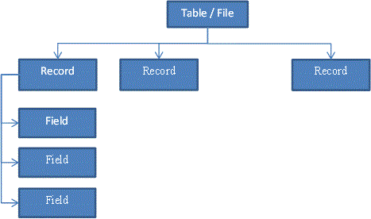

A database is made up of related files or tables, each file/table containing related **records**, which are made up of related **fields,** which are in turn made up of **values** that contain related characters(such as dates, time, text, numbers etc).

**Query Language**

The data in a database is accessed using query language

Query language includes the following types of commands or instructions:

* SELECT - Get information
* UPDATE - update information
* INSERT - insert new information
* DELETE - delete information

The SELECT & UPDATE can be for many records, but we sometimes need to be more specific, we can use CONDITIONS to filter the records

A filter is usually for a Field group of Fields on a record. These fields are compared against a value (number or letters or boolean, etc.) or another field

E.g. Date <”01/01/2018”, SIze >= 10

The comparison operators include:

|  |
| --- |
| Symbol |
| < |
| > |
| <= |
| >= |
| = |
| <> |
| AND |
| OR |

#### 1.03.18

#### Advantages

* **Ease of editing**: Data in the form of images, audio, video, text and numbers, can be easily updated and modified as required.
* **Ease of storage:** Large amounts of data can be stored on a disk or CD. It can be retrieved, revised and rearranged as appropriate.
* **Quick search**: Large amounts of data can be searched and sorted quickly and accurately.
* **Performing calculations**: Precise and complex calculations can be performed on the data very quickly. Recalculations of the data assist with predictions and decision-making.
* **Ease of transmission:** Data can be easily exchanged. The Internet provides a convenient way of accessing information throughout the world.

#### Disadvantages

* The **cost** of hardware, software and installation may be prohibitive.
* **Compatibility** with existing technology must be investigated.
* The **participants** in the information system need to be **trained**. People are often reluctant to adopt new methods.
* Social and ethical issues such as **privacy, security, copyright** and the **changing nature of work** need to be addressed.
* Quality of Digitised Data may be less/lost from Analog Data

#### 5.3.18

**Why does Information Technology use digital data?**

It uses digital data because it is software and hardware and can only read binary.

Outline the Advantages and Disadvantages of digitising data

|  |  |
| --- | --- |
| Advantages | Disadvantages |
| Ease of editing | Cost of hardware |
| Ease of storage | Compatibility with existing technology |
| Quick search | The participants in information system need to be trained |
| Performing calculation | Social and ethical issues such as privacy, security, copyright and the changing nature of work |
| Ease of transmission | Quality of digitalized data may be less/lost from analog data. |
|  |  |
|  |  |

Explain the need for quality data

* Accuracy: if it’s not accurate the data will be incorrect
* Timeliness: if the data is years old and changed over the course of time it will be incorrect
* Accessibility: if the data can’t be accessed then only very few people can actually make use of that data

Identify the current digitising trends:

* Newspapers on the internet –
* Telephone Systems (VoIP) Voice over IP –
* Video on DVD and Blueray -
* Facsimile -
* Media Retrieval Management –

#### 8/3

Digital media

Any data that has been converted to a form that a computer can understand. It can be broken up into:

* Text and numbers
* Hypertext
* Audio
* Images
* Video and/ or animations

**Text =** written characters, letters, number etc.

**Audio =** sound that has been digitalised

**Hypertext=** above or more = hypertext allows a user to navigate through a link to another document

**Definitions**

**Images**

* Still pictures can be either bitmapped or vector
* Paint graphics are saved as bit-maps
* Each individual pixel is saved
* Pixel = **Pic**ture **El**ement (smaller part of the image)

### 13/3/18 Summarise Information

**Validation vs Verification**

**Introduction**

Once you have collected some or all of your data, you will need to enter it into your system.

It is at this point where many different types of errors can occur, coining the phrase Garbage In Garbage Out (GIGO).  Basically, if you enter data which contain mistakes and errors then, no matter how thorough or clever your queries are, you will always get second rate, error laden results.

To date, there is no 100% guaranteed foolproof method for entering data into a system which is completely error free.  However, there are techniques that you can use to help you reduce the errors to a minimum.

***Two of these techniques are called Validation and Verification.***

**Validation**

Validation is one way of trying to reduce the number of errors in the data being entered into your system.

The validation is performed by the computer where you enter the data.  It is the process of checking the data against the set of validation rules which you set up when developing your new database system.

|  |
| --- |
| **DEFINITION: Validation**aims to make sure that data is **sensible, reasonable, complete** and **within acceptable boundaries** |

It is critical that you understand what this definition means and can repeat it when asked in an examination question.

Students regularly say in exam answers that "validation checks that the data is correct".  It does NOT !!

If you enter "Smithe" instead of "Smith" or "07/08/07" instead of "08/07/07", no amount of validation in the world will pick up that human error.

***So while Validation can help to reduce the number of errors when entering data, it cannot stop them - be very clear about it.***

**Range Check**

*A range check is commonly used when you are working with data that consists of numbers, currency or dates/times.*

*A range check allows you to set boundaries:*

|  |  |  |
| --- | --- | --- |
| **Boundary** | **Description** | **Validation** |
| Upper limit | The maximum price of any item in a shop is $100 | <=100 |
| Lower limit | In a shop, you cannot sell a negative number of items, however you can sell no items | >=0 |
| A range | To achieve a B grade, you must score between 75% - 84% | >=75 AND <=84  between 75 and 84 |

**Type Check**

*When you set up a new system you will****choose the most appropriate data type****for each field.*

***A type check will ensure that the correct type of data is entered into that field.***

*For example, in a clothes shop, dress sizes may range from 8-18.  A number data type would be a suitable choice for this data.  By setting the data type as a number, only numbers could be entered e.g. 10, 12, 14 and you would prevent anyone trying to enter text such as "ten" or "ten and a half".*

*Some data types can perform an extra type of check.*

*For example, a date data type will ensure that a date that you have entered can actually exist e.g. it will not allow you to enter the date****31/02/15***

**Length Check**

*Sometimes you may have a set of data which always has to be the same number of characters.*

*For example, an Australian Land Line Phone number has 8 numbers (or 10 including Area Code).*

*A length check could be set up to ensure that exactly 8 (or 10) numbers are entered  into the field.  This type of validation cannot that the 8 numbers are correct, but it can ensure that 7 or 9 numbers aren't entere****d.***

*This also applies to the Australian Postcode, which must be exactly 4 numbers long.*

**Lookup**

*Where you have a field which contains a limited list of items which will be regularly entered then a lookup list can help reduce errors.*

*For example:*

* + A shop might put the dress sizes into a lookup list
  + A car showroom might put the car models into a lookup list
  + A vet might list the most popular type of animals that they are dealing with

*The benefits of a lookup list are that they:*

* Speed up data entry because it is usually much faster to pick from a list than to type each individual entry.
* Improve accuracy because they reduce the risk of spelling mistakes
* limit the options to choose from by presenting the required options

*However, using lookup validation techniques does not prevent someone from still entering data into the field and so mistakes can still be made*

**Presence Checks**

*There might be an important piece of data that you want to make sure is always stored.*

*For example, a school will always want to know an emergency contact number, or a video rental store might always want to know a customer's address, a wedding shop might always want a record of the bride's wedding date.*

*A presence check makes sure that a critical field cannot be left blank, it must be filled in.  If someone tries to leave the the field blank, then an error message will appear and you won't be able to progress to another record or save any other data which you have entered.*

**Verification**

It was mentioned earlier that validation cannot make sure data that you enter is correct, it can only check that it is sensible, reasonable and allowable.

However, it is important that the data in your database is as accurate as possible.

Verification can be used to help make sure that the date in your database contains as few mistakes as possible.

|  |
| --- |
| **DEFINITION: Verification means that the data on the original source documents is identical to the data that you have entered into the system  or object document.** |

**Verification Methods**

Verification can be performed in a few ways:

**Entering the data twice.**

*Think about when you enter a new Password, you have to type it in twice. This lets the computer check if you have typed it exactly the same both times and not made a mistake.  It verifies that the first version is correct by matching it against the second version.*

*Whilst this can help to identify many mistakes, it is not ideal for large amounts of data:-*

* + it would / could take a person a lot of time to enter the data twice.
  + They could enter the same mistake twice, so it would not get picked up
  + You would end up with two copies of the data.

**Checking the data on the screen against the original paper document**

*This saves having to enter the data twice. It can help pick up errors where data has been entered incorrectly or transposed.*

*However, it is not always easy to keep moving your eyes back and forth between a monitor and a paper copy.  Also, if you are tired or your eyes feel "blurry" then you might miss errors.*

**Printing out a copy of the data and comparing the printout to the original paper document.**

*This is probably the easiest of the verification methods because you can have both copies side by side and scan both for mistakes.*

*However, it can be time consuming if there is large amounts of data to check and if you do it too quickly, mistakes could be overlooked.*