# DeepSearcher Flowchart: From `main.py` to RAG Query Resolution

1. Application Entry and Initialization FlowA diagram of a flowchart

   AI-generated content may be incorrect.
2. Document Loading Flow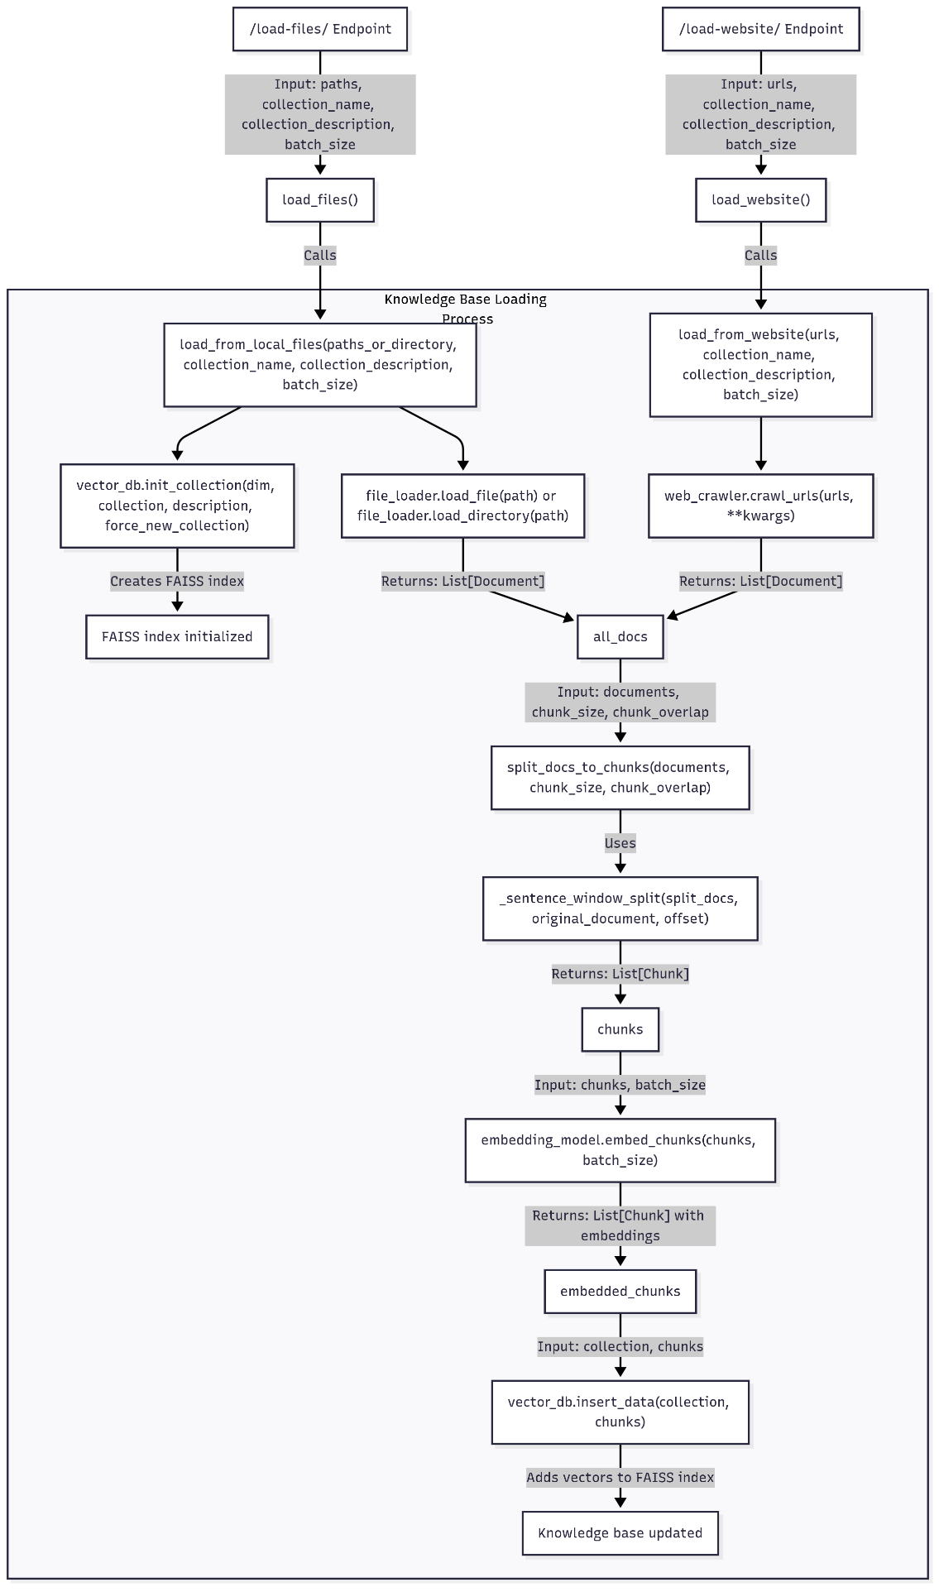
3. Query Execution Flow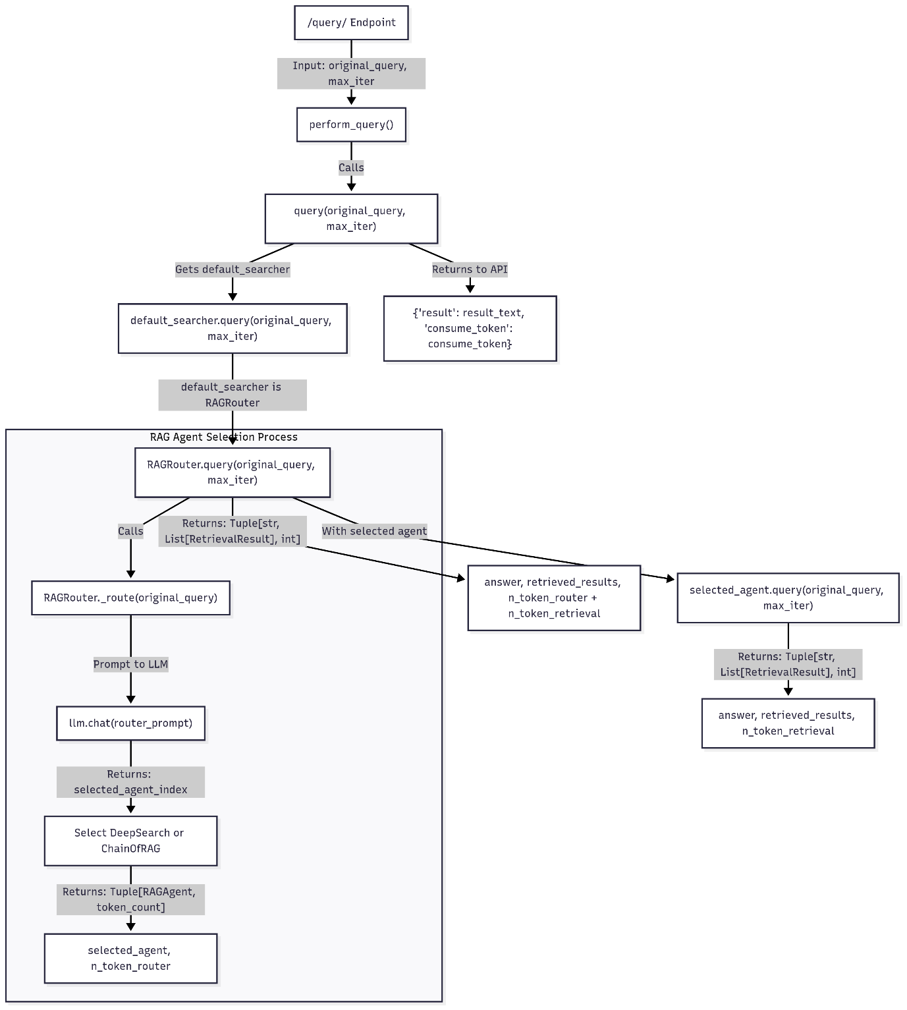
4. DeepSearch Agent workflow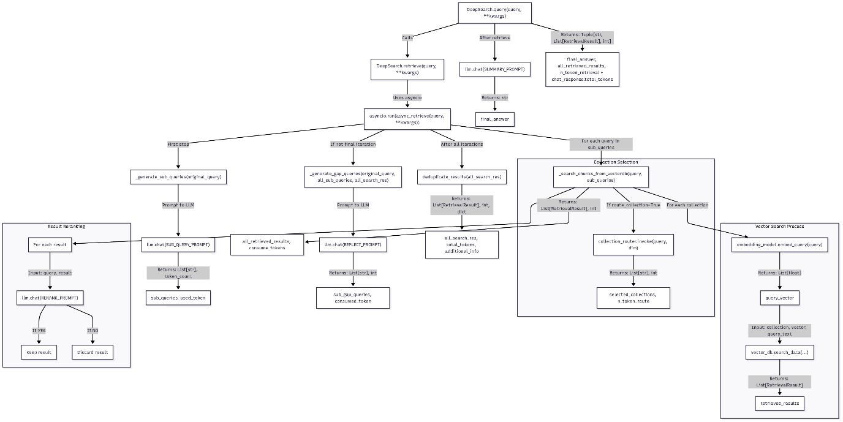
5. Chain of RAG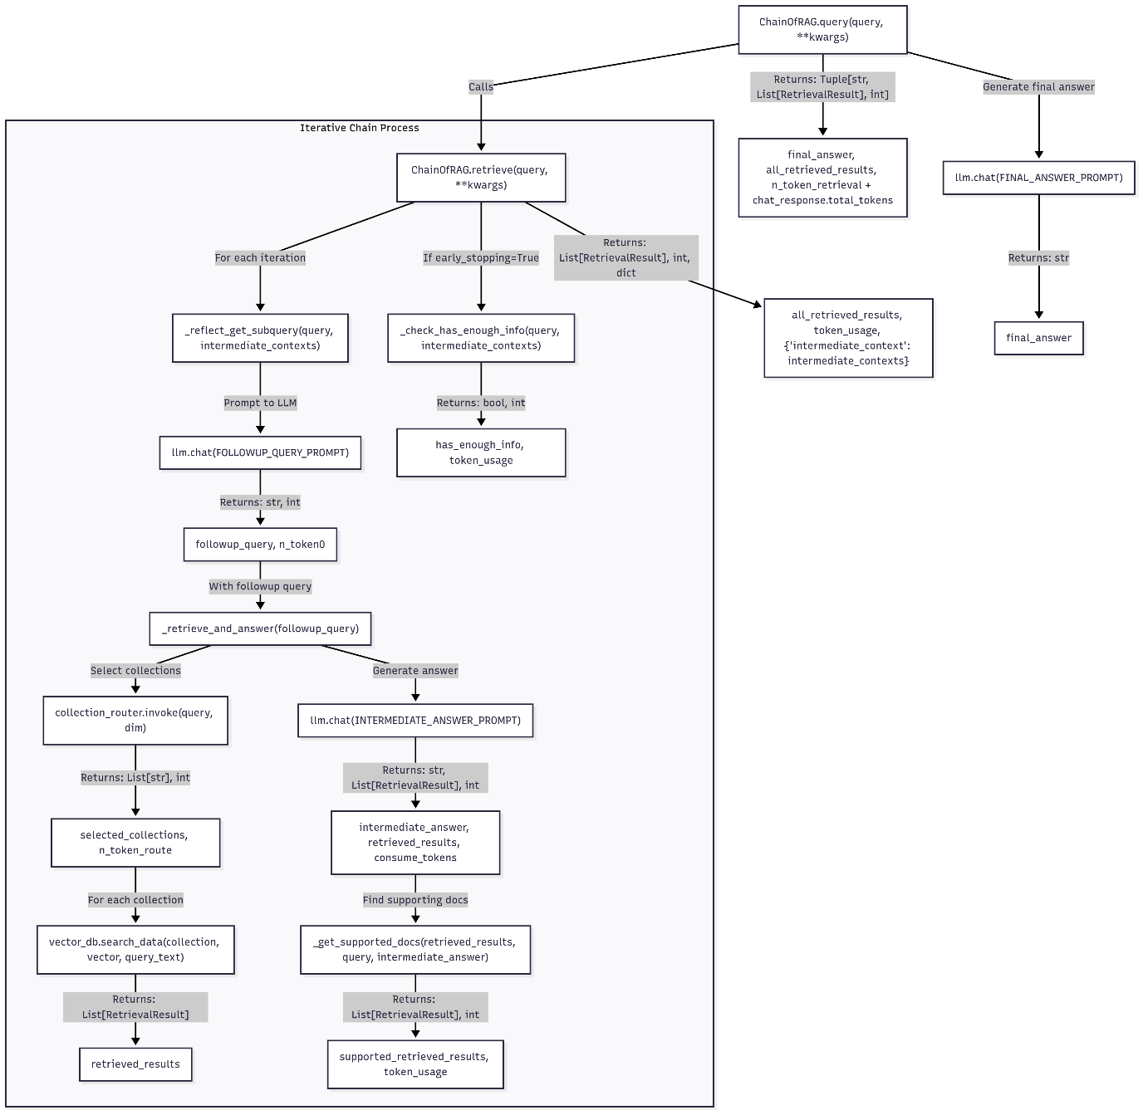
6. Naïve RAG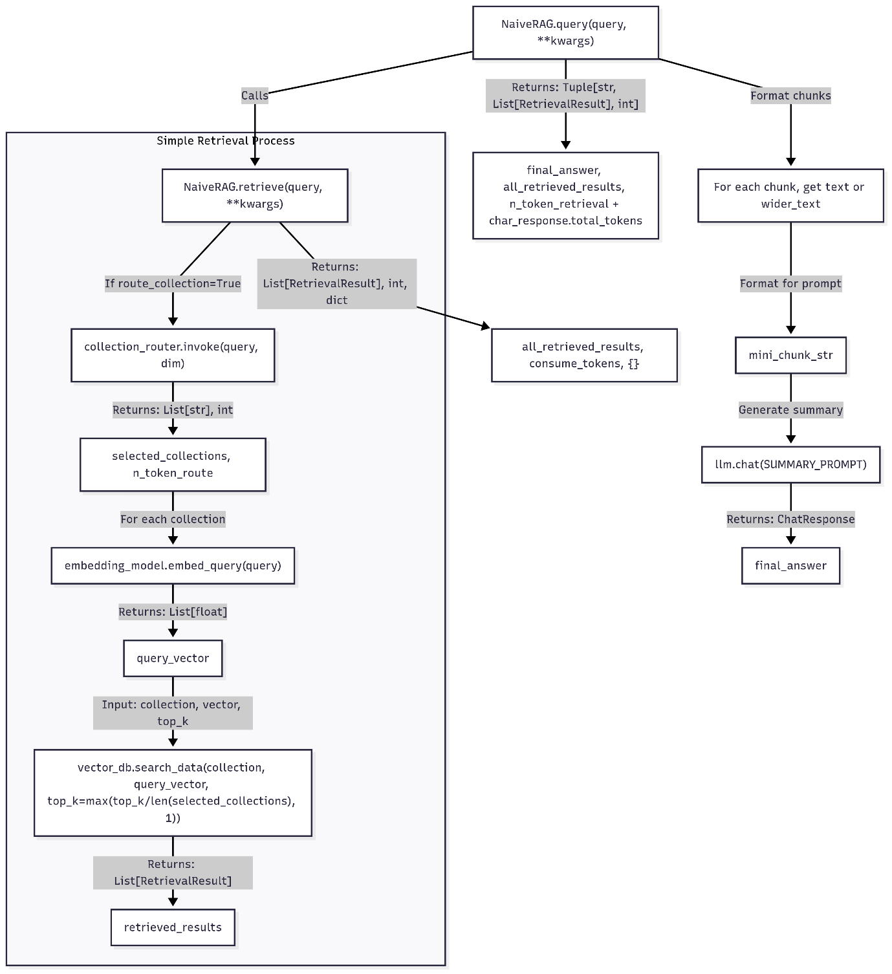
7. FAISS Vector Database Operations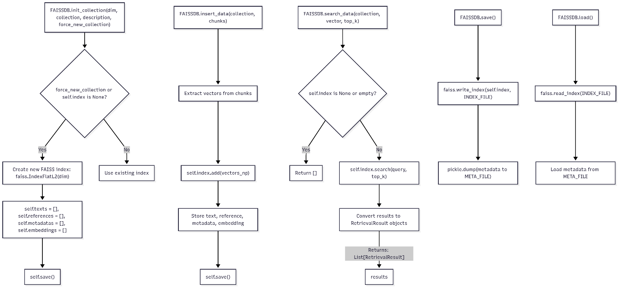
8. OpenAI Embedding Operations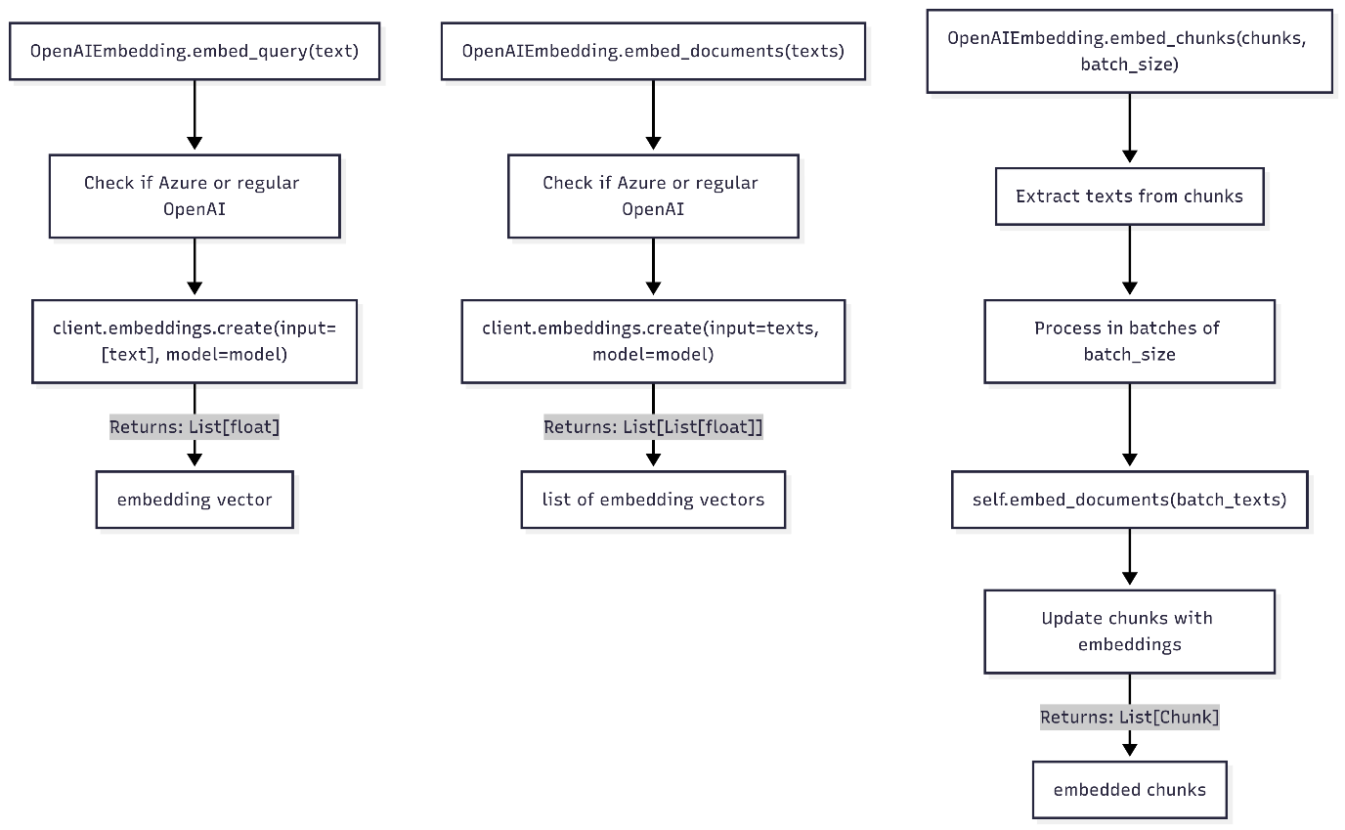
9. Document Splitting Operations

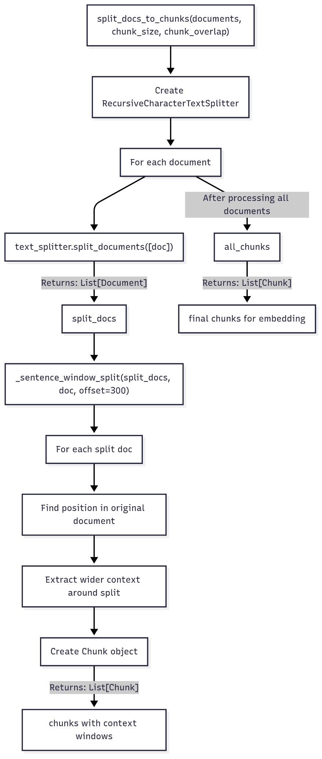

1. **Complete End-to-End Query Flow: From User Request to Response**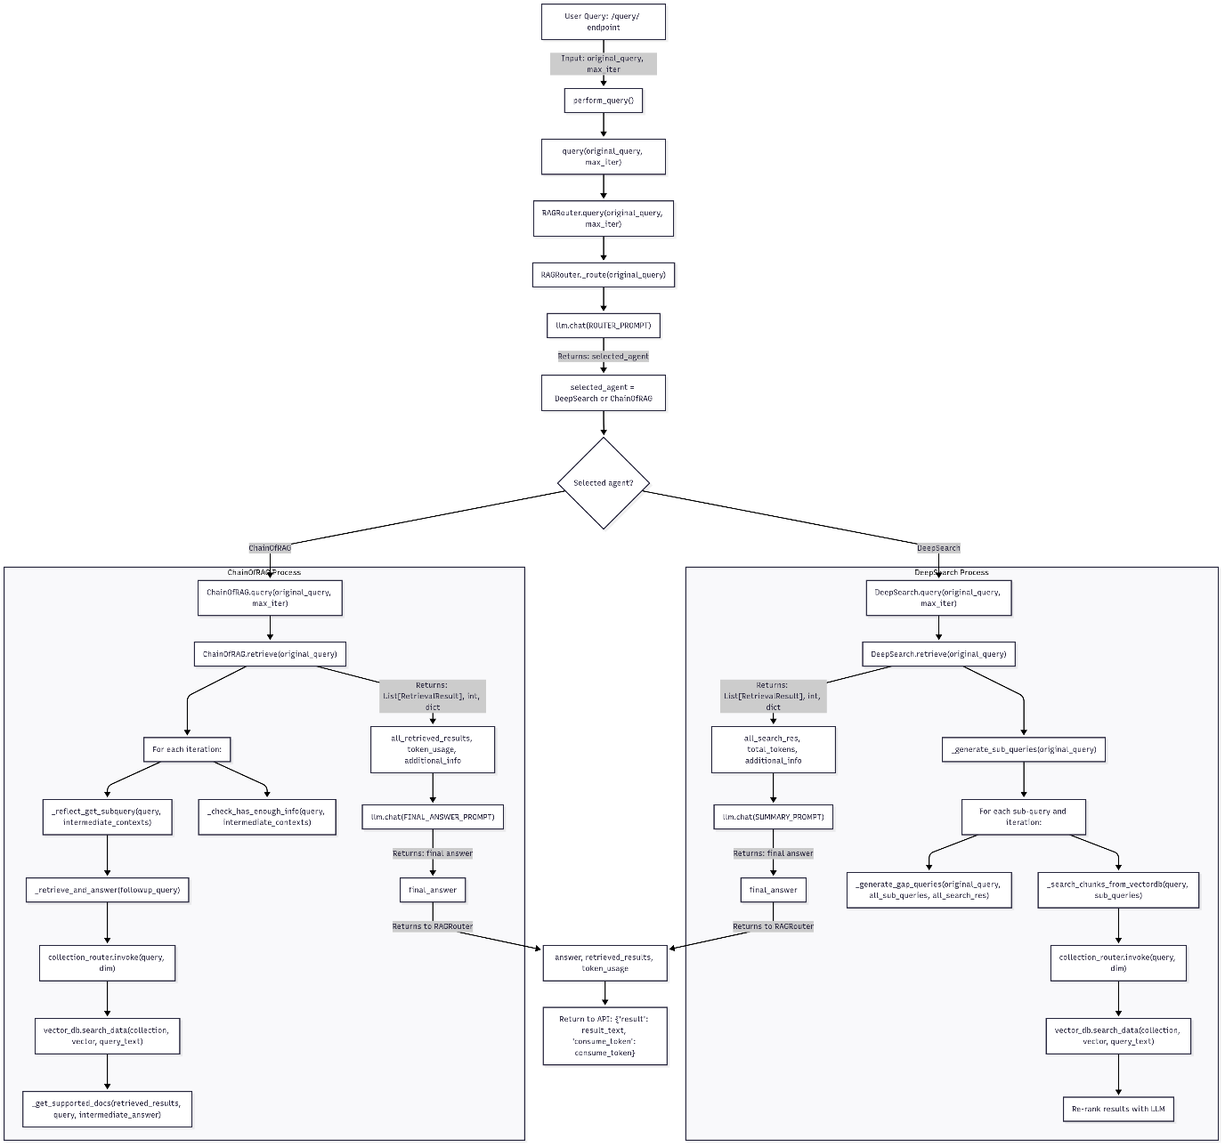

**Key Components**

1. **FastAPI**: Web framework that handles HTTP requests

2. **Configuration**: Manages settings and component initialization

3. **ModuleFactory**: Creates instances of LLMs, embeddings, etc.

4. **RAGRouter**: Routes queries to appropriate RAG agents

5. **DeepSearch**: Complex RAG agent for comprehensive information retrieval

6. **ChainOfRAG**: RAG agent that decomposes queries into iterative steps

7. **NaiveRAG**: Simple RAG agent for basic retrieval operations

8. **FAISSDB**: Vector database for storing and searching embeddings

9. **OpenAIEmbedding**: Generates embeddings using OpenAI's API

