Central Philippines State University
San Carlos Campus, San Carlos City, Negros Occidental
College of Computer Studies
University ID Maker System
Technical and User Documentation

Item | Details
Course | Web Systems and Technology (PFIT 03)
Proponents | Lyra Michelle S. Judiana (Project Manager); Mayome L. Panunciar (System Analyst); Leah V. Libongcogon (System Developer); Angeline V. Piala (Project Documentation)
Submitted to | Feleciano L. Santiago Jr., MSIT, Course Instructor
Academic year | 2026 - 2027
Technology | Vue 3, Vue Router 4, Vite 5

Table of Contents
1. Overview
2. Alignment with the Proposal
3. Users and Permissions
4. ID Application Workflow
5. Data Model
6. System Architecture
7. Installation
8. User Guide
9. Testing Checklist
10. Scope, Limitations, and Future Work

1. Overview
The University ID Maker System replaces the manual collection of personal information and hand-prepared identification cards with a single digital workflow. Applicants submit their details and photo, authorized personnel verify and approve them, and the system produces standardized, print-ready ID cards. Every step is recorded so that ID transactions can be monitored and reviewed later.

2. Alignment with the Proposal
The table below maps each specific objective in the project proposal to the part of the system that delivers it.
Proposal objective | Where it is implemented
1. Digital data-entry module (name, ID number, department, profile picture) | ID record form (RecordForm.vue). The photo is cropped to 3:4 and compressed in the browser.
2. Automated ID generation from standardized templates | IdCard.vue renders the front and back from one fixed template, with a live preview.
3. Centralized database with search, retrieval, and update | ID records page (Records.vue): search by name, ID number, or course; filter by status.
4. Print-ready cards with consistent layout | Print queue (Print.vue): CR80 size (54 x 85.6 mm), 9 cards per A4 sheet, fronts then mirrored backs.
5. Authentication and access control | Sign-in page, role-based route guard (main.js), and role checks in each view.
6. Status monitoring and reporting | Dashboard counts per status and course, transaction log, and a status tracker for applicants.

Problem-statement questions 2 and 3 (submitting information and tracking its status) are covered by the student My ID application page.

3. Users and Permissions
Capability | Administrator | ID officer | Student
Sign in | Yes | Yes | Yes
Submit and track own application | No | No | Yes
View dashboard and transaction log | Yes | Yes | No
Create, edit, and search ID records | Yes | Yes | Own record, until approved
Verify, approve, or reject records | Yes | Yes | No
Print IDs; mark as printed or released | Yes | Yes | No
Delete records | Yes | No | No

Demo accounts for evaluation are listed in Table 1.
Role | Username | Password
Administrator | admin | Admin@2026
ID officer (authorized personnel) | idofficer | Officer@2026
Student | student | Student@2026
Table 1. Demo accounts for evaluation

4. ID Application Workflow
An ID moves through five statuses: Pending, Approved, Printed, Released, and Rejected. A rejected application returns to the applicant with remarks so that it can be corrected and resubmitted.
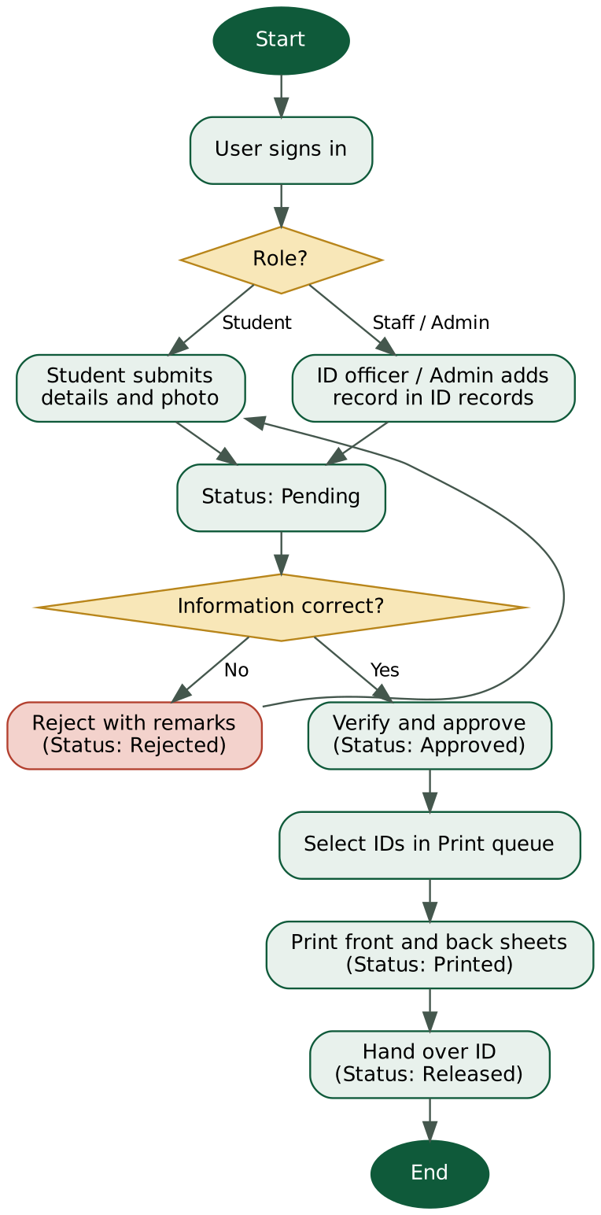
Figure 1. ID application flowchart

5. Data Model
Only data needed for ID production is stored, in line with the scope of the proposal. ID numbers must be unique and may contain letters, numbers, and hyphens.
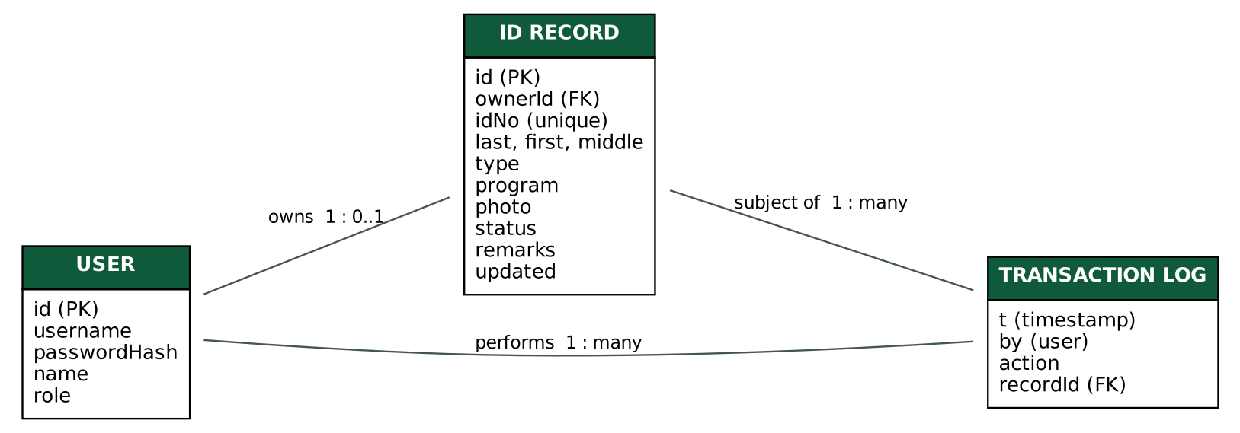
Figure 2. Entity-relationship diagram

6. System Architecture
- Framework: Vue 3 (Composition API), Vue Router 4 in hash mode, built with Vite 5.
- State: one reactive store (src/store.js) saved to the browser localStorage. The signed-in session lives in sessionStorage and ends when the tab closes.
- Card rendering: CSS container query units let one card component scale from on-screen preview to exact physical size when printed. The back of the card carries a Code 39 barcode of the ID number, drawn as SVG.

src/
main.js router and access-control guard
store.js data, authentication, record actions, transaction log
App.vue application shell and role-based navigation
styles.css design tokens and shared styles
components/IdCard.vue
views/ Login, Dashboard, Records, RecordForm, Print

7. Installation
Requirements: Node.js 18 or newer.
npm install
npm run dev (development server)
npm run build (production files in dist/)

8. User Guide

8.1 Students
- Sign in and open My ID application.
- Enter your name, ID number, and course, then upload a clear, front-facing photo.
- Select Submit application and follow progress on the status tracker. If the application is returned, read the remarks, correct the details, and resubmit.

8.2 ID officers and administrators
- Open ID records to search, add, or edit records. Use Preview to inspect the front and back of a card.
- For each Pending record, choose Verify and approve or Reject (a reason is required).
- Open Print queue, tick the approved IDs, and select Print. Use A4 paper at 100% scale with duplex on the long edge, then confirm the prompt to mark the IDs as Printed.
- After handover, select Mark released on the record.
- Use the Dashboard to monitor totals per status and course and to review recent transactions.

9. Testing Checklist
# | Test | Expected result
1 | Sign in with a wrong password | Error message, no access
2 | Open #/records while signed out | Redirected to the sign-in page
3 | Student opens #/records | Redirected to My ID application
4 | Add a record with a duplicate ID number | Save is blocked with a message
5 | Approve a Pending record | Status changes; a log entry appears on the dashboard
6 | Reject a record with remarks | Student sees the remarks and can resubmit
7 | Print two approved IDs | Preview shows a front page and a mirrored back page
8 | ID officer looks for a delete option | Delete button is not available

10. Scope, Limitations, and Future Work
In line with the proposal, the system does not manufacture or deliver physical cards and offers only the standardized template rather than advanced graphic design. Current limitations of this prototype are:
- Data is stored in each browser, so records are not shared between computers.
- Passwords use a lightweight hash suited to a demo, not production security.
- Reports are limited to dashboard summaries and the transaction log.
Recommended next steps are a server API with a database, proper password hashing and session tokens, user management for administrators, selectable card templates, exportable reports (PDF and CSV), and bulk import of student records.

