**Creating OnBoarding Screen**

Delete ViewController

new folder Views/Onboarding

create new cocopod file, OnboardingViewController

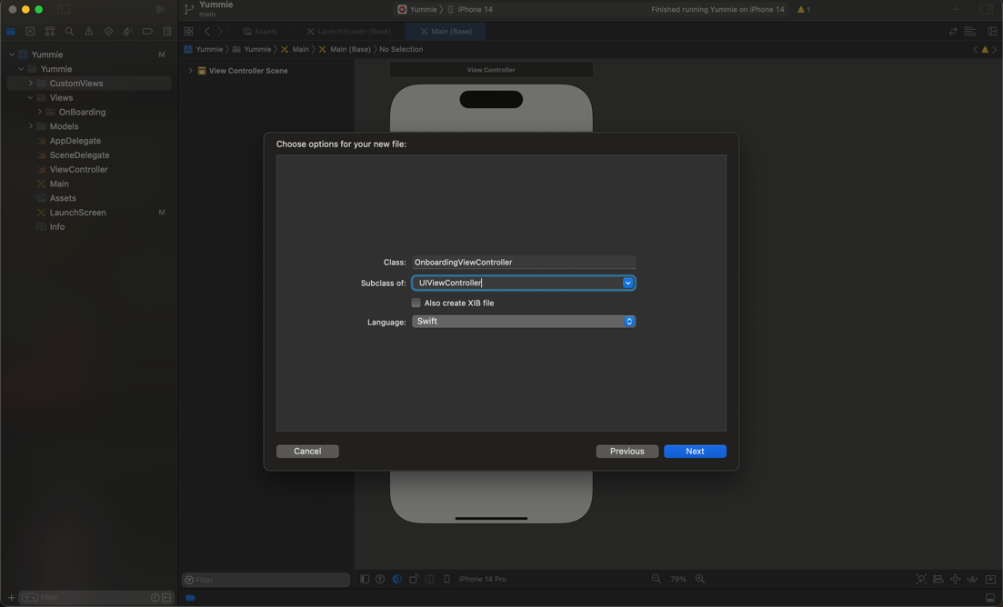

Comeback Main file

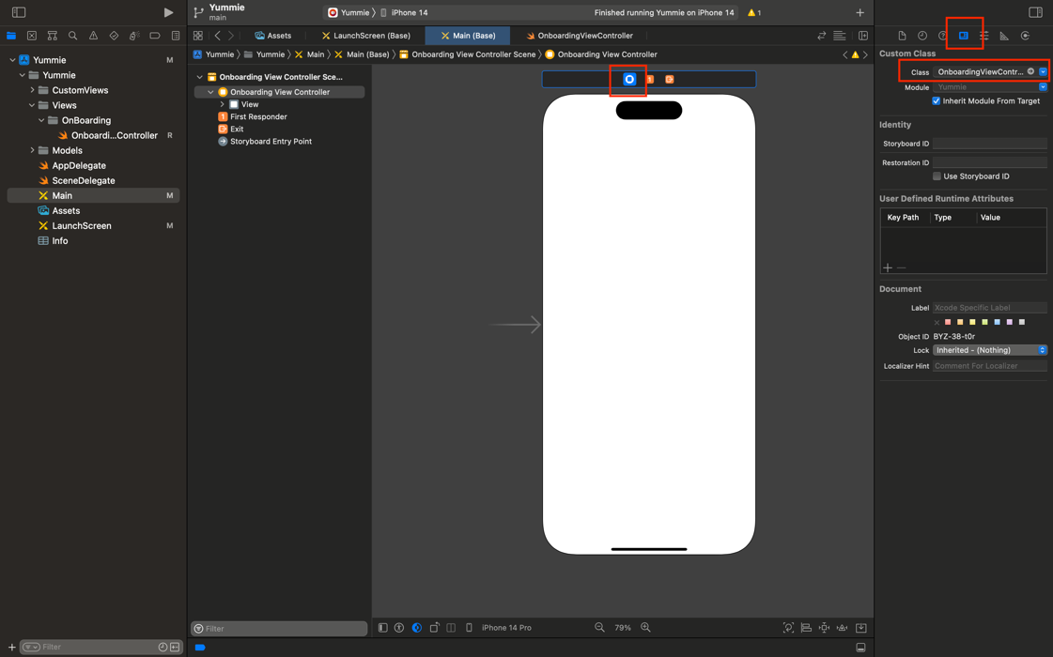

Add ControllView, PageSCroll, Button UI

Connect UIView

Change to mode Assest to view the code, From left side control + drag

Do the same with button and pageControl

Connect Function

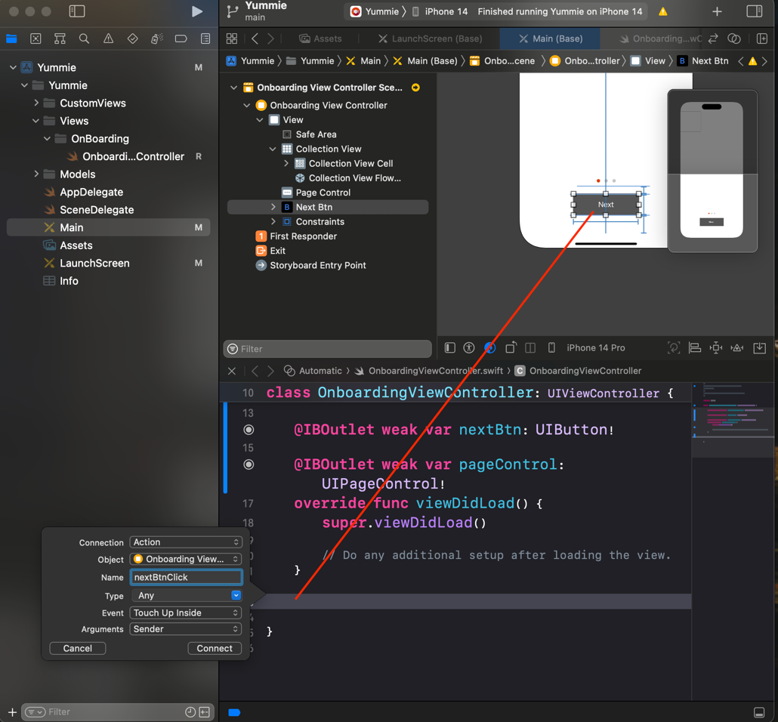

Create folder Extention -> new extension swift file

Create a new cocopod file inside Views/OnBoarding

Connect CellControlView with Main

