1.将一个宏的定义移到它本身的使用前，否则编译不过

搜索宏：DESC_ENABLE_REPORT_ATT_CNTR_STATE

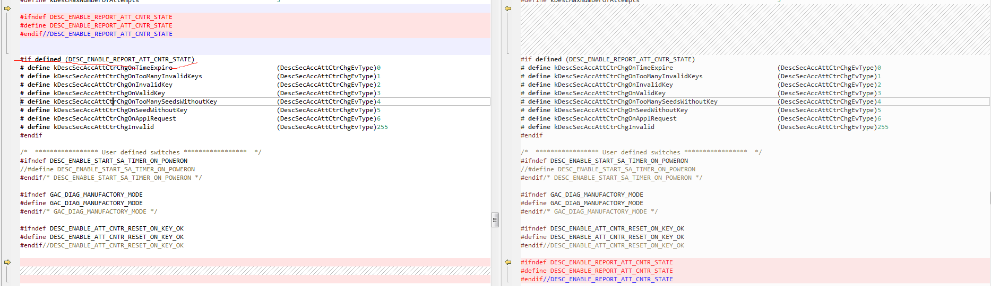

2.重构上电后安全计数器设置的函数

更改函数：DescSecurityOnceInitPowerOn

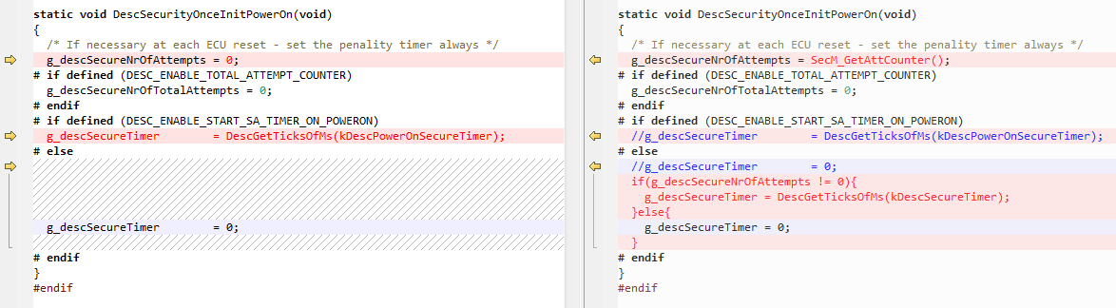

复制代码：

/* If necessary at each ECU reset - set the penality timer always */

g_descSecureNrOfAttempts = SecM_GetAttCounter();

# if defined (DESC_ENABLE_TOTAL_ATTEMPT_COUNTER)

g_descSecureNrOfTotalAttempts = 0;

# endif

# if defined (DESC_ENABLE_START_SA_TIMER_ON_POWERON)

// g_descSecureTimer = DescGetTicksOfMs(kDescPowerOnSecureTimer);

# else

// g_descSecureTimer = 0;

# endif

if(g_descSecureNrOfAttempts != 0){

g_descSecureTimer = DescGetTicksOfMs(kDescSecureTimer);

}else{

g_descSecureTimer = 0;

}

3.新增一个函数vuint8 SecM_GetAttCounter(void)用于上电后读取EEP存储的安全访问失败计数

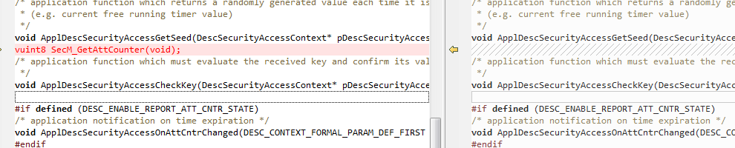

4.把诊断28服务的最小长度2改为3

搜索数组：g_descSvcHead

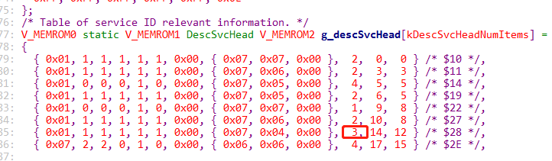

5.功能寻址 0x7E 0x7F不做出响应

搜索宏：DESC_ADD_SUPPRESSED_FUNC_NRC



#define DESC_ADD_SUPPRESSED_FUNC_NRC case 0x7f: case 0x7e:

6.CommunicationControl (0x28)

CommunicationType 只有kDescCommControlMsgAppl ==0x01 ，kDescCommControlMsgNm==0x2

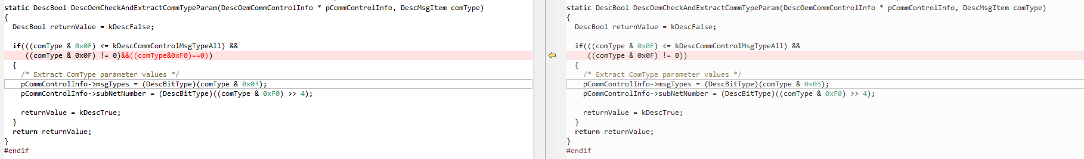

搜素：DescOemCheckAndExtractCommTypeParam

复制代码：((comType & 0x0F) != 0)&&((comType & 0xF0) == 0))

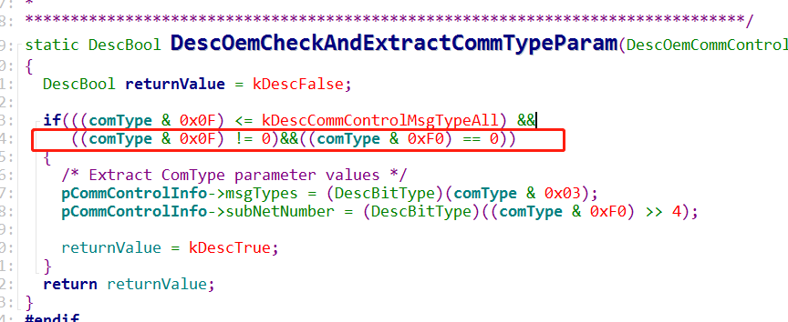

7.屏蔽宏DESC_ENABLE_USE_ERR_CNTR_PROTECTION 支持一直响应种子的请求

搜索宏：DESC_ENABLE_USE_ERR_CNTR_PROTECTION



8.2F服务的NRC31优先级调整：

添加代码：/* Generated state checks */

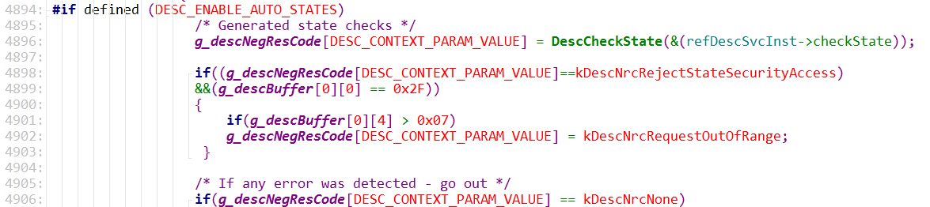

if((g_descNegResCode[DESC_CONTEXT_PARAM_VALUE]==kDescNrcRejectStateSecurityAccess)

&&(g_descBuffer[0][0] == 0x2F))

{

if(g_descBuffer[0][4] > 0x07)

g_descNegResCode[DESC_CONTEXT_PARAM_VALUE] = kDescNrcRequestOutOfRange;

}

9.2E服务0xF199的NRC31和27服务NRC13优先级调整

搜索位置：DescOemOnReqLengthNotMatched(DESC_CONTEXT_PARAM_VALUE);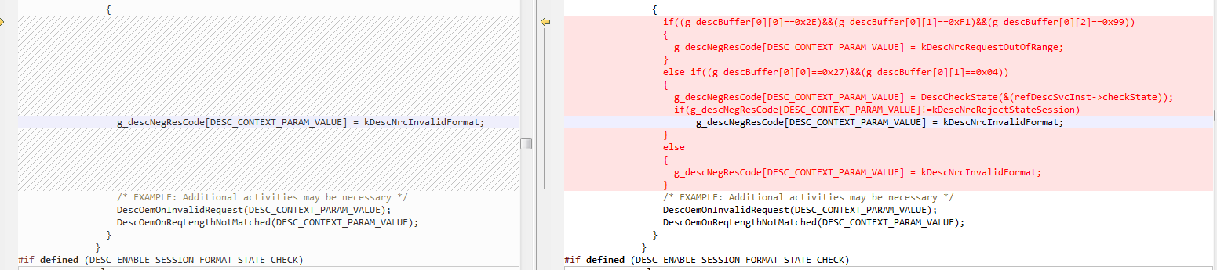 if((g_descBuffer[0][0]==0x2E)&&(g_descBuffer[0][1]==0xF1)&&(g_descBuffer[0][2]==0x99))

{

g_descNegResCode[DESC_CONTEXT_PARAM_VALUE] = kDescNrcRequestOutOfRange;

}

else if((g_descBuffer[0][0]==0x27)&&(g_descBuffer[0][1]==0x04))

{

g_descNegResCode[DESC_CONTEXT_PARAM_VALUE] = DescCheckState(&(refDescSvcInst->checkState));

if(g_descNegResCode[DESC_CONTEXT_PARAM_VALUE]!=kDescNrcRejectStateSession)

g_descNegResCode[DESC_CONTEXT_PARAM_VALUE] = kDescNrcInvalidFormat;

}

else

{

g_descNegResCode[DESC_CONTEXT_PARAM_VALUE] = kDescNrcInvalidFormat;

}

10. ccl_par.c中以下两个函数:

IlTxWait();IlRxWait();需要被修改成IlTxStop();IlRxStop();

IlTxRelease();IlRxRelease();需要被修改成IlTxStart();IlRxStart();

搜索：CclBusOffStart CclBusOffEnd

