Background information about MS basic programs that I wrote in the late 80s and early 90s.

* Programs were written in Microsoft compiled basic, the predecessor to visual basic. I bought that program when I was in graduate school (1986-87) and paid for some new versions early in my WGF career (I couldn’t get the department to pay for them). The last version I have is Microsoft BASIC PDS (Professional Development System) 7.1. I think this was the last release of the BASIC PDS prior to the first release of visual basic.
* Most of the code has a .bas file extension
* Each program has a file with a .bi extension. It is an “include file” that has a bunch of variable and subroutine declarations that every piece of code needs to know when it is compiled.
* There is a text file named “makefile” for each program. It looks like a DOS batch file that lays out the steps that the compiler takes to build the executable file. Below is the makefile for creelcal

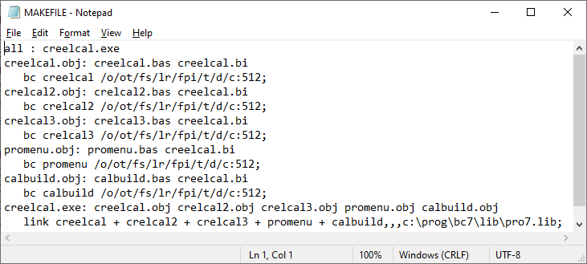

* Back in the old days the way computer programs interacted with the computer screen and got user input was different and more labor/coding intensive. Each of these programs has a whole lot of code focused on getting user input, and structuring the output to a text file. I think in each program that I wrote there is one file that actually does the calculations or whatever job that program is supposed to do.
* I paid for some code libraries like Crescent Software's QuickPak Professional Library and perhaps some others. It may be amusing to some of you that I found reference to those in programming newsletters that I subscribed to and were mailed to me by snail mail. I purchased those code libraries by mailing a check, and the files were shipped to me on a floppy disk… If you look in the code I give credit to those libraries and things I copied out of books or the user manual.
* I started working for WGF in March of 1988. Interesting to me that I started writing the CreelCal program soon after I arrived and the first version was “published” in January 1989. The last revision document was in May of 2004.
* It was interesting to look through the code and see where I had left behind debugging code. In the calbuild.bas file you can see the debugging statements that are not indented like the rest of the code. Took me a minute to remember that those had been scattered throughout to figure out where things broke and what caused the problem. I commented them out rather than deleting them so I must not have been confident that the bug was fixed.
* I’m kind of proud of the fact that I can read this 30+ years later and mostly make sense of what the code is supposed to do. I like that I was careful about indenting to see which statements were nested within other conditions or subroutines. I took a couple of programming courses as an undergrad (FORTRAN and PASCAL). It is clear that those instructors taught me the value of adding comments. Also kind of cool that at least a couple of the programs are still being used after all this time.
* Just one last “times have changed” anecdote. In the readme file for the QuickPak Pro it included this statement. I like the large file size warning.

*“The INSTALL.EXE program will unpack all of the necessary .EXE and data files, and place them into the drive and directory you choose. If the directory does not exist INSTALL will create it. The unpacked demonstration files occupy approximately 700k bytes, so you could also install them to a high capacity floppy disk if you prefer.”*