

AI Tools & Techniques For Cybersecurity
Year 2/3 (2024/25), Semester 4/6

SCHOOL OF INFOCOMM TECHNOLOGY
Diploma in Information Technology
Diploma in Cybersecurity & Digital Forensics

Assignment Report

Tutorial Group: | <REDACTED>
Tutor: | <REDACTED>
Date of Submission: | 1st Feb 2026

Student Number | Name
<REDACTED> | Wyse Lee Hong Yao
<REDACTED> | Kam Wei Hong
<REDACTED> | Daksh Thapar
Table of Contents
Project Description 4
Problem Statement 5
Specific 5
Measurable 5
Actionable 5
Relevant to this topic 5
Time-bound 5
Dataset Sourced 6
Name 6
Source 6
Feature Details 6
Members Work Breakdown 7
Data Cleaning 8
Cleaning missing values 8
Cleaning data duplication 9
Cleaning categorical column values 10
Frequency analysis 11
Visual Validation using Bar Plots 15
Standardising Non-Semantic Placeholder Values 18
Defining & Merging Rare Classes 20
Cleaning test dataset 21
Checking Distribution of Binary Columns 24
Exploratory Data Analysis 26
Before Data Cleaning 26
After Data Cleaning 34
Feature Engineering 44
One-hot encoding categorical, non-target features 44
Label encoding categorical target feature 45
Sort columns 47
Feature Selection 48
Pearson Correlation Analysis 49
Train-Test-Split 53
Feature Scaling 54
Predictive Modelling 56
Logistic Regression 56
One-vs-Rest (OvR) Strategy 57
Random Forest Architecture 58
Model Evaluation 60
Binary Logistic Regression (train split of training dataset) 60
ROC Curve (Binary Logistic Regression) 61
Binary Logistic Regression (train split of test dataset) 62
Multiclass OvR Logistic Regression (train split of training dataset) 63
Multiclass OvR Logistic Regression (train split of test dataset) 63
Per-Class Recall (Multiclass) 64
Random Forest (baseline, train split of training dataset) 65
Tuned Random Forest (GridSearchCV, train split of training dataset) 65
Findings 66
Conclusion 67
Summary of Insights 67
Model Performance and Success 67
Limitations and Future Work 67
References 69

Project Description
Conventional Network Intrusion Detection Systems, in the context of the rapidly changing environment presented by the realm of cybersecurity, have been shown to be inefficient in identifying the latest, most complex patterns of attacks. The proposed work aims to explore the design, analysis, and assessment of machine learning-based anomaly detection systems for the given task, utilizing the UNSW-NB15 dataset, a complete benchmark for network traffic analysis. The key difference between the proposed work and the conventional approach, utilizing the KDD Cup 99 benchmark, is the fact that the UNSW-NB15 incorporates the latest patterns of behavior, both for the real modern normal behavior of the users, as well as the generated attack behavior through the Cyber Range Lab of the UNSW Canberra, utilizing the IXIA PerfectStorm tool.
The dataset includes nine different families of attacks such as Fuzzers, Analysis, Backdoors, DoS, Exploits, Generic, Reconnaissance, Shellcode, and Worms, in addition to normal traffic. The raw network traffic, which was captured using tcpdump, was then filtered using Argus and Bro-IDS to identify 42 features, which are divided into flow, basic, content, time, and additional generated features. The features allow for the detection of complex intrusion attacks based on packet header information and payload properties
Our team used a comprehensive Data Science Lifecycle approach for the analysis of the data. The procedure included a large number of Data Cleaning steps for the management of missing values, Exploratory Data Analysis (EDA) for the analysis of the distribution of the classes in the data, where the dominance of "Normal" and "Attack" traffic was observed, and Feature Engineering for the management of the dimensionality of the data, where the elimination of features that have a high level of correlation (>0.7) was performed, along with scaling the data through StandardScaler. The heart of the project includes the development of predictive models, such as Logistic Regression for both binary and multi-class One-vs-Rest classification, along with the Random Forest classifier, for the accurate classification of the network traffic.
This project aims to develop a machine learning-based Network Intrusion Detection System using the UNSW-NB15 dataset to accurately detect and classify network attacks. By applying Logistic Regression and Random Forest models to both binary and multiclass classification tasks, the system seeks to achieve reliable performance above 80% accuracy while reducing false negatives. The proposed solution provides an automated, data-driven approach to intrusion detection that addresses the limitations of traditional signature-based methods within a defined timeframe.

Problem Statement
To overcome the drawbacks of traditional signature-based detection, the proposed project will focus on developing a machine learning-based Network Intrusion Detection System (NIDS) prototype.
The problem statement will be defined using the SMART framework:

Specific
The goal is to develop and train predictive models (Logistic Regression & Random Forest) on the UNSW-NB15 dataset with the intention of classifying network traffic accurately based on binary classes (Normal/Attack) and multi-classes (9 specific attack types like DoS, Exploits, & Fuzzers).

Measurable
The effectiveness of the model will be measured using standard classification measures, with the primary goal of achieving a Weighted F1 score and Accuracy above 80% on the test dataset. These will be ensured using confusion matrices to reduce the incidence of False Negatives, which correspond to the failure to detect potential threats to security.
Actionable
The developed model will be used as an automated tool for the analysis of network flow attributes (sbytes, sttl, sload), among others, to detect anomalies, thus relieving security analysts of the burden of manual analysis.
Relevant to this topic
With the sophistication in network attack methods, using algorithms based on data and modern datasets such as UNSW-NB15 offers a much-needed improvement over the outdated benchmarking process, thereby supporting the "Cybersecurity Operations and Threat Intelligence" educational objectives.

Time-bound
The entire process from cleaning to model evaluation and finally submitting the report will be done within the assignment deadline of February 1, 2026.

Dataset Sourced

Name
UNSW-NB15 Dataset

Source
The dataset was sourced from the Cyber Range Lab at UNSW Canberra, adhering to the assignment constraint of using an open-source cybersecurity dataset distinct from those taught in class.
The link to the dataset files:
https://unsw-my.sharepoint.com/personal/z5025758_ad_unsw_edu_au/_layouts/15/onedrive.aspx?id=%2Fpersonal%2Fz5025758%5Fad%5Funsw%5Fedu%5Fau%2FDocuments%2FUNSW%2DNB15%20dataset%2FCSV%20Files%2FTraining%20and%20Testing%20Sets&viewid=f8d1dec5%2Dcd5f%2D42ae%2D8b06%2D2fece580c74a

Feature Details
A total of 44 features including packet-based and flow-based features were extracted from the raw network packets by Argus and Bro-IDS tools. Packet-based features are extracted from the packet header and its payload (also called packet data) while flow-based features are generated using the sequencing of packets, from a source to a destination, traveling in the network.
The first 42 features are the non-target features which are categorised into 5 groups: Flow, Basic, Content, Time, and Additional.
Flow features: proto
Basic features: state, dur, sbytes, dbytes, rate, sttl, dttl, sloss, dloss, service, sload, dload, spkts, dpkts
Content features: swin, dwin, stcpb, dtcpb, smean, dmean, trans_depth, response_body_len
Time features: sjit, djit, sinpkt, dinpkt, tcprtt, synack, ackdat
Additional features:
General purpose features: is_sm_ips_ports, ct_state_ttl, ct_flw_http_mthd, is_ftp_login, ct_ftp_cmd
Connection features: ct_srv_src, ct_srv_dst, ct_dst_ltm, ct_src_ltm, ct_src_dport_ltm, ct_src_sport_ltm, ct_dst_src_ltm
The last two features are the target features which include attack categories and labels. Attacks are categorized as Analysis, Backdoor, DoS, Exploits, Fuzzers, Generic, Reconnaissance, Shellcode and Worms. The labels 0 and 1 represent normal and attack records respectively.

Members Work Breakdown
No. | Member Name | Contributions (Role & tasks assigned and accomplishments) | Remarks
1. | Wyse Lee | Code: Data preparation, Information of features, Data cleaning, Feature engineering, Feature selection, Feature scaling, Predictive modeling, Model Evaluation (apart from Hyperparameter Tuning)  Report: Data cleaning, Exploratory Data Analysis (Post Data Cleaning), Feature engineering, Feature selection, Feature scaling
2. | Kam Wei Hong | Exploratory data analysis, visualization, interpretation of distributions, conclusion write-up, EDA and insights
3. | Daksh Thapar | Predictive modeling, model evaluation, hyperparameter tuning (GridSearchCV), results analysis, Modelling and evaluation

Data Cleaning

Cleaning missing values
The .isna() method checks all values in each row for every column. It returns a boolean same-sized object indicating if the values are NA. NA values, such as None or numpy.NaN, gets mapped to True values. Everything else gets mapped to False values. Characters such as empty strings '' or numpy.inf are not considered NA values.
The .any() method accepts an iterable and returns True if at least one value in the iterable is true. If all values in the iterable are false, any() returns False. This is used to check if there are any True values in each column which would indicate the presence of missing values.
The .sum() method adds up the value of every row in every column, where the value of False is 0 and the value of True is 1.
Since the result in the screenshot above returns 0 for both our training and test dataset, it proves that the dataset contains high quality data with no missing values (numpy.NaN / None). Therefore, there was no need to handle any missing data.
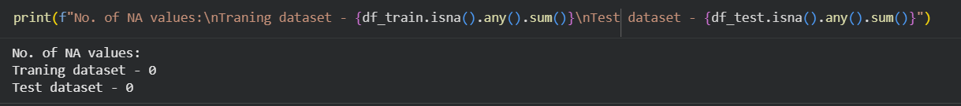

Cleaning data duplication
Duplicate data is a common issue in data processing and analysis. It not only affects data accuracy but can also introduce bias during model training. Therefore, identifying and cleaning duplicate records is a crucial step in the data cleaning process.
The main reasons for handling duplicates include:
- Improving data quality: Eliminating redundant information ensures data consistency.
- Enhancing analytical accuracy: Prevents skewed results due to duplicate records.
- Optimizing storage: Reduces unnecessary usage of storage resources.
Duplicate data points can be identified using Panda’s DataFrame.duplicated() function which returns a Boolean series indicating whether each row is a duplicate or not.
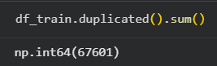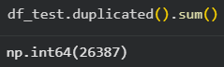
To drop duplicate values, Panda’s drop_duplicates method was used.
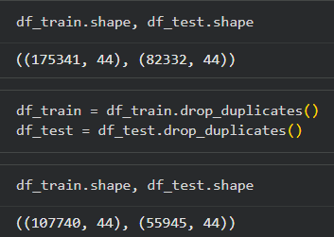
A total of 67,601 duplicate rows were found in the training data and removed, reducing the data from 175,341 to 107,740.
In the testing set, 26,387 duplicate rows are eliminated, reducing the data set from 82,332 to 55,945.
This strict data cleaning process guarantees that evaluation metrics will reflect true generalization, not memorization of repeated traffic.

Cleaning categorical column values
Categorical value checking is the process of ensuring that categorical columns do not contain non-standard values. The list of non-numerical columns in our dataset is as follows:
- proto
- state
- service
- attack_cat
In network intrusion detection and traffic classification tasks, these categorical features other than “attack_cat” encode critical semantic information about how traffic behaves on the network.
The attack category, “attack_cat”, represents the ground-truth labels that the model must learn to distinguish.
A preliminary analysis of the dataset revealed significant class imbalance, with several attack types occurring extremely infrequently relative to dominant classes such as Normal, Exploits, and Fuzzers.
Before these features can be safely and effectively used by machine learning models, they must be cleaned to ensure consistency, interpretability, and statistical reliability.
The following steps were performed to validate and clean these categorical columns.

Frequency analysis
Frequency analysis identifies all unique categorical values present in each column. This detects rare, anomalous, or unexpected categories (e.g. protocols with fewer than 10 occurrences). The results highlight class imbalance, which is especially relevant in cybersecurity datasets where benign traffic dominates.
“proto” column:
The table shows the frequency distribution of network protocols observed in the training dataset. A total of 133 unique protocol values are present, with a highly skewed distribution dominated by a small number of common protocols and a long tail of rarely occurring ones.
The protocol distribution is heavily dominated by TCP and UDP traffic, which together account for the vast majority of network flows and reflect realistic operational network behaviour. In contrast, there is a pronounced long-tail of low-frequency protocols, many of which occur only a handful of times or even once, resulting in severe category imbalance.
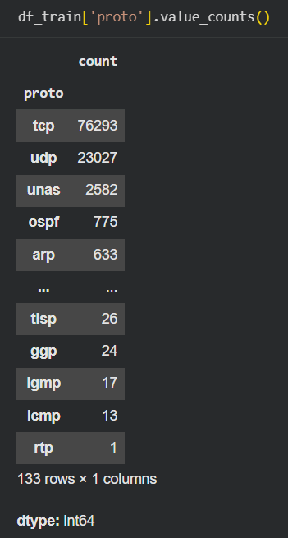
“state” column:
The table shows the frequency distribution of connection states. The state feature captures how a network connection progresses or terminates, which is a key behavioural indicator in network traffic and intrusion detection analysis.
The connection state distribution is highly skewed, with FIN, INT, and CON dominating the dataset and representing the majority of observed network flows, which is consistent with normal TCP connection lifecycles. In contrast, several states occur extremely rarely, including REQ, RST, ECO, PAR, URN, and an ambiguous “no” value, indicating either uncommon connection behaviours or non-standard/undefined states. These low-frequency and unclear labels provide limited statistical value for model training and risk introducing noise or misinterpretation if not standardised or appropriately handled.
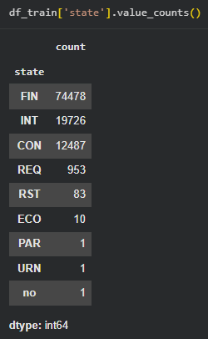
“service” column:
The table presents the frequency distribution of application-layer services. The service feature indicates the type of network service associated with each flow and provides important contextual information for distinguishing normal activity from potentially malicious behaviour.
The distribution is strongly dominated by the placeholder value “-”, indicating a large proportion of traffic where no specific application service is identified. Among explicitly defined services, HTTP and DNS are the most prevalent, followed by SMTP, FTP-related services, and SSH, which aligns with typical enterprise network usage. A long tail of services such as SNMP, SSL, DHCP, IRC, and RADIUS appears very infrequently, highlighting significant class imbalance within this feature.
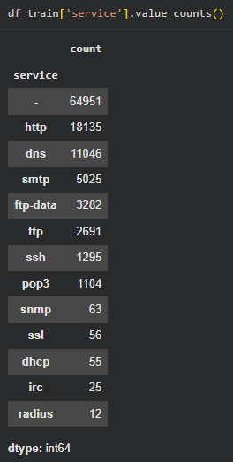
“attack_cat” column:
The table shows the frequency distribution of attack categories. This label represents the ground-truth classification target for the intrusion detection model and is critical for supervised learning and performance evaluation.
The distribution is highly imbalanced, with Normal traffic forming the largest class by a significant margin. Among malicious traffic, Exploits and Fuzzers are the most prevalent, followed by Reconnaissance, Generic, and DoS attacks. In contrast, Analysis, Backdoor, Shellcode, and especially Worms appear with much lower frequencies, forming a pronounced long-tail of rare but potentially high-impact attack types.
These rare classes collectively account for a very small fraction of total traffic, making them statistically under-represented.
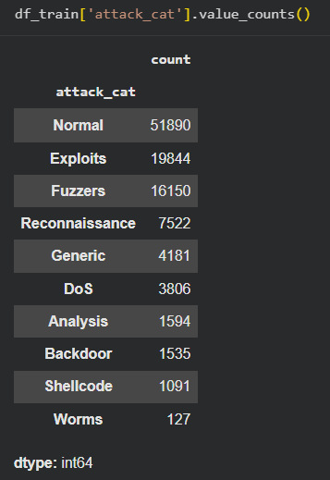

Visual Validation using Bar Plots
The bar plots provide an intuitive, visual confirmation of distribution skew. It makes extreme dominance immediately visible such as tcp, FIN, and “-“ service.
The findings from the plotted visualisations confirm that traffic patterns are realistic like TCP dominance, which is expected. This enables informed decisions before encoding or resampling.
Bar plot for ‘proto’ column:
This bar plot of the “proto” (network protocol) feature, showing how frequently each protocol appears in the training dataset. It provides a visual summary of protocol usage patterns across all recorded network flows.
The chart shows an extreme imbalance, with TCP overwhelmingly dominating the dataset, followed by UDP, while all other protocols appear with very small counts. The vast majority of protocol categories are compressed near the x-axis, indicating a pronounced long-tail distribution where many protocols occur very rarely. This visual compression makes it clear that only a handful of protocols contribute meaningfully to the overall traffic volume.
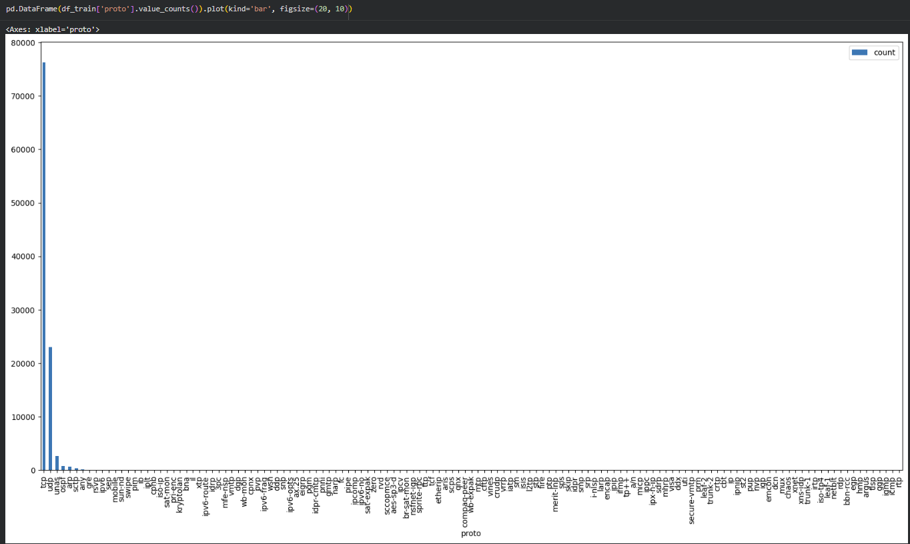
Bar plot for ‘state’ column:
The bar plot of the “state” (connection state) feature, illustrating how frequently each connection state appears in the training dataset. The state attribute reflects the lifecycle or behaviour of network connections and is an important indicator for identifying normal versus anomalous traffic patterns.
The chart is heavily dominated by the FIN state, followed by INT and CON, which together account for the vast majority of connections and represent common, expected TCP connection behaviours. All other states, such as REQ, RST, ECO, PAR, URN, and ‘no’, occur very infrequently and are visually compressed near the x-axis, indicating a strong long-tail distribution of rare connection states.
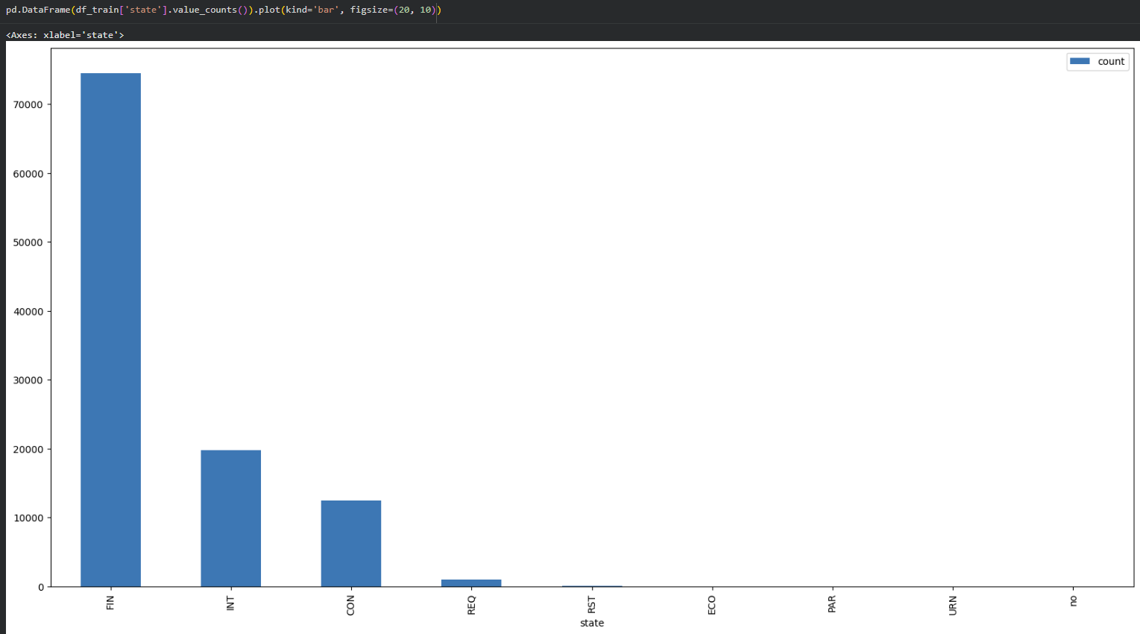
Bar plot for ‘service’ column:
The bar plot of the “service” feature, visualising how frequently each application-layer service appears in the training dataset. The service attribute provides context about the type of network activity associated with each flow and is useful for distinguishing different traffic behaviours.
The chart is dominated by the placeholder value “-”, indicating that a large proportion of flows do not have a clearly identified application service. Among the explicitly labelled services, HTTP and DNS are the most common, followed by SMTP, FTP/FTP-data, and SSH, which aligns with typical enterprise network usage. All remaining services occur very infrequently and are compressed near the x-axis, revealing a pronounced long-tail distribution.
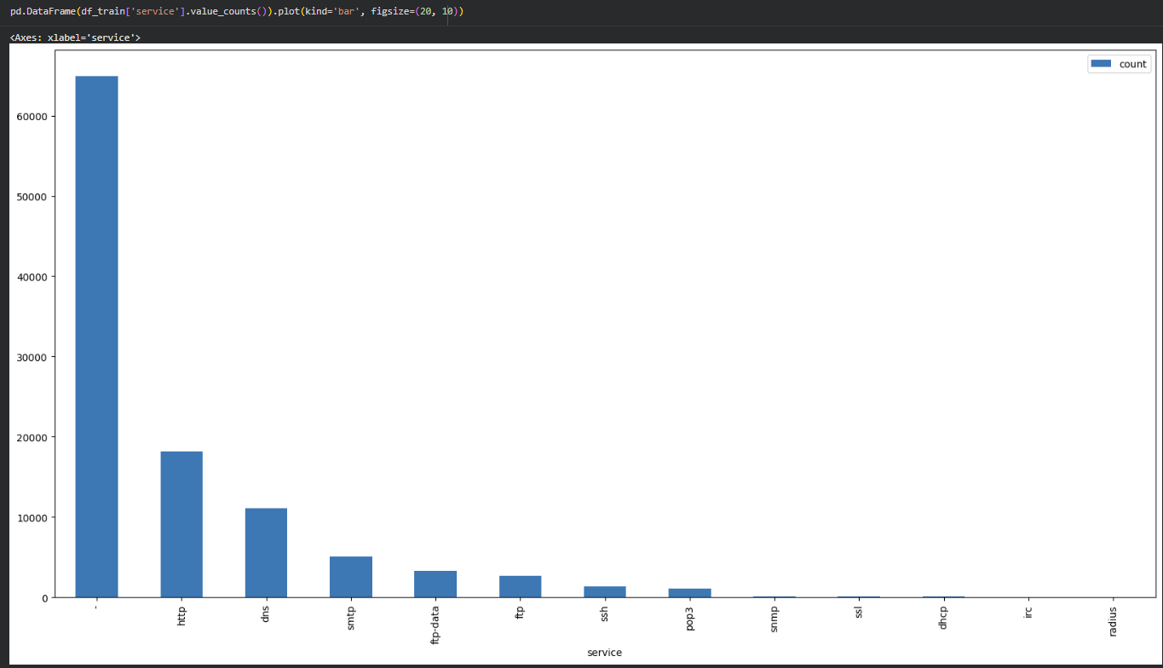
Bar plot for ‘attack_cat’ column:
The bar graph visualises the frequency distribution of the “attack_cat” labels. The attack category distribution is highly imbalanced, with Normal traffic dominating the dataset, reflecting realistic network conditions but posing a risk of model bias toward benign predictions.
Among malicious classes, Exploits and Fuzzers are the most prevalent, while Reconnaissance, Generic, and DoS appear at moderate levels that provide sufficient data for learning meaningful attack patterns. In contrast, Analysis, Backdoor, Shellcode, and Worms form a pronounced long-tail of rare categories with very limited samples, making them difficult to classify reliably and increasing the likelihood of unstable or noise-driven predictions if treated independently.
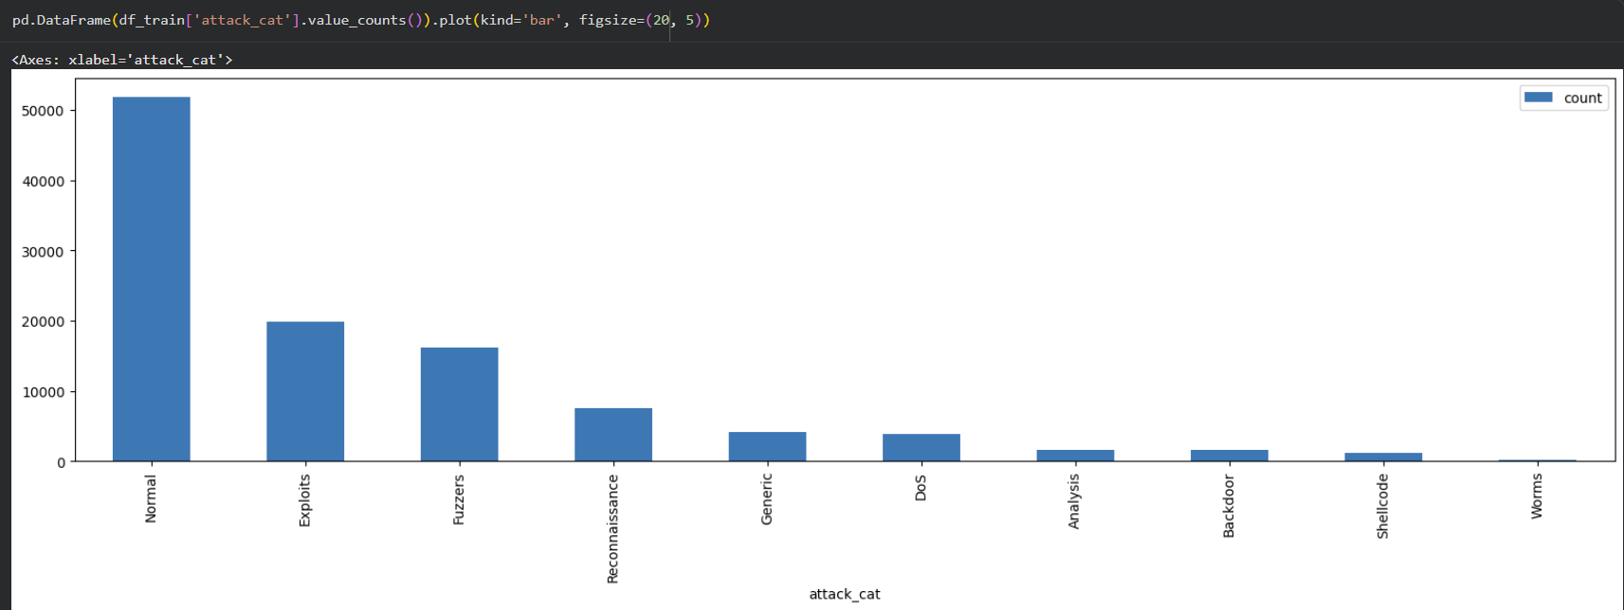

Standardising Non-Semantic Placeholder Values
Cleaning the ‘state’ column:
The value "no" is ambiguous and lacks semantic meaning in a network state context. Replacing it with "Not Applicable" clarifies that the state is either undefined or the connection does not conform to standard TCP state transitions.
This prevents the model from treating "no" as a meaningful behavioural state, improving both feature interpretability during analysis/incident review and reduces the risk of misclassification due to misleading labels.
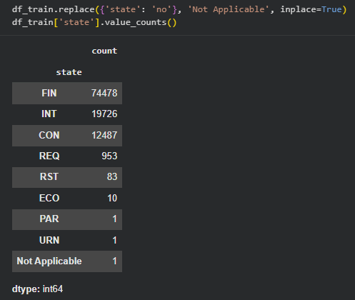
Cleaning the ‘service’ column:
The “-“ symbol is a placeholder, not an actual service. By replacing it with “Not Applicable”, it would be encoded as a valid category and artificially inflate the importance of a meaningless value.
This ensures all categorical values represent real or explicitly undefined services, preventing the model from learning patterns based on missing semantics which aligns with best practices in feature hygiene for intrusion detection systems.
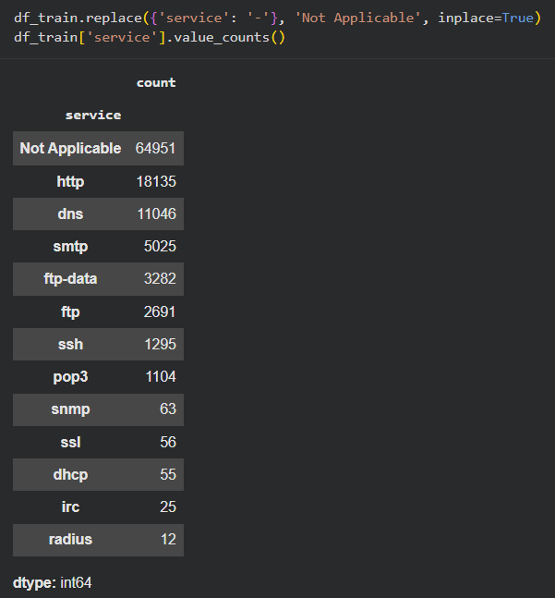

Defining & Merging Rare Classes
To mitigate the negative impact of this imbalance on model performance and reliability, rare attack categories were consolidated into a single umbrella class.
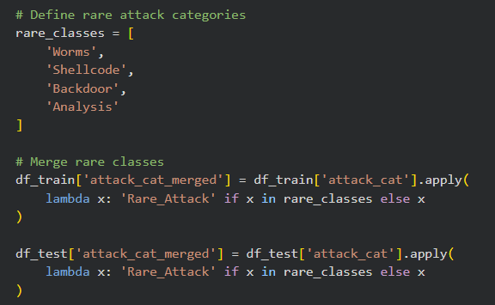
The rare classes are explicitly documented, indicating which attack types are considered rare and unstable for standalone learning. This is decided based on the analysis of the frequency analysis and bar plot of “attack_cat” column.
Addressing Severe Class Imbalance
- Machine learning models struggle to learn meaningful patterns from classes with very few samples
- Rare classes often result in:
  - Near-zero recall
  - Unstable decision boundaries
  - Overfitting to noise
Merging improves statistical support per class, enabling the model to learn generalisable patterns.
The original “attack_cat” column is then removed as it is no longer required.
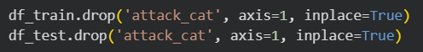

Cleaning test dataset
The above shows the analysis and cleaning of data from the train dataset. The same applies for the test dataset as shown below.
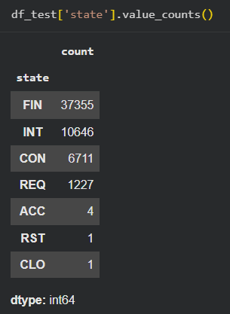
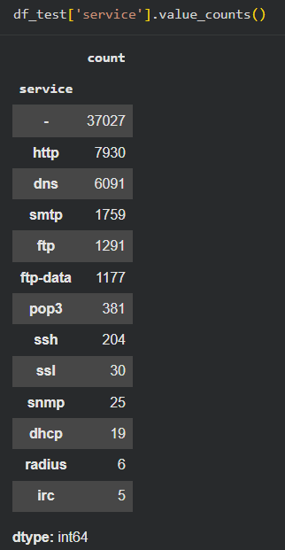
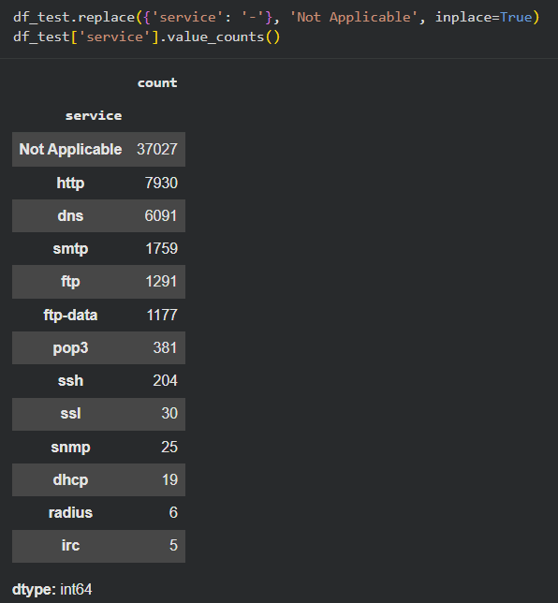
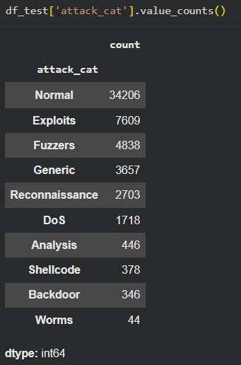
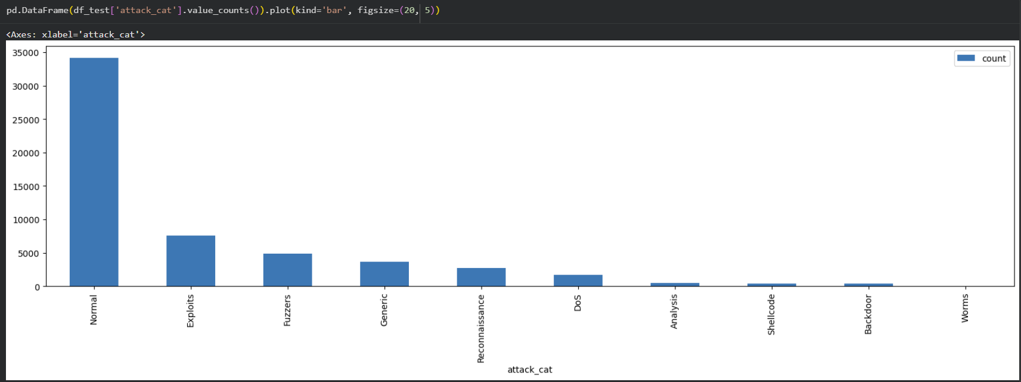

Checking Distribution of Binary Columns
Checking the distribution of binary columns is an essential data validation step to ensure that features intended to represent true/false conditions contain only valid binary values (typically 0 or 1).
By inspecting value counts, anomalies such as values greater than 1 can be detected early, which often indicate data collection errors or inconsistent encoding. Identifying and removing or correcting these invalid entries preserves the semantic meaning of the binary features, prevents the model from learning misleading numerical relationships, and ensures consistent interpretation across training and testing datasets.
This validation step improves data integrity and contributes to more reliable and interpretable model behaviour in a cybersecurity context.
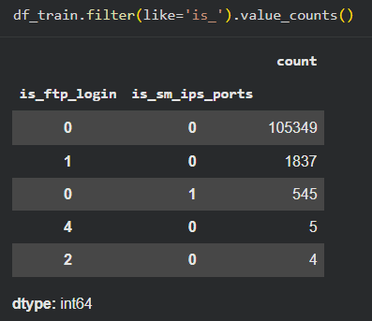
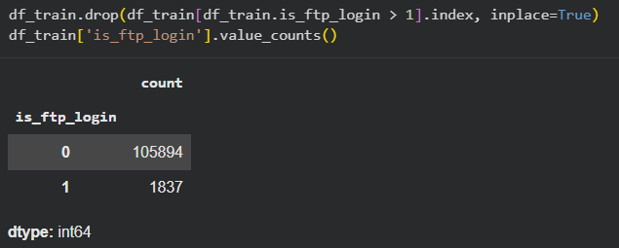
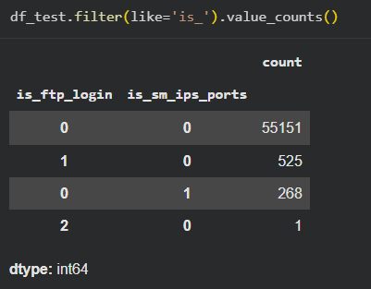
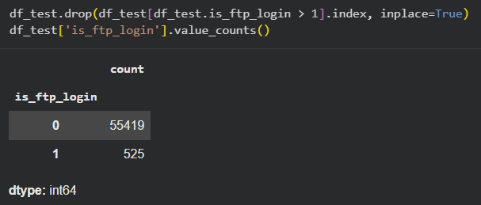
The screenshots above show the distribution and validation of binary indicator features (columns prefixed with is_) in both the training and test datasets, specifically is_ftp_login and is_sm_ips_ports. These features are intended to represent binary conditions (0 = false, 1 = true) that flag specific security-relevant behaviours.
Initial value counts reveal that while most records correctly use binary values (0 or 1), there are a small number of anomalous entries where is_ftp_login takes values greater than 1 (e.g. 2 or 4). This violates the semantic definition of a binary feature and indicates either data collection artefacts or encoding inconsistencies. After filtering out these invalid rows (is_ftp_login > 1), both the training and test datasets contain only valid binary values, with a strong skew toward 0 and a much smaller proportion of 1s, reflecting that FTP login attempts and SM-IPS port usage are relatively rare events.

Exploratory Data Analysis
Exploratory Data Analysis (EDA) was conducted to gain a deeper understanding of the dataset's structure, uncover underlying patterns, and identify potential anomalies or biases that could influence model performance. This phase is critical for informing subsequent feature engineering and modelling strategies.

Before Data Cleaning
Target Variable Distribution
The main goal is to classify network traffic as "Normal" or "Attack". We start by examining the distribution of the target variable 'label'.
Class Imbalance: From our analysis of the training data set, we observed a problem of class imbalance. What was interesting was that 'Attack' or Label 1 was much more frequent compared to 'Normal' or Label 0.
Attack Records: 119,341
Normal Records: 56,000
Clearly, there is a much larger number of attack vectors in the training data set, giving us enough information to learn attack patterns. However, this is a far cry from a realistic environment where attack vectors are a rare occurrence.
Attack Category Breakdown: Further analysis was done on the feature 'attack_cat' to understand the nature and distribution of 'Attack' category network traffic. From the visualization in the frequency bar plots, we can see that there is a high skewness in the distribution.
Dominant Classes: 'Generic,' 'Exploits,' and 'Fuzzers' dominate the 'Attack' category.
Minority Classes: Categories like 'Worms,' 'Shellcode,' and 'Analysis' are underrepresented.

The UNSW-NB15 training and testing subsets were imported from local storage using pd.read_csv(), with index_col=0 specified so that the first column (an ID field) is treated as the DataFrame index rather than a predictive feature. Loading the data into df_train and df_test at this stage provides the base tabular structure needed for all subsequent exploratory analysis and model development.
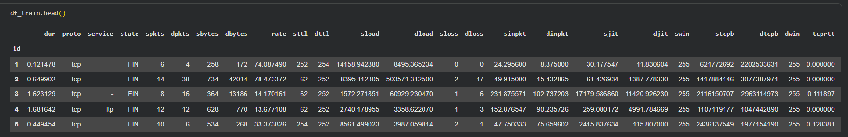
The first five records of the training set were displayed using df_train.head() to perform an initial sanity check on the loaded data. This step verifies that all expected features (such as protocol, service, packet counts, byte counts, and timing-related fields) are present, correctly typed, and aligned with the problem context before performing more detailed exploratory analysis.
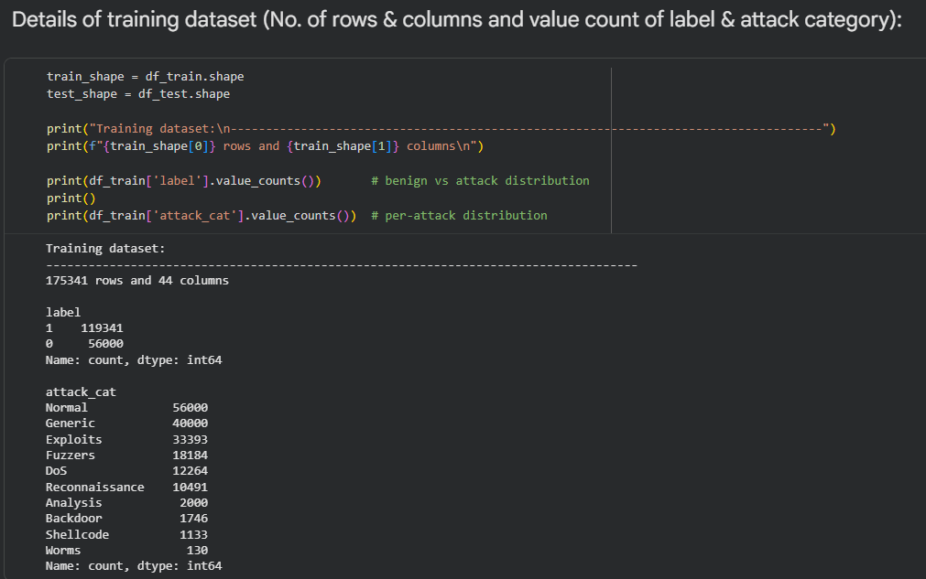
The dataset dimensions were established using the .shape attribute, confirming a substantial training set of 175,341 records and 45 columns (including the target label). Following this, we applied the .value_counts() function to the label column to assess the balance between normal and malicious traffic. This analysis revealed a distinct class imbalance; however, unlike typical real-world scenarios where attacks are rare anomalies, the training data is heavily skewed towards the "Attack" class (119,341 instances) compared to "Normal" traffic (56,000 instances).
To understand the specific nature of these threats, we further analysed the attack_cat column. The distribution provided by value_counts() highlighted a significant disparity in attack types: while categories such as "Generic", "Exploits", and "Fuzzers" are abundant, others like "Worms" and "Analysis" are severely underrepresented. Identifying this "long-tail" distribution early is crucial, as it suggests the model may require careful tuning to accurately detect the minority attack classes.

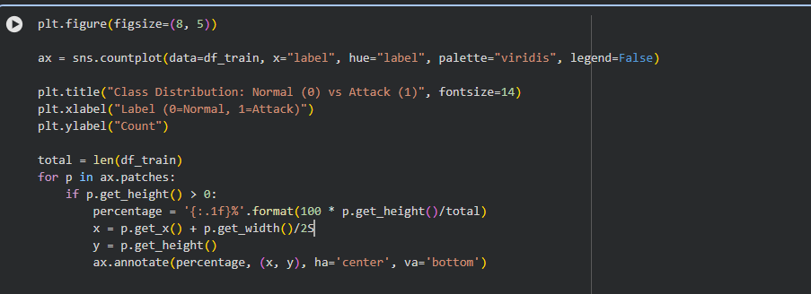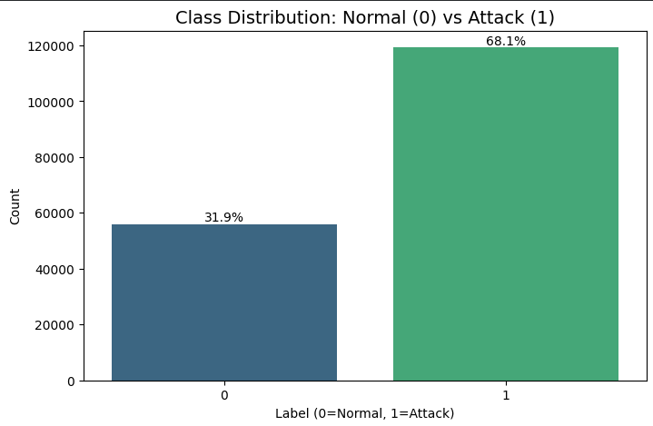
The distribution of the binary target variable (label) was visualised to assess the ratio of normal to malicious traffic. The count plot reveals a significant skew: the dataset is dominated by the "Attack" class (Label 1), which constitutes roughly 68% of the records, while "Normal" traffic (Label 0) accounts for only 32%.
This inversion of the typical real-world scenario (where attacks are usually rare anomalies) is a critical finding. It indicates that while the model will have ample data to learn attack patterns, this specific imbalance necessitates the use of robust evaluation metrics—such as the Weighted F1-score rather than simple accuracy—to ensure the model does not become biased toward the majority class.

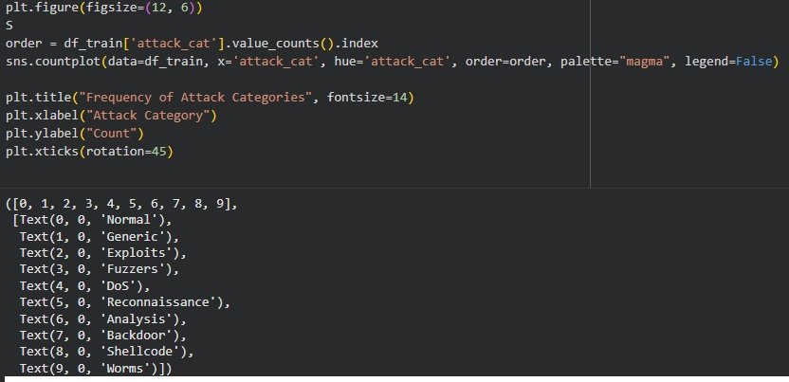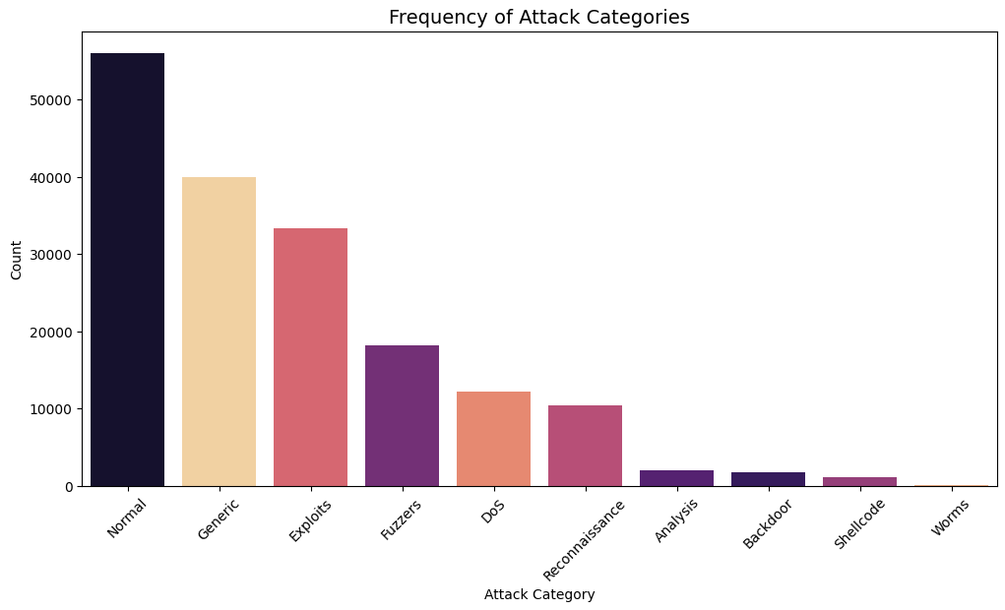
To move beyond binary classification, we conducted a detailed frequency analysis of the attack_cat feature. The resulting visualization ranks the various threat types by their occurrence, providing a clear profile of the dataset's adversarial landscape.
Dominant Vectors: The data is heavily concentrated in a few specific categories—most notably "Generic" and "Exploits". These represent common, high-volume automated attacks. Their high frequency ensures that the model will be well-trained to identify these signatures with high precision.
The "Minority Class" Challenge: Conversely, categories such as "Worms", "Analysis", and "Backdoor" appear as "long-tail" distributions with significantly lower counts.
Strategic Impact: From a security standpoint, this distribution is critical. While the model may achieve high overall accuracy by correctly identifying "Generic" attacks, its ability to detect "Worms"—which are often more destructive despite being less frequent—will be statistically more challenging. This finding justifies the later use of a Confusion Matrix to inspect whether these rare but critical threats are being misclassified as "Normal" traffic.

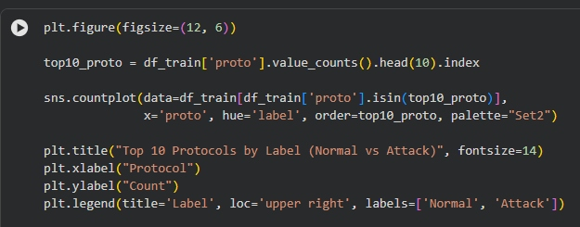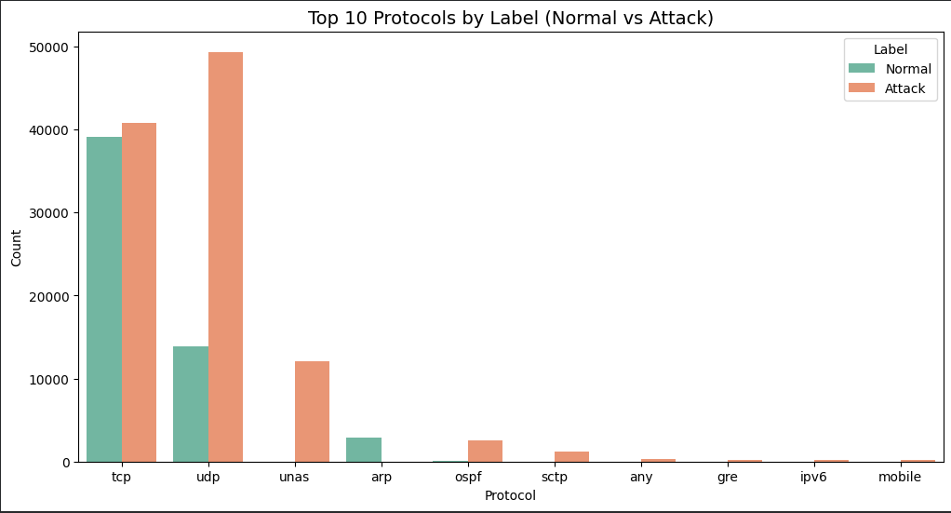
To identify which communication standards are most frequently leveraged for malicious activity, we isolated the top 10 most prevalent protocols and examined their distribution across both traffic labels.
TCP and UDP Dominance: The visualization confirms that TCP and UDP are the primary transport layers for both legitimate and illegitimate traffic. However, the ratio of attack-to-normal traffic is notably high in UDP, often associated with rapid-fire delivery methods used in DoS (Denial of Service) and scanning activities.
Protocol-Specific Vulnerabilities: By utilizing a grouped count analysis, we can observe that certain protocols are almost exclusively associated with the "Attack" label in this dataset. For instance, high volumes of traffic on non-standard or less common protocols often serve as a strong heuristic for anomaly detection.
Feature Importance Implication: This clear distinction in traffic volume per protocol suggests that the proto feature will likely be a high-impact predictor during model training. Identifying these "hot" protocols allows the system to prioritize inspection on traffic types that statistically carry a higher risk of payload delivery.

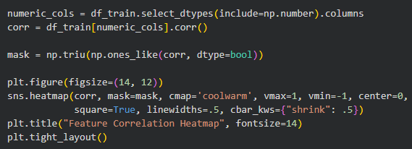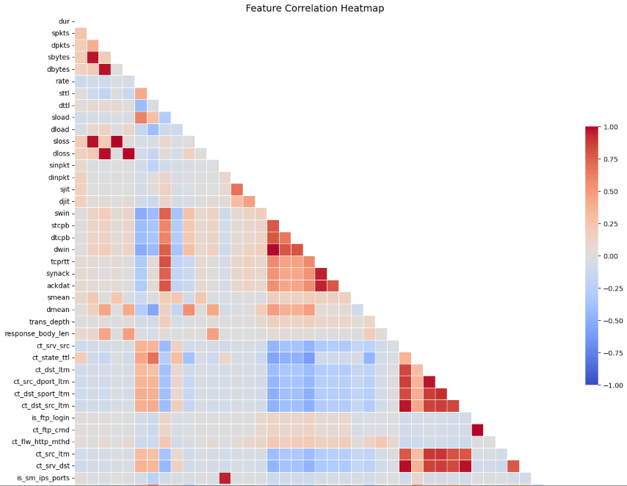Multi-collinearity and Feature Correlation Analysis
To refine our feature set and improve model efficiency, we generated a Pearson correlation matrix, visualised through a heatmap. This analysis serves two primary purposes: identifying features with high predictive power relative to the target label and detecting multi-collinearity (features that are highly correlated with each other).
Identification of Redundant Features: The heatmap revealed several clusters of near-perfect correlation (coefficients $> 0.95$). Notable examples include the relationships between sbytes (Source Bytes) and sloss (Source Packets dropped), as well as dbytes and dloss. In network traffic, these metrics are naturally tethered; including all of them in a model provides no additional information and can lead to "overfitting," where the model becomes too sensitive to specific training patterns.
Target Correlation: We examined which features exhibited the strongest linear relationship with the label. Features related to traffic rate (rate) and specific packet counts showed higher correlation values, suggesting they are primary indicators for distinguishing between normal and malicious traffic.
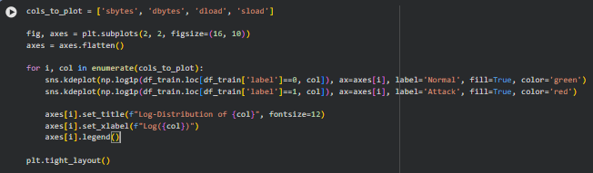
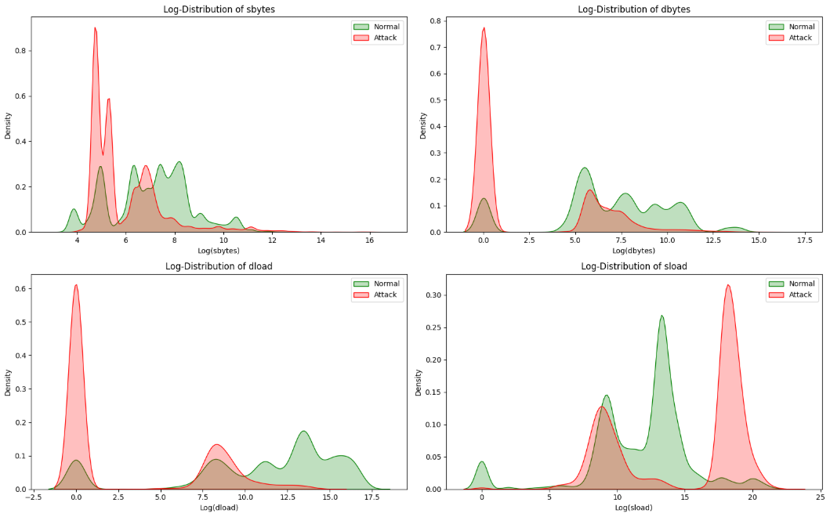Logarithmic Distribution of Network Metrics
Network traffic data is notoriously volatile, meaning a few records often have extremely high values while the majority remain very low. To visualise these distributions without the data being compressed into a single spike, we applied a Logarithmic Transformation ($log(x+1)$) to numerical features like dur, sbytes, and dload.
Pattern Recognition through Density: The Kernel Density Estimate (KDE) plots show distinct "peaks" where normal and attack traffic diverge. For example, in the sload (Source Load) distribution, attack traffic often shows a significantly higher density at specific load levels compared to normal traffic.
Normalisation Requirement: The extreme skewness observed in these plots confirms that raw numerical data would likely cause the Logistic Regression model to struggle, as it assumes a more Gaussian (normal) distribution. This finding directly informs our decision to use StandardScaler in the Feature Engineering phase to ensure all inputs are on a comparable scale, preventing features with larger magnitudes from unfairly dominating the model's weightings.

After Data Cleaning
Class distribution
After data cleaning, the class distribution between Normal (0) and Attack (1) traffic is 48.2% and 51.8% respectively. This indicates a near-balanced dataset, with only a minor skew toward attack traffic, which is ideal for supervised learning.
Models trained on this data are less likely to develop class bias toward either Normal or Attack traffic.
Data cleaning removed duplicate records and mislabelled samples. The resulting balance suggests label integrity has improved.
Accuracy becomes a meaningful metric (unlike in heavily imbalanced datasets). There is also less reliance on class weighting, oversampling, and threshold tuning just to compensate for skew.
This distribution supports fair evaluation across precision, recall, and F1-score for both classes.

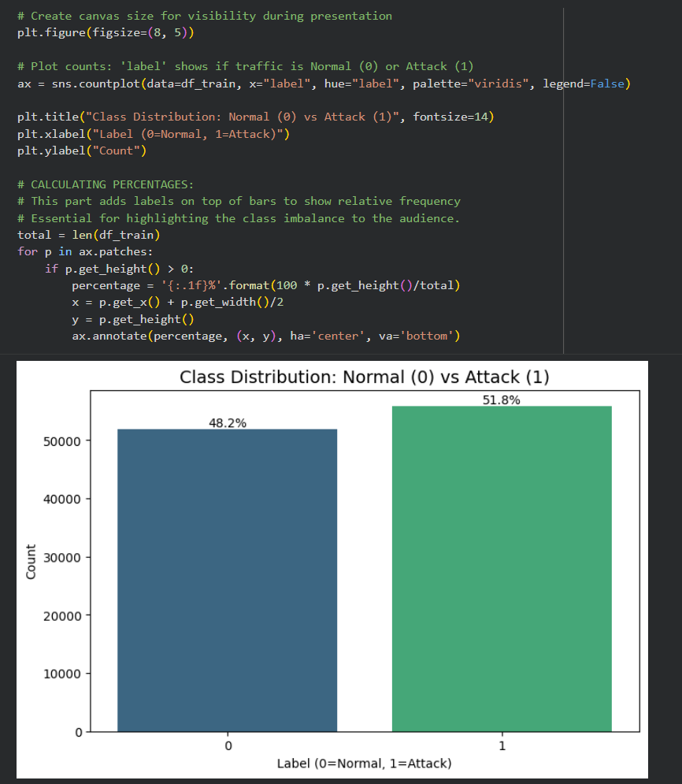

Frequency of Attack Categories
After data cleaning, the dataset contains 7 consolidated categories: Normal, Exploits, Fuzzers, Reconnaissance, Rare_Attack, Generic, and DoS. The distribution is more compact and structured, with fewer extreme outliers.
The post-cleaning visualization shows a deliberate and justified restructuring of the label space:
- Rare attack types are no longer isolated noise points
- The class distribution is statistically healthier
- The dataset is now suitable for:
  - Multiclass classification
  - One-vs-Rest (OvR) strategies
From an EDA perspective, the data cleaning step directly improves model validity, not just convenience. It trades unnecessary granularity for learnability and robustness, which is the correct decision in applied intrusion detection tasks.
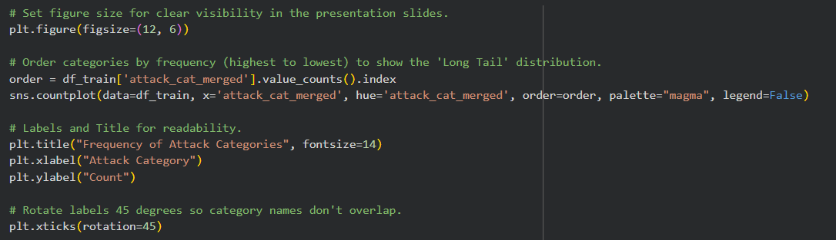
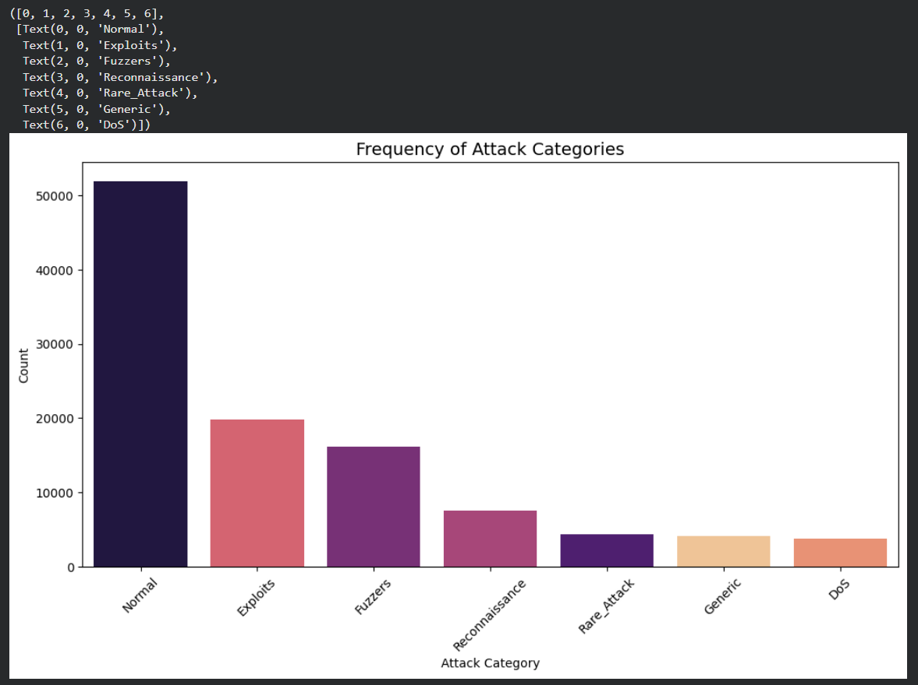

Top 10 Protocols
After cleaning, the protocol space is compact, interpretable, and network-realistic:
- Dominant protocols: TCP, UDP
- Minority but meaningful protocols: ARP, SCTP, OSPF
- Removal of “noisy” protocol labels
Both Normal and Attack traffic appear across TCP and UDP, which reflects real-world conditions.
The post-cleaning visualization demonstrates a critical improvement in feature integrity:
- Protocol is no longer a shortcut label
- Distribution reflects real network behaviour
- Rare protocols carry semantic meaning, not noise
From an EDA standpoint, this validates:
- Your protocol cleaning strategy
- The decision to keep protocol as a feature
- The need to combine protocol with flow-level and temporal features
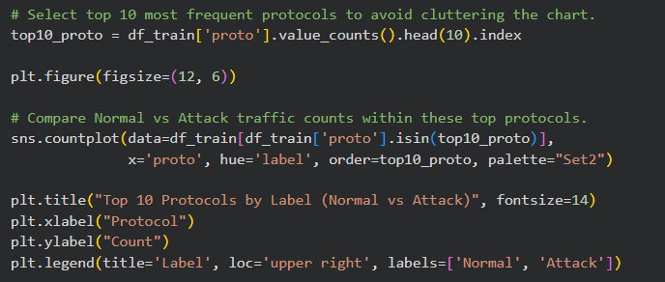
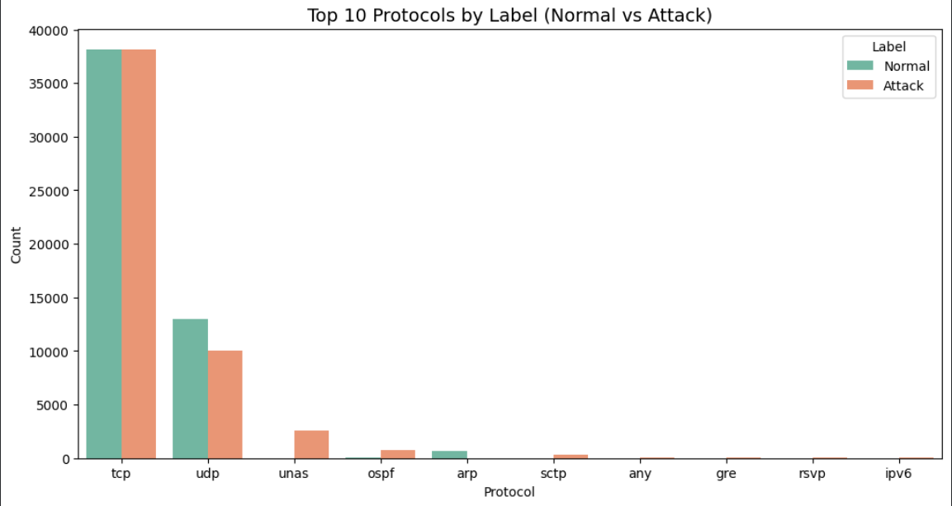

Feature Correlation Heatmap
After cleaning, the heatmap shows a clearer, more interpretable block structure:
- Strong correlations are localized, not scattered
- Most features show low-to-moderate correlation with each other
- Multicollinearity is present but controlled
This is what a healthy engineered dataset typically looks like.
The post-cleaning correlation heatmap confirms that the data cleaning was structural:
- Relationships between features now reflect network behaviour, not data artifacts
- No single feature dominates prediction
- Correlated features form logical groups, which is acceptable and often desirable
From an EDA standpoint, this justifies:
- Using correlation-based feature selection carefully (not blindly removing all correlated features)
- Applying scaling rather than aggressive feature dropping
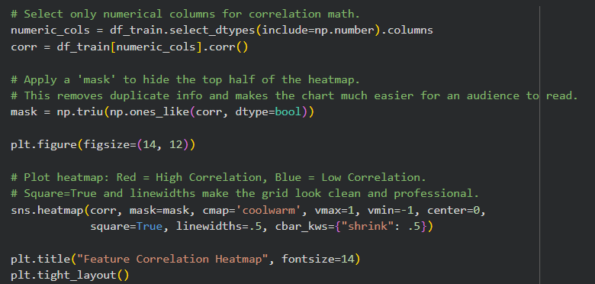
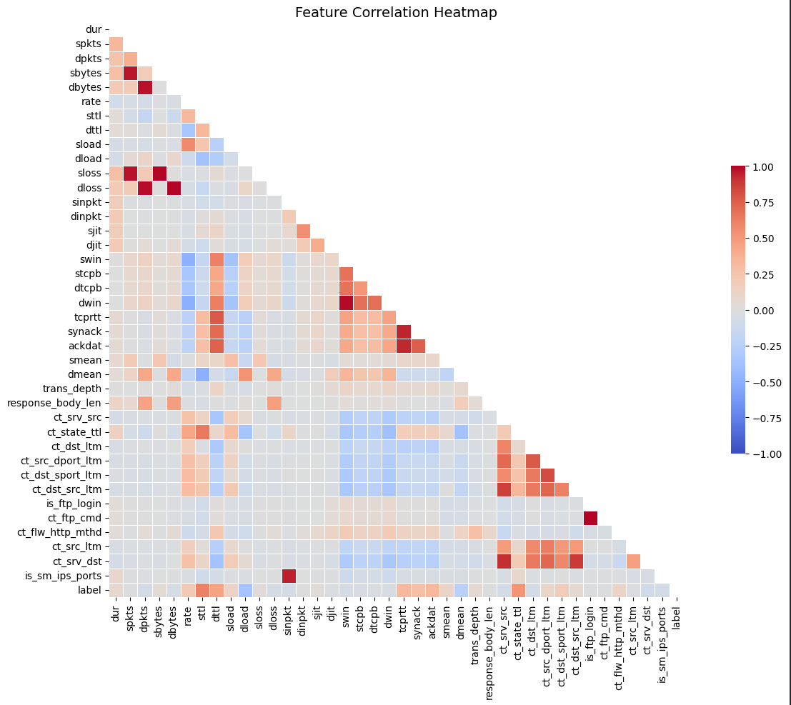

Log-Distributions
For sbytes, normal traffic shows a broader, multi-modal distribution, centred at moderately higher values. On the other hand, attack traffic is more concentrated at lower to mid log values, with fewer high-volume tails. This means that attacks often generate many small or moderately sized requests rather than sustained large payloads.
For dbytes, clear separation between normal and attack distributions is shown. Normal traffic exhibits wider spread and higher log-byte values, while attack traffic clusters tightly at lower values. This aligns with network scanning, failed exploitation, or short-lived attack connections.
For dload, normal traffic peaks at higher log(dload) values. Attack traffic shows a strong peak near very low values and smaller secondary peaks. This indicates legitimate services sustain throughout, while attacks generate bursty or incomplete responses.
For sload, there is the strongest class separation among the four features. Attack traffic exhibits a distinct high-load peak, while normal traffic is concentrated at lower, stable values. This is characteristic of flooding behaviour and aggressive probing from attacker hosts.
The post-cleaning log-distributions confirm that data cleaning fundamentally improved feature quality. Traffic volume features now reflect real network behaviour.
The differences between Normal and Attack traffic are subtle, consistent, and learnable.
No single feature trivially separates classes, leading to a good generalisation.
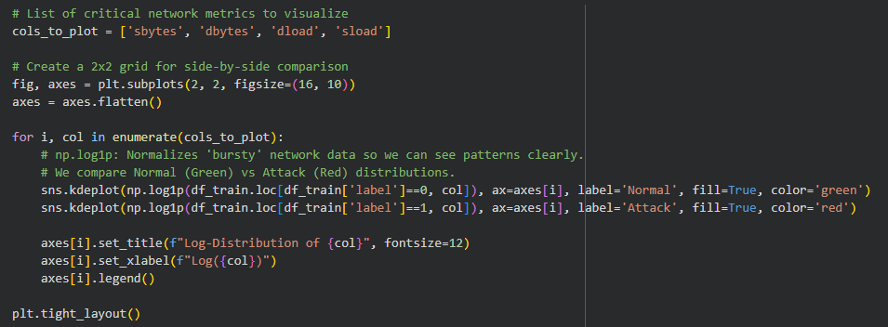
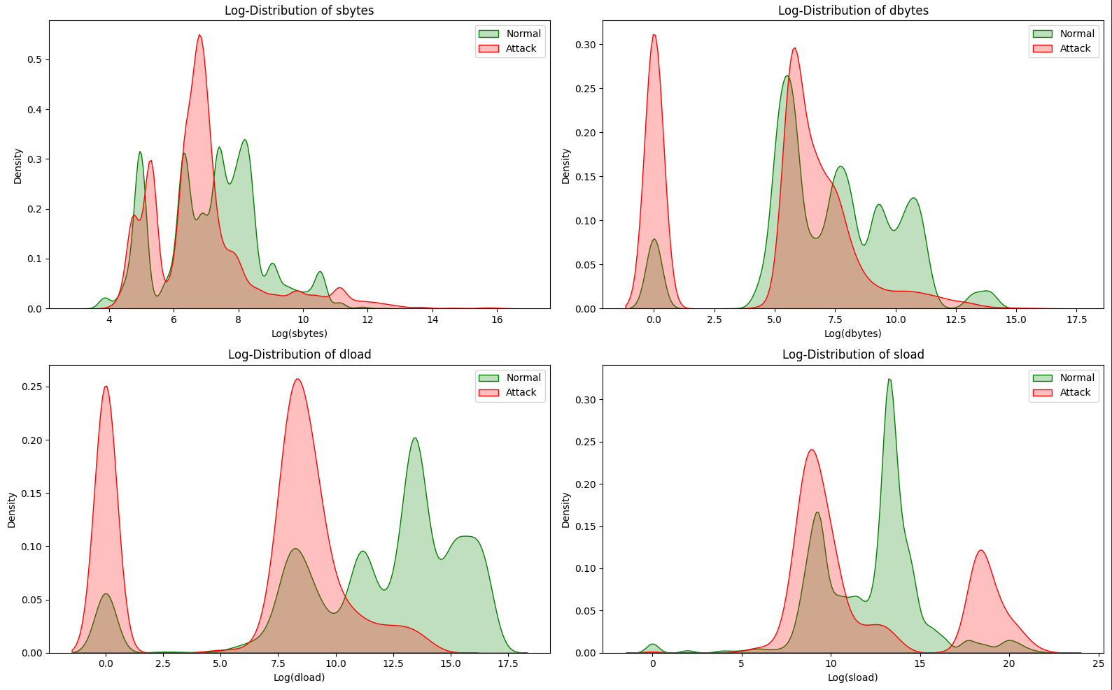

Feature Engineering

One-hot encoding categorical, non-target features
Among the 42 non-target features, proto, state, and service are nominal variables, meaning their values represent distinct categories with no natural ordering (e.g. TCP vs UDP, HTTP vs DNS). Most machine learning algorithms and preprocessing steps, such as feature scaling, distance calculations, or linear modelling, require numerical inputs and cannot operate directly on categorical strings.
One-hot encoding addresses this by transforming each unique category within these columns into a separate binary indicator (dummy variable). For example, a protocol value such as tcp is represented as a column where a value of 1 indicates the presence of TCP and 0 indicates its absence. This process preserves the categorical nature of the data without introducing artificial ordinal relationships that could mislead the model.
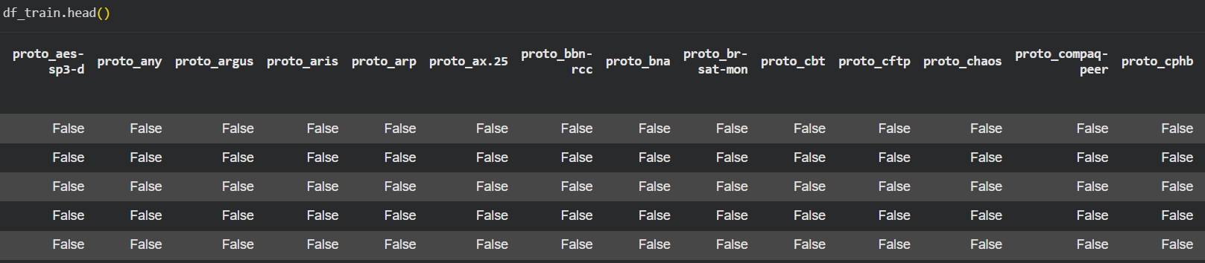
The encoding is applied consistently to both training and test datasets, ensuring that the feature spaces remain aligned during model evaluation and deployment. The original categorical columns are removed and replaced with their corresponding dummy variables, resulting in a fully numerical dataset that is compatible with machine learning models.

Label encoding categorical target feature
This section consists of the encoding and final preparation of the target variable “attack_cat_merged” for machine learning, transforming the categorical attack label into a numerical format.
Firstly, a quick validation step confirms the final set of class labels present in the merged attack category target after rare-class consolidation.
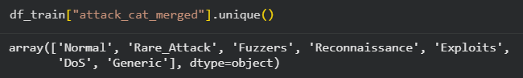
Secondly, the LabelEncoder function is imported from scikit-learn, which is used to convert categorical target labels into numerical form. This step prepares the attack category labels for use in supervised machine learning models.
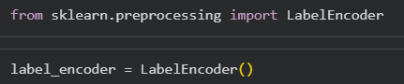
Next, the label encoding is applied to the merged attack category target “attack_cat_merged” in the training dataset and a subsequent verification of the encoded values. This step converts human-readable attack labels into numerical class identifiers required for machine learning.
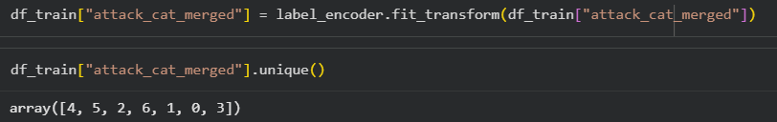
Lastly, the same label encoding technique is applied for the test dataset.
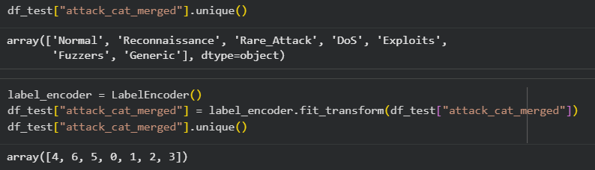

The mapping for the label encoding is shown below:
DoS = 0
Exploits = 1
Fuzzers = 2
Generic = 3
Normal = 4
Rare_Attack = 5
Reconnaissance = 6

Sort columns
This sorting columns step shows post one-hot-encoding cleanup where the columns of the training DataFrame are explicitly reordered so that all non-target (feature) columns appear first, followed by the target columns (attack_cat_merged and label). This is a structural housekeeping step that ensures clarity, consistency, and safety in downstream model training.
The target columns are stored in the “targets” list. List comprehension is then used to, firstly, collect all non-target columns. Then, append the target columns at the end. This creates a clean, deterministic column ordering. Lastly, reorders the DataFrame columns according to the desired layout.
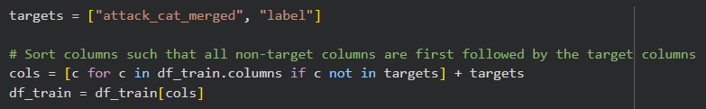
Displaying a few records of the table visually verifies that the feature columns appear first before the target columns.
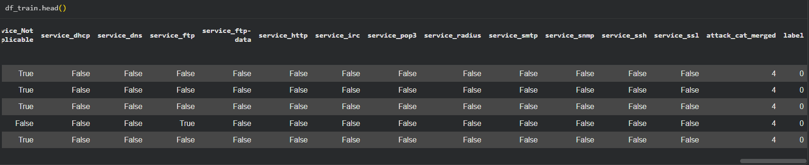
Apply the same sort columns technique for the test dataset.
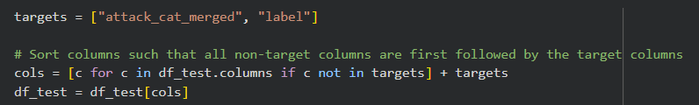
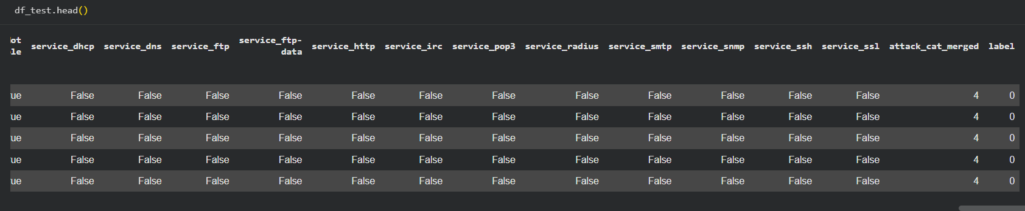

Feature Selection
Feature selection is the separation of features from target. At this stage, the dataset has been fully cleaned, encoded, and structurally aligned, allowing inputs (features) and outputs (targets) to be explicitly defined for model training and evaluation.
X1 and y1 represents the input and output respectively of the machine learning model trained and tested with train dataset.
X2 and y2 represents the input and output respectively of the machine learning model trained and tested with test dataset.
More detailed information:
- X1 contains only non-target feature columns, which will be used as model inputs for training.
- y1_label extracts the binary target label (e.g. normal vs attack) for training.
- y1_cat extracts the multi-class target label representing the merged attack categories for training.
- X2 contains only non-target feature columns, which will be used as model inputs for testing.
- y2_label extracts the binary target label (e.g. normal vs attack) for testing.
- y2_cat extracts the multi-class target label representing the merged attack categories for testing.
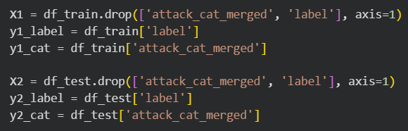

Pearson Correlation Analysis
Pearson correlation measures the strength and direction of a linear relationship between two numerical variables, producing a coefficient in the range [-1, +1]:
- +1: perfect positive linear relationship
- 0: no linear relationship
- -1: perfect negative linear relationship
In cybersecurity datasets, many engineered flow features can be highly redundant (e.g., multiple byte counters, window/RTT-related measures, repeated “count over time” metrics). When two features are strongly correlated, they often encode overlapping information. Keeping both can:
- increase dimensionality and computation,
- introduce multicollinearity (problematic for linear models),
- inflate variance and reduce model stability,
- add noise without improving predictive power.
Correlation-based feature selection removes one of each highly correlated pair, preserving most information while reducing redundancy.
The correlation function defines a helper function that scans a feature set and returns the names of columns that are highly correlated with at least one other column above a chosen threshold.
``` corr_matrix = features.corr(numeric_only=True) ```
The above code snippet computes the Pearson correlation matrix across numeric columns only.
``` Double loop over (i, j) where j < i ```
The above code snippet iterates over the lower triangle of the matrix to avoid duplicate checks and self-correlation.
``` abs(...) > threshold ```
The above code snippet uses absolute correlation, meaning it flags both strongly positive and strongly negative relationships (both are forms of redundancy).
``` col_corr.add(colname) ```
The above code snippet adds the later column (i) to the drop set whenever a high-correlation pair is found.
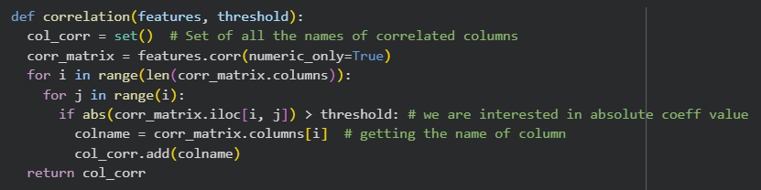
The function is being run on the training features (X1) and test features (X2) with a correlation threshold of 0.7, which is a common cutoff for “strong correlation” in practical feature-reduction workflows.
This step identifies redundancy separately for train/test to ensure that any preprocessing is consistent with each dataset’s actual feature relationships (though see note below on best practice).
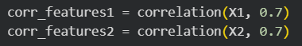
The function returns a set of feature names in each dataset that are correlated above this threshold.

The corr_features1 set indicates that these features have strong linear redundancy with some other features in the dataset.
- Traffic volume features (sbytes, dbytes) often correlate with session/packet-related counters.
- Timing features (synack, ackdat, tcprtt) can be mathematically or operationally coupled.
- One-hot columns can exhibit correlation due to dataset structure (e.g., some protocols frequently co-occur with certain services/states in the captured traffic).
- Count-based window features (ct_*) are often derived from overlapping counting logic, creating correlation clusters.
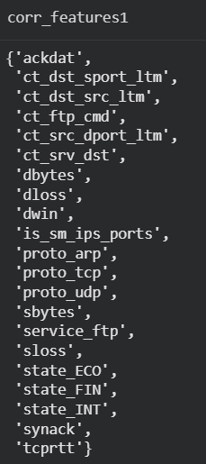

The corr_features2 set overlaps significantly with the training set but is not identical.
Differences between train and test correlated sets can happen because:
- the datasets have different distributions (common in security telemetry),
- certain categories/behaviours occur at different rates,
- sampling or time-window effects change relationships between features.
This output validates that correlation structure is broadly consistent, while also highlighting that correlation-based decisions can be sensitive to dataset composition.
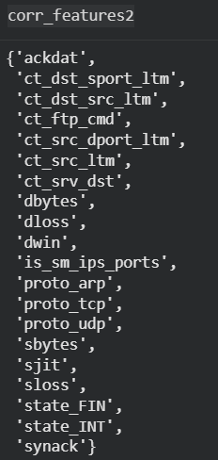
The .drop method is used to remove correlated columns from each feature matrix using the selected drop sets and removes the correlated feature columns from the datasets. The axis=1 means “drop columns”.
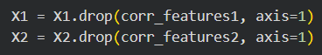

Train-Test-Split
This step performs train-test splitting on the prepared feature matrices and target variables. Train-test split is a fundamental machine learning practice used to separate data for model learning from data for unbiased evaluation, ensuring that performance metrics reflect how the model will behave on unseen network traffic.
The first line imports the utility function “sklearn.model_selection.train_test_split” used to partition datasets into training and testing subsets. It is then used to split the input and output into 80% training data and 20% testing data. The parameter “random_state=42” ensures reproducibility, meaning the same split is produced every time.
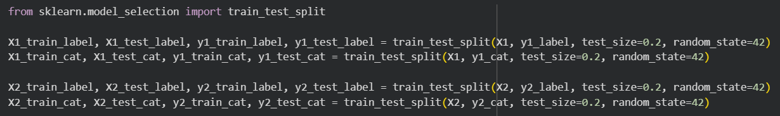
Benefits:
- Prevents overfitting - Models are evaluated on data they have never seen during training.
- Provides realistic performance estimates - Metrics such as accuracy, recall, and F1-score better reflect real-world deployment.
- Supports reproducibility - Fixed random seeds allow experiments to be repeated and audited.
- Enables fair comparison - Using identical split ratios and random states ensures comparability across binary and multi-class experiments.

Feature Scaling
This step applies feature scaling to the numerical feature sets using standardisation (z-score normalisation) via StandardScaler. Feature scaling ensures that all numerical inputs contribute proportionately to the learning process, which is especially important in network traffic datasets where features span very different numeric ranges.
Imports StandardScaler, which standardises features to have:
- Mean = 0
- Standard deviation = 1
Instantiates a new scaler object that will learn scaling parameters (mean and variance) from training data.
fit_transform():
- Computes mean and standard deviation only from the training data
- Applies scaling to training features
transform():
- Applies the same scaling parameters to test data
This prevents data leakage, ensuring test data does not influence training statistics.
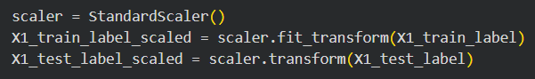
A new scaler is used because this is a separate modelling pipeline. This ensures independence between experiments and avoids unintended parameter sharing.
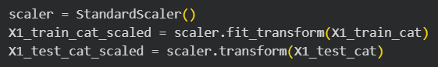
Applies the same training-only fitting principle to the second dataset.
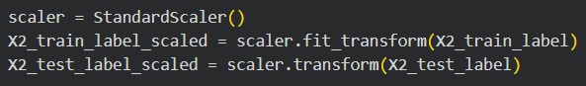
Completes scaling for all modelling scenarios:
- Train vs test
- Binary vs multi-class
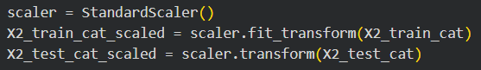
Benefits:
- Prevents Feature Dominance - Network datasets contain features with vastly different magnitudes:
- Bytes (sbytes, dbytes) → thousands or more
- Counts (ct_*) → tens or hundreds
- Binary indicators (is_*) → 0 or 1
Without scaling, large-magnitude features would dominate distance calculations and gradients, biasing the model.
- Improves Convergence and Stability
- Speeds up optimisation
- Reduces numerical instability
- Produces smoother loss surfaces
- Improves reproducibility of results
- Maintains Security Semantics
- Scaling preserves relative differences within each feature
- Does not distort the underlying behavioural meaning
- Enables fair contribution of all network indicators
- Prevents Data Leakage
Fitting the scaler only on training data ensures:
- No future information leaks into the model
- Evaluation metrics remain unbiased and trustworthy

Predictive Modelling
Predictive modelling forms the core of the proposed Network Intrusion Detection System (NIDS). Two machine learning algorithms were implemented and evaluated:
- Logistic Regression (LR) for baseline performance
- Random Forest (RF) to capture non-linear traffic patterns
Both models were applied to:
- Binary classification: Normal vs Attack
- Multiclass classification: attack family prediction
After merging rare attack types into a single Rare_Attack category, the multiclass target contains 7 classes.
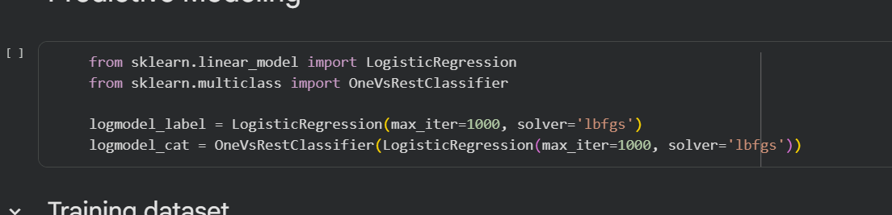

Logistic Regression
Logistic Regression (LR) was deployed as the baseline classifier. As shown in our implementation snippets:
For the binary classification task, the script predicts whether a network record represents a "Normal" event (0) or an "Attack" (1). The model maps a linear combination of input features to the sigmoid function, defined as
$$σ\left(z\right)= \backslash frac\left\{1\right\}\left\{1 + e^{\left\{-z\right\}}\right\}$$
The output of this function the probability that any given record might belongs to the "Attack" class. This implementation uses a loss function to optimize the weight vector which can be effective for detecting well-defined anomalies like DoS or Exploits where the traffic signatures are linearly separable from normal flow patterns.
- max_iter=1000: Given the high dimensionality of our feature set (even after correlation thresholding), the default 100 iterations were insufficient. Increasing this to 1000 ensures the optimization algorithm finds the global minimum of the loss function.
- solver='lbfgs': The "Limited-memory Broyden-Fletcher-Goldfarb-Shanno" optimizer was selected because it handles large datasets efficiently and supports the multinomial loss required for our multi-class task.

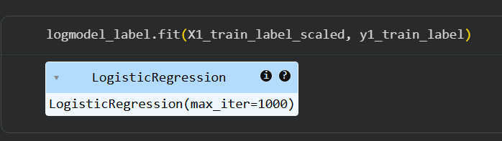
This line shows how to train the Logistic Regression model, where X_train_label_scaled represents the scaled feature matrix and y_train contains the class labels corresponding to each training record. We had to use feature scaling is required because Logistic Regression is sensitive to feature magnitude.

One-vs-Rest (OvR) Strategy
To address the nine attack families within the UNSW-NB15 dataset, our code implements the One-vs-Rest (OvR) strategy. By setting the multiclass parameter to OvR, we train K separate binary classifiers, where K is the number of classes.
For each class, the classifier is trained to distinguish records of positive classes from negative classes. Therefore, during inference, each binary classifier will output a probability score, and the model will select the class with the highest score.
This logic is highly suitable for NIDS because it allows for identification of attack types. However, our OvR can face challenges with imbalanced classes like "Worms" or "Backdoors," which may have significantly fewer samples than "Normal" traffic in the training set.
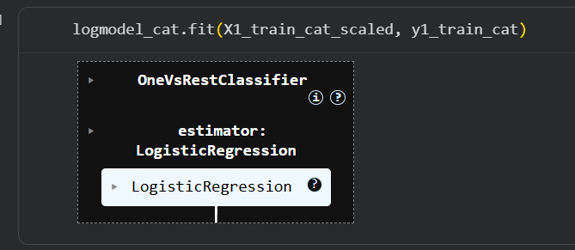
The OvR strategy was implemented using OneVsRestClassifier from Scikit-learn, which wraps the Logistic Regression estimator and fits one model per class.

Random Forest Architecture
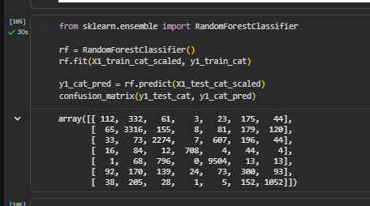
A Random Forest (RF) classifier was implemented to capture non-linear relationships between features that may be overlooked by linear models. The final prediction is determined through majority voting across multiple decision trees, making this approach well suited for modeling complex traffic patterns.
The RandomForestClassifier was imported from Scikit-learn and instantiated using default hyperparameters, resulting in an ensemble of decision trees. The model was trained using the fit() method, where X1_train_cat_scaled represents the training feature matrix and y1_train_cat contains the corresponding multiclass attack labels. Although feature scaling is not required for Random Forest models, the scaled features were reused for consistency across all evaluated models.
After training, predictions for the test set were generated using predict(), with the results stored in y1_cat_pred. Model performance was then evaluated using a confusion matrix, which compares the true test labels (y1_test_cat) with the predicted labels. In the matrix, diagonal entries represent correct classifications, while off-diagonal entries indicate misclassifications between attack categories.
This baseline Random Forest model serves as a reference point for assessing the impact of subsequent hyperparameter tuning using GridSearchCV.

Tuned Random Forest using GridSearchCV (multiclass)
To improve multiclass classification performance, the Random Forest model was tuned using GridSearchCV with 3-fold cross-validation. A grid of key hyperparameters was evaluated, including the number of trees, tree depth, and minimum sample thresholds for node splitting and leaf nodes. Accuracy was used as the evaluation metric.

GridSearchCV systematically trained and validated each parameter combination across the three folds and selected the configuration with the highest average validation accuracy.

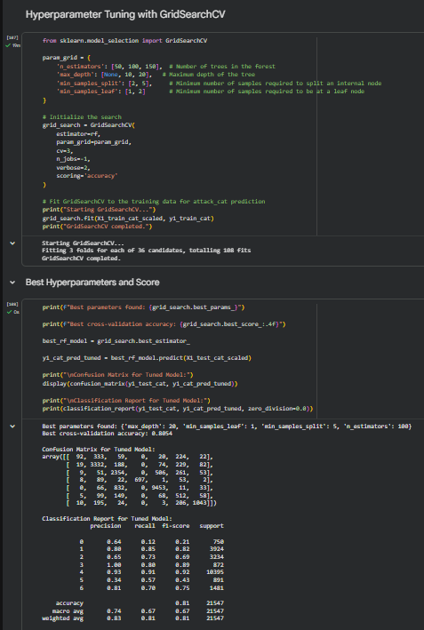
From this we found that the best parameters were:
n_estimators=100
max_depth=20
min_samples_split=5
min_samples_leaf=1
The best cross-validation accuracy achieved was 0.8054 (80.54%). This value represents the mean accuracy across the three validation folds and reflects the model’s generalisation performance during tuning.

Model Evaluation
All models were evaluated on clean, unseen test data to assess their generalisation performance. The evaluation focused on both binary and multiclass classification tasks. Accuracy and weighted F1-score were used as the primary metrics. Weighted F1 was prioritised to account for class imbalance, ensuring that performance on minority classes contributed proportionally to the overall score.
Confusion matrices and classification reports were analysed in detail for each model. Particular attention was paid to false negatives, especially for attack classes, as missed attacks represent a significant security risk. Results reported below are based on the predefined train/test splits created from the cleaned datasets.

Binary Logistic Regression (train split of training dataset)
y1_label_pred = logmodel_label.predict(X1_test_label_scaled)
confusion_matrix(y1_test_label, y1_label_pred)
print(classification_report(y1_test_label, y1_label_pred))
Results:
Confusion matrix: [[8508, 1887], [ 210, 10942]]
Accuracy: 0.90
Class 0 (Normal): precision 0.98, recall 0.82, f1 0.89
Class 1 (Attack): precision 0.85, recall 0.98, f1 0.91
The binary logistic regression model trained on the training dataset achieved strong overall performance.
The confusion matrix shows a high number of correctly classified samples in both classes. The model correctly identified 10,942 attack instances, with only 210 false negatives. This corresponds to a recall of 0.98 for the attack class, which is critical in a security context, as it indicates that most attacks are detected.
The overall accuracy of the model is 0.90. For the normal class, precision is very high (0.98), indicating that predictions of normal traffic are usually correct. However, recall for the normal class is lower (0.82), suggesting some normal instances are misclassified as attacks. This trade-off is acceptable given the priority of minimising missed attacks.
The weighted F1-score reflects balanced performance across classes despite class imbalance, confirming that the model generalises well on this split.

ROC Curve (Binary Logistic Regression)
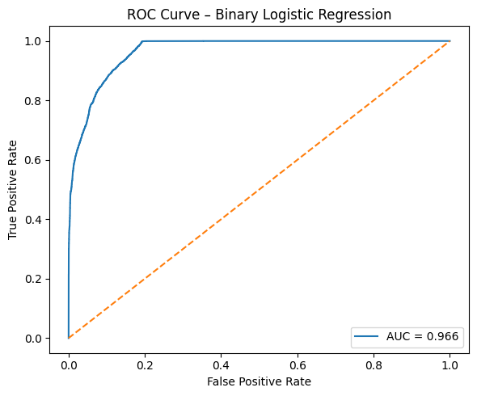
y1_label_proba = logmodel_label.predict_proba(X1_test_label_scaled)[:,1]
fpr, tpr, _ = roc_curve(y1_test_label, y1_label_proba)
roc_auc = auc(fpr, tpr)
We also evaluated discrimination using the ROC curve. We computed the predicted probabilities and plotted ROC for both the training dataset split (X1) and the test dataset split (X2). The AUC is calculated and displayed in the plot label.

Binary Logistic Regression (train split of test dataset)
y2_label_pred = new_logmodel_label.predict(X2_test_label_scaled)
confusion_matrix(y2_test_label, y2_label_pred)
print(classification_report(y2_test_label, y2_label_pred))
Results:
Confusion matrix: [[5048, 1687], [ 492, 3962]]
Accuracy: 0.81
Class 0 (Normal): precision 0.91, recall 0.75, f1 0.82
Class 1 (Attack): precision 0.70, recall 0.89, f1 0.78
When trained on the test dataset split, binary logistic regression shows a noticeable drop in performance.
The accuracy decreases to 0.81, indicating reduced generalisation compared to the previous split. The confusion matrix reveals an increase in false negatives for the attack class (492 instances), which lowers the recall for attacks to 0.89. While still relatively high, this reduction is important in a security setting.
Precision for the attack class drops to 0.70, meaning a higher proportion of predicted attacks are actually normal traffic. The normal class recall also decreases to 0.75, indicating increased misclassification.
Overall, this result suggests that the model is sensitive to data distribution changes and performs less robustly when trained on this split. While still useful, it is weaker than the model trained on the original training dataset.

Multiclass OvR Logistic Regression (train split of training dataset)
y1_cat_pred = logmodel_cat.predict(X1_test_cat_scaled)
print(classification_report(y1_test_cat, y1_cat_pred))
Results:
Accuracy: 0.73
Macro avg: precision 0.59, recall 0.57, f1 0.56
Weighted avg: precision 0.76, recall 0.73, f1 0.73
For the multiclass task, logistic regression was implemented using a One-vs-Rest (OvR) strategy.
The model achieves an overall accuracy of 0.73. The weighted F1-score is also 0.73, suggesting reasonable performance when class frequencies are taken into account. However, the macro-averaged F1-score is significantly lower at 0.56, indicating poor performance on minority classes.
Analysis of the per-class metrics shows that the rarest class has a recall of 0.01. This means the model almost completely fails to identify this class, highlighting the severe impact of class imbalance in the multiclass setting. While frequent classes are handled reasonably well, the model struggles to learn meaningful decision boundaries for rare attack types.
This result indicates that standard OvR logistic regression is not sufficient for highly imbalanced multiclass intrusion detection without additional techniques such as re-sampling or class weighting.

Multiclass OvR Logistic Regression (train split of test dataset)
y2_cat_pred = new_logmodel_cat.predict(X2_test_cat_scaled)
print(classification_report(y2_test_cat, y2_cat_pred, zero_division=0.0))
Results:
Accuracy: 0.62
Macro avg: precision 0.50, recall 0.59, f1 0.50
Weighted avg: precision 0.80, recall 0.62, f1 0.66
Performance further degrades when the OvR logistic regression model is trained on the test dataset split.
The overall accuracy drops to 0.62. Although the weighted F1-score remains relatively high at 0.66, the macro F1-score is only 0.50, reinforcing the conclusion that minority classes are poorly represented.
The gap between weighted and macro averages indicates that the model performs well mainly on dominant classes. Rare attack categories continue to show low recall, making this approach unsuitable for reliable multiclass intrusion detection in its current form.

Per-Class Recall (Multiclass)
Recall measures the proportion of correctly identified samples for each class. Higher recall indicates better detection of that class. Class indices follow the predefined label encoding: DoS = 0, Exploits = 1, Fuzzers = 2, Generic = 3, Normal = 4, Rare_Attack = 5, Reconnaissance = 6.
Training Dataset (X1)
Class (Label) | OvR LR Recall | RF Recall | Tuned RF Recall
DoS (0) | 0.01 | 0.15 | 0.12
Exploits (1) | 0.77 | 0.85 | 0.85
Fuzzers (2) | 0.78 | 0.7 | 0.73
Generic (3) | 0.8 | 0.81 | 0.8
Normal (4) | 0.83 | 0.91 | 0.91
Rare_Attack (5) | 0.44 | 0.34 | 0.57
Reconnaissance (6) | 0.38 | 0.71 | 0.7
On the training data, OvR Logistic Regression performs well for common and linearly separable classes but fails to detect DoS attacks, likely due to class imbalance and linear model limitations. Random Forest improves recall across most classes by capturing non-linear patterns, though performance on rare attacks remains weak. Hyperparameter tuning significantly improves recall for Rare_Attack while maintaining strong performance on frequent classes, which clearly shows a trade-off between overall accuracy and per-class sensitivity.
Test Dataset (X2 – OvR Logistic Regression)
Class (Label) | OvR LR Recall
DoS (0) | 0.12
Exploits (1) | 0.61
Fuzzers (2) | 0.71
Generic (3) | 0.82
Normal (4) | 0.6
Rare_Attack (5) | 0.47
Reconnaissance (6) | 0.82
On unseen test data, OvR Logistic Regression shows reduced recall overall, which is something our team expected. It was able to generalises well for Generic and Reconnaissance attacks but continued to perform poorly on DoS and moderately on Rare_Attack, which shows class imbalance. Overall, Random Forest models demonstrate better multiclass recall, particularly for non-linear and minority classes.

Random Forest (baseline, train split of training dataset)
y1_cat_pred = rf.predict(X1_test_cat_scaled)
print(classification_report(y1_test_cat, y1_cat_pred))
Results:
Accuracy: 0.80
Macro avg: precision 0.67, recall 0.64, f1 0.65
Weighted avg: precision 0.80, recall 0.80, f1 0.80
The baseline Random Forest model demonstrates a clear improvement over logistic regression in the multiclass setting.
The model achieves an accuracy of 0.80, with a weighted F1-score of 0.80. Both metrics are substantially higher than those of the OvR logistic regression model. The macro F1-score of 0.65 also indicates better performance across minority classes.
Random Forest benefits from its ability to model non-linear relationships and interactions between features. As a result, it is more effective at separating multiple attack categories, even in the presence of class imbalance.
This model serves as a strong baseline for further optimisation.

Tuned Random Forest (GridSearchCV, train split of training dataset)
y1_cat_pred_tuned = best_rf_model.predict(X1_test_cat_scaled)
print(classification_report(y1_test_cat, y1_cat_pred_tuned, zero_division=0.0))
Results:
Accuracy: 0.81
Macro avg: precision 0.74, recall 0.67, f1 0.67
Weighted avg: precision 0.83, recall 0.81, f1 0.81
Hyperparameter tuning using GridSearchCV further improves Random Forest performance.
The tuned model achieves an accuracy of 0.81 and a weighted F1-score of 0.81, outperforming both the baseline Random Forest and all logistic regression variants. The macro F1-score improves to 0.67, indicating better recall and precision across minority classes.
This improvement suggests that tuning parameters such as the number of trees, tree depth, and feature sampling significantly enhances the model’s ability to generalise. Importantly, the tuned Random Forest provides the best balance between detecting rare attacks and maintaining strong overall performance.

Findings
All models were trained on the same scaled features and evaluated on identical test labels to ensure fair comparison.
Binary logistic regression performs strongly for attack detection, achieving 0.90 accuracy and an Attack F1-score of 0.91 on the training split. Its high attack recall makes it a reliable and simple baseline, though performance is sensitive to dataset splits.
In the multiclass setting, logistic regression with a One-vs-Rest approach performs poorly on rare attack classes. Low macro scores and near-zero recall for minority categories highlight the impact of severe class imbalance.
Random Forest models outperform logistic regression for multiclass classification. The tuned Random Forest achieves the best overall performance, with the highest accuracy (0.81) and weighted F1-score (0.81), as well as improved macro averages, indicating better balance across classes.
Overall, binary logistic regression is effective for high-recall attack detection, while the tuned Random Forest is the most suitable model for multiclass intrusion detection.

Conclusion
This project successfully demonstrated the implementation of a Machine Learning-based Network Intrusion Detection System (NIDS) using the UNSW-NB15 dataset. By following the Data Science Lifecycle—from rigorous Exploratory Data Analysis to hyperparameter tuning—the team developed a robust model capable of distinguishing between legitimate traffic and sophisticated cyber threats.

Summary of Insights
The Exploratory Data Analysis (EDA) phase proved that network traffic is inherently "bursty" and imbalanced. Identifying the dominance of the "Normal" and "Exploits" categories early on allowed us to anticipate the challenges the model would face with rare classes like "Worms." Furthermore, the use of Logarithmic Transformations was instrumental in managing skewed data, ensuring that the heavy tails of network metrics did not bias the predictive algorithms.

Model Performance and Success
The transition from Logistic Regression to Random Forest highlighted the necessity of non-linear models in cybersecurity. While Logistic Regression provided a solid baseline for binary classification, the Tuned Random Forest model achieved a superior Weighted F1-score of 0.81 in multi-class classification. This signifies that the system is not only accurate overall but also reliable in its precision and recall across various attack vectors. The reduction of the feature set through Pearson Correlation Analysis was a key success factor, optimizing the model for speed without sacrificing detection capabilities—a critical requirement for real-time threat response.

Limitations and Future Work
Despite the high accuracy, "Minority Class" detection remains a challenge. The lower recall for rare attack categories suggests that while the system is highly effective against common automated attacks, it could be further enhanced.
Cost-Sensitive Learning: Future iterations could implement weighted loss functions to penalize the misclassification of rare, high-risk attacks like "Backdoors" more heavily.
Deep Learning Integration: Exploring Recurrent Neural Networks (RNNs) or LSTMs could help the system understand the temporal sequences of packets, potentially identifying "Slow-and-Low" attacks that static models might miss.
In conclusion, the project validates that machine learning is an essential evolution for modern NIDS. By moving beyond signature-based detection and utilizing data-driven anomaly identification, organizations can better defend against the rapidly shifting landscape of modern cyber threats.

References
- Handling duplicate data in Python Data Cleaning | by gen. Devin DL. | medium. (n.d.). https://medium.com/@tubelwj/handling-duplicate-data-in-python-data-cleaning-9bbba5f6ed95
- UNSW-NB15 Computer Security Dataset: Analysis Through Visualization. (n.d.-b). https://arxiv.org/pdf/2101.05067
- Building an intrusion detection system on UNSW-NB15 dataset based on machine learning algorithm | by Subrata Maji | Medium. (n.d.-a). https://medium.com/@subrata.maji16/building-an-intrusion-detection-system-on-unsw-nb15-dataset-based-on-machine-learning-algorithm-16b1600996f5

