AI Verdict — Incident-to-Verdict End-to-End Architecture Flow
Complete lifecycle of an incident from FortiSIEM sync or JSON/ZIP upload through ground-truth isolation, deterministic policy/evidence gates, Server 2 vLLM reasoning, independent safety validation, and database commit.
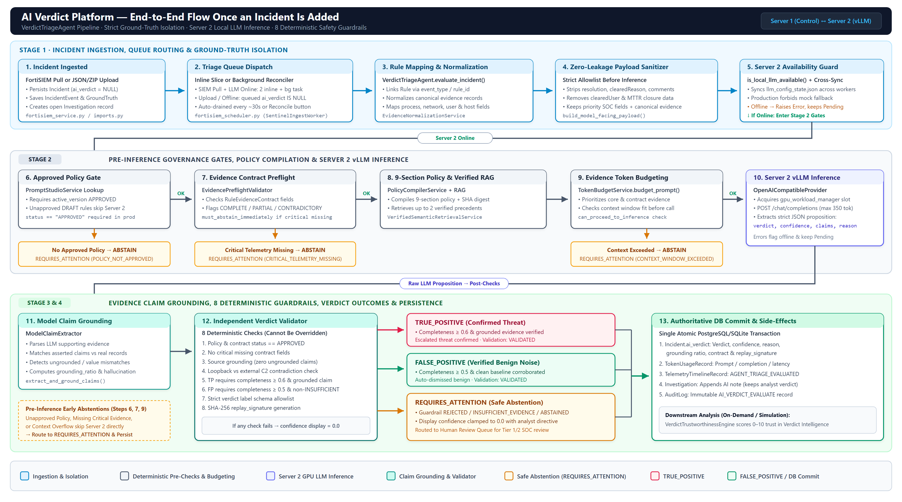

1. Incident Entry Paths & Backlog Queueing
How newly ingested incidents enter the pipeline and reach VerdictTriageAgent.evaluate_incident().
Important Architectural Principle: Strict Ground-Truth & Abstention Safety
All analyst resolution keys (resolution, clearedReason, comments, clearedUser, MTTR) are stripped before prompt construction via build_model_facing_payload(). In production mode, simulated fallback is disabled and incidents remain Pending until Server 2 (vLLM) is reachable. If an approved rule policy or critical telemetry is missing, the platform safely abstains as REQUIRES_ATTENTION rather than guessing.

Ingress Channel | Immediate Behavior on Save | Backlog / Scheduler Execution
FortiSIEM Batch / Continuous Pull  (fortisiem_service.py) | Saves Incident (ai_verdict=NULL), IncidentEvent, HistoricalGroundTruth, and Investigation. If auto_triage_llm=true and Server 2 is online, evaluates up to 2 incidents inline. | Remaining incidents (incidents_to_evaluate[2:]) run via _evaluate_incidents_background() or SentinelIngestWorker without short HTTP timeout cancellations.
JSON / ZIP Archive Upload  (imports.py / ingestion_service.py) | Saves Incident (ai_verdict=NULL), auto-creates missing Rule record + a DRAFT template prompt (unapproved for live inference until reviewed in Studio). | Queued as Pending. Drained every ~30s when Server 2 is online by SentinelIngestWorker._supervisor_loop (when auto_ai_verdict=true) or manual Reconcile Pending.
Explicit Reconciliation / Server 2 Connect | Updating/testing Server 2 config writes shared llm_config_state.json across all 4 Uvicorn workers and Celery workers. | Automatically triggers trigger_pending_reconciliation(), or operators can click Process Pending / Reconcile Pending (background=true).
2. Stage-by-Stage Execution Pipeline (VerdictTriageAgent.evaluate_incident)
Sequential stages implemented in backend/app/services/ai_verdict_service.py.
Pipeline Step | Processing Logic & Services | Gate / Outcome Effect
Stage 3 · Rule Auto-Mapping | Looks up Rule by event_type / rule_id. Creates a default ACTIVE Rule if unmapped and backfills sibling incidents. | Incident.rule_id linked
Stage 4 · Canonical Normalization & Sanitization | EvidenceNormalizationService extracts structured process, network, hash, user, and host evidence. build_model_facing_payload() strips all historical resolution/closure fields. | Zero-leakage payload + canonical records
Stage 5 · Server 2 Availability Guard | Syncs shared llm_config_state.json across workers and checks is_local_llm_available(). In production, mock fallback is strictly disabled. | Offline → LocalLLMUnavailableError (remains Pending)
Stage 6 · Approved Policy Gate | Fetches active rule version in PromptStudioService. Must have status == APPROVED in live production. | Not APPROVED → Immediate REQUIRES_ATTENTION (POLICY_NOT_APPROVED)
Stage 7 · Preflight Evidence Validation | EvidencePreflightValidator verifies RuleEvidenceContract fields and checks obvious contradictions (e.g., localhost loopback conflict). | Critical missing → Immediate REQUIRES_ATTENTION (CRITICAL_TELEMETRY_MISSING)
Stage 8–9 · Policy Compile, RAG & Token Budget | PolicyCompilerService builds 9-section policy + SHA digest; VerifiedSemanticRetrievalService fetches up to 2 rule-scoped precedents; TokenBudgetService fits context window. | Overflow → Immediate REQUIRES_ATTENTION (CONTEXT_WINDOW_EXCEEDED)
Stage 10 · Server 2 vLLM Inference | Acquires gpu_workload_manager slot and calls OpenAICompatibleProvider (/chat/completions, max_tokens ≤ 350) expecting strict JSON verdict schema. | Returns proposed verdict, raw confidence, claims & reason
Stage 11–12 · Claim Grounding & 8 Validator Checks | ModelClaimExtractor maps claims to canonical evidence; IndependentVerdictValidator enforces 8 deterministic safety checks + SHA-256 replay signature. | Rejects hallucinations, contradictions, or low completeness
Stage 13 · Atomic Commit & Post-Sync | Commits Incident.ai_verdict, TokenUsageRecord (INCIDENT_TRIAGE), TelemetryTimelineRecord, Investigation notes (preserving analyst verdict), and AuditLog. | Persisted; Trustworthiness 0–10 scored on inspection/simulation
3. Final Verdict Decision Rules (IndependentVerdictValidator)
Deterministic criteria that determine whether the LLM proposition is accepted or downgraded to REQUIRES_ATTENTION.
Final Verdict | Required Validation Conditions | Display & Workflow Action
TRUE_POSITIVE | Approved policy/contract, zero critical missing fields, zero unsupported claims, no loopback/C2 contradiction, evidence completeness ≥ 0.6, and at least one grounded claim (when claims are present). | Accepted as confirmed threat (validation_status = VALIDATED); raw model confidence displayed alongside replay signature.
FALSE_POSITIVE | Approved policy/contract, preflight != INSUFFICIENT, evidence completeness ≥ 0.5, and zero ungrounded claims or contradictions. | Accepted as verified benign activity (validation_status = VALIDATED); noise auto-dismissed.
REQUIRES_ATTENTION | Triggered if any pre-inference gate abstains (POLICY_NOT_APPROVED, CRITICAL_TELEMETRY_MISSING, CONTEXT_WINDOW_EXCEEDED) or post-inference validator flags REJECTED / INSUFFICIENT_EVIDENCE / ABSTAINED. | Validated display confidence forced to 0.0; explicit analyst_action_directive directs incident to Human Review Queue.

