添加注释

1. ctrl+shift+p打开
2. 输入snippets点击进入用户代码片段配置

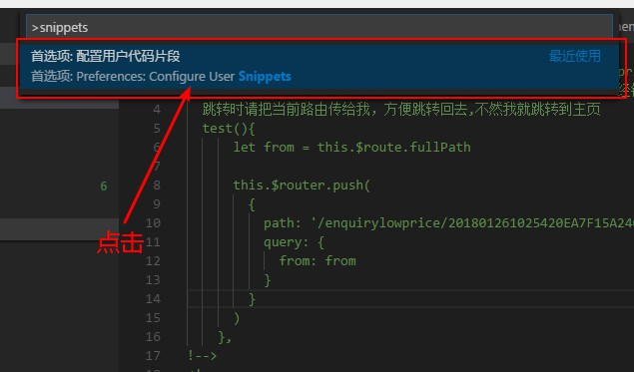

1. 配置css.json/css

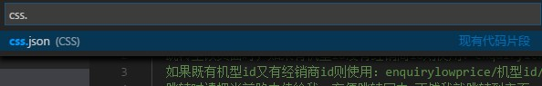

进入之后输入

"Print to cssTitle": {

    "prefix": "cssNoteTitle",

    "body": [

      "/*",

      " * @description: ",

      " * @author: 查嘉磊 ",

      " * @date: ${CURRENT_YEAR}-${CURRENT_MONTH}-${CURRENT_DATE} ${CURRENT_HOUR}:${CURRENT_MINUTE}:${CURRENT_SECOND}",

      " * @version V1.0.5 ",

      "*/"

    ],

    "description": " Title对应css注释标题"

  },

  "Print to cssItem":{

    "prefix": "cssNoteItem",

    "body": [

      "/*",

      " * @description: ",

      " * @author: 查嘉磊 ",

      " * @date: $0 ",

      "*/"

    ],

    "description": "Item对应css类注释"

  }

用法：

在<style></style>标签中间

输入css会出现下面的选项

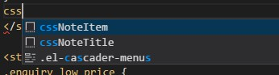

Title对应css注释标题

Item对应css类注释

注意：使用sass或less等css语言需重新设置less.json和sass.json

1. 配置javascript.json/javascript

  "Print to jsNoteTitle": {

    "prefix": "jsNoteTitle",

    "body": [

      "/*",

      " * @description:",

      " * @author: 查嘉磊",

      " * @date: ${CURRENT_YEAR}-${CURRENT_MONTH}-${CURRENT_DATE} ${CURRENT_HOUR}:${CURRENT_MINUTE}:${CURRENT_SECOND}",

      " * @version: V1.0.5",

      "*/"

    ],

    "description": " jsNoteTitle对应开始标题注释"

  },

  "Print to jsfn": {

    "prefix": "jsfn",

    "body": [

      "/**",

      " *@functionName: ${TM_CURRENT_LINE}",

      " *@params1: ${1:参数1}",

      " *@params2: ${2:参数2}",

      " *@params3: ${3:参数3}",

      " *@params4: ${4:参数4}",

      " *@description:",

      " *@author: 查嘉磊",

      " *@date: ${CURRENT_YEAR}-${CURRENT_MONTH}-${CURRENT_DATE} ${CURRENT_HOUR}:${CURRENT_MINUTE}:${CURRENT_SECOND}",

      " *@version: V1.0.5",

      "*/"

    ],

    "description": " Jsfn对应方法注释"

  },

  "Print to jsModify": {

    "prefix": "jsModify",

    "body": [

      "/**",

      " *@ description:",

      " *@modifyContent:",

      " *@ author: 查嘉磊",

      " *@date: $0",

      "*/"

    ],

    "description": "JsModify对应方法修改注释"

  },

  "Print to jsVariable": {

    "prefix": "jsVariable",

    "body": [

      "/**",

      " *@description:",

      " *@author: 查嘉磊",

      " *@date: ${CURRENT_YEAR}-${CURRENT_MONTH}-${CURRENT_DATE} ${CURRENT_HOUR}:${CURRENT_MINUTE}:${CURRENT_SECOND}",

      " *@variable1: ${1:变量1}",

      " *@variable2: ${2:变量2}",

      " *@variable3: ${3:变量3}",

      " *@variable4: ${4:变量4}",

      " *@variable5: ${5:变量5}",

      "*/"

    ],

    "description": " JsVariable 对应变量注释"

  },

用法和css类似在script标签内输入js

出现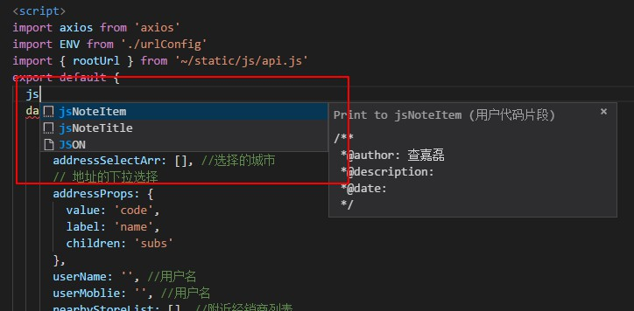

注意：jsNoteTitle对应开始标题注释

Jsfn对应方法注释

JsModify对应方法修改注释

JsVariable 对应变量注释

1. 编辑vue-html.json/html

  "Print to htmlStart":{

    "prefix": "htmlStart",

    "body": [

      "<!-- $0start @author: 查嘉磊 !-->"

    ],

    "description": " Start在html区块开始时使用"

  },

  "Print to htmlItem":{

    "prefix": "htmlEnd",

    "body": [

      "<!-- $0end @author: 查嘉磊 !-->"

    ],

    "description": " End在html区块开始时使用"

  }

用法

在template标签内

输入html出现

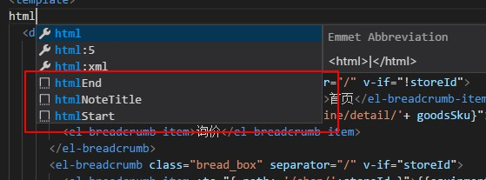

注意：Start在html区块开始时使用

End在html区块开始时使用

1. vue.json/html文件配置

  "Print to vueTitle": {

    "prefix": "vueTitle",

    "body": [

      "<!-- ",

      " * @description: ",

      " * @fileName: ${TM_FILENAME} ",

      " * @author: 查嘉磊 ",

      " * @date: ${CURRENT_YEAR}-${CURRENT_MONTH}-${CURRENT_DATE} ${CURRENT_HOUR}:${CURRENT_MINUTE}:${CURRENT_SECOND}",

      " * @后台人员: $1 ",

      " * @version: V1.0.5 ",

      "!-->"

    ],

    "description": "在vue文件开头配置注释"

  }

在vue文件开头配置注释

使用方法在vue文件开头输入vue选择

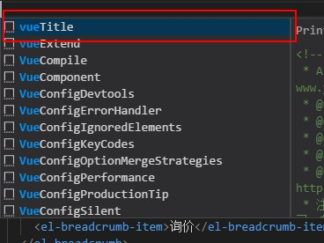

出现注释

1. 最重要的是将作者名改为自己的名字，注释时请填写描述和时间若出现排版错乱请修改body数组里面的字符串内容 换行使用\n 空格就是空格