

Team Portfolio

Aleksander Bobiński, Patryk Chodorowski, Mario Fukuoka, Maciek Grzelczak

Supervised by: Dr. inż. Zbigniew Chaniecki, Dr.inż. Krzysztof Grudzień

Łódź University of Technology  
Computer Science  
Project Based Learning  
June 2018

# We are Team Pathfinder.

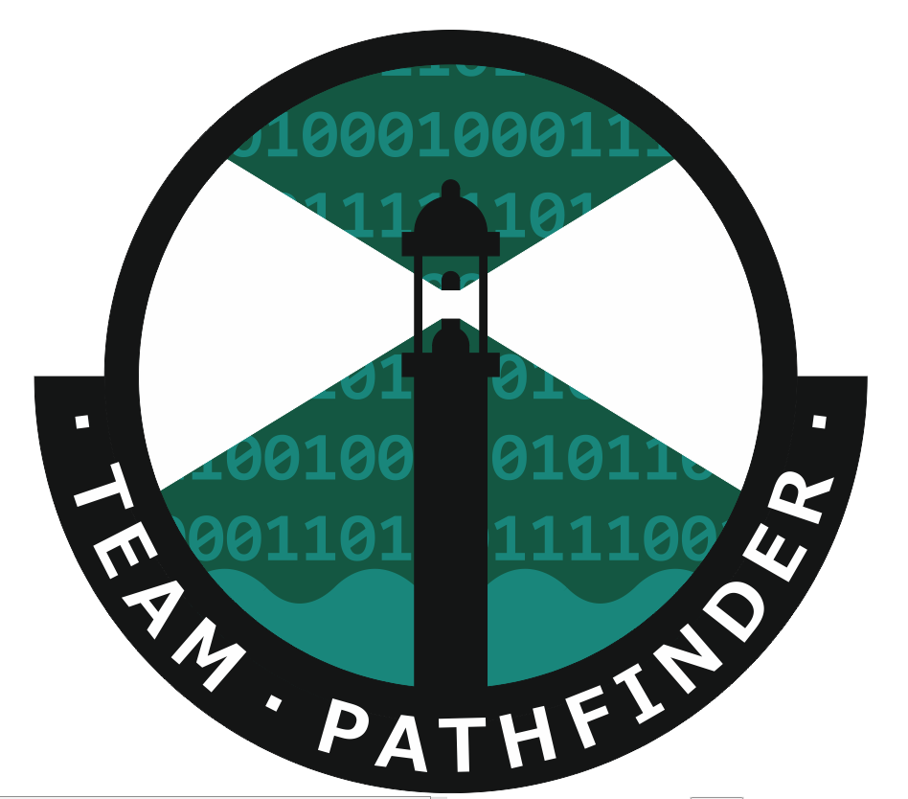Illuminating the path ahead

Our goal is to illuminate the path ahead, which means to help others find the information they are looking for.

# We are:

|  |  |
| --- | --- |
| Aleksander Bobiński |  |
| Inquisitive and knowledgeable, he is the one behind the analysis of data and the internal structure of the solution. He was the one to define the problem, analyze and choose one of the potential solutions and then design and implement the part of the program responsible for saving a list of installed software. He also implemented a part of the GUI and program logic. He is the author of the portfolio. |  |
| Patryk Chodorowski |  |
| Pragmatic and full of passion, Patryk is the creator of a program that provided tremendous aid in the analysis of large quantities of data obtained from our surveys. He wrote parts of the GUI of the application as well as the program logic itself, and created a draft of the Article. |  |

|  |  |
| --- | --- |
| Mario Fukuoka |  |
| The creative force of the team, he is the man behind splendid graphics, but also the one who keeps the motivation levels high. Mario created the template and graphics for the mid-term presentation, and designed and created the team logo. Furthermore, he wrote the article and also implemented a connection to an external license analyzer in our application. |  |
| Maciek Grzelczak |  |
| Maciek is the one responsible for distributing the surveys and creating a major part of the solution. He is the author of the software lister, an utility inside the application that scans the user’s Windows registry looking for installed software. He wrote the post-implementation survey used to gather feedback from the real world solution test. |  |

# Team SWOT Analysis:

|  |  |
| --- | --- |
| **Strengths** | **Weaknesses** |
| * Good programming skills * Excellent communication | * Lack of presentation skills * First time working together |
| **Opportunities** | **Threats** |
| * Learning how to gather and analyze data * Learning how to work together | * The expansive domain of the problem can be overwhelming |

Our lack of presentation skills does not hinder the communication between us since we are all accustomed to technical explanations. In fact, having only technical people on our teams allows us to better complement each other as we understand the intentions of one another clearly and are able to work more efficiently. This also allows us to mitigate any chances for misunderstandings stemming from our lack of experience working together. The PBL and the complementary Team Building and Communication Skills courses have further empowered us by giving us a chance and necessary guidance needed to learn how to work with people with whom we have never worked before.

It is hard to imagine that a team could be unaffected by the project they are currently working on. The nature of the problem we faced did influence team motivation however we have dealt with this obstacle by using small steps rather than large leaps in our work on the project, because of this we learned how to gather and analyze large amounts of data in simple steps which is a useful skill to have.

# What we are working on:

The main topic of our project is expansive. It is based on a simple, straightforward question that has far-reaching implications: “Is my computer lawful?” The problem definition we have arrived to is that people who care about the legality of their computers don’t know what is installed on their machines and do not read licenses. Some solutions to parts of the problem exist, however they are incomplete and one has to use them separately as components rather than a single well-defined working system. Our goal is to support those who care care about the lawfulness of their computers by giving them the tools necessary to both find the software that is installed on their computers and also help them read and understand licenses. We would like to create a single application which has all the functionalities of existing components built into it. The program should also balance the limitations of existing solutions with fixes and additional features.

# How we are working together:

**Task and Interpersonal Relationship:**

During the project we have all worked together and only divided the work when it was necessary. Tasks such as creating the team name, logo, writing interview questions and conducting the interviews, writing survey questions and distributing the survey were done as a team. Most important of all when deciding on what to do next we do it together.

We are always open minded. We share ideas without hesitation, because we know that each and every aspect of it will be analyzed without any bias.

A proof of our excellent team work can be seen in the results of a survey about 5 different dysfunctions of a team. The results were overwhelmingly positive which means that our team is far from dysfunctional. The results of the survey can be found on the following pages. 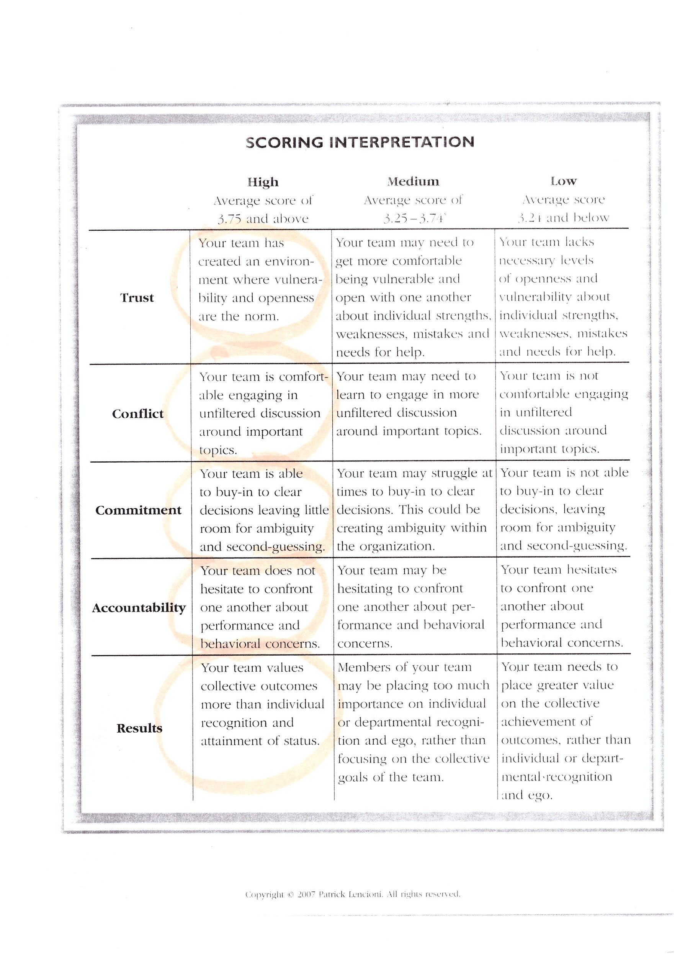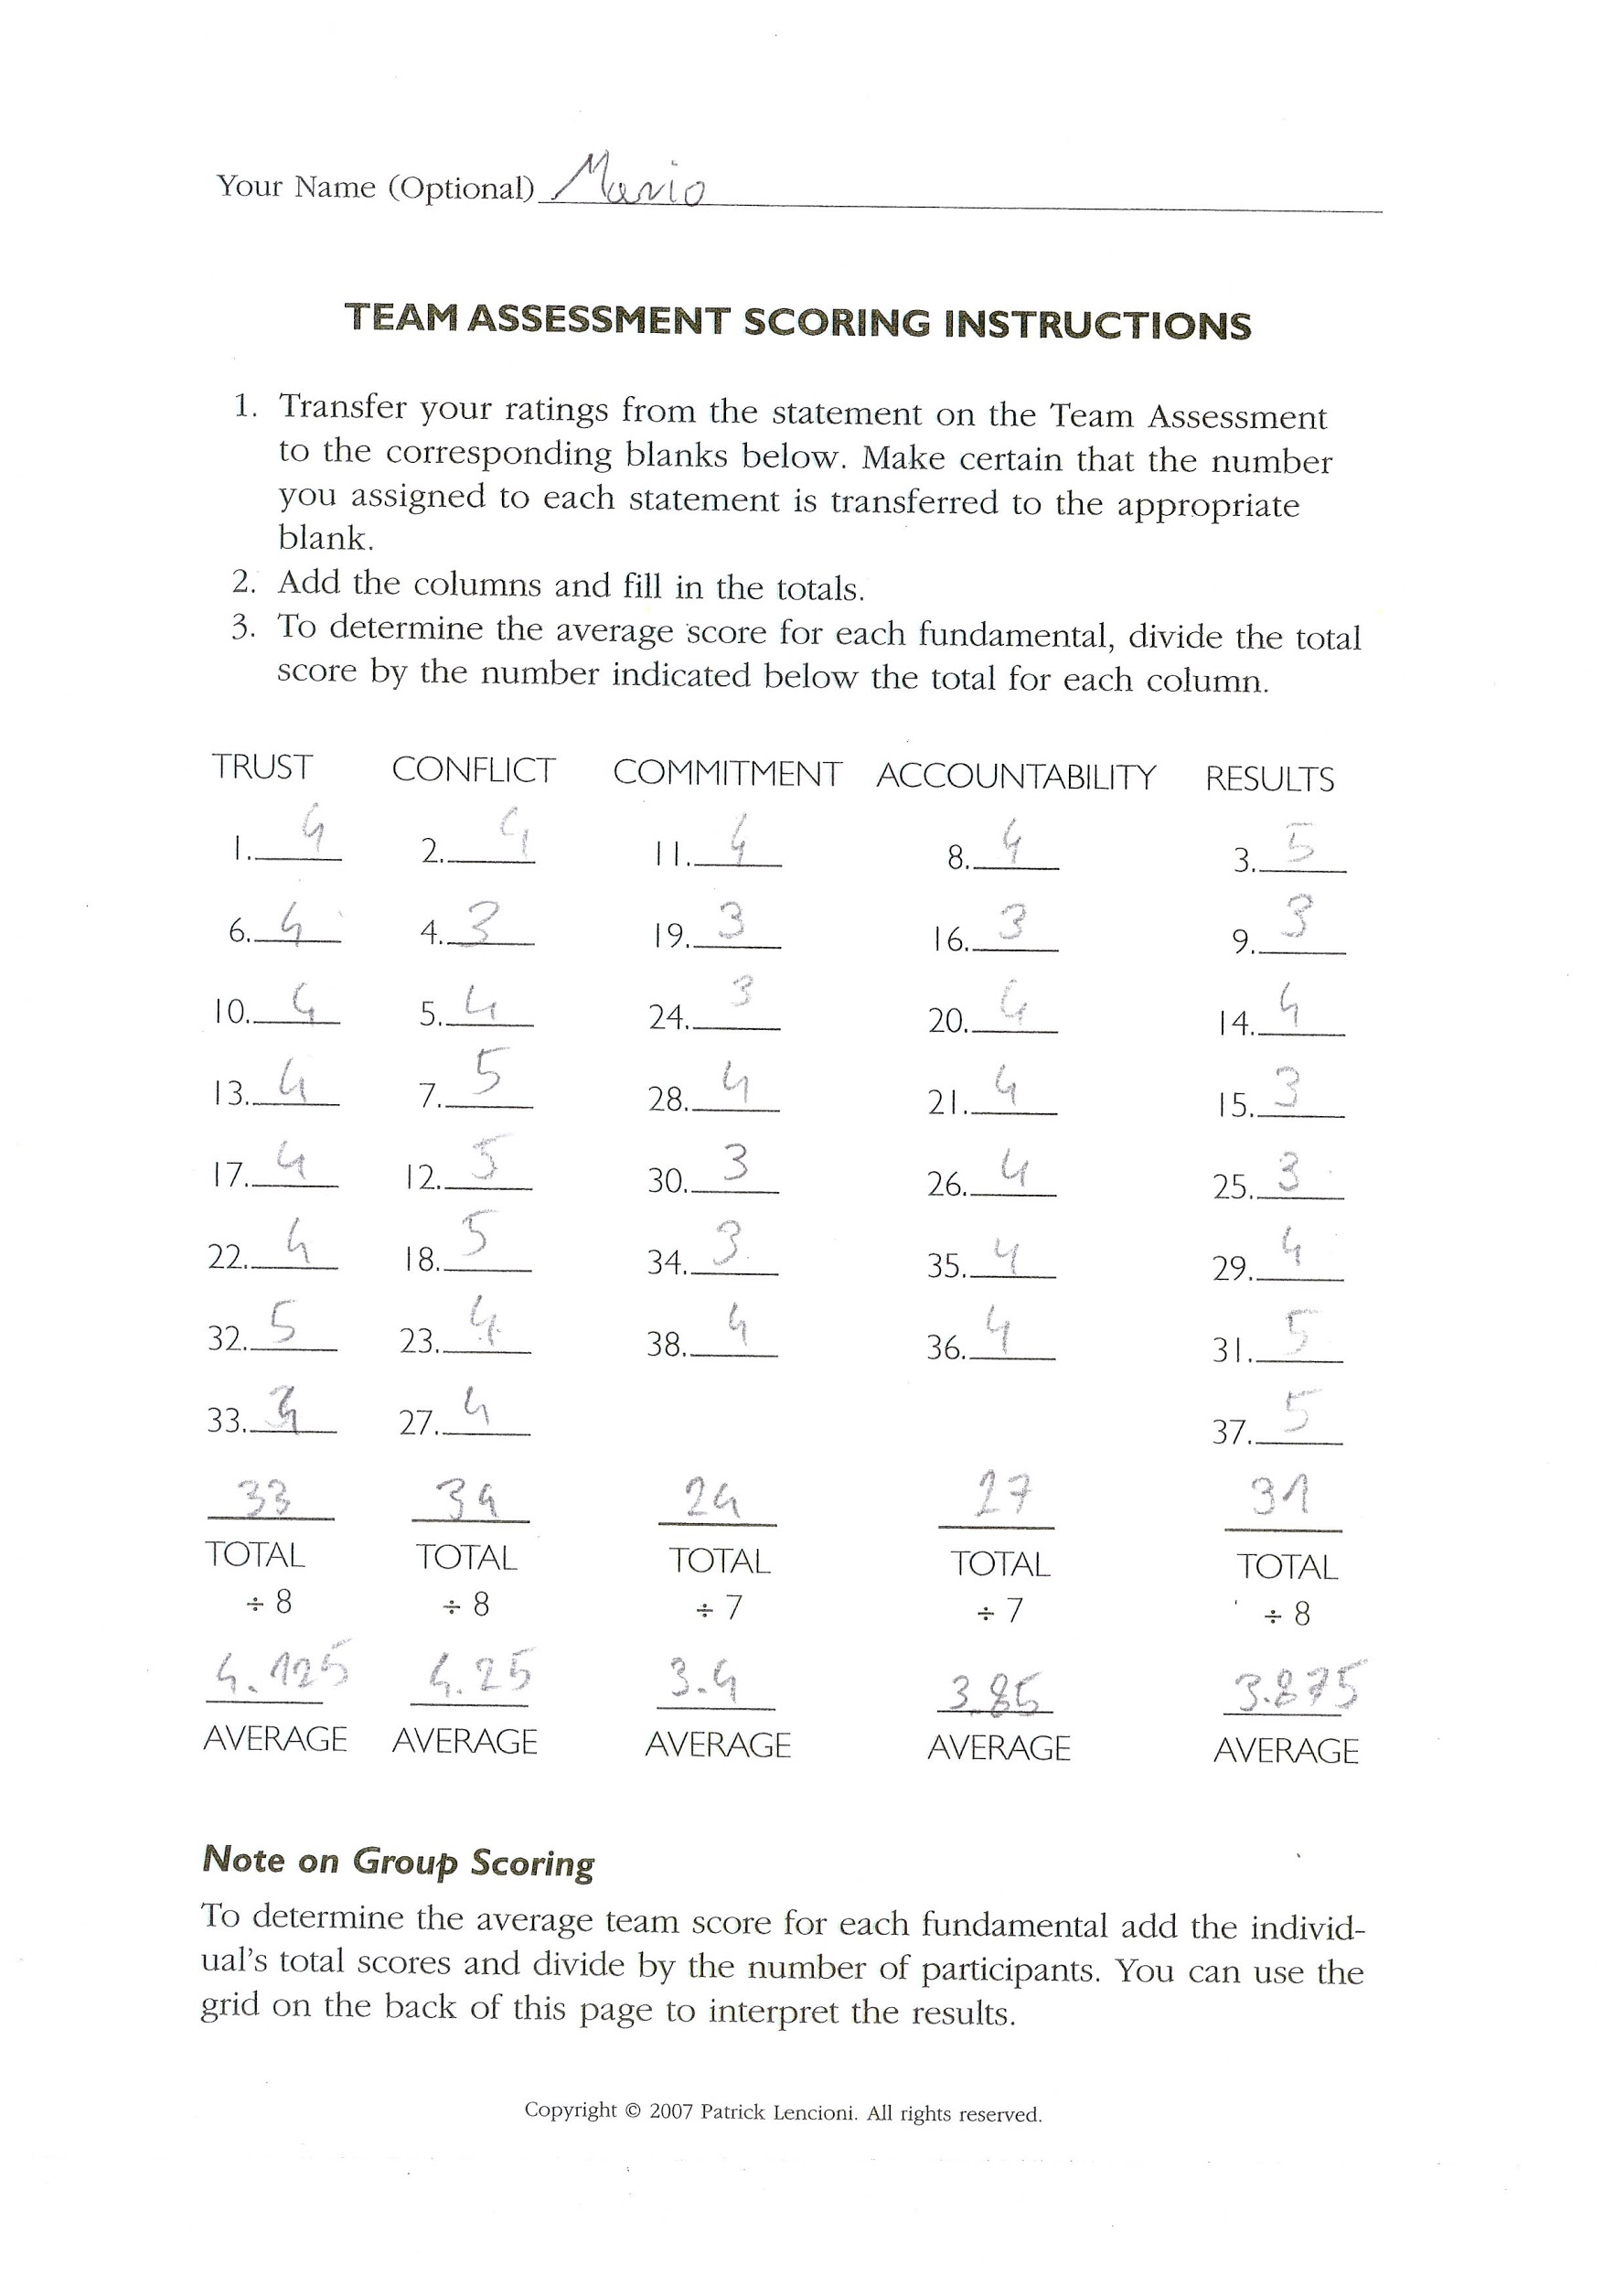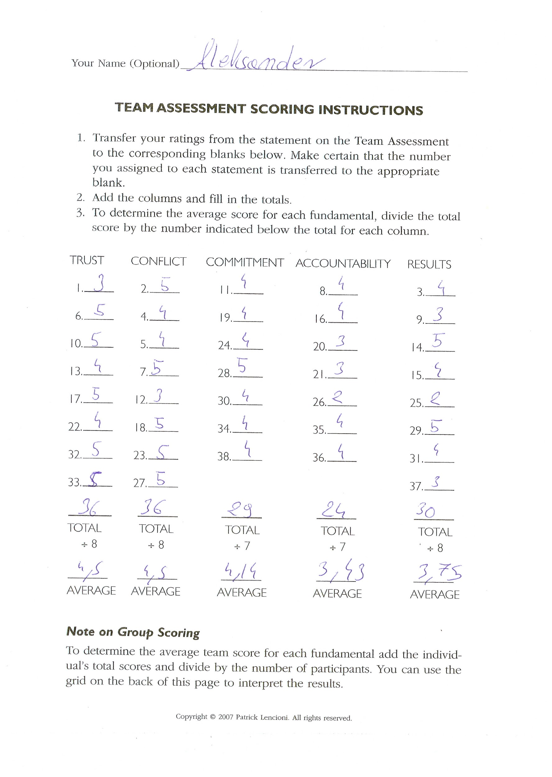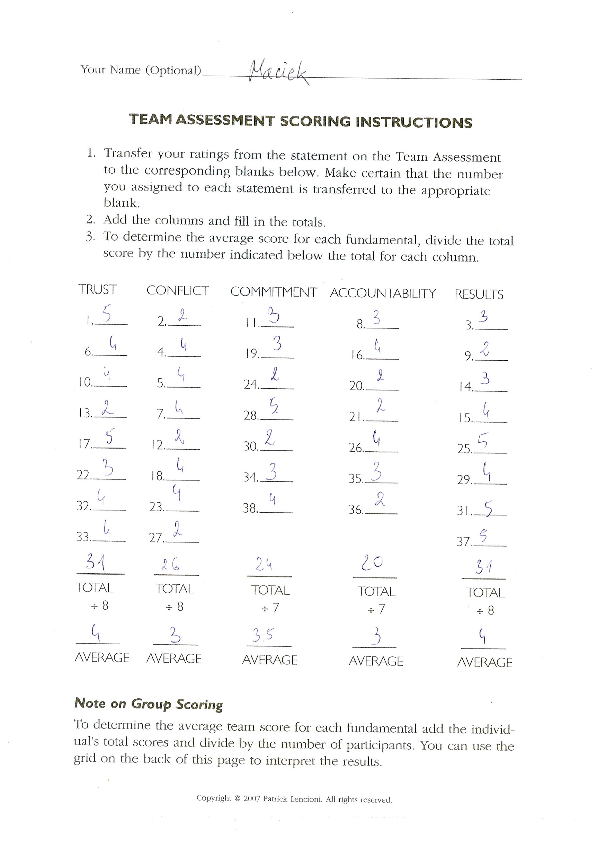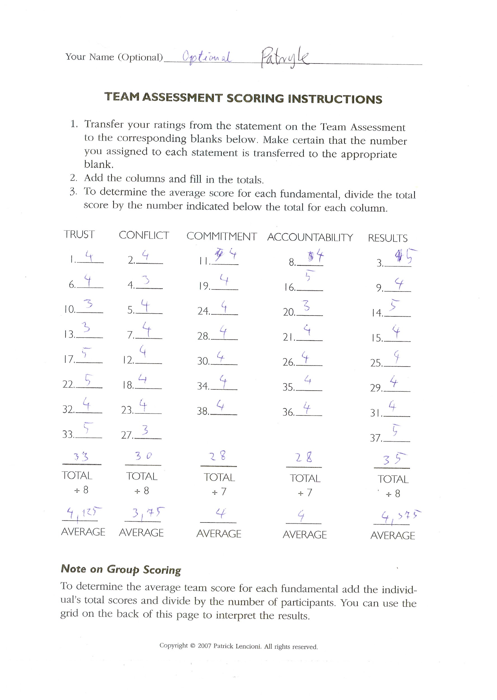

**Stakeholders’ Analysis:**

Our stakeholders are a large and diverse group the only common factor they share is the defined problem. To make sure that the results of our work benefit them we often conduct surveys and interviews. We then analyze the feedback and adjust our work accordingly. Because the target audience is so vast, it is challenging to find the right balance and conform to each person’s request.

**Meetings:**

Every week on Wednesday we met with our supervisors to present the current status of work and discuss project related topics. The minutes from the meetings contain the topics that were brought up as well as a brief summary of the discussion followed by conclusions which are often strictly related to a task that is do be done in the following week. When working on a task we frequently communicated with each other maintaining the workflow coherent and understandable. Our meetings were organized in a similar fashion to our workflow, they were well organized and understandable to every team member. A chairman and a scribe were selected to maintain order and any contribution to the discussed subject was welcome.

1. **Tools used to generate ideas and make decisions:**

There is a number of tools we used to generate ideas, for example we used the 5 Whys technique to discover the source of the question “Is my computer lawful?” Nonetheless we regularly relied on brainstorming because we found that it’s straightforward approach to a discussed problem helps us better utilize the fact that we have four member on our team, which means four times as many ideas. Other tools such as starbursting or the Ishikawa diagram were also considered during our decision making process as they were presented during the TB&CS classes.

**Leadership in our team:**

The leadership in our team is mixed. The main leader is Mario however at times better expertise of a certain subject leads to other members of the team gaining the authority of a leader for the duration of a task. Because Mario is appointed as the leader our work is always well organized and the short and infrequent changes in leadership don’t disturb this state but rather benefit diversity.

**Conflict in our team:**

As with any group project conflict is unavoidable, we do however resolve all the conflicts as fast as possible in the most meaningful way possible. Often what will happen is a person will bring up an idea that cannot be incorporated into the project, the idea will then be discussed and confronted with the conflicting element of the project, then a choice is made whether to stand by the original or move to the new idea. The factors considered are the time limitations, work needed to implement both ideas and last but not least the consequences of choosing one over the other.

**Time management in our team:**

Sometimes an issue in our team is time management. Due to the fact that we live in different parts of the town and that we all have extracurricular activities it is difficult to schedule meetings so that all of us can attend them. We found that the easiest way to communicate for us is to hold Discord meetings, which are meeting that we have over VoIP services. This eliminates the need for us to travel long distances effectively wasting time as well as allowing us to work in the comfort of our homes. Despite that, we still meet in person before, during or after our classes at the University with the specific purpose to practice or show the results of the work which we cannot share through online services.

# Action Plan:

1. During one of the Team Building and Communication Skills classes we have created a graphical representation of our work history and plans for the future.
2. 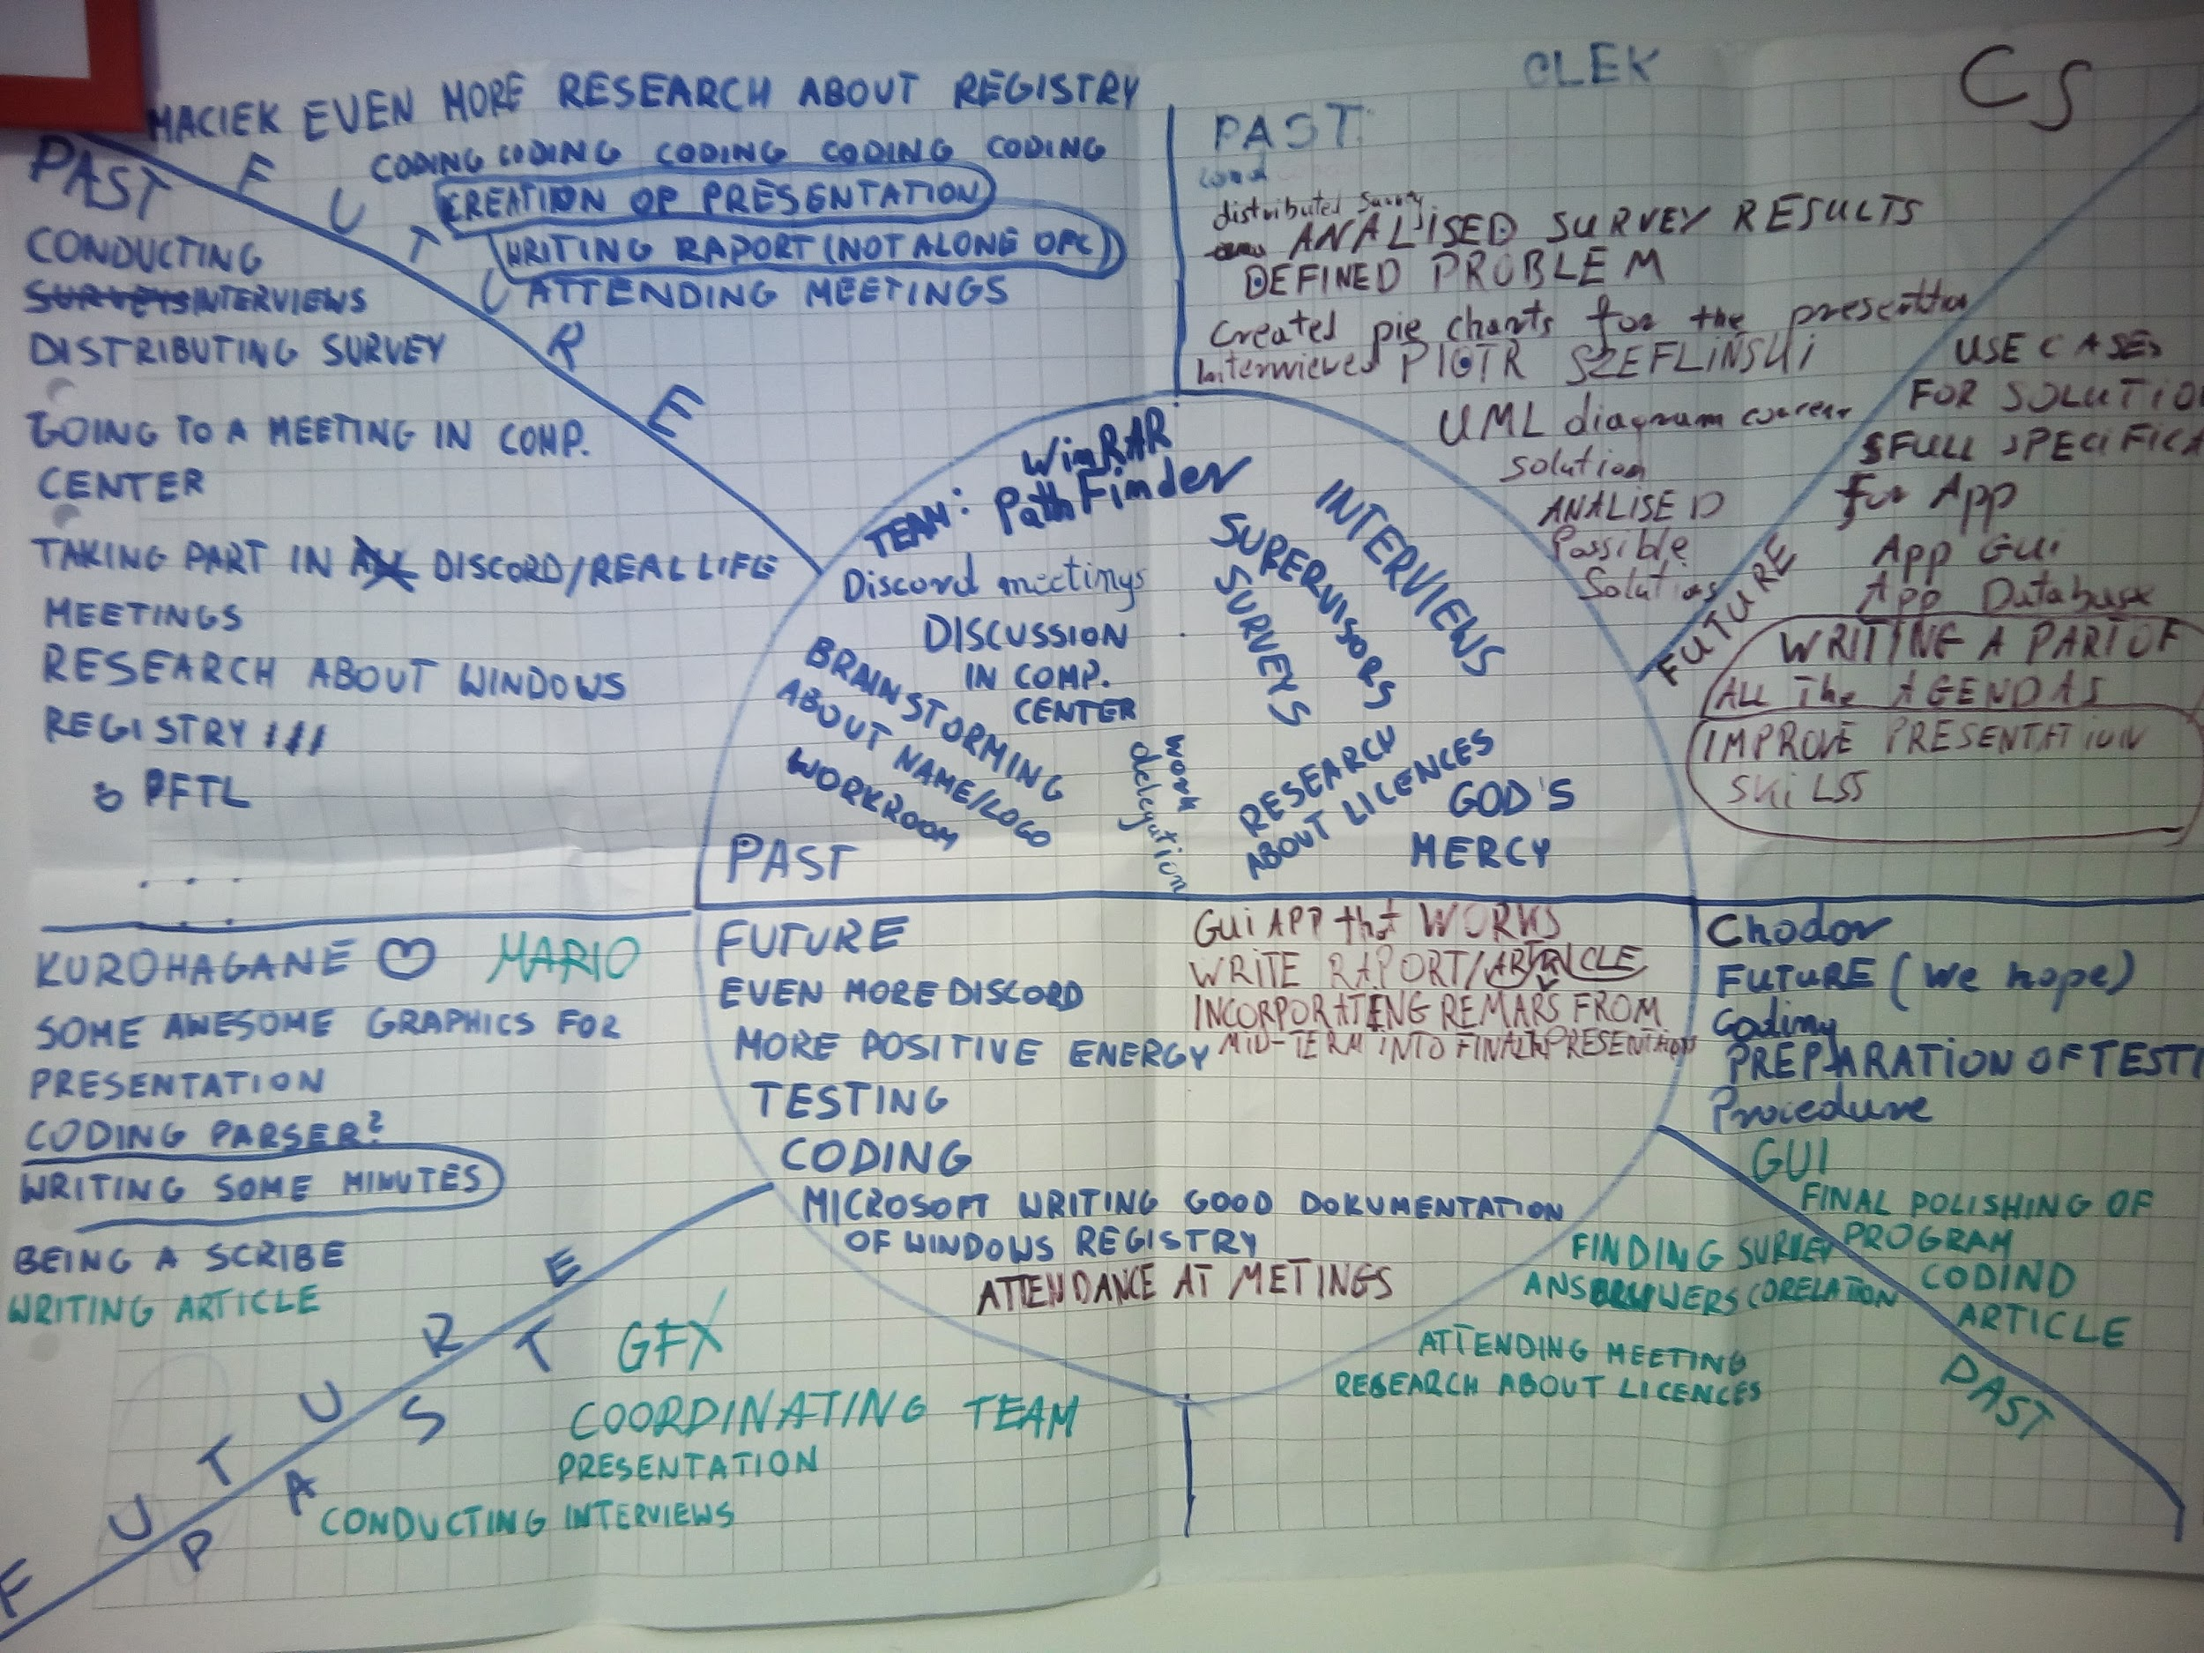
3. Although the work was divided and each person had their own tasks to complete we still often discussed and assessed the progress. Whenever one of us needed help with a task we would all be there to assist.

# Abstract:

*This project tackles the problem of keeping track of lawful use of software. Due to how ubiquitous the internet is, downloading and installing new software is very easy, yet keeping track of its licensing can be hard. It is difficult to tell when a license permits the usage of  a program in a certain situation. Additionally, licenses can be confusing and easy to misunderstand. During the project, over 370 people are interviewed and surveyed and it is found that users who claim that they care about lawful use of software do not read licenses and do not know in entirety what they have installed on their computers. The proposed solution is a desktop application meant to help users search for programs which are installed but not known by them, organize them along with finding their corresponding licenses, and also analyze the licenses to summarize them for faster and easier understanding of their content.*

# Conclusions:

We enjoyed the process of problem-based-learning although it is demanding at times because to solve our problems we must first find the right tools. This is a burden and unfortunately leads to misguided decisions which cost the whole team. On the other hand, it allows for greater freedom and gives enormous satisfaction when milestones are achieved.

We have successfully created a team in which diversity is welcome and responsibility is shared.

During the process of the whole PBL we acquired new technical knowledge as well as learned more about the world of legal issues that we are entangled in yet fail to notice it in our everyday lives. Furthermore, we have confronted some of our fears while creating and conducting the surveys. We were forced to research problems which we have never faced before which was a pleasant experience in the end. Finally, we learned that the work of any software developer is to cooperate closely with both their teammates and the client in order to create the product that is needed.

We have faced multiple problems on our way during the PBL course, such as time management issues, incomprehensible tasks, difficulty in communicating intentions and conflicts. Each of those problems was solved by finding common ground, it was challenging but not impossible. The key to success here was great communication and motivation. In a way each of the obstacles faced made us more confident and help our bond grow stronger.

The problem-based-method is difficult to assess objectively since as a byproduct of the freedom given to us we have probably learned things that are outside of the curriculum but may be useful to us in our future careers. This means that during a conventional course we could have gained more technical knowledge strictly associated with our specialization. On the other hand, it is difficult to imagine how a conventional course could teach self-discipline, trust and respect for teammates, accountability and critical thinking as well as solving problems in a different way than just retaking an exam.