# Team Pathfinder Final presentation handout.

# Possible solutions to the defined problem. “People who care about licenses don’t know what is installed on their computers and don’t read licenses.”

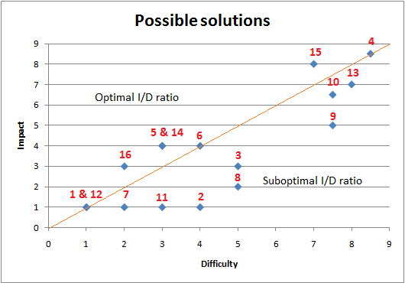

|  |  |  |  |
| --- | --- | --- | --- |
| Nr. | Solution | Difficulty | Impact |
| 1 | A poster, to show people that they do not know as much as they think they do about licenses and that it is worth reading them | 1 | 1 |
| 2 | A poster, to show people that they do not know as much as they think they do about licenses and that it is worth reading them | 4 | 1 |
| 3 | Video game which will raise awareness that writing software is not an easy task and that people should not pirate them. | 5 | 3 |
| 4 | A website where people can read a summary/explanation of a software license, written by other users. | 8,5 | 8,5 |
| 5 | Software which reminds the user about expiration dates of his trials and subscriptions. | 3 | 4 |
| 6 | Motivational program which would keep track of how much software is legal, and then record progress done towards having a fully lawful computer. | 4 | 4 |
| 7 | Tool for organizing time that will help the user find the time to read licenses. | 2 | 1 |
| 8 | License reading course organized by a lawyer. | 5 | 2 |
| 9 | Virtual space where user can install software in order to see whether it also installs other software with it. | 7,5 | 5 |
| 10 | Docker for windows (operating-system-level virtualization) | 7,5 | 6,5 |
| 11 | Software which will tell you what licenses, or what parts of a license are interesting to you depending on who you are e.q. probably your expertise/technical familiarity, profession, etc. | 3 | 1 |
| 12 | A quiz meant to show people how little they know about licenses, thus encouraging them to be better informed. | 1 | 1 |
| 13 | Q&A service with lawyers for answering license-related questions | 8 | 7 |
| 14 | Software & license manager/database | 3 | 4 |
| 15 | License analyzer/summarizer | 7 | 8 |
| 16 | Software lister to list hard to find installed software by searching the registry | 2 | 3 |