The famous ACM (Advanced Computer Maker) Company has rented a floor of a building whose shape is in the following figure.

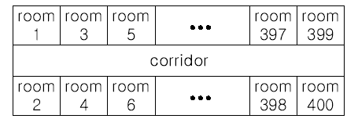

The floor has 200 rooms each on the north side and south side along the corridor. Recently the Company made a plan to reform its system. The reform includes moving a lot of tables between rooms. Because the corridor is narrow and all the tables are big, only one table can pass through the corridor. Some plan is needed to make the moving efficient. The manager figured out the following plan: Moving a table from a room to another room can be done within 10 minutes. When moving a table from room i to room j, the part of the corridor between the front of room i and the front of room j is used. So, during each 10 minutes, several moving between two rooms not sharing the same part of the corridor will be done simultaneously. To make it clear the manager illustrated the possible cases and impossible cases of simultaneous moving.

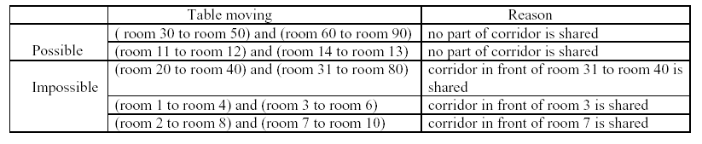

For each room, at most one table will be either moved in or moved out. Now, the manager seeks out a method to minimize the time to move all the tables. Your job is to write a program to solve the manager's problem.

**Input**

The input consists of T test cases. The number of test cases ) (T is given in the first line of the input file. Each test case begins with a line containing an integer N , 1 <= N <= 200, that represents the number of tables to move.   
Each of the following N lines contains two positive integers s and t, representing that a table is to move from room number s to room number t each room number appears at most once in the N lines). From the 3 + N -rd   
line, the remaining test cases are listed in the same manner as above.

**Output**

The output should contain the minimum time in minutes to complete the moving, one per line.

**Sample Input**

3

4

10 20

30 40

50 60

70 80

2

1 3

2 200

3

10 100

20 80

30 50

**Sample Output**

10

20

30

Ancient Roman empire had a strong government system with various departments, including a secret service department. Important documents were sent between provinces and the capital in encrypted form to prevent eavesdropping. The most popular ciphers in those times were so called substitution cipher and permutation cipher.   
Substitution cipher changes all occurrences of each letter to some other letter. Substitutes for all letters must be different. For some letters substitute letter may coincide with the original letter. For example, applying substitution cipher that changes all letters from 'A' to 'Y' to the next ones in the alphabet, and changes 'Z' to 'A', to the message "VICTORIOUS" one gets the message "WJDUPSJPVT".   
Permutation cipher applies some permutation to the letters of the message. For example, applying the permutation <2, 1, 5, 4, 3, 7, 6, 10, 9, 8> to the message "VICTORIOUS" one gets the message "IVOTCIRSUO".   
It was quickly noticed that being applied separately, both substitution cipher and permutation cipher were rather weak. But when being combined, they were strong enough for those times. Thus, the most important messages were first encrypted using substitution cipher, and then the result was encrypted using permutation cipher. Encrypting the message "VICTORIOUS" with the combination of the ciphers described above one gets the message "JWPUDJSTVP".   
Archeologists have recently found the message engraved on a stone plate. At the first glance it seemed completely meaningless, so it was suggested that the message was encrypted with some substitution and permutation ciphers. They have conjectured the possible text of the original message that was encrypted, and now they want to check their conjecture. They need a computer program to do it, so you have to write one.

**Input**

Input contains two lines. The first line contains the message engraved on the plate. Before encrypting, all spaces and punctuation marks were removed, so the encrypted message contains only capital letters of the English alphabet. The second line contains the original message that is conjectured to be encrypted in the message on the first line. It also contains only capital letters of the English alphabet.   
The lengths of both lines of the input are equal and do not exceed 100.

**Output**

Output "YES" if the message on the first line of the input file could be the result of encrypting the message on the second line, or "NO" in the other case.

**Sample Input**

JWPUDJSTVP

VICTORIOUS

**Sample Output**

YES