**测试接口目录**

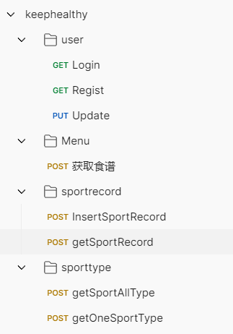

**Login接口测试**

<http://localhost:8081/main/login?userId=123456&password=123456>

**userId、password用自己的数据**

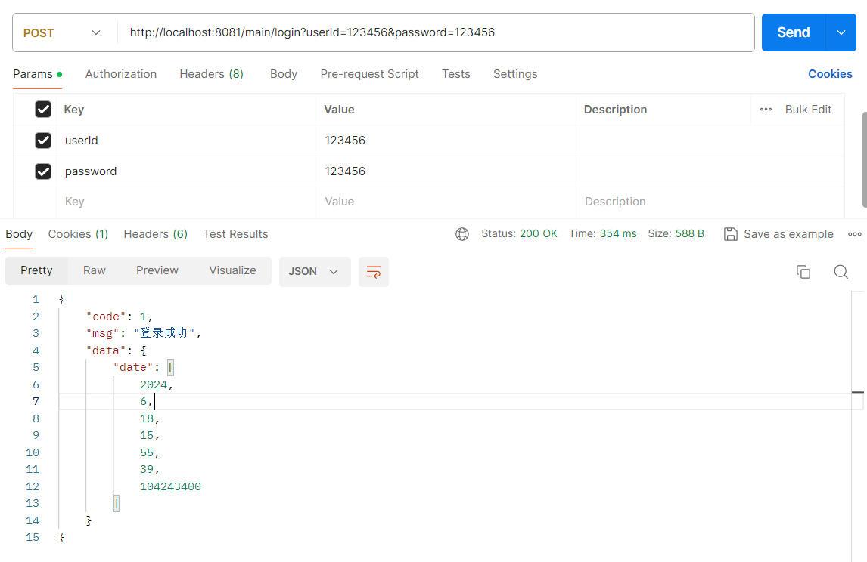

**Regist接口测试（user表中没有age属性的会报错，age是后面加的，相应的entity文件需要修改）**

**entity中的user表：**

package org.example.keephealthy02.Entity;

import com.baomidou.mybatisplus.annotation.TableName;

import lombok.AllArgsConstructor;

import lombok.Data;

import lombok.NoArgsConstructor;

import java.time.LocalDate;

import java.util.Date;

@Data

@AllArgsConstructor

@NoArgsConstructor

@TableName("user")

public class User {

private String id;

private String name;

private String password;

private Integer sex;

private Integer age;

private LocalDate birthday;

private Double height;

private Double weight;

private Double targetweight;

private String pastMedicalHistory;

}

<http://localhost:8081/main/regist>

例子：

{

    "id": "1",

    "name": "XXX",

    "password": "123456",

    "age":20,

    "birthday": "1990-01-01",

    "height": 175,

    "weight": 70,

    "targetweight": 65,

    "pastMedicalHistory": "None"

}

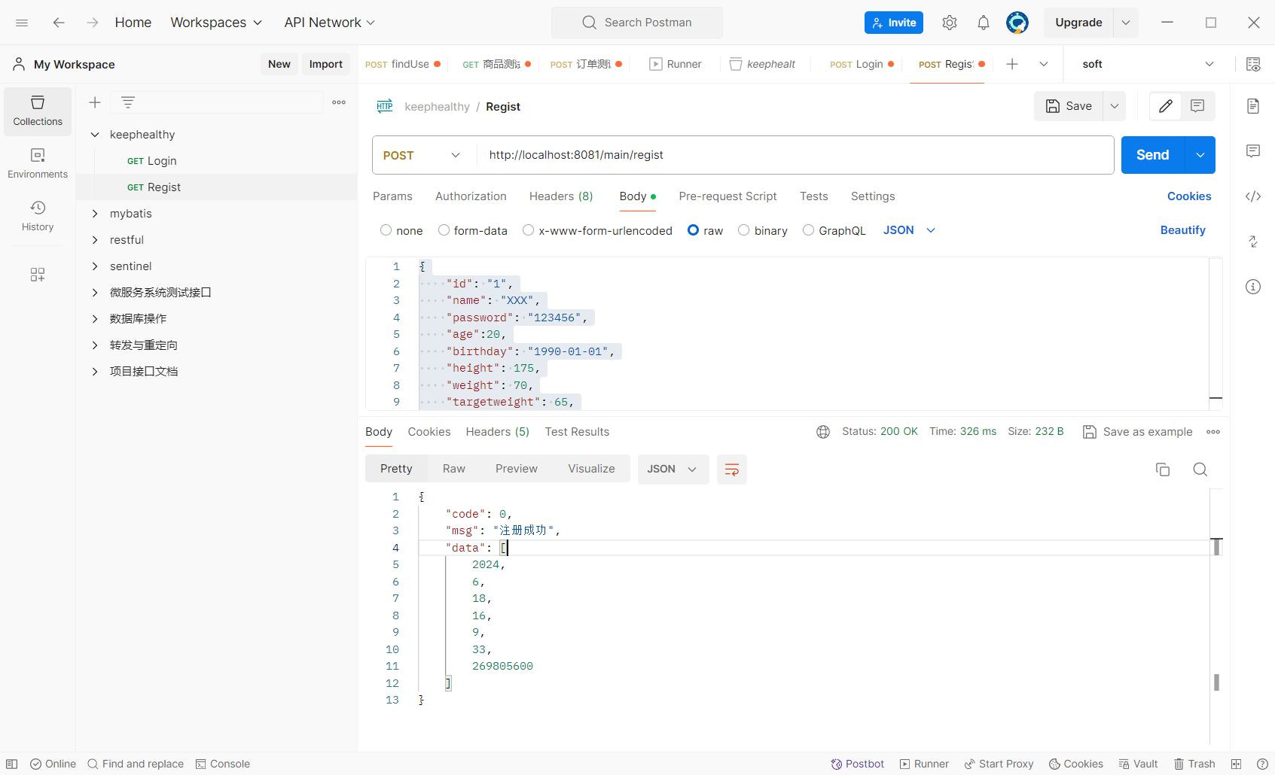

**Update接口测试（需要拿到Login的token参数）**

[http://localhost:8081/main/update](http://localhost:8081/main/regist)

例子：

{

    "id": "1",

    "name": "XXX",

    "password": "123456",

    "age":20,

    "birthday": "2004-01-01",

    "height": 175,

    "weight": 70,

    "targetweight": 65,

    "pastMedicalHistory": "None"

}

**Login参数复制下来（在下图中位置）**

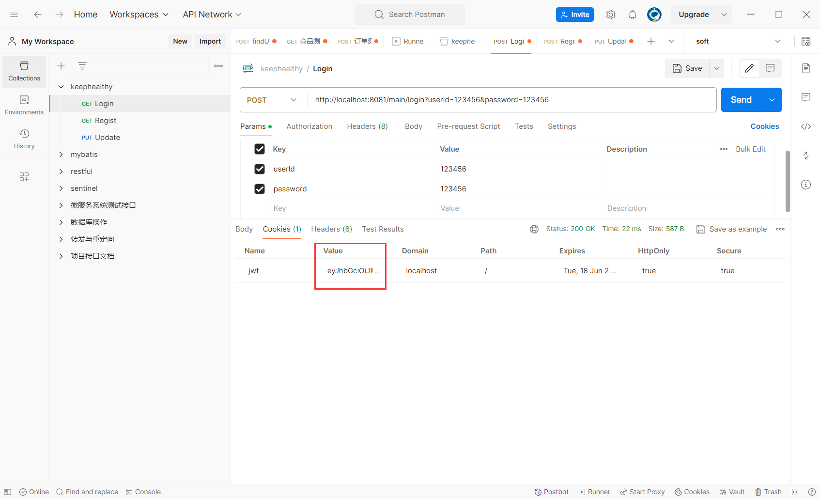

**在update的header中**

**添加一个名为：Authorization的参数**

**然后把token值放入其中**

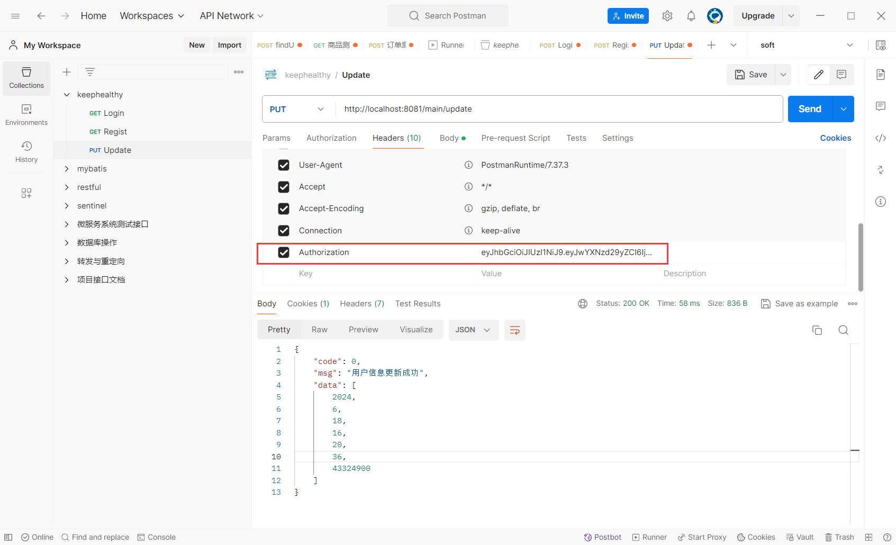

**用户更新成功**

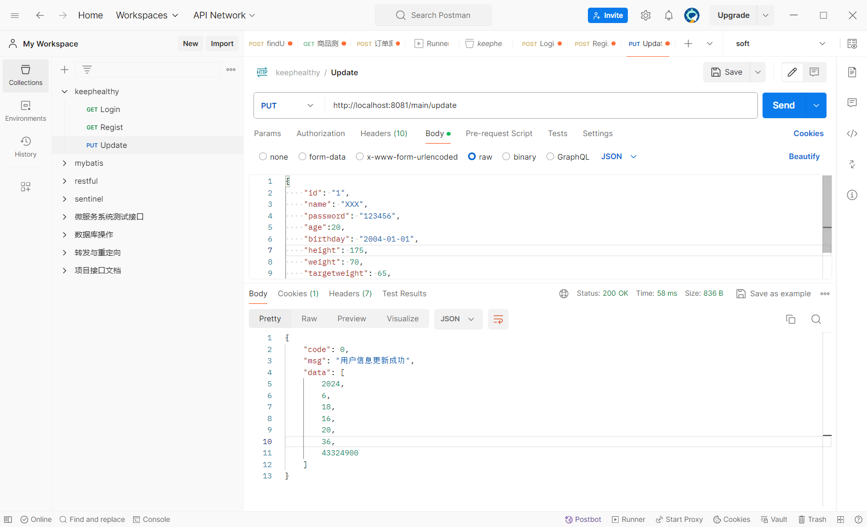

**Menu——获取食谱接口测试**

**http://localhost:8081/diet/getMenuRecord**

**例子：**

**menu的sql脚本：**

**CREATE TABLE menu (**

**menuId VARCHAR(50) PRIMARY KEY,**

**make VARCHAR(255),**

**image VARCHAR(255),**

**tips VARCHAR(255),**

**calorie DOUBLE**

**);**

**INSERT INTO menu (menuId, make, image, tips, calorie) VALUES**

**('1', '拌土豆丝', 'image1.jpg', '美味又简单的土豆丝', 120.0),**

**('2', '麻辣香锅', 'image2.jpg', '香辣爽口的川菜经典', 350.0),**

**('3', '清蒸鱼', 'image3.jpg', '健康又营养的清蒸鱼', 180.0),**

**('4', '凉拌黄瓜', 'image4.jpg', '清凉开胃的夏日小食', 50.0),**

**('5', '牛肉面', 'image5.jpg', '充满回忆的正宗牛肉面', 300.0);**

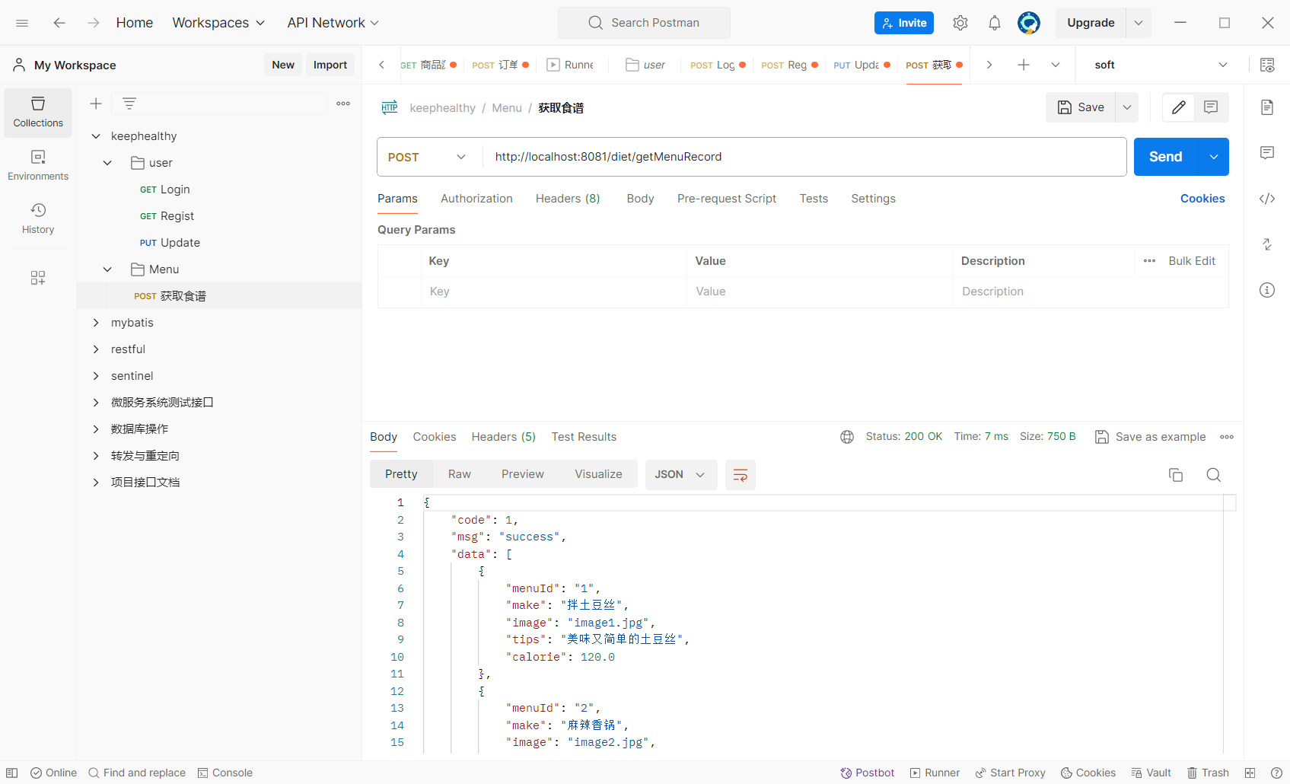

**Sport——获取所有运动类型接口测试**

**http://localhost:8081/sport/type/getSportType**

**sql：**

**CREATE TABLE sport_type (**

**sport_id INT PRIMARY KEY,**

**sport_name VARCHAR(255),**

**single_calorie INT**

**);**

**INSERT INTO sport_type (sport_id, sport_name, single_calorie) VALUES**

**(1, '跑步', 100),**

**(2, '游泳', 150),**

**(3, '篮球', 120);**

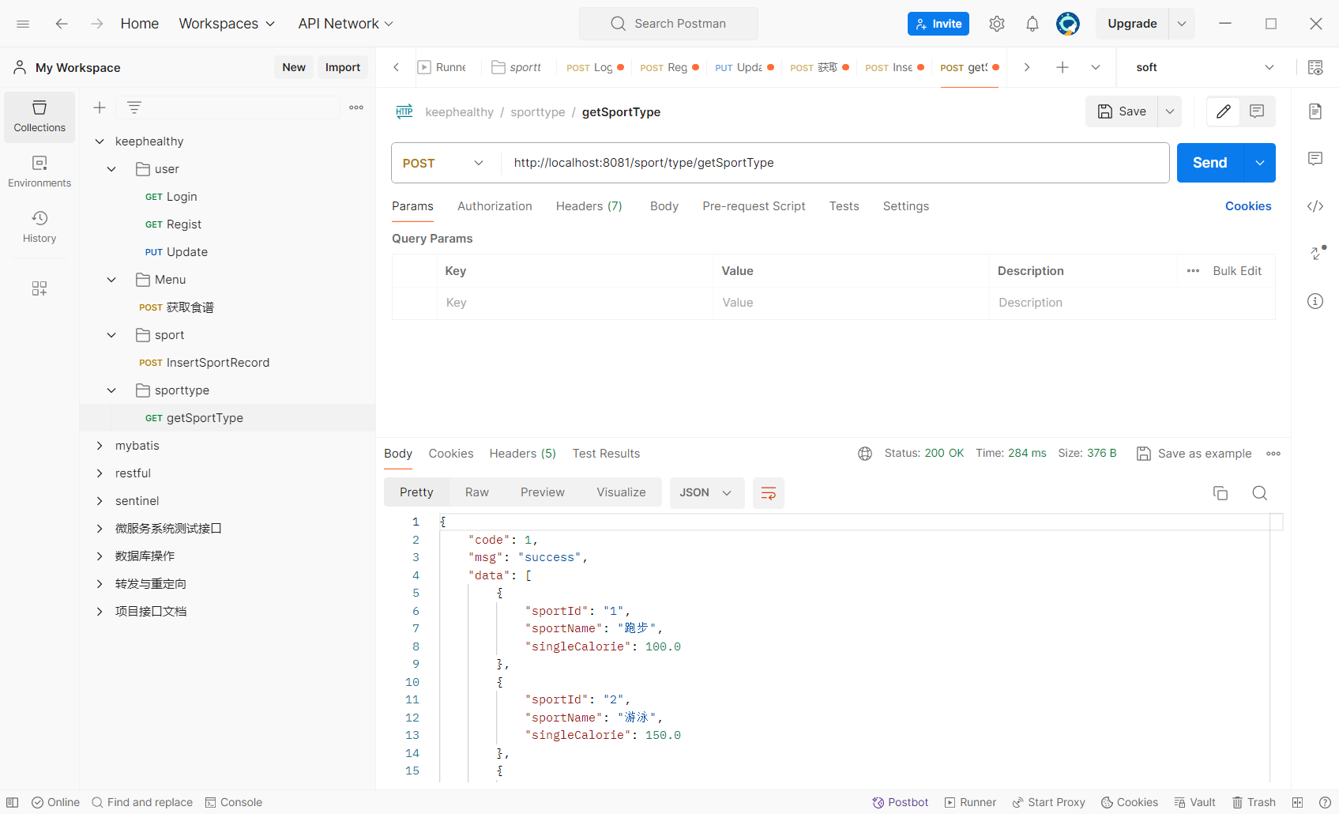

**Sport——获取单个运动类型接口测试**

<http://localhost:8081/sport/type/getOneSportType?sportId=1>

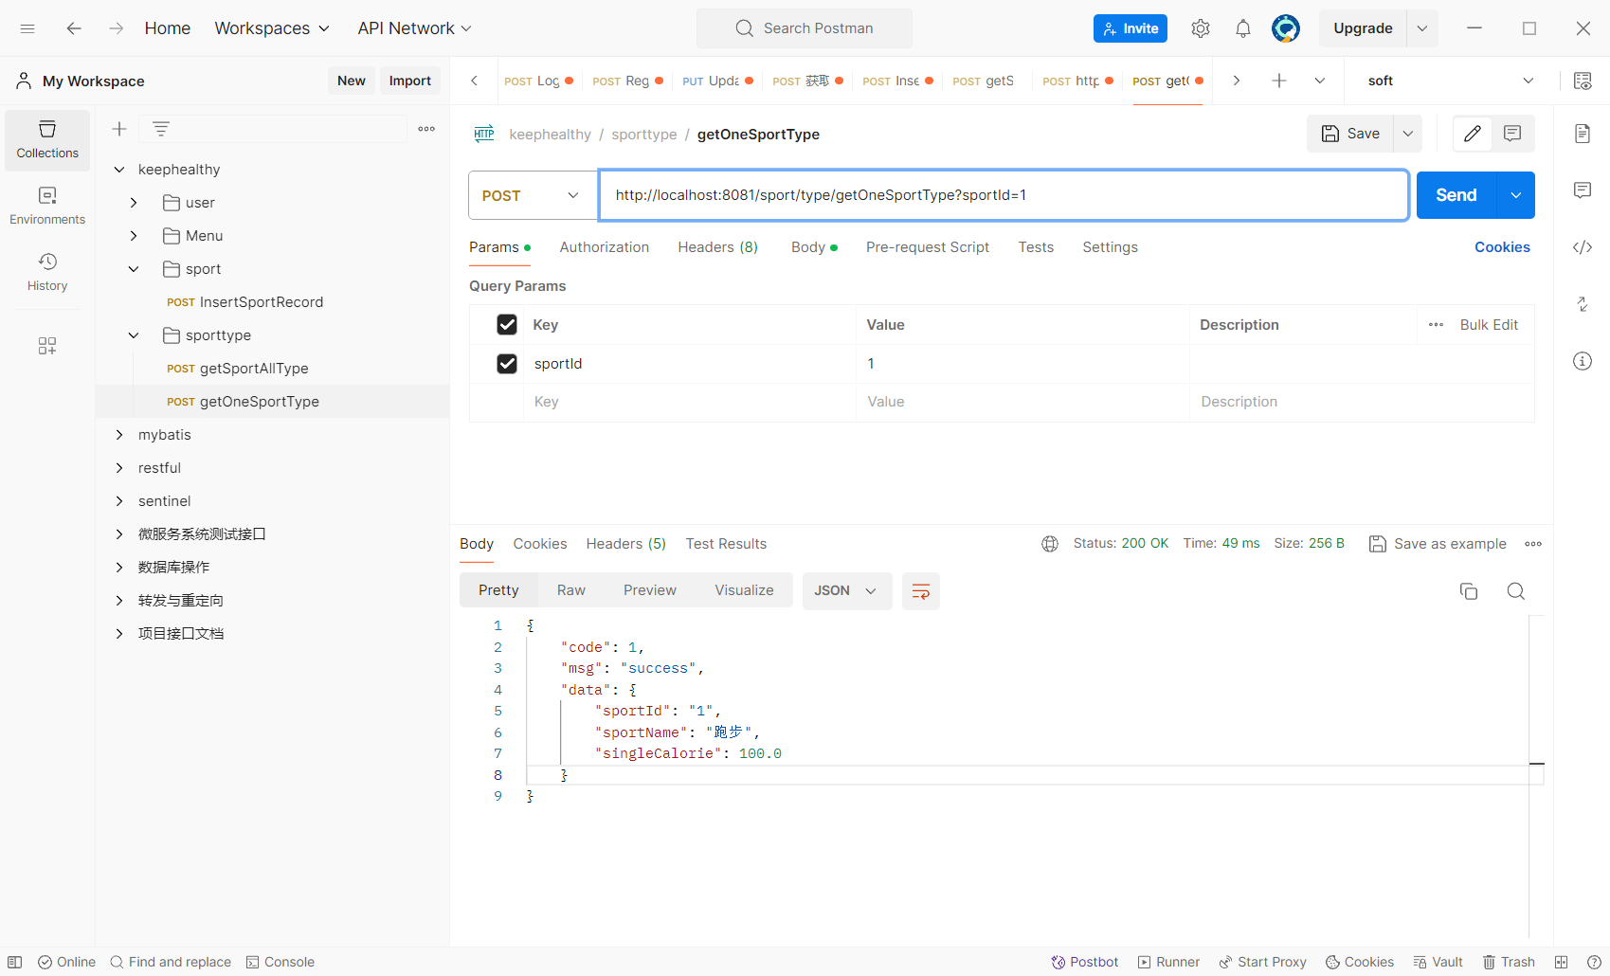

**Sportrecord——插入运动记录接口测试**

**例子：http://localhost:8081/sport/insertSportRecord?lastTime=100&userId=1&sportId=2**

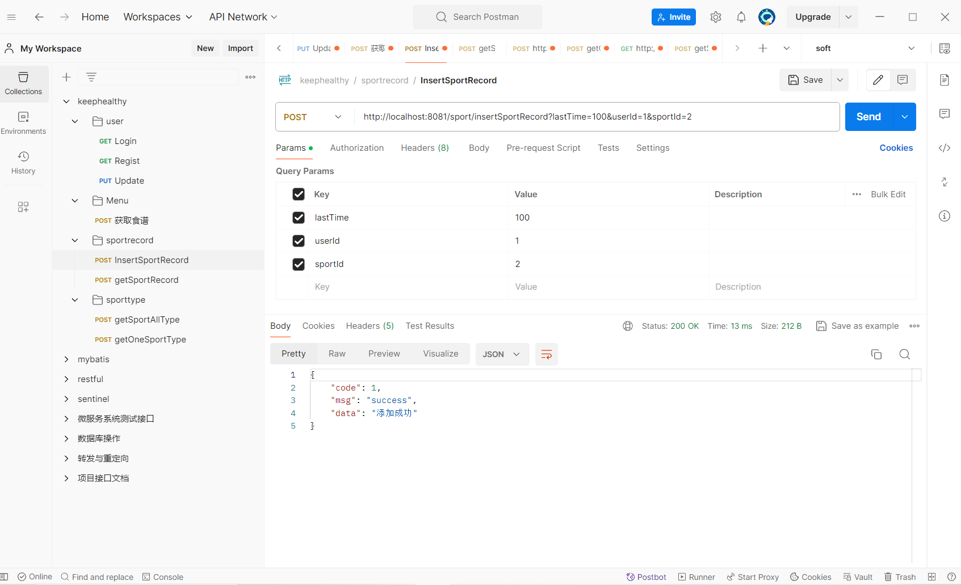

**Sportrecord——查询用户运动记录**

**<http://localhost:8081/sport/getSportRecord?userId=123456>**

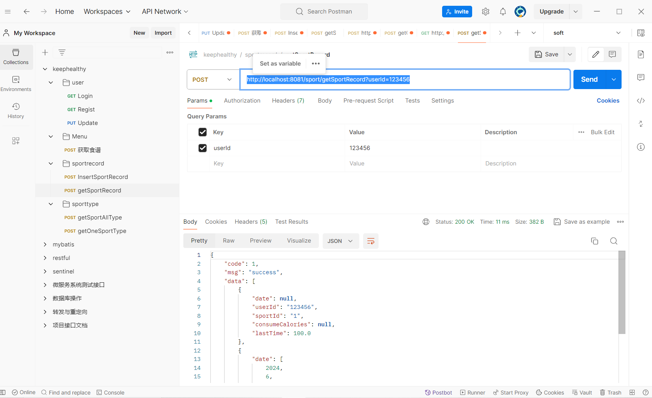

**健康分析——getHealthyDate**

**http://localhost:8081/healthyanalysis/getHealthyDate?date=2024-06-21**

（数据库要有数据的前提再查询）

**Params填入date**

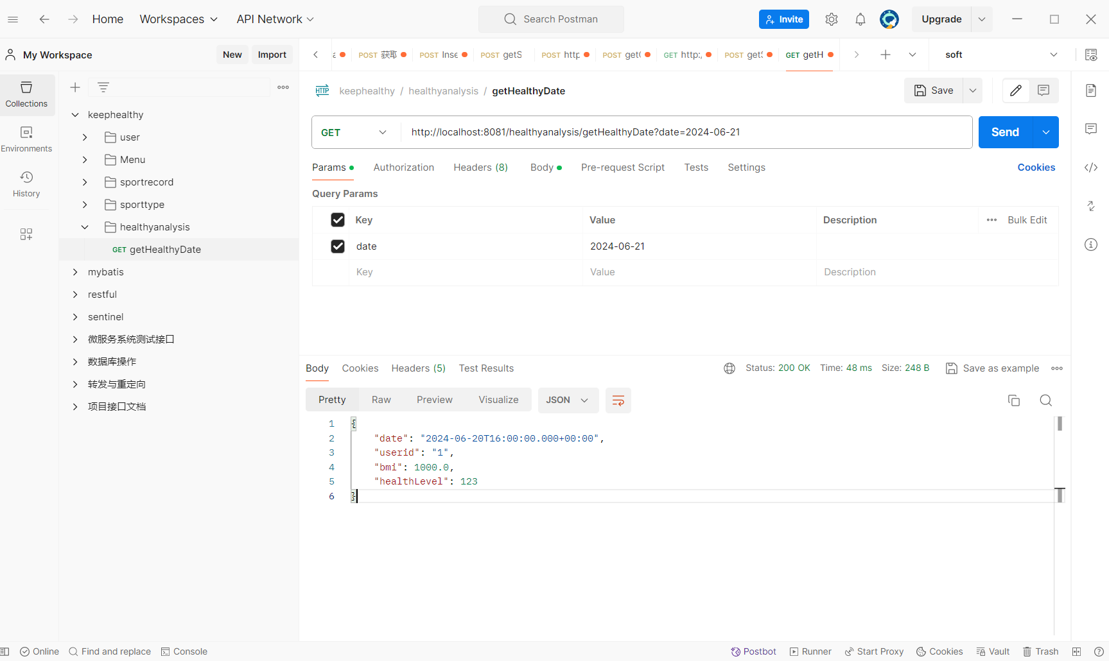

**Body中的raw中填入user信息，如下图**

