Jian Xu

[jxu72364@usc.edu](mailto:jxu72364@usc.edu)

Problem1

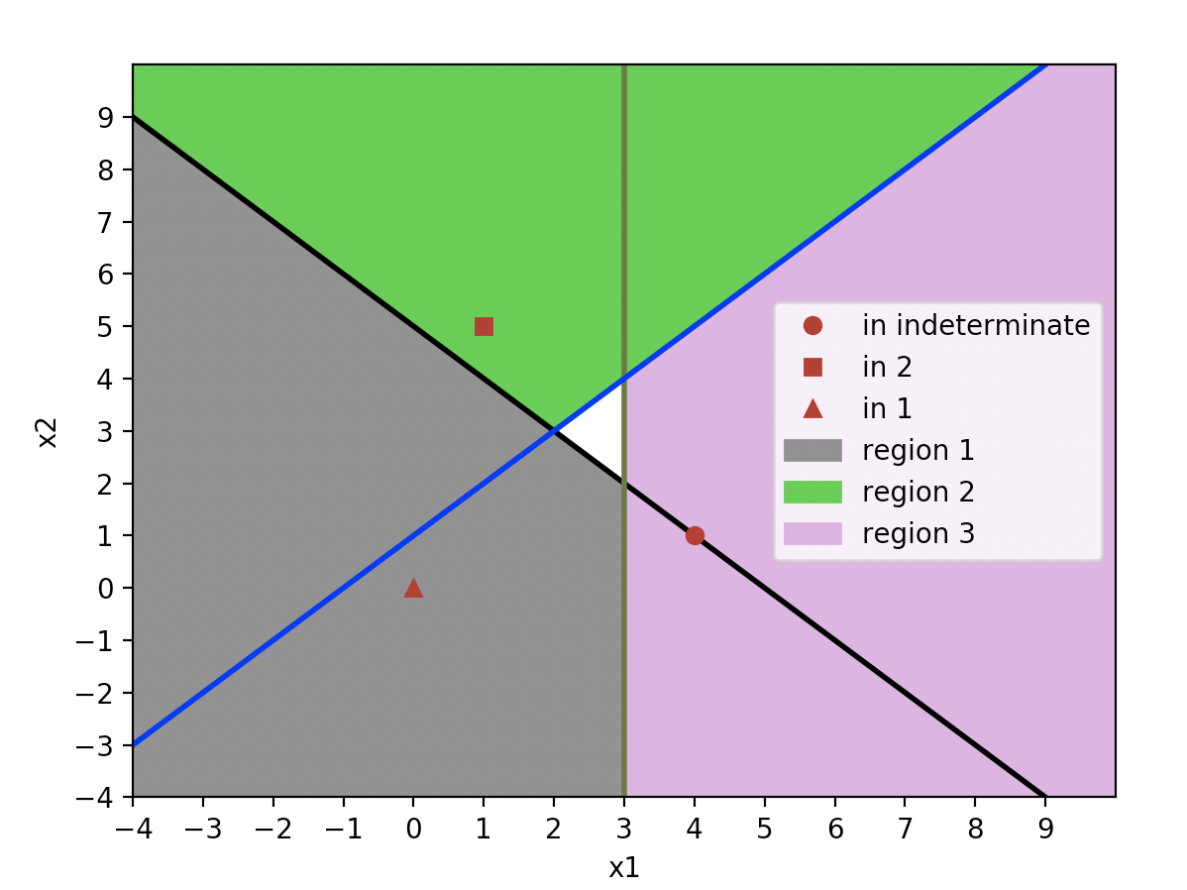

We can find that the white area is indeterminate regions, and Point(0,0) belongs to region1. Point(1,5) belongs to region 2.

Point(4,1) cannot be classified because it is exactly on the decision boundaries.

Problem2

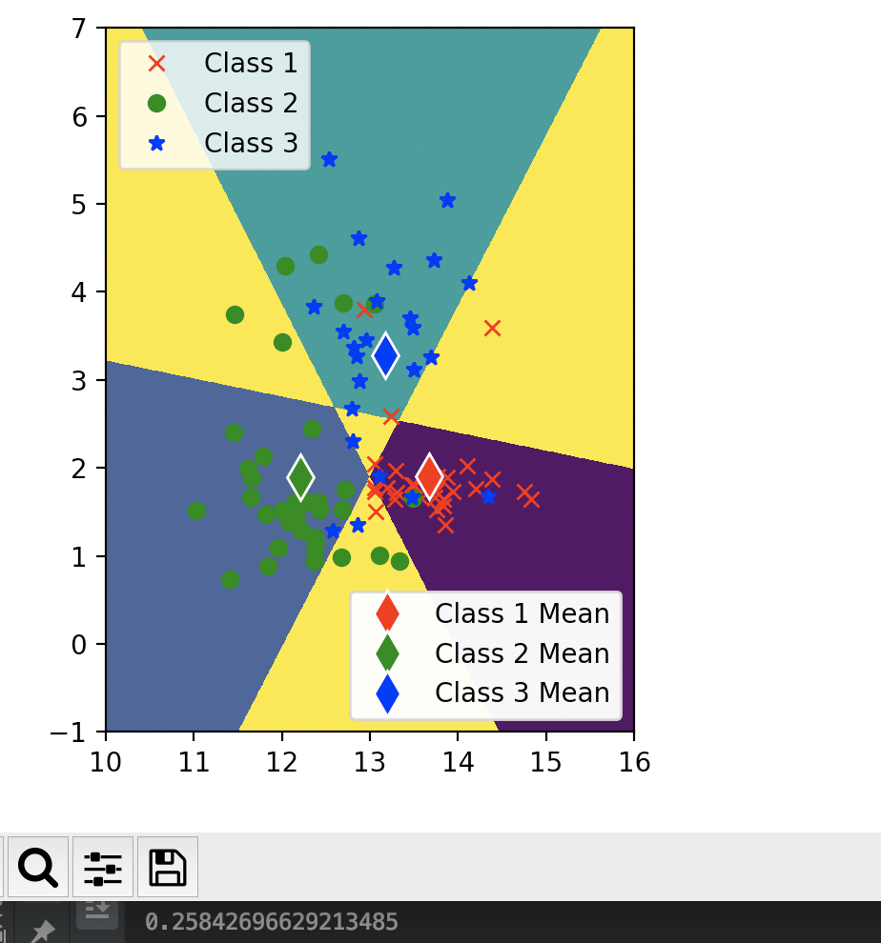

Using x1 and x2, the classification error on the training set is about 0.258426966

Therefore, the accuracy on training set is about 0.741573034

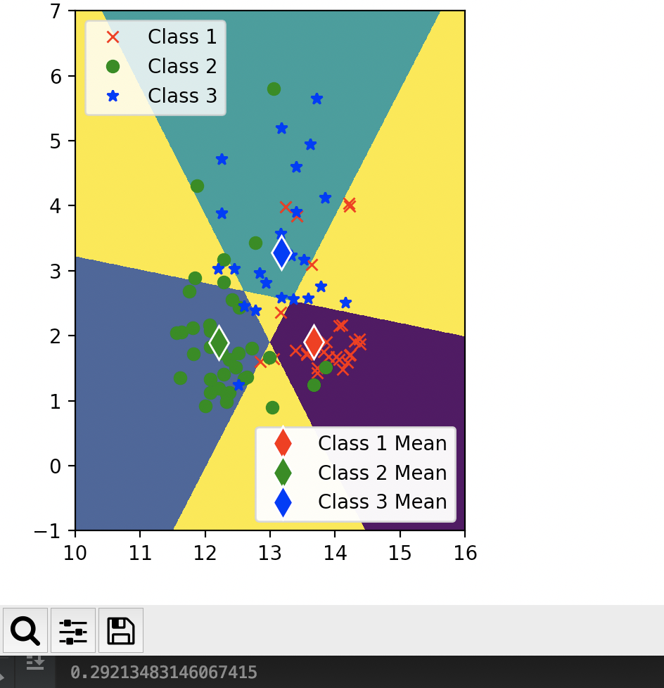

Using x1 and x2, the classification error on the testing set is about 0.292134

Therefore, the accuracy on testing set is about 0.7078651

Problem3

（a）

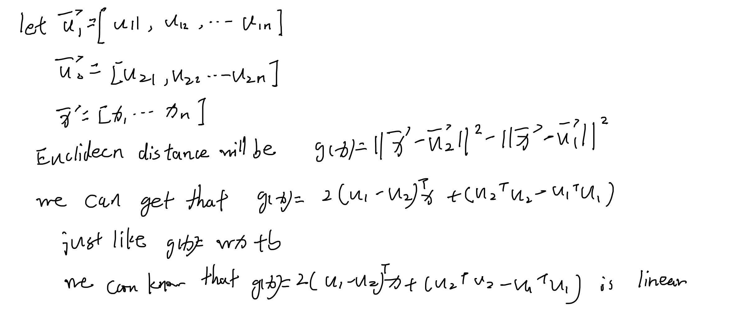

（b）

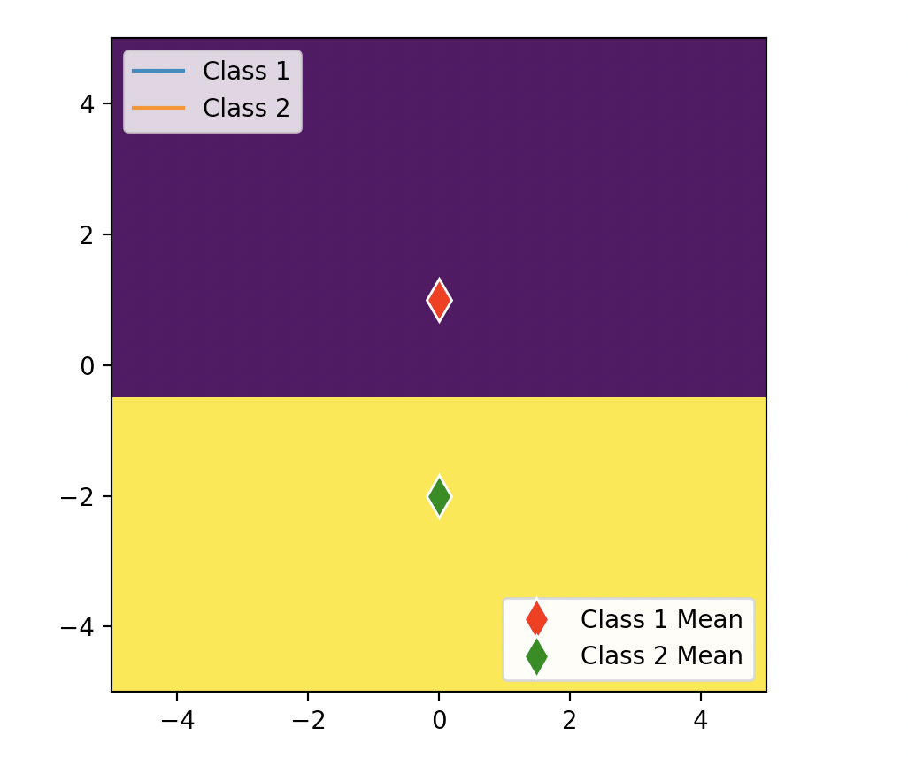

(c)

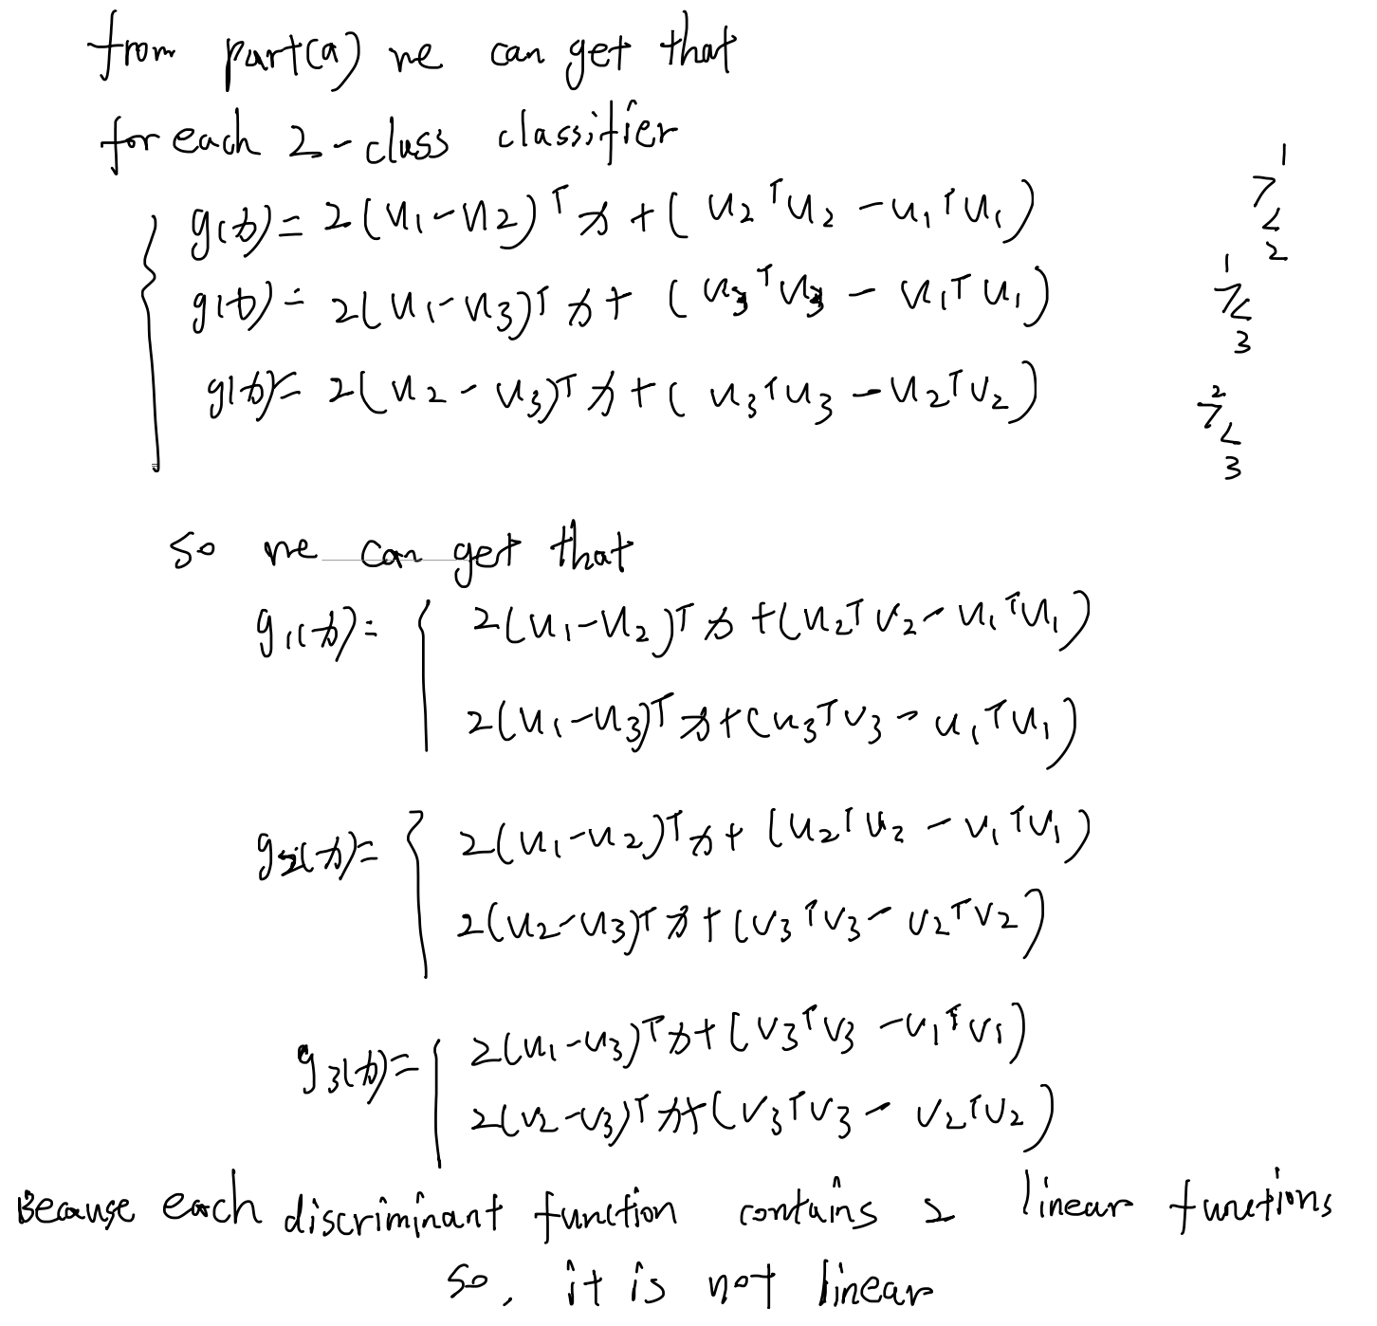

(d)

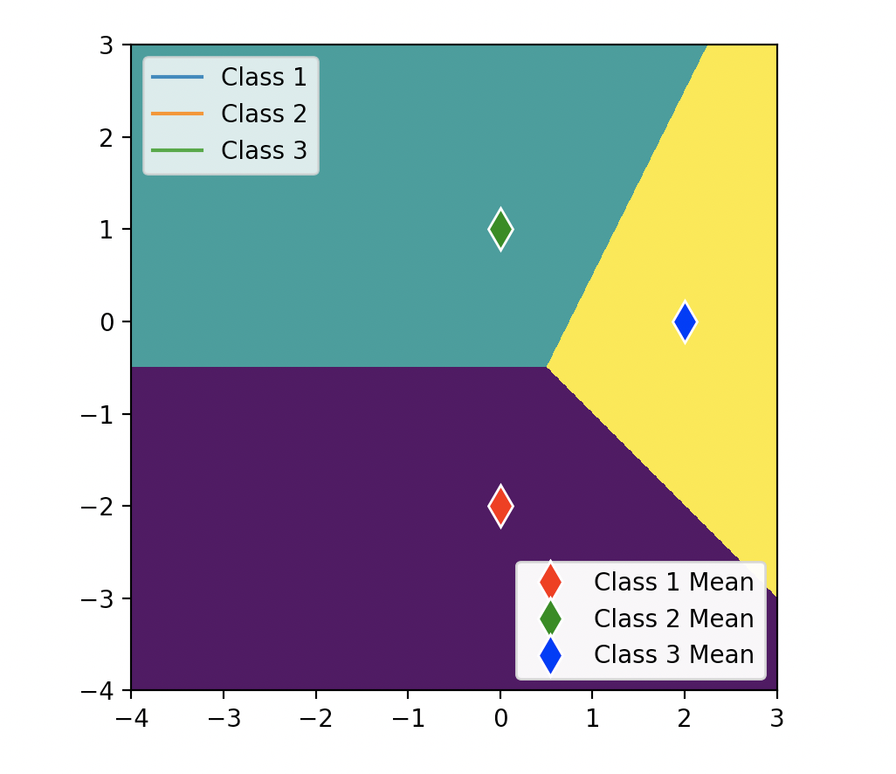

Problem4

