Jian Xu

[jxu72364@usc.edu](mailto:jxu72364@usc.edu)

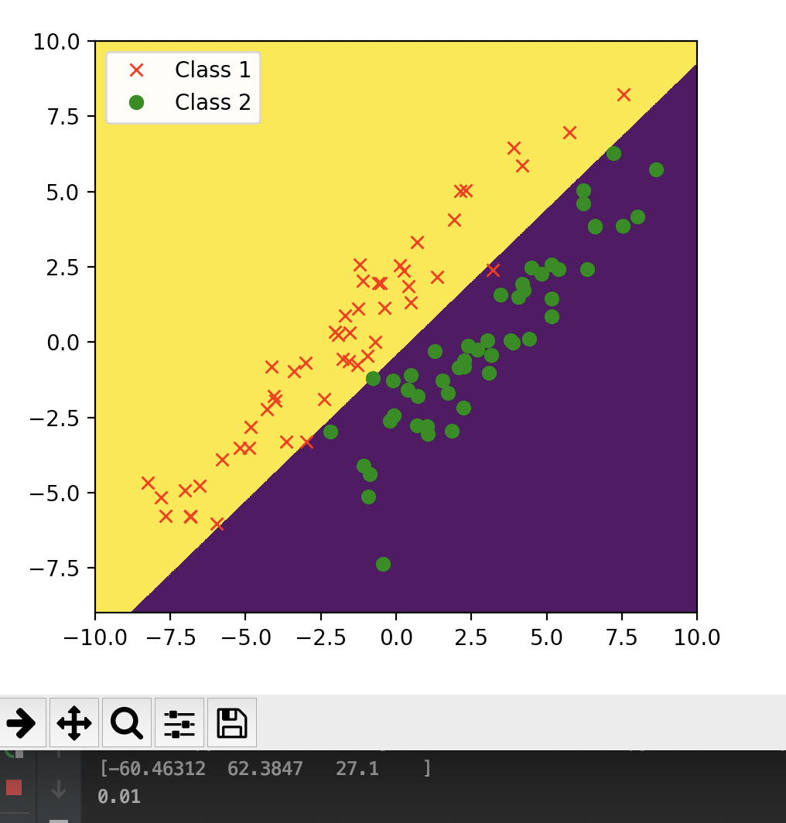

the classification error rate on the training set sythetic1 is 0.01

the weight vector is[-60.46312 62.3847 27.1]

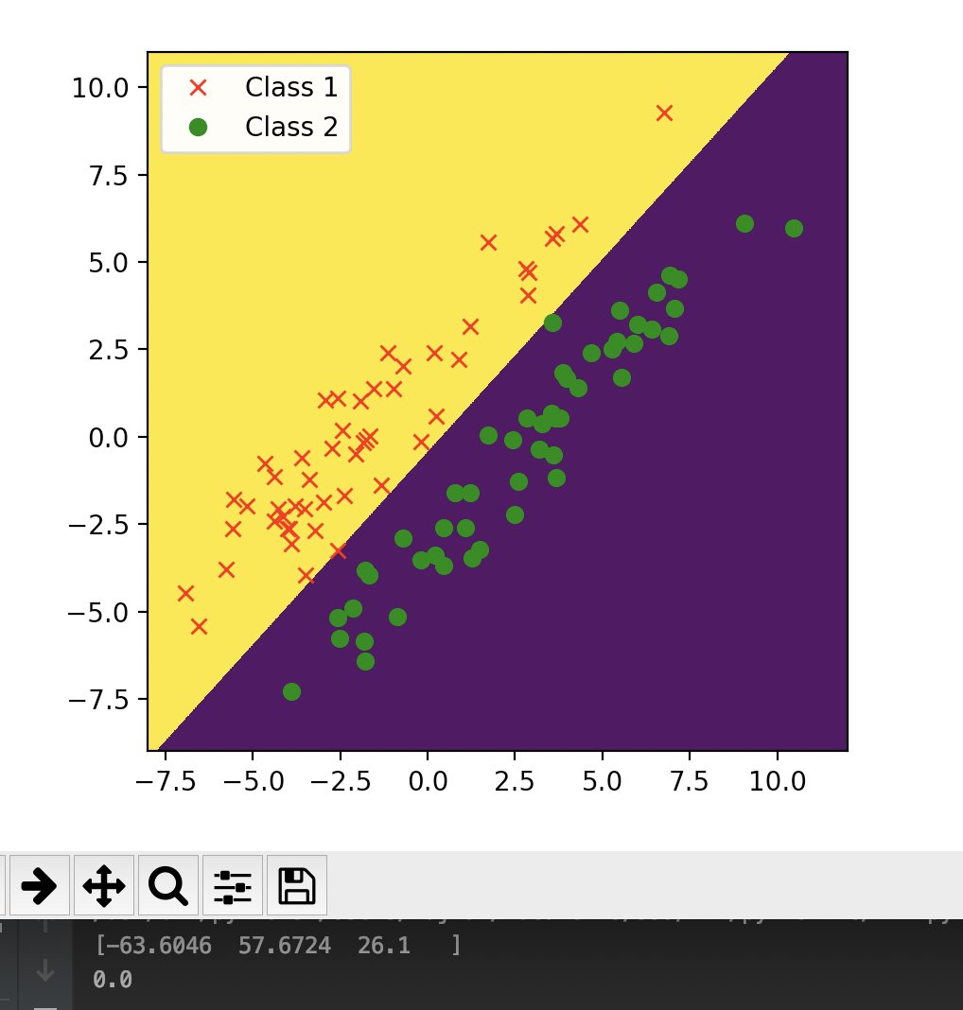

the classification error rate on the test set sythetic1 is 0.0

the weight vector is[-63.6046 57.6724 26.1]

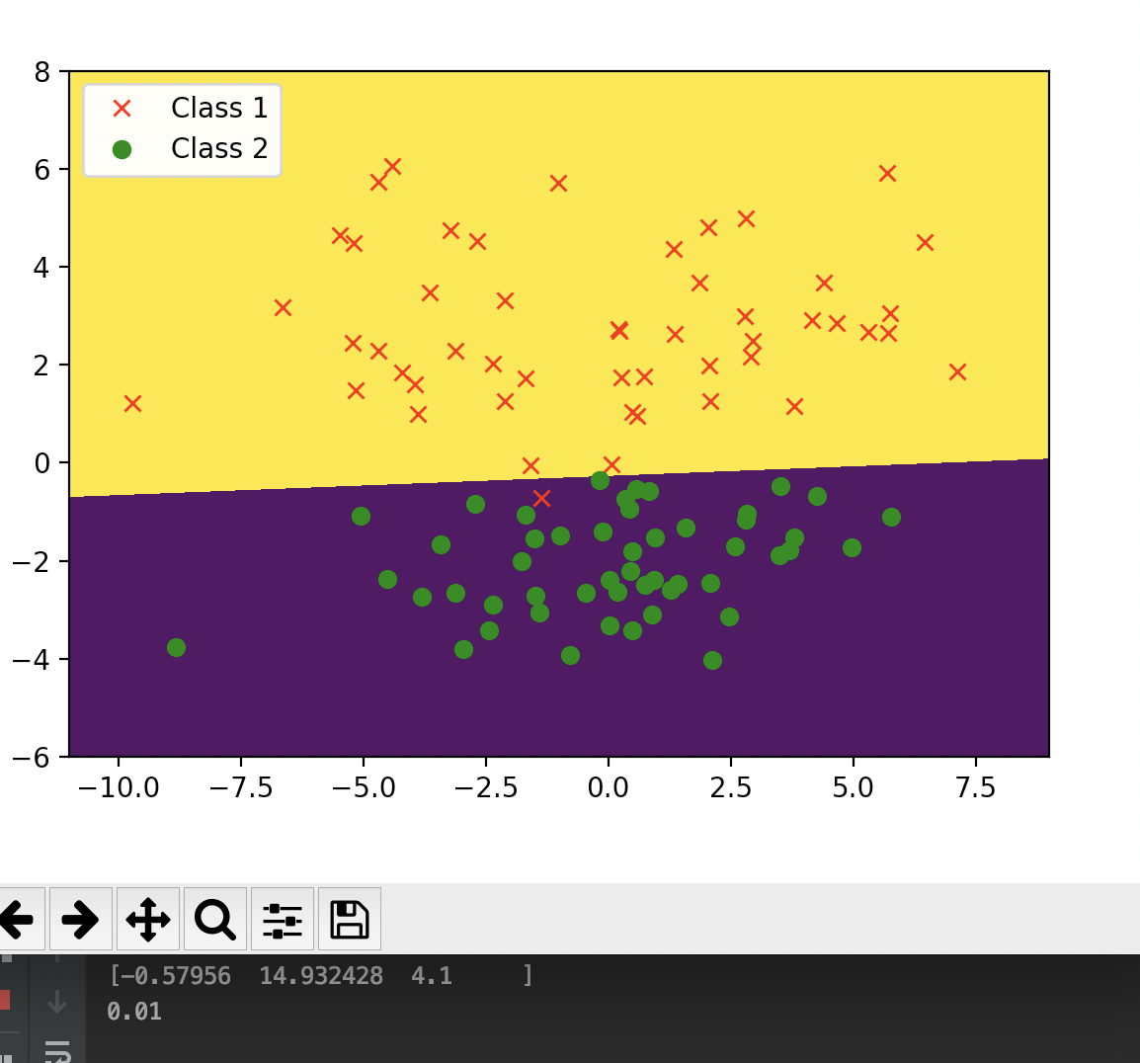

the classification error rate on the training set sythetic2 is 0.01

the weight vector is[-0.57956 14.932428 4.1]

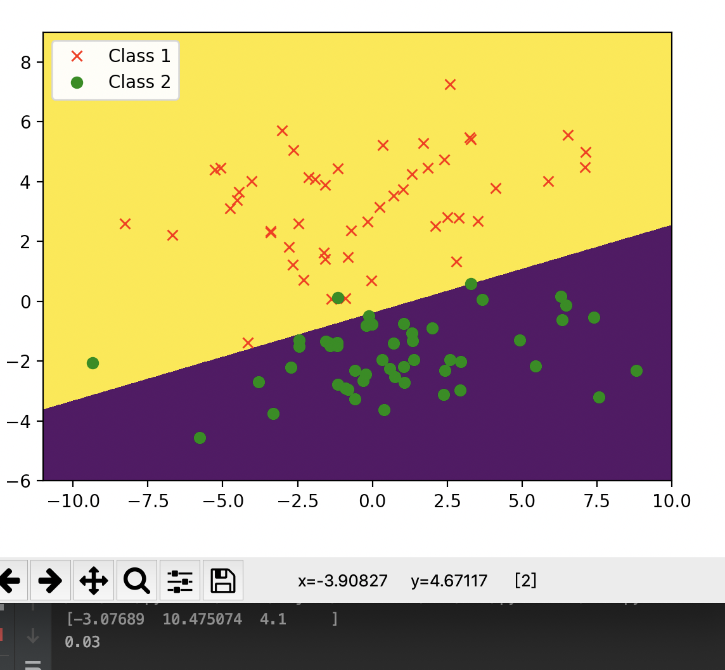

the classification error rate on the test set sythetic2 is 0.03

the weight vector is[-3.07689 10.475074 4.1]

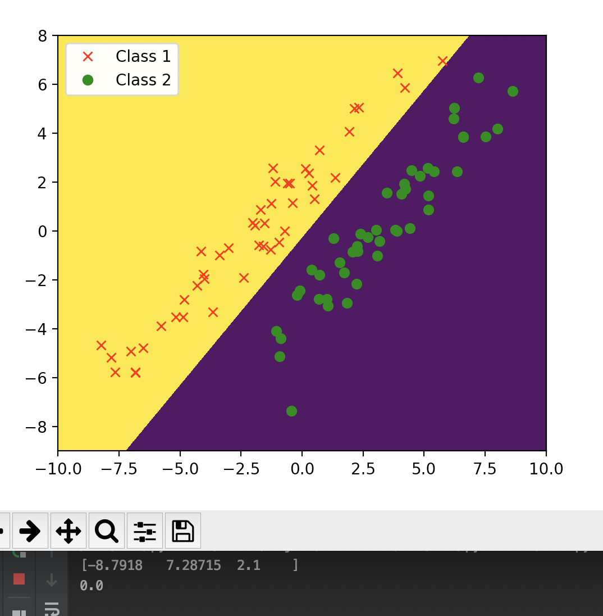

the classification error rate on the training set sythetic3 is 0

the weight vector is[-8.7918 7.28715 2.1]

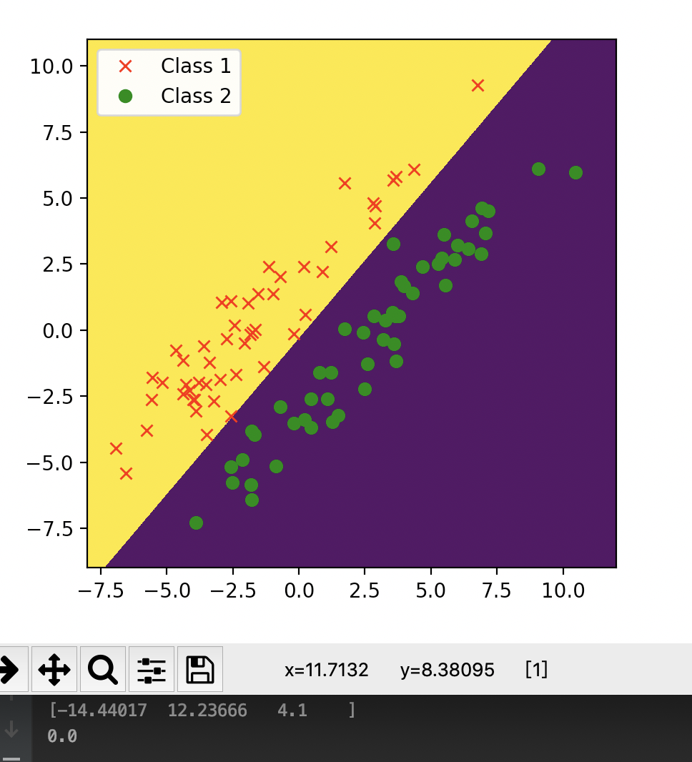

the classification error rate on the test set sythetic3 is 0

the weight vector is[-14.44017 12.23666 4.1]

(C)

Using nearest means, the error rates of training and test set for synthetic1 are 0.21 and 0.24, for sythetic2 are 0.03 and 0.04.

Using perceptron, the error rates of training and test set for synthetic1 are 0.01 and 0, for sythetic2 are 0.01 and 0.03.

We can find that because the distribution of the datasets is different, sometimes using nearest means can get the results as good as perceptron, but sometimes it cannot.

But in the data sets synthetic1 and synthetic2, perceptron always has a good result.

