深圳大学考试答题纸
(以论文、报告等形式考核专用)
二○ 一八 ～二○ 一久 学年度第 一 学期
课程编号 | 1503100001 |  | 课程名称 |  | 移动设备交互应用 |  | 主讲教师 |  | Basker George | 评分
学 号 |  |  | 姓名 |  |  | 专业年级
教师评语：(Every team member should submit report)
Marking scheme is as follows: Maximum points: 100

Sr. No | Marking Topic | Maximum Points | Points Scored
1) | HTML code | 10 Points
2) | CSS code | 10 Points
3) | JavaScript / JQuery | 10 Points
4) | PHP code | 10 Points
5) | Animation | 10 Points
6) | SQL codes | 10 Points
7) | Site Map and Wireframe mode of your Web Pages | 10 Points
8) | Responsive Design | 10 Points
9) | Report | 10 Points
10) | Demo and Power Point Presentation | 10 Points
Total Score

Basker George

8th January, 2019

Signature of every Team member:

题目： |  | 《TaoKe:A course evaluation system(淘课课程评价系统)》report

1 Project requirement analysic
  - Background
Everytime we have to choose lessons and teachers, we will find that I don’t know which teacher is suitable, which lessons I actually want to learn. Why is that? When we choose class, what we can get from the page is the lessons’ name and it’s teacher. It’s not enough to figure out whether this lesson is worthy.
  - Purpose
This website is aimed to solve this problem. We will provide a platform which student who have take this lessons before can markdown their advises and score the lessons and teachers. What’ s more, as the runner, we will provide the textbook list and some review file to students.
  - User analysic
This system is built for student who have no idea on what this lessons will teach and whether this lesson’s teacher is good enough or not. So, SZU students are the main user.
  - System main features
    - Courses search
Student can search the course freely.
    - Courses introduction
Student can know about what this course will teach.
    - Courses teacher appraise
Student can know whether the teacher is suitable.
    - Courses textbook
The website will provide the textbook needed in courses
    - Courses review file
The website will provide some documents which include abstract knowledge and examination range.
    - Article sharing
Student acess the website will see some good articles.
  - Tools and envirement
    - Tools
Hbulider, XAMPP（SyApache+MySQL+PHP+PERL）
1.5.2 Envirement
Windows 10 version 1803
- Project design
  - Wireframe
    - Index
Large(PC):
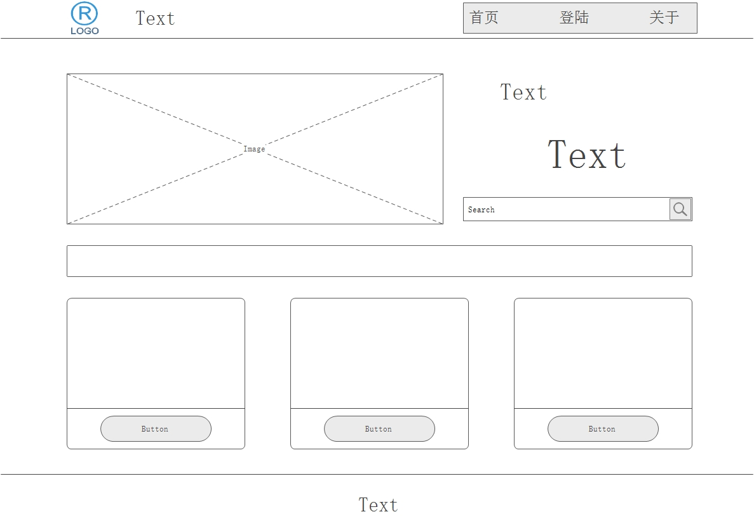
Middle(tablet):
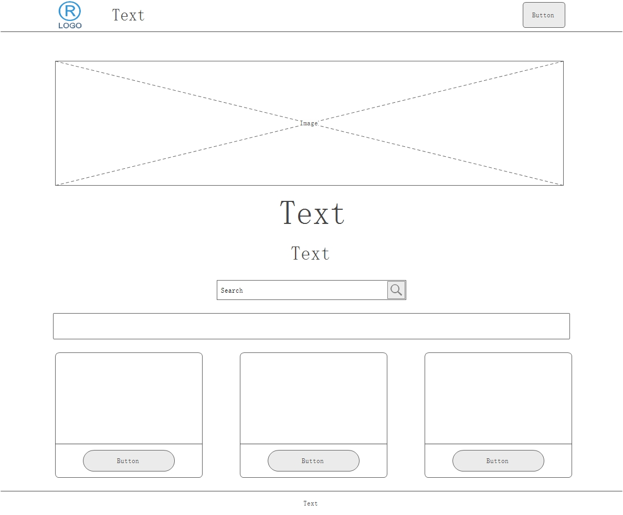
Small(phone):
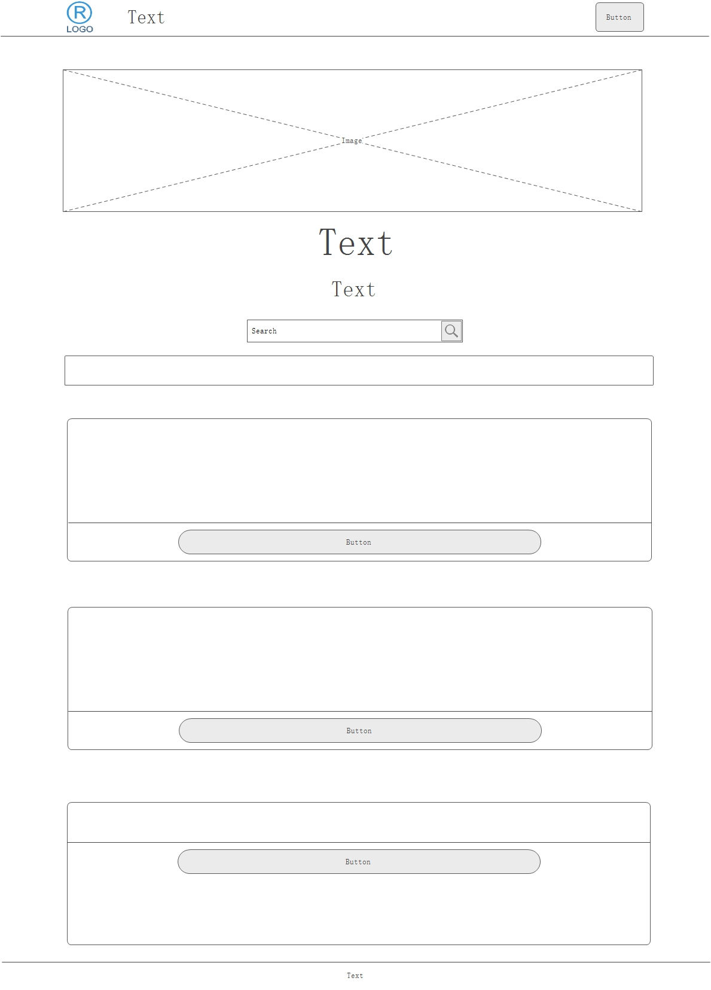
    - Courses
Middle&small:
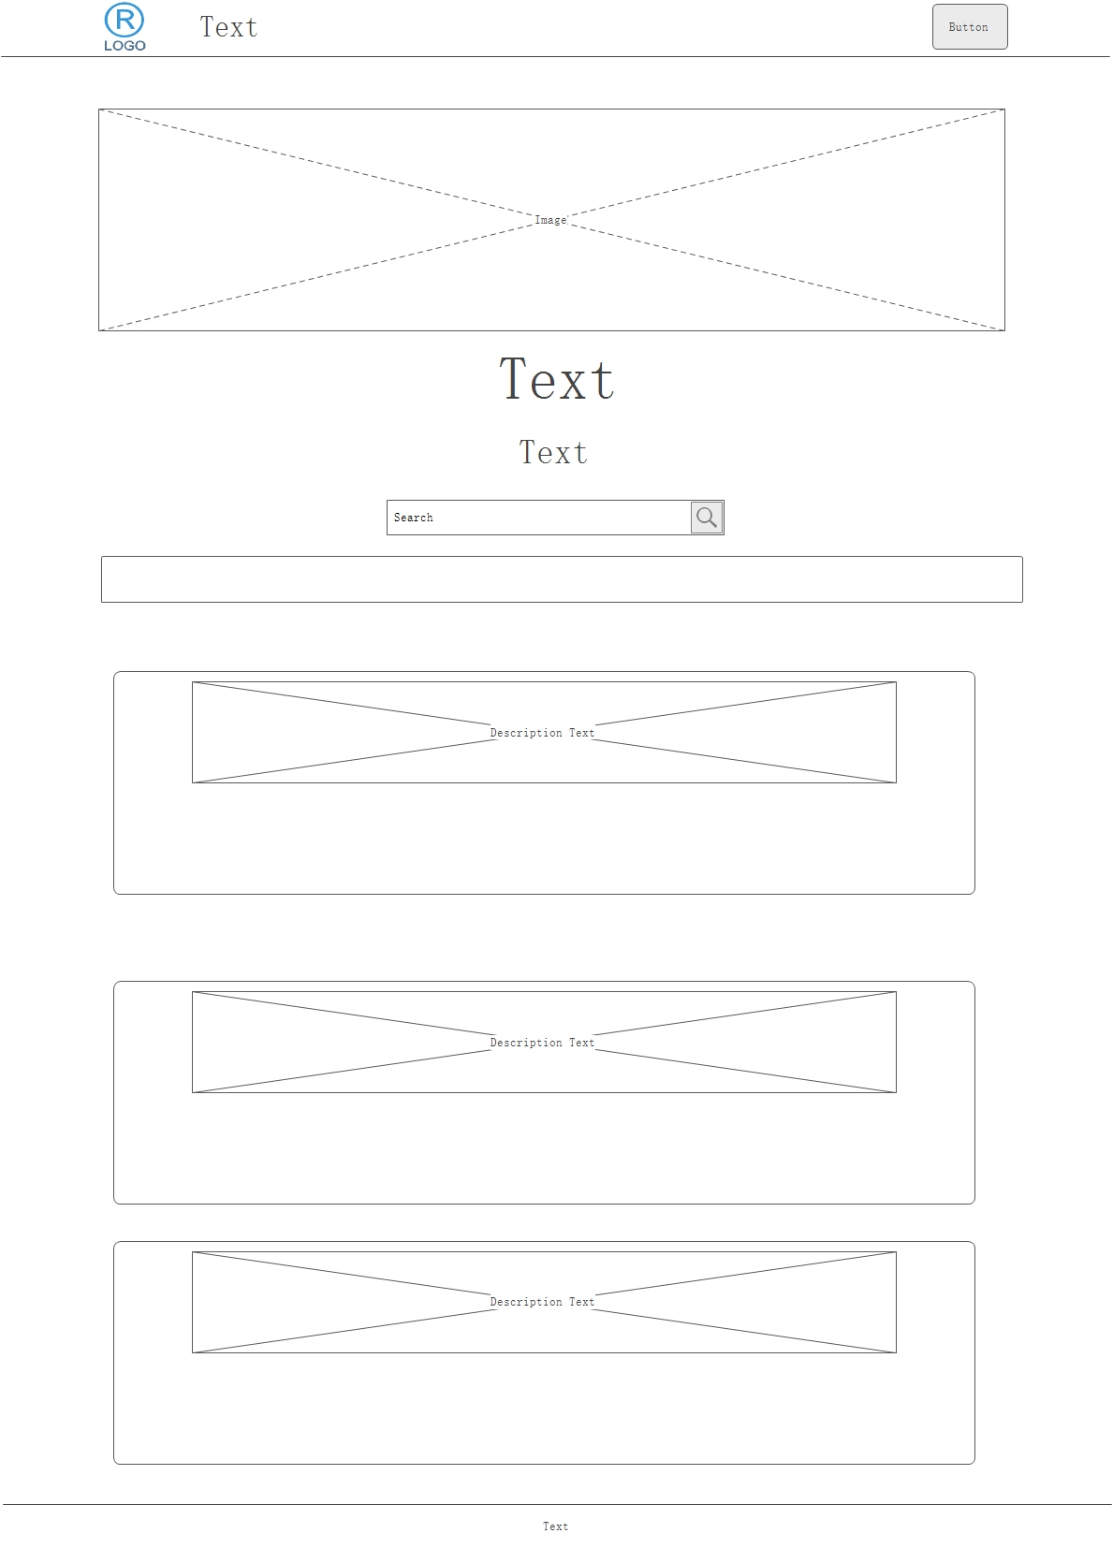
Large:
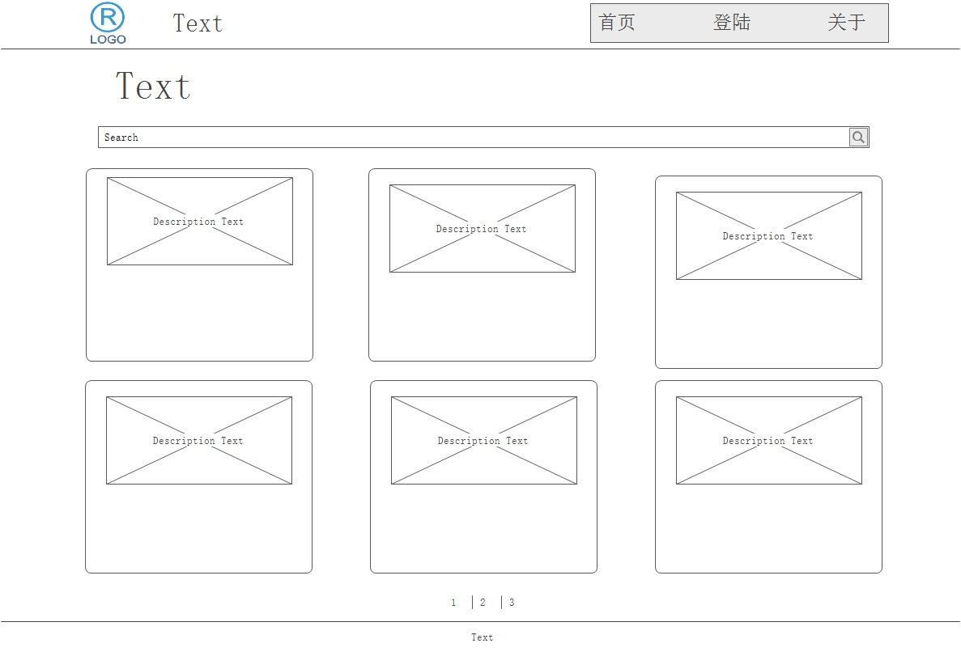

    - Course-detail
Large:
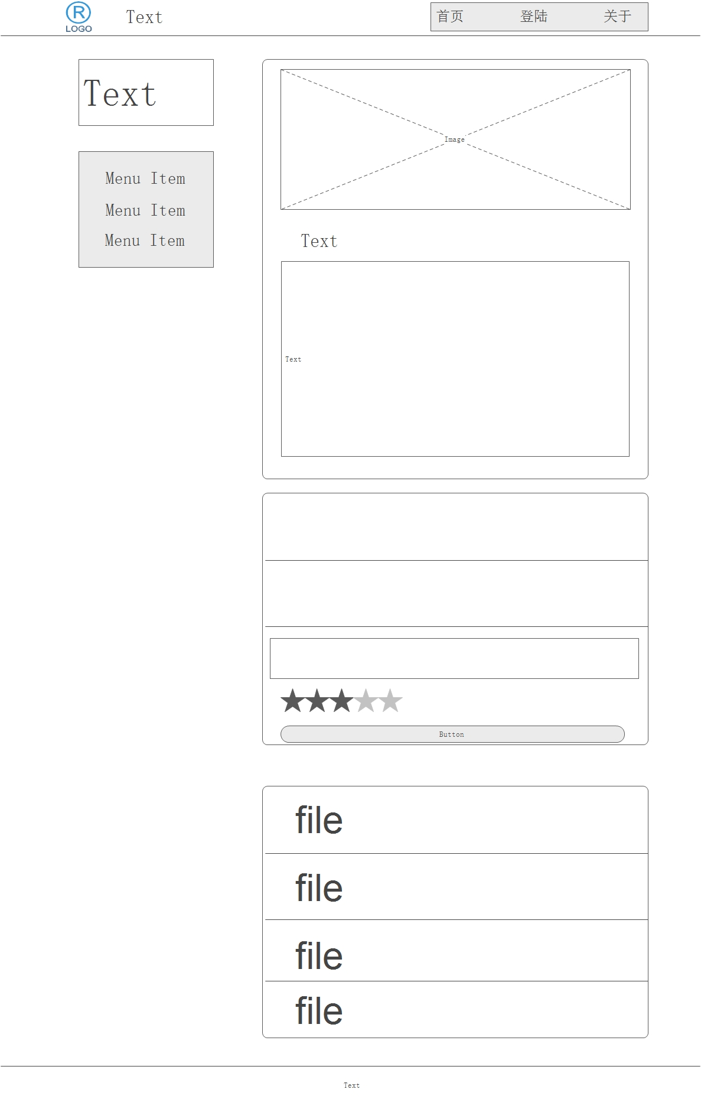
Middle&Small:
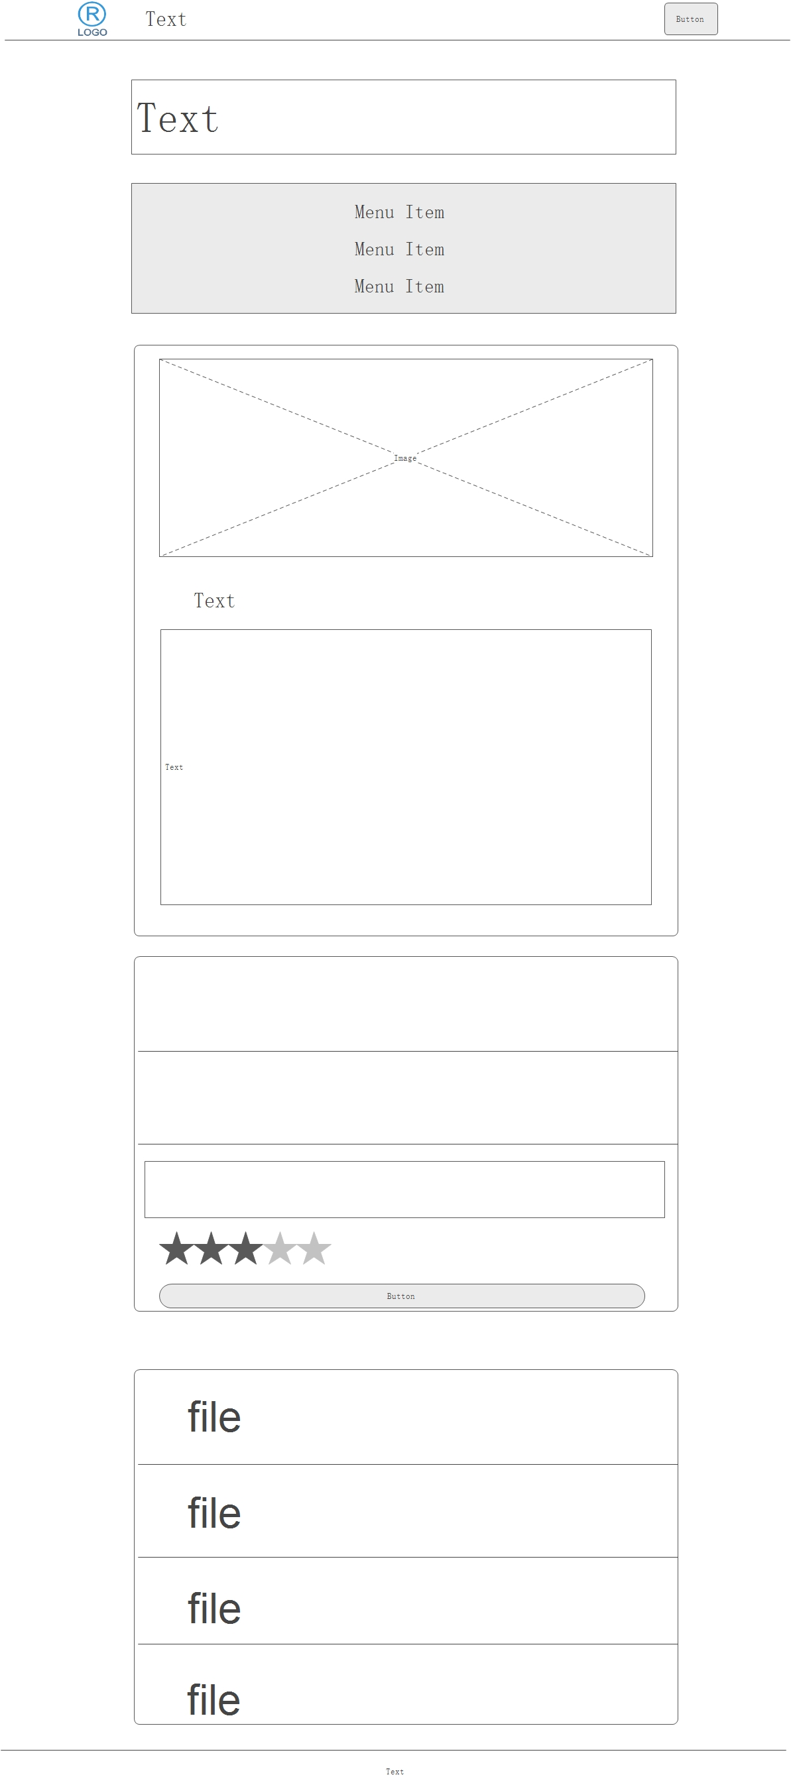
  - Sitemap
http://127.0.0.1:8020/mobile-web/pcourse/index.php
http://127.0.0.1:8020/mobile-web/pcourse/course.php
http://127.0.0.1:8020/mobile-web/pcourse/course-detail.php
http://127.0.0.1:8020/mobile-web/pcourse/About.php
http://127.0.0.1:8020/mobile-web/pcourse/article.php
http://127.0.0.1:8020/mobile-web/pcourse/self-info.php
http://127.0.0.1:8020/mobile-web/pcourse/comment.php
http://127.0.0.1:8020/mobile-web/pcourse/login.php
http://127.0.0.1:8020/mobile-web/pcourse/logout.php

- User guide

TaoKe User Guide
- Login&Logout
  - regesit
  - login
  - logout
- Self-information
- Search Course
- Course-detail
  - Comment
  - Textbook
  - Review file
- Sharing article
- About

