训练采用12组数据

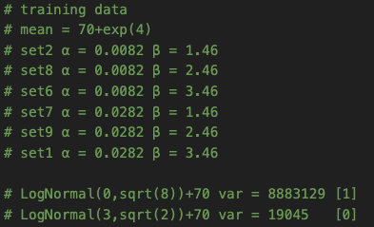

所有看的见的点，ab tau都看得见 的拟合效果不错



ab看的见，tau看不见也是OK的

a = 0.0282 b = 3.46



a = 0.0282 b = 2.46



a = 0.0282 b = 1.46



a看的见，b和tau看不见

a = 0.0282 b = 2.96



a = 0.0282 b = 1.96



b看的见，a和tau看不见，预测的不好

a = 0.0232 b = 3.46



a = 0.0232 b = 1.46



ab tau都看不见，预测的并不好

# set = 3

# a = 0.0182

# b = 2.46



# set = 4

# a = 0.0232

# b = 2.96



Inference结果并不好

a=0.0282 b=3.46 对tau~Logn(1,sqrt(6)) [0.667] 和 tau~Logn(2,sqrt(4)) [0.333]进行预测 50w次SSA的结果



五次不同SSA 做Inference的参数解出的distribution和SSA的对比，都很接近

Attribute = [0.667]



Attribute = [0.333]



a=0.0282 b=2.96



五次不同SSA 做Inference的参数解出的distribution和SSA的对比

Attribute = [0.667]



Attribute = [0.333]

