Design with Microprocessors

Project

NodeMCU

NodeMCU Communication Network

On Home Wi-Fi

Apreutesei Rares

Gr 30237

1. Project Schematic

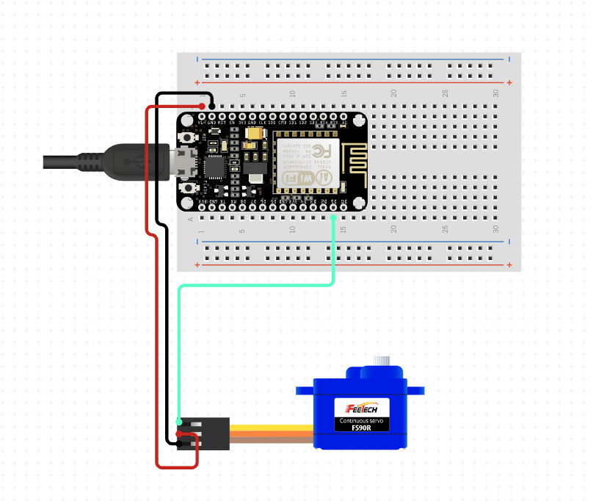

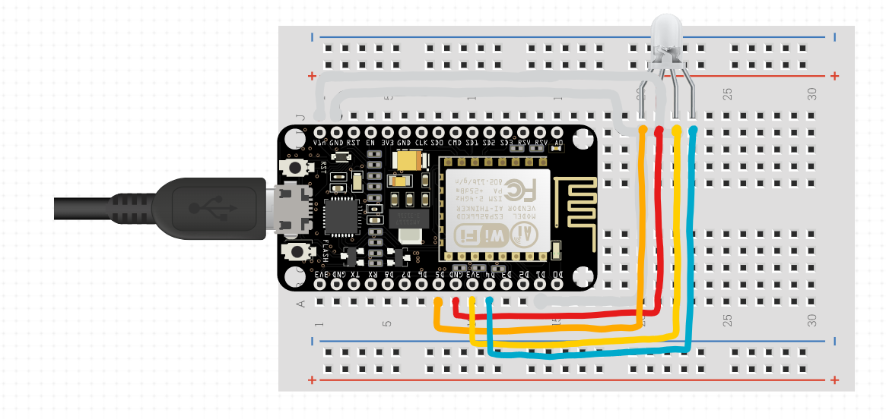

1. Components used

* 3x NodeMCU V3
* 1x Servo 9g Tower Pro
* 1x MG 996R TowerPro
* RGB led

1. Project functionality

This project consists in a number of NodeMCU boards controlled by a main NodeMCU acting like a HUB:

* The HUB creates a webserver with several buttons and controls that can be accessed from any device accessing the boards IP on the home Wi-Fi. It receives the inputs from the server through http requests and then processes them and sends the relevant information to the other boards.
* The buttons send 2 numbers to the board through an http get request to the board, the first number representing which board to control, the other the state of the button, on or off.
* The first button controls a small servo. When the button is in the off position the servo is in its initial state of 0 degrees. When the button switches to the on position the servo turns 90 degrees.
* The second and third buttons control a 360 turning servo. When none of the buttons are in the on position the servo remains stationary. When the first button is switched on the servo will start rotating at full speed clockwise. When the second button is pressed the motor starts rotating counter clockwise.
* The color picker at the bottom of the page is used to choose a color. The hex value of the color is then transformed into 3 different values, R, G and B and then sent back to the board. The values are then sent to the RGB Led.
* The data from the webserver is sent through a xmlhttprequest, for the motors on the /update with the format /updata?output=<>&state=<> path and for the color on the /color path as /color?R=<>&G=<>&B=<>.
* Communication between boards is done through a packet represented by a struct with an int which represents the state of the motors, on or off.
* I’ve chose this project because I wanted a cheap and personalized way of automating my home. I also chose to implement it this way, with a hub connected to the Wi-Fi and the other slaves connected directly to the hub, because it added a bit more security then using the home router as a so called hub.
* Other improvements to the project would be adding some sort of login or personal token which would boost the security of the connectivity. Adding a heatsink to the chips would also help prevent any damage from overheating.