# 20171129第十三周上机

完成以下任务, 最终结果保存到文件”学号姓名第十三周作业.sql”中，将结果文件打成压缩包，文件名为“学号姓名第十三周作业.rar”，上传到FTP上UPLOAD文件夹中我们的课程子文件夹内。

首先执行week13_base.sql和week13_datainsert.sql，完成库、表的创建，以及数据的导入工作。

1. 编写一个程序，创建一个静态只进游标读取表department的所有记录，打开游标后，首先显示表department的记录行数和游标状态，接着逐行显示表department的记录（用WHILE结构来测试游标的函数@@FETCH_STATUS的返回值），最后关闭和释放游标。

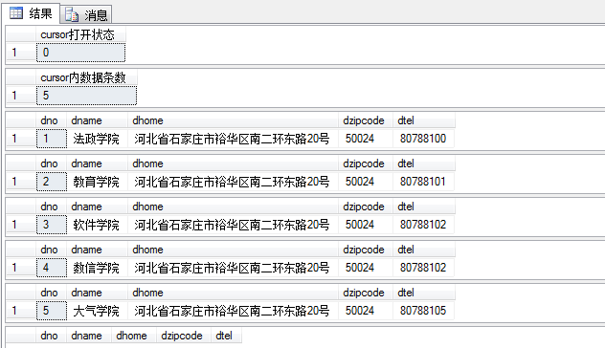

答：

declare cur_department cursor static forward_only

for

select * from department order by dno

go

open cur_department

go

select "cursor打开状态"=@@ERROR

select "cursor内数据条数"=@@CURSOR_ROWS

fetch next from cur_department

while(@@FETCH_STATUS=0)

begin

fetch next from cur_department

end

go

close cur_department

deallocate cur_department

1. 编写一个程序，声明一个滚动游标，读取student表中所有记录，打开游标后，依次读取并显示第一条记录、最后一条记录、从头数第3条记录和倒数第三条记录。

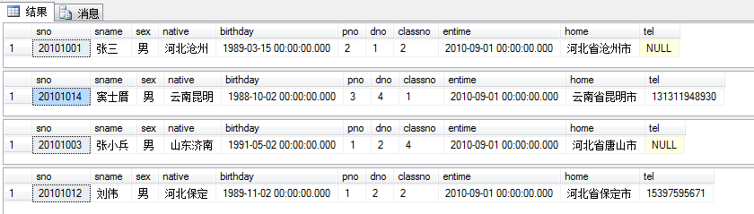

答：

use edu

go

declare cur_stu cursor scroll

for

select * from student

go

open cur_stu

fetch first from cur_stu

fetch last from cur_stu

fetch absolute 3 from cur_stu

fetch absolute -3 from cur_stu

close cur_stu

deallocate cur_stu

1. 创建存储过程，使用游标查询成绩表中所有成绩未登录的同学，按照下列格式输出相关同学的学号、姓名和课程信息。

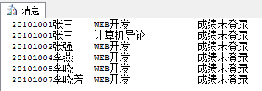

答：

drop procedure studentswithoutscore

go

create procedure studentswithoutscore

as

begin

declare cur_sc cursor static

for select sno,cno from student_course where score is NULL

declare @tsno char(8),@tcno char(10), @tsname char(8), @tcname char(20)

declare @msg char(20)

set @msg='成绩未登录'

--set @cur_sc = cursor for select sno,cno from student_course where score is NULL

open cur_sc

fetch next from cur_sc into @tsno,@tcno

while @@FETCH_STATUS=0

begin

select @tsname = sname from student where sno = @tsno

select @tcname = cname from course where cno = @tcno

print @tsno+@tsname+@tcname+@msg

--print @tsno + ':' + @tcno

fetch next from cur_sc into @tsno,@tcno

end

close cur_sc

deallocate cur_sc

end

go

exec studentswithoutscore

1. 创建存储过程printgrade，输入课程号，能按如下格式显示该课程的成绩单，并输出选修该课程的学生人数，如果输入的课程号不存在，输出 '输入错误，没有该课程号！'的错误提示信息。然后调用此存储过程输出课程编号为’2’的课程的相关成绩信息(要求在存储过程中使用游标技术逐行输出课程成绩单。)

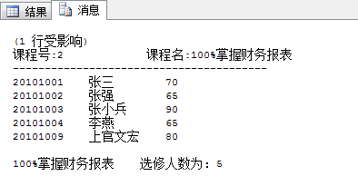

答：

drop procedure printgrade

go

create procedure printgrade(@cno char(10))

as

begin

DECLARE @sno VARCHAR(10),@grade int,@cname varchar(20),@sname varchar(20),@num int

declare stu cursor static

for

select student.sno,student.sname,student_course.score

from student,student_course

where student.sno=student_course.sno and student_course.cno=@cno

select top 1 * from student_course

where cno=@cno

if(@@rowcount=0)

begin

raiserror('您输入的课程号不存在！',16,1)

return

end

else

begin

select @cname=cname

from course

where course.cno=@cno

print '课程号:'+@cno+' '+'课程名:'+@cname

print '----------------------------------------'

open stu

set @num=@@CURSOR_ROWS

fetch next from stu

into @sno,@sname,@grade

while @@FETCH_STATUS=0

begin

print @sno+' '+@sname+' '+cast(@grade as char(3))

fetch next from stu into @sno,@sname,@grade

end

print ' '

print @cname+'选修人数为：'+cast(@num as char(3))

CLOSE stu

DEALLOCATE stu

end

end

go

exec printgrade '2'