# DL Lab 3

## New Images

Figure 0.1 lewis_2

Figure 0.2 lewis_1

## Output screen shots

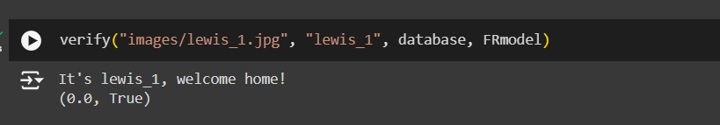

Figure 0.3 Face verification output for lewis_1

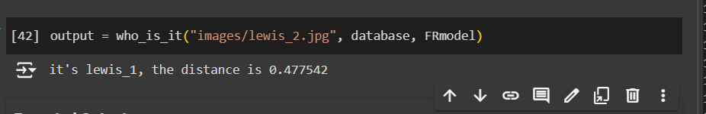

Figure 0.4 Face recognition output for lewis_2

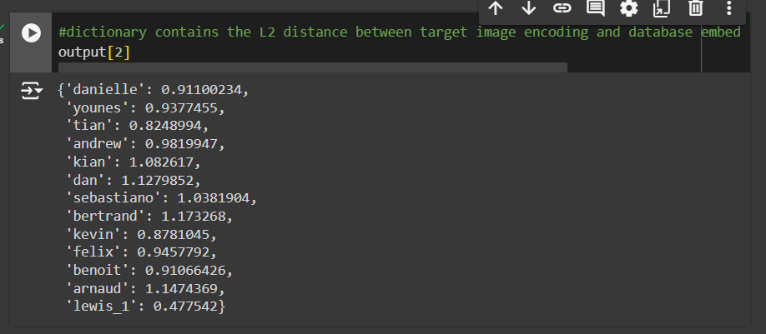

Figure 0.5 Output[2] screenshot