

Andro Haavandi | X00057252 | December 21, 2015

WDD2 CA1

Website built with express.js and node.js

Table of Contents

Introduction 2

Site Functionality 2

Launch instructions 4

Test user credentials 5

Simple user 5

Admin user 5

Bibliography 5

# Introduction

My submission for WDD2 CA1 is a Christmas themed NodeJS website.

It has 2 main pages with additional 2 pages that are only visible when user is logged in.

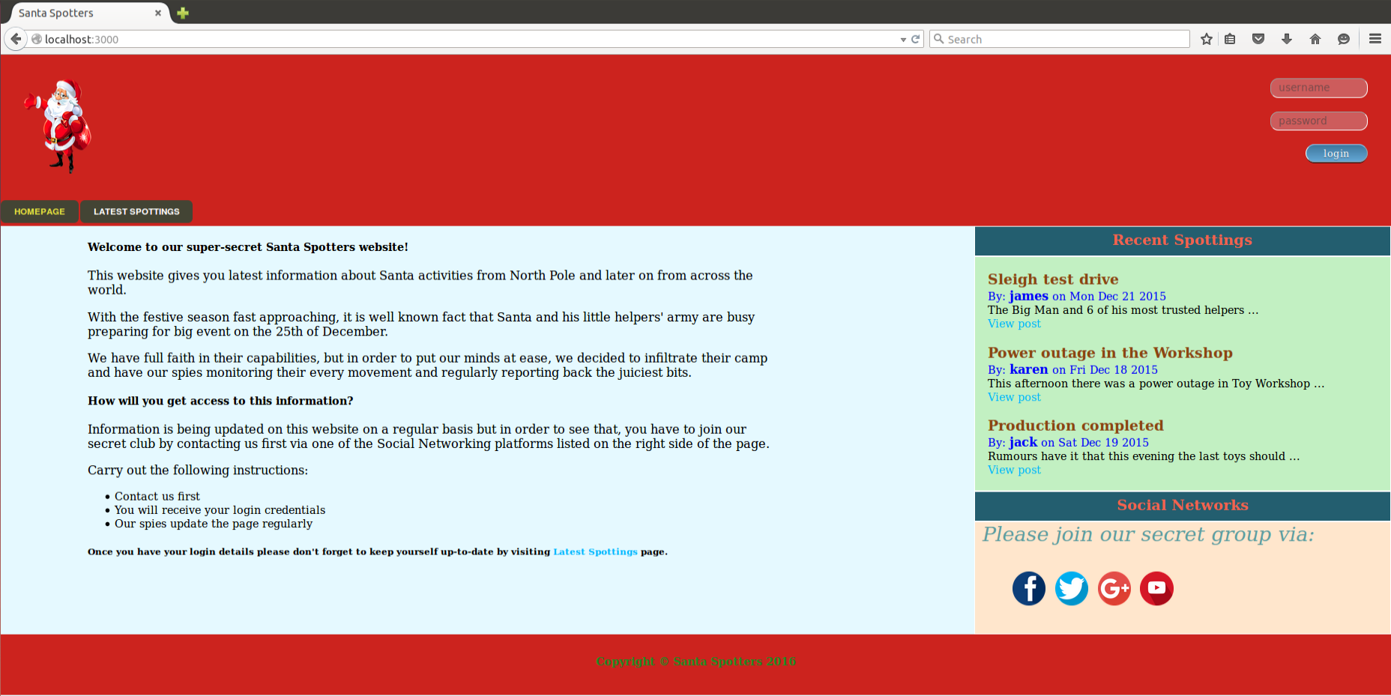

Website is for a secret group that wants to track Santa’s activities and movements on North Pole.

Website has been built using the Express Web Application Framework and has been designed to adhere to the MVC (Model-View-Controller) Software Architectural pattern.

# Site Functionality

* Registered users have access to “Latest Spottings” page that has full entries of information submitted by “spies in Santa’s camp”.

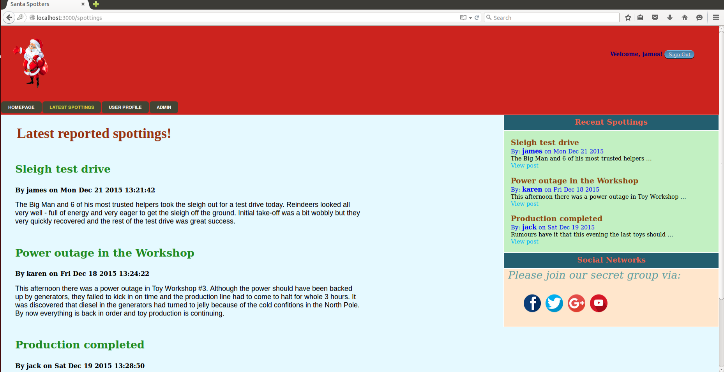

* Website visitors that have not logged in will only see partial entries. In order to view the full text, they are redirected to Login page. 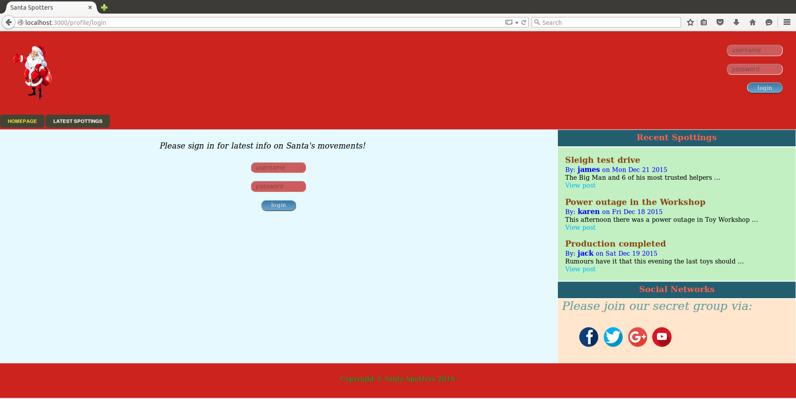
* Logged in user can also edit the details of their User Profile.

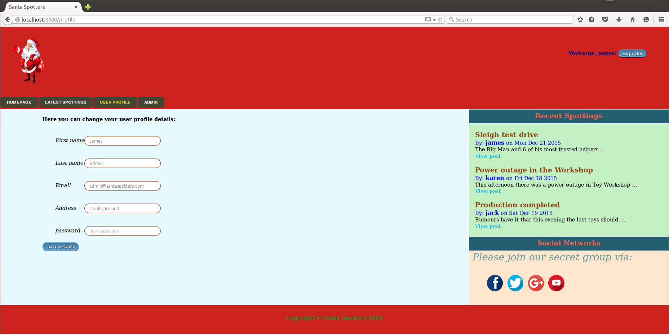

* Some users that are with admin status can also view the list of all registered users on the “Admin page”

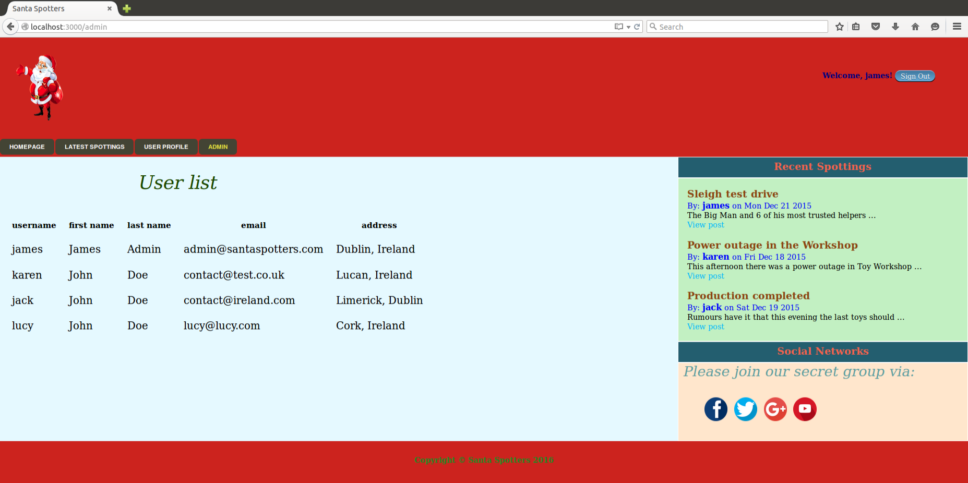

* Website is connected to MongoDB database that stores user details and submission entries.

# Launch instructions

1. Go to website/dbdump directory and run *mongorestore*
2. Go to website directory and run *node bin/www*
3. Open browser at localhost:3000

## Test user credentials

### Simple user

jack / jack

### Admin user

james / james

# Bibliography

<http://blog.ijasoneverett.com/2013/03/a-sample-app-with-node-js-express-and-mongodb-part-1/>

<http://code.tutsplus.com/tutorials/build-a-complete-mvc-website-with-expressjs--net-34168>

<http://code.runnable.com/UTlPPF-f2W1TAAEY/login-auth-using-sessions-in-express-for-node-js-and-authentication>

<https://www.youtube.com/watch?v=Hq9YwkyoWhU&list=PLY5tkzDKhjh4kVlvCxDCRLNw2Mw8cWtD2>