Median middle number in dataset

Mode most often occurring

Mean sum / n

House prices - median

Salaries - median

Goals - mean

Girls names - mode

User satisfaction - mode

# read in the athletes.csv file

ath <- read.csv('C:\\student\\X00098007\\athletes.csv',header=T)

ath_f <- ath[ath$Sex==1,]

ath_m <- ath[ath$Sex==0,]

ath_fht <- ath_f$Ht

ath_mht <- ath_m$Ht

# open a new window

# hist_male <- hist(ath_mht, col = "blue", labels = TRUE)

#x11()

#hist_female <- hist(ath_fht, col = "pink", labels = TRUE)

hist(ath_fht, col = "pink", labels = TRUE)

x11()

hist(ath_mht, col = "blue", labels = TRUE)

hist_sport <- hist(ath$sport)

boxplot(ath_f)

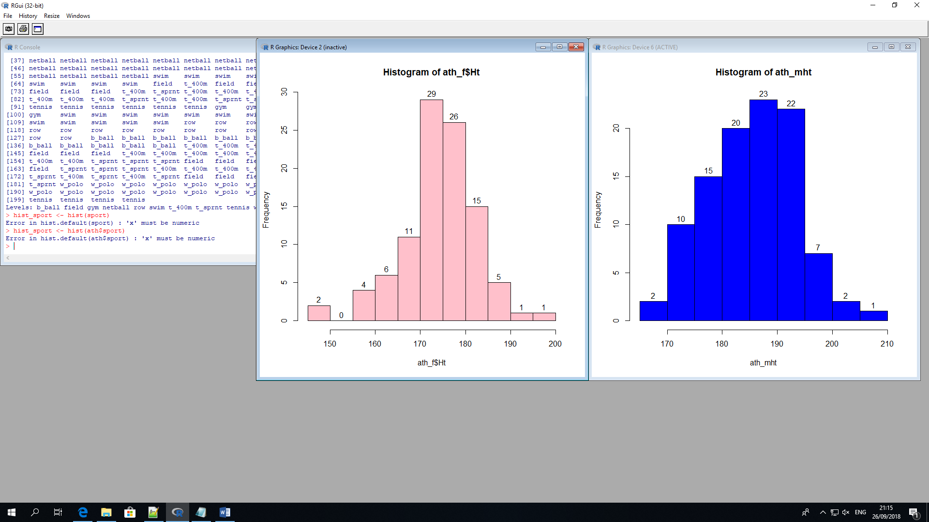

Outliers are of interest in the financial industry as they can cause incorrect results in monetary calculations,

such as interest earned, deposits made

Large deposit, money laundering...

Boxplot

boxplot(ath_f)

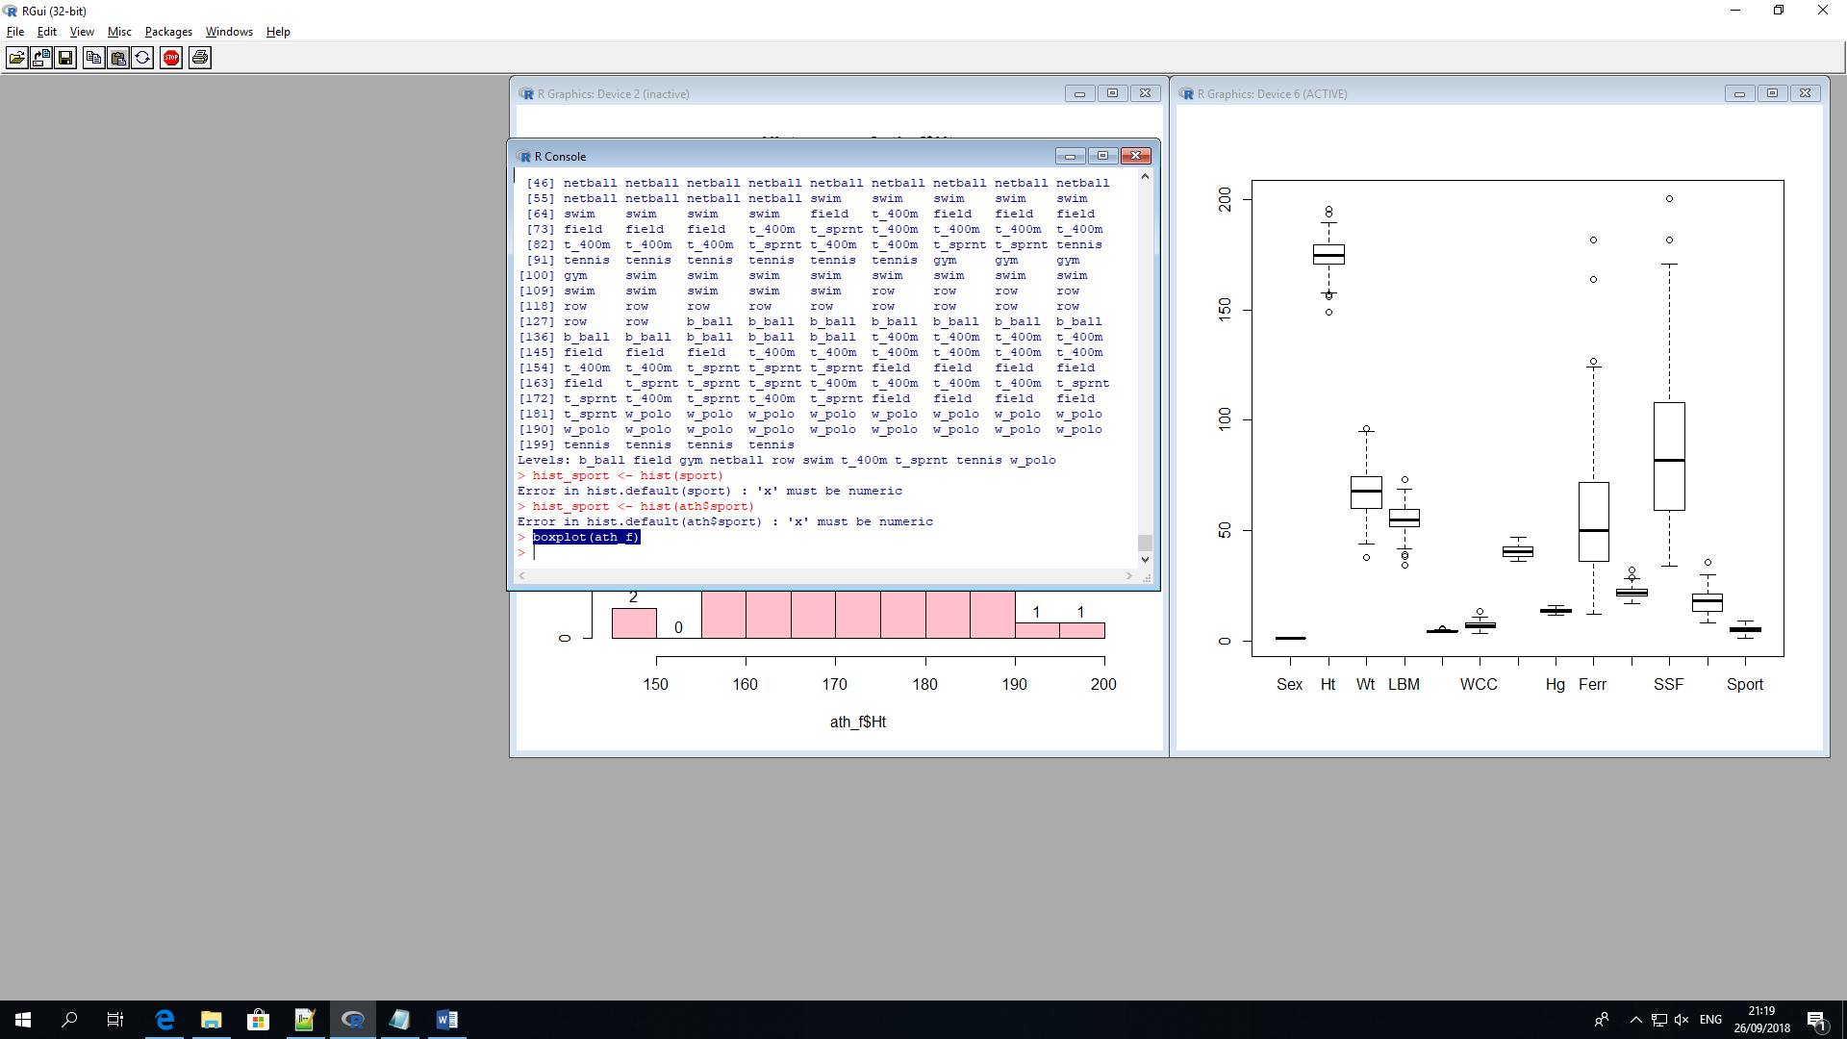

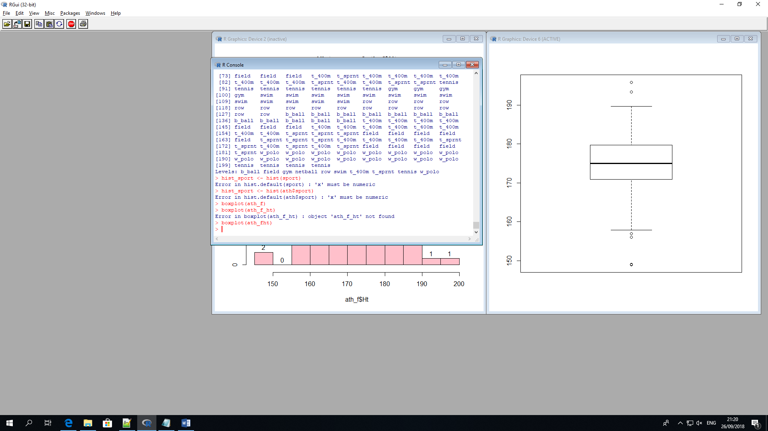

boxplot(ath_mht)

