> reg.data <- read.table('E:\\DAP\\regression.txt',header=T)

> attach(reg.data)

> names(reg.data)

[1] "growth" "tannin"

> plot(tannin,growth,pch=21,col="blue",bg="red")

> model <- lm(growth~tannin)

> predict(model,list(tannin=5.5))

1

5.063889

> predict(model,list(tannin=8))

1

2.022222

> predict(model,list(tannin=2))

1

9.322222

> predict(model,list(tannin=10))

1

-0.4111111

> predict(model,list(tannin=15))

1

-6.494444

> predict(model,list(tannin=-3))

1

15.40556

> predict(model,list(tannin=-15))

1

30.00556

> predict(model,list(tannin=2))

1

9.322222

> predict(model,list(tannin=6))

1

4.455556

> predict(model,list(tannin=6.0))

1

4.455556

> windows(7,7)

> par(mfrow=c(2,2))

> plot(model

+ )

>

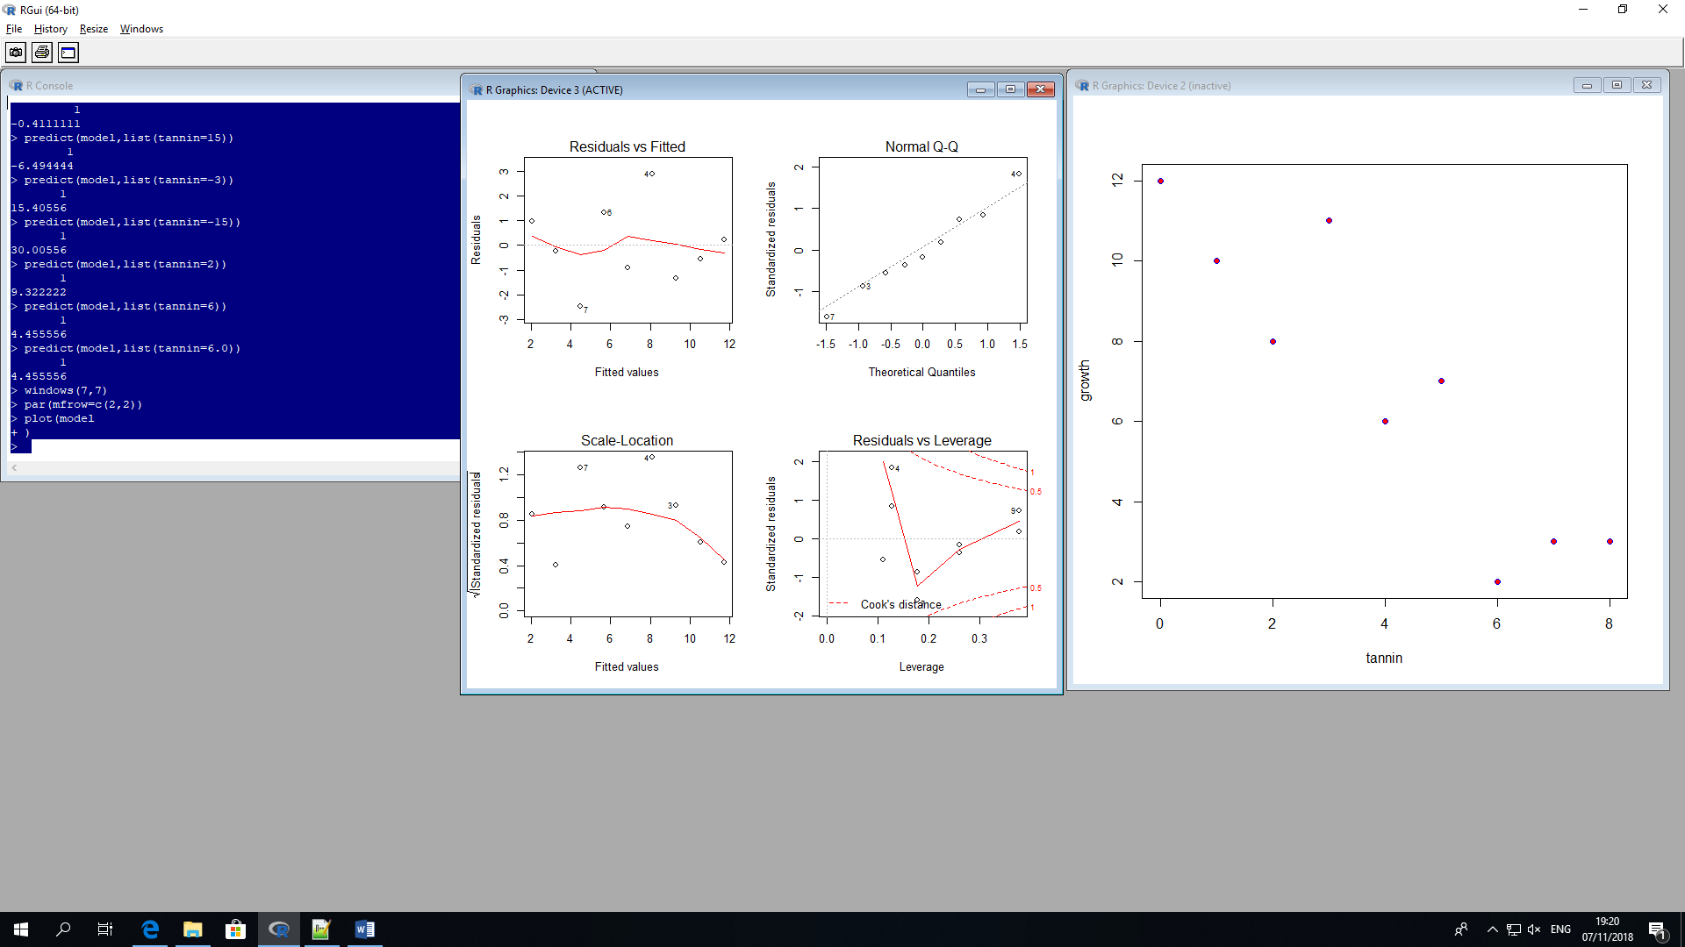

Fertilizer Model

> fer.data <- read.table('E:\\DAP\\fertilizer.txt',header=T)

> attach(fer.data)

> names(fer.data)

[1] "yield" "fertilizer.kg"

> plot(tannin,growth,pch=21,col="blue",bg="red")

> plot(fertiliser.kg,yield,pch=21,col="green",bg="grey")

Error in plot(fertiliser.kg, yield, pch = 21, col = "green", bg = "grey") :

object 'fertiliser.kg' not found

> plot(fertiliser-kg,yield,pch=21,col="green",bg="grey")

Error in plot(fertiliser - kg, yield, pch = 21, col = "green", bg = "grey") :

object 'fertiliser' not found

> plot(fertiliser-kg,yield,pch=21,col="green",bg="grey")

Error in plot(fertiliser - kg, yield, pch = 21, col = "green", bg = "grey") :

object 'fertiliser' not found

> fer.data <- read.table('E:\\DAP\\fertilizer.txt',header=T)

> attach(fer.data)

The following object is masked from fer.data (pos = 3):

yield

> head(fer.data)

yield kg

1 1.00 0.00

2 2.33 1.20

3 3.54 2.10

4 3.86 3.20

5 4.11 3.56

6 5.11 4.11

> names(fer.data)

[1] "yield" "kg"

> plot(kg,yield,pch=21,col="green",bg="grey")

> model <- lm(yield~kg)

> predict(model,list(kg=4))

1

6.46467

> predict(model,list(kg=8))

1

12.86146

> predict(model,list(kg=15))

1

24.05584

> predict(model,list(kg=20))

1

32.05182

> predict(model,list(kg=2))

1

3.266276

> windows(7,7)

> par(mfrow=c(2,2))

>

> plot(model)

>

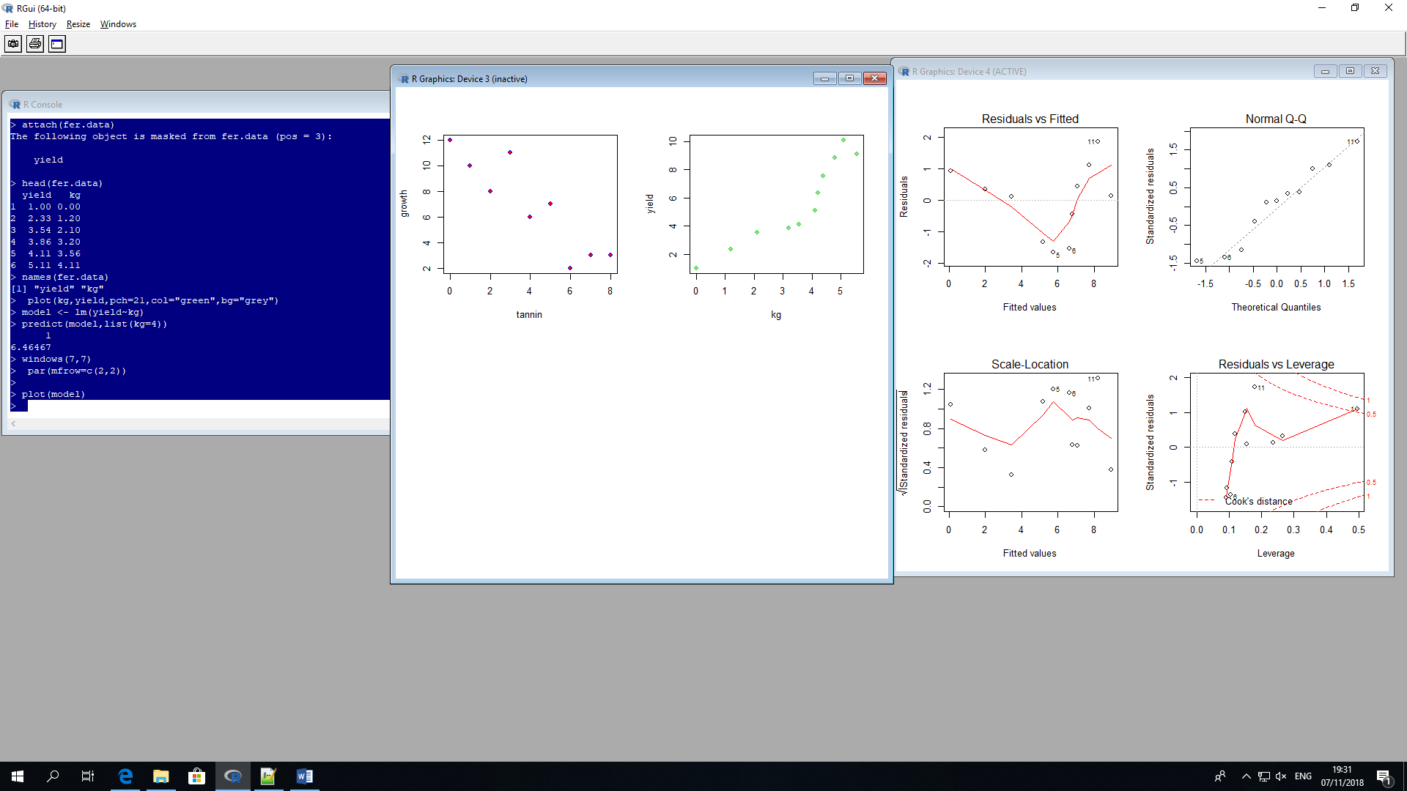

Deflection of line in Fitted Values. Clusters not normally distributed

S-shaped QQ plot

Water Model

> reg.data <- read.table('E:\\DAP\\water.txt',header=T)

> water.data <- read.table('E:\\DAP\\water.txt',header=T)

> attach(water.data)

The following object is masked from fer.data (pos = 3):

yield

The following object is masked from fer.data (pos = 4):

yield

> names(water.data)

[1] "yield" "water1"

> plot(water1,yield,pch=21,col="purple",bg="blue")

> model <- lm(yield~water1)

> predict(model,list(water1=8))

1

79.70349

> predict(model,list(water1=10))

1

105.4352

> windows(7,7)

> par(mfrow=c(2,2))

> plot(model)

>

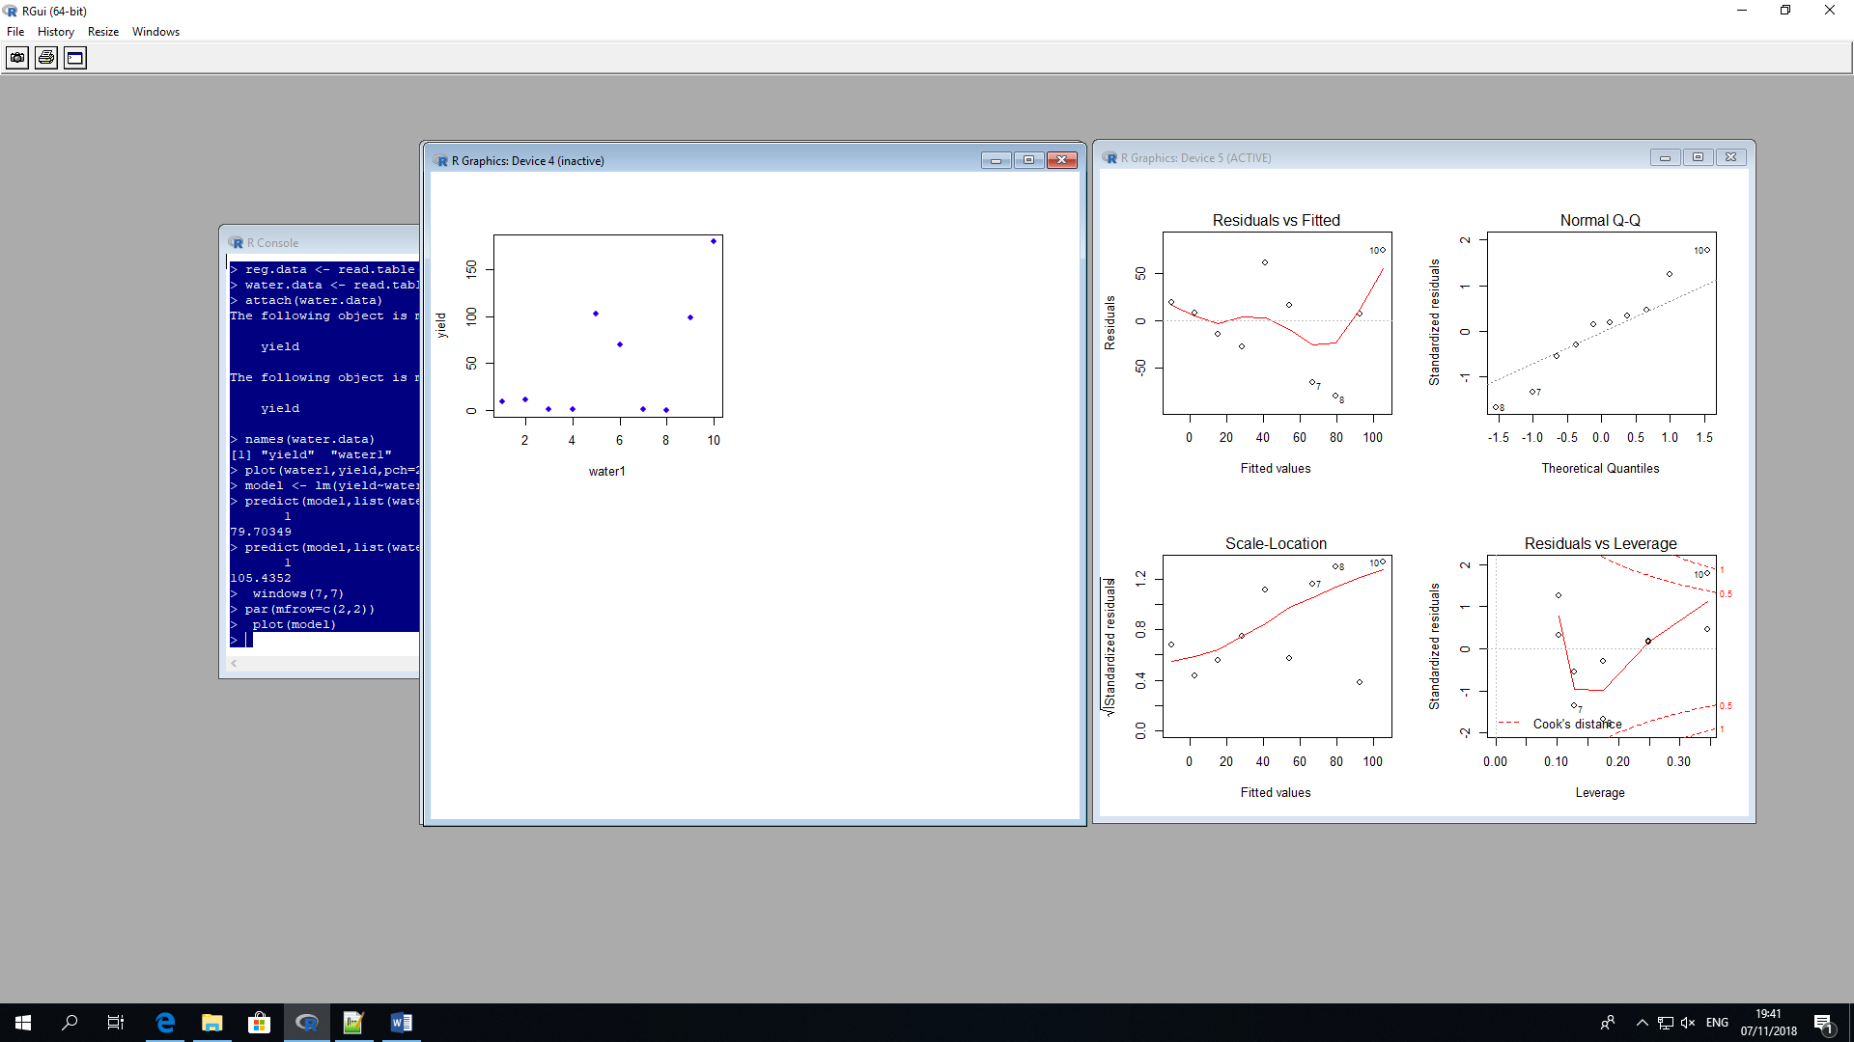

Deflection of line in Fitted Values. Clusters not normally distributed

S-shaped QQ plot