Continuous Assessment 1

Enterprise Database Technologies

4th Year Computer Science

Sean Shelley X00121161 | Robert Osborne X00109797

Contents

Introduction 3

Histograms for Numeric Variables Overlaid with the Target Variable 4

Age by Target 4

Campaign by Target 4

Duration by Target 5

PDays by Target 5

Cons Conf Index by Target 6

Cons Price Index by Target 6

Euribor by Target 7

Nr.Employed by Target 7

Previous by Target 8

Bar Charts for Categorical Variables Overlaid with the Target Variable 9

Contact by Target 9

Day of Week by Target 9

Education by Target 9

Housing by Target 10

POutcome by Target 10

Martial by Target 10

Job by Target 11

Month by Target 11

Loan by Target 11

Scatter Plots for Each Numeric Pair 12

Appendix: 14

Results Data Frame 14

# Introduction

The following piece of work, for this assignment, was created by Robert Osborne and Sean Shelley

It included the use of the ‘*Banking*’ dataset from Moodle.

# Histograms for Numeric Variables Overlaid with the Target Variable

## Age by Target

A picture containing screenshot

Description generated with high confidence

The Age for the Banks marketing campaign is heavily focused on those around the age of 30. From the information displayed in the histogram, we see that most people contacted by the marketing campaign, did not subscribe to the term deposit.

The graph also shows a skewness towards the younger age demographic. While also being lightly kurtosis. As the graph starts tailing off as the age of the clients increase.

## Campaign by Target

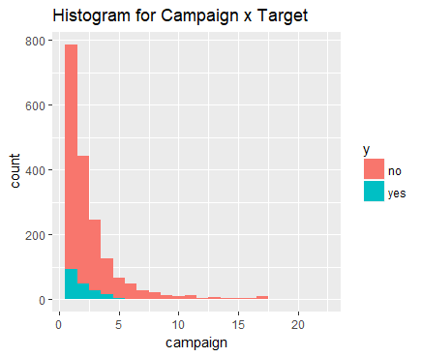

Form this graph we can that the first clients contacted, where contacted the most, with around 800 calls from the marketing campaign. With very few of those who the campaign first contacted subscribing to the term deposit.

The graph shows a skewness towards the left, as show in the graph with the first client receiving the most phone calls. It is also lightly kurtosis as the campaign stars called move from client to client.

## Duration by Target

A picture containing text, map

Description generated with high confidence

Duration of most of the phone calls the marketing campaign made were very short. Most of which were less than 1000 seconds. Only a very small number of calls went beyond 3000 seconds, and like with the other graphs, most did not subscribe to the term deposit.

Skewness can also be seen in this graph as he it is skewed to the left, towards the shorter phone calls. There is a very light kurtosis as the seconds of the phone calls increase.

## PDays by Target

A screenshot of a cell phone

Description generated with high confidence

## Cons Conf Index by Target

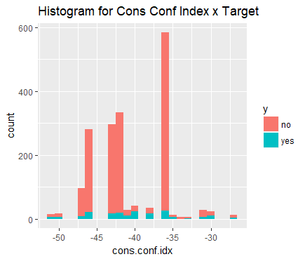

## Cons Price Index by Target

A picture containing text, screenshot

Description generated with high confidence

## Euribor by Target

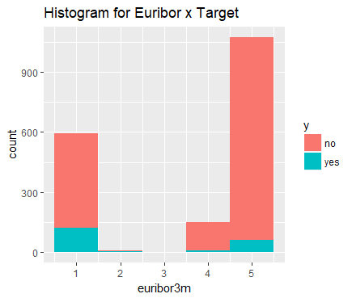

## Nr.Employed by Target

A picture containing text

Description generated with high confidence

## Previous by Target

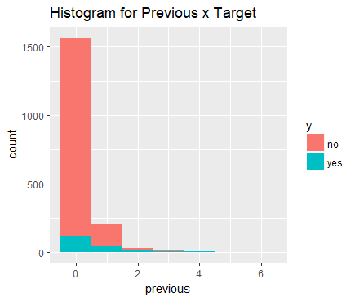

# Bar Charts for Categorical Variables Overlaid with the Target Variable

## Contact by Target

A screenshot of a cell phone

Description generated with high confidence

## Day of Week by Target

A screenshot of a cell phone

Description generated with high confidence

## Education by Target

A screenshot of a cell phone

Description generated with high confidence

## Housing by Target

A screenshot of a cell phone

Description generated with high confidence

## POutcome by Target

A screenshot of a cell phone

Description generated with high confidence

## Martial by Target

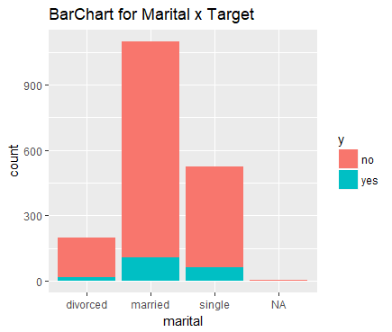

## Job by Target

A screenshot of a cell phone

Description generated with high confidence

## Month by Target

A screenshot of a cell phone

Description generated with high confidence

## Loan by Target

A screenshot of a cell phone

Description generated with high confidence

# Scatter Plots for Each Numeric Pair

|  |  |  |  |
| --- | --- | --- | --- |
|  | A close up of a piece of paper  Description generated with high confidence | A close up of a piece of paper  Description generated with high confidence | A close up of a white background  Description generated with high confidence |
| A screenshot of a cell phone  Description generated with high confidence | A screenshot of a cell phone  Description generated with very high confidence | A close up of a white background  Description generated with high confidence | A screenshot of a cell phone  Description generated with high confidence |
| A close up of a piece of paper  Description generated with high confidence | A screenshot of a cell phone  Description generated with very high confidence | A screenshot of a cell phone  Description generated with high confidence | A close up of a white wall  Description generated with high confidence |
| A screenshot of a cell phone  Description generated with high confidence |  | A picture containing photo  Description generated with high confidence | A screenshot of a cell phone  Description generated with very high confidence |
| A screenshot of a cell phone  Description generated with very high confidence | A picture containing sky  Description generated with high confidence | A close up of a white wall  Description generated with high confidence | A screenshot of a cell phone  Description generated with very high confidence |
| A screenshot of a cell phone  Description generated with high confidence | A picture containing outdoor  Description generated with high confidence | A picture containing photo  Description generated with high confidence | A screenshot of a cell phone  Description generated with very high confidence |
| A screenshot of a cell phone  Description generated with high confidence | A screenshot of a cell phone  Description generated with high confidence | A close up of a piece of paper  Description generated with high confidence | A screenshot of a cell phone  Description generated with very high confidence |
| A screenshot of a cell phone  Description generated with high confidence | A screenshot of a cell phone  Description generated with high confidence |  | A close up of a piece of paper  Description generated with high confidence |
|  | A picture containing photo  Description generated with high confidence | A close up of a device  Description generated with high confidence |  |

# Appendix:

## Results Data Frame

