**Bachelor of Science (Honours)**

**Computing**

**Semester 3**

**Module:**

**Web Design & Development**

**Group CA2**

**Report Writing:**

**Current Report**

**(Report Written by Aaron Gilmore)**

Lecturer: Enda Lee

Submission Date: 21st November 2016

**Student Details: Word Count**

Aaron Gilmore X00117932

1261

Jason Gibson X00127672

Lee Farrell X00127091

**Declaration**

The above named students declare that the content of this Continuous Assessment project is solely the work of the individuals whose names appear on this cover sheet. The work of any other authors has been cited and referenced in full.

|  |  |  |  |
| --- | --- | --- | --- |
|  |  |  |  |

**Table of Contents**

Executive Summary pg.3

Section 1:

Intended Users pg4

Site Navigation pg4,5

Section 2:

Page Structure pg6

Colour Scheme pg6

Page Features pg7

Images& Media pg7,8

Contribution of Students pg9

**Executive Summary**

The object of this report is to document the current rendition of our site and the decisions we have made that have affected our site up until now.

We will then break down into 2 main sections:

Section 1 which will look at the sites structure and navigation, this will involve why we decided on how the site would be traversed by the users and why we thought this would be the most effective way of structuring our site.

Section 2 which will look at page design, which involves our reasoning behind our color scheme some of our page features and why we relied on heavy use of images and media.

**Section 1: Site Structure & Navigation**

**Intended Users:**

Our user base will be used by anyone with access to a device capable of internet connectivity and an interest in movies. We intend not to cater to a specific age group sex or religion but to everyone who watches movies. As such we have also decided that the 2 main types of users on our site will simply be known as members and administrators.

The members of our website will be roughly 96% of users. They will be the everyday users that will use the site to find new movies to watch and review the if they so wish.

The administrators will be the remaining 4% of users. They will be the people who will be trusted with the upkeep and maintenance of the site, their roles will include the creation updating and deleting of movies on the site as well as monitoring and deleting harmful comments made by users.

We considered creating a third type of user, a moderator type, which would fall between normal member and administrator. The concept was that a moderator would be more heavily involved in the moderating of comments to take the burden off of administrators. We decided that for this rendition of the site we would leave them out as until the site gained lots of traffic the administrators could handle the monitoring of comments. If needs be we intend to introduce it in the future.

**Site Navigation:**

We decided to construct our site in a way anyone could use it. It follows the simple structure off

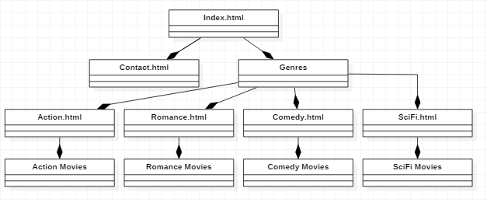

The website is designed so that getting from page to page is simple and so that at no point would any of our clients fell lost.

We initially had another page on the level of contact us and Genres called about us, on this page we would have had information about the site creators and other information about the site but after consideration it was decided that it was just a clutter page that was taking up room as only a very small minority would care to visit this page.

We kept navigation consistent on all pages. All pages come with a navigation bar at the top of the page which allows for quick access to the home page the contact us page and the 4 pages linked in the drop down genre bar.

We decided to remove a genre html page which would link to each individual genre type page as we wanted to keep the site as simplistic and easy to navigate as possible. Removing this page meant that members would only have to click 2 buttons to read about the movie they were looking for.

We looked for inspiration on other movie websites such as IMDB but found their sites catered to a much more tech savvy audience. Their site, to people who are not computer literate, seems cluttered with much unnecessary information, polls, pop ups and more items that, to someone just looking for some inspiration for a movie to watch, is useless and off putting.

**Section 2: Page Design**

**Page Structure:**

As previous said we designed each page to a very simple standard as the idea of our site is to simply give the user an idea of a movie they’d like to watch.

Our primary page design followed a format which included a navigation bar at the top of the page, followed by the page’s content, followed by a footer which included a back to top button to bring the user back to the navigation bar.



We followed this format for most of our pages in order to have a strong structure to our site.

**Colour Scheme:**

For our colour scheme we decided to go extremely simple for this rendition of our site. We followed a simple black, grey & white structure. We found this colour scheme goes well with the simple design of the site and found that the white backdrop went excellent with movie posters on some of our pages.

**Page Features:**

While we decided to develop a simplistic style for most of our pages we did place some advanced features that our users could appreciate. On our main page we developed a carousel to catch the user’s attention the second they log onto our site. As well as the carousel on the main page we also have a random movie section.

We thought the random movie button would be an excellent addition to our site as we as users ourselves know that sometimes we don’t know what we want to watch and could spend minutes just scrolling through a feed of movies not knowing what to click or view. With this addition our users who don’t know what they want simply need to click a button and be taken to a random movie of random genre. We feel as though this feature is extremely beneficial to many users as sometimes people need a hand with their choices.

Another feature we added was the comment box at the bottom of every individual movie page. This allows users to talk and converse via the comment about the movie. We belive this is a good feature as it allows users to review different movies and these reviews will aid other users in picking movies to watch. We also have hopes that this form of communication can help grow a community and expand our site.

**Images & Media:**

Our site relies heavily on the use of images and media. We believed, being a movie site, that the use of images and media would be a cornerstone of our site as people are attracted to what they see not a massive block of text. For this reason, we decided to, on every individual page, put a poster image followed by the description followed by a trailer for the movie.

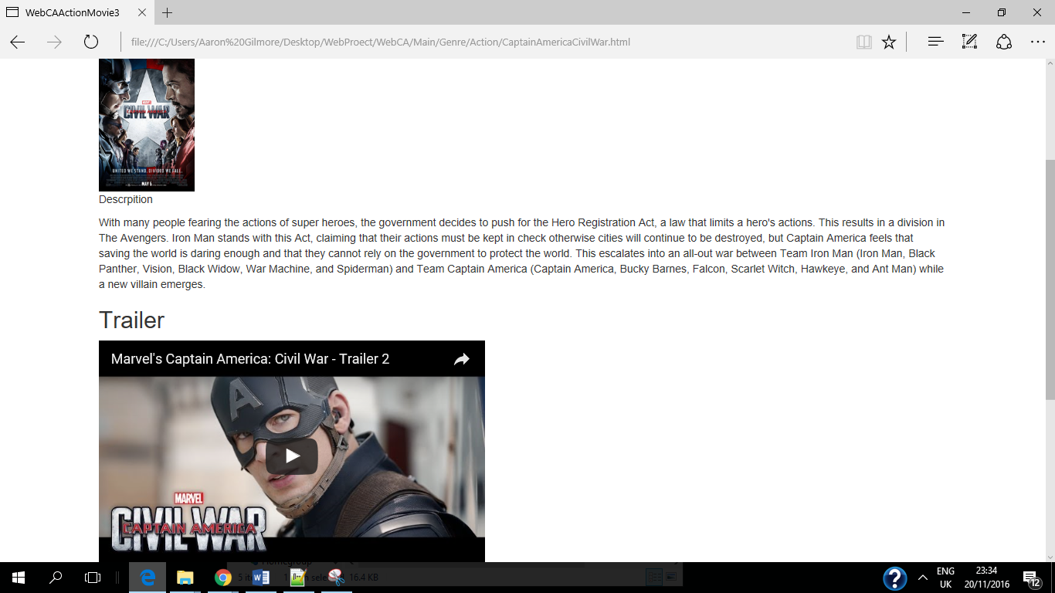

**Contribution of Work:**

Index.html: Aaron Gilmore, Jason Gibson

Random Button: Jason Gibson

Contact.html: Lee Farrell

Romance Movies: Aaron Gilmore

Comedy Movies: Aaron Gilmore

Action Movies: Jason Gibson

Sci-fi Movies: Lee Farrell

Page Linking: Aaron Gilmore

Comment Section: Aaron Gilmore:

CSS Design: Lee Farrell, Jason Gibson

HTML: Aaron Gilmore

Report: Aaron Gilmore

GIT: Aaron Gilmore