**Bachelor of Computing (Honours)**

**Semester 3**

**Module:**

**WEB Design and Development 1**

**GROUP CA2**

**IT TALLAGHT**

Lecturer: ENDA LEE

Submission Date: 21st NOV 2016

**Student Details: Word Count**

JESBIN JAMES X000119137

546

JAMIE COHAN x00129747

DANIEL LEBEDYEV X00129055

Table of Contents

Introduction

Site Structure

Site Contents

Our Work

Group Members Contribution

Introduction

For our project, we decided to choose a small car dealership as our project theme and it was agreed by each member due to the similar interest about cars. At the start as a group we got together and looked up on various site templates on cars as looked for ideas similar to our website that we going to make. As we looked on there were various websites with similar layout and most had the essential stuff such as the search bar, drop downs of car menu and latest offers.

Then the following week we planned a rough sketch about the layout that we were going to make and there were few suggestions on the important stuff that needs to be there was a good banner, dynamic style for page, extensive information, well navigable navbar which is the vital for a website as it needs to be usable for every age group without any hassle.

Site Structure

We took to paper to sketch how we wanted the site to look like after we had viewed numerous other similar sites.

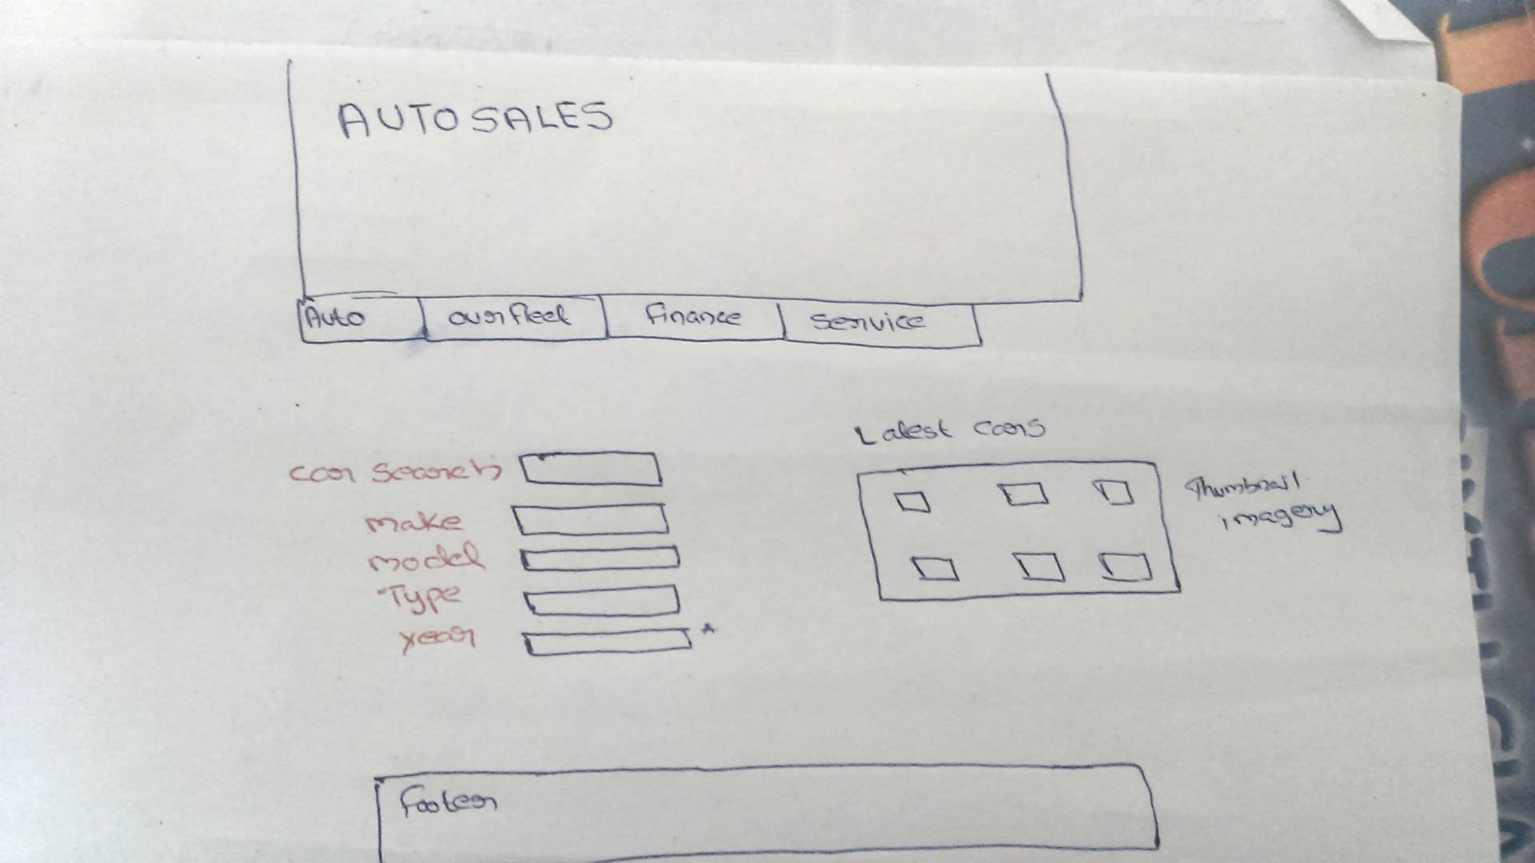

Then afterwards we wanted the website to look more professional as we planned more stuff such as the carousels and review page for the index page, Location and a query forum for customers to ask questions which we felt is a must for a car website.

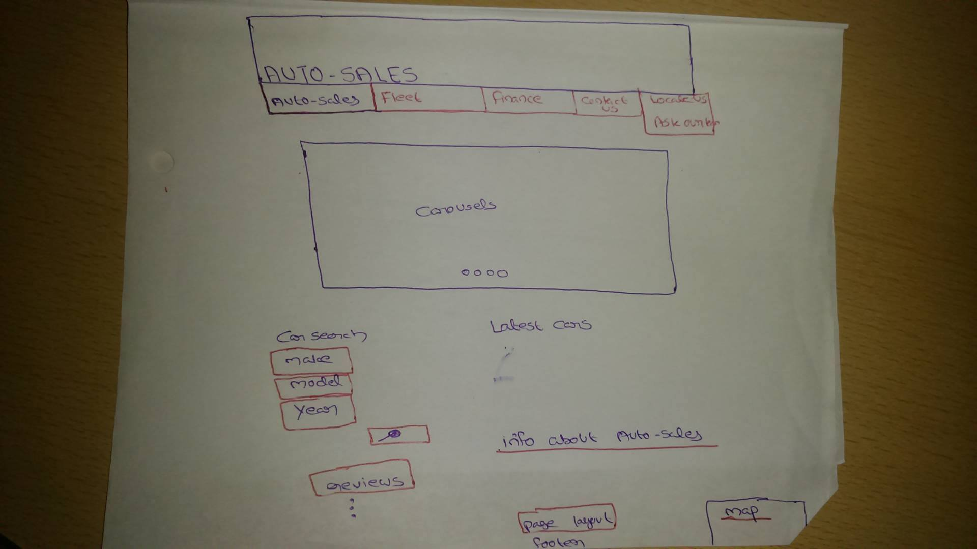

After agreeing on the structure of the home page, the rest of the group went off to do there our parts of the website using the layout of the home page as a reference.

Site Contents

The site is made up of an index, Used Car, Car Service, Contact Us, About Us which contains 2 dropdowns, Ask Our Staff and Location page. You can see this all laid out on the navigation bar. There is also an enquiry form for people who would like to enquiry about car servicing or repair.

The colour scheme we chose because we thought it would go well for a car dealership. The colours go well and attract users to our site.

We used many images in our website to show users our products. We used portfolio items and carousals.

Our Work

Our 3 group members had separate tasks between each of us. Jamie (x00129747) designed the layout of the web page including the overall color of the web page, navigation bar and banner image. Jamie also did the Used Car Section and the Car Service. Jesbin(x00119137) did the Index page and the Contact us page. Daniel (x00129055) did the Ask our team page and the Locate Us page. We had the project on Github so we could all work on it together as a group. After we had agreed on all the page contents we decided it was time to put it in play. Jamie transferred the project.

Team Contributions

Index and Contact us – Jesbin James **(X00119137)**

Our Fleet & Finance - Jamie Cohan(X00129747)

Locate us & Ask Our Team - Daniel Lebedyev (X00129055)