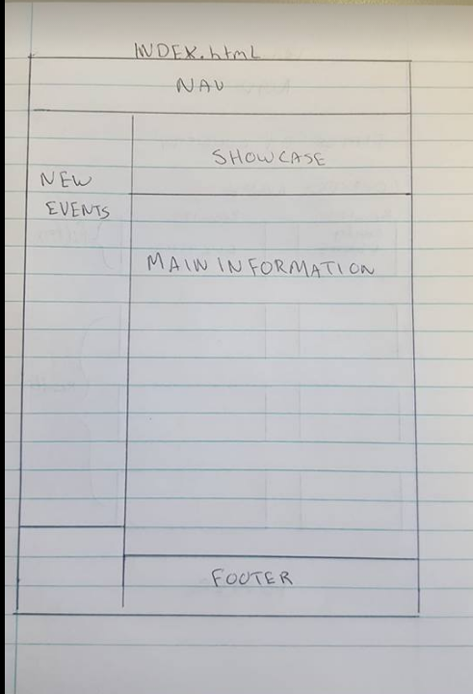

Index.html

Venues.html

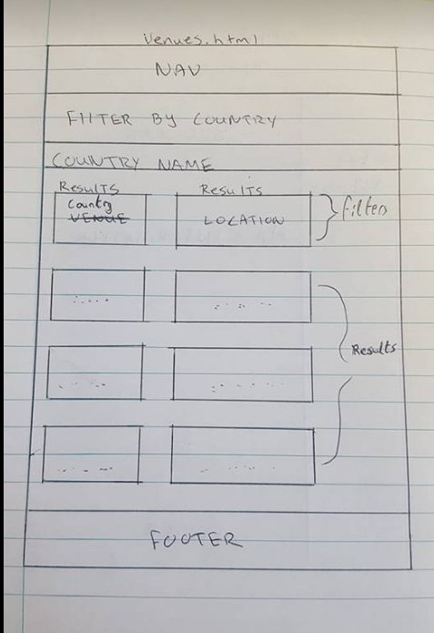

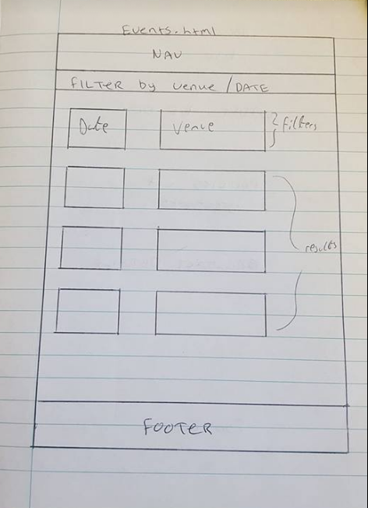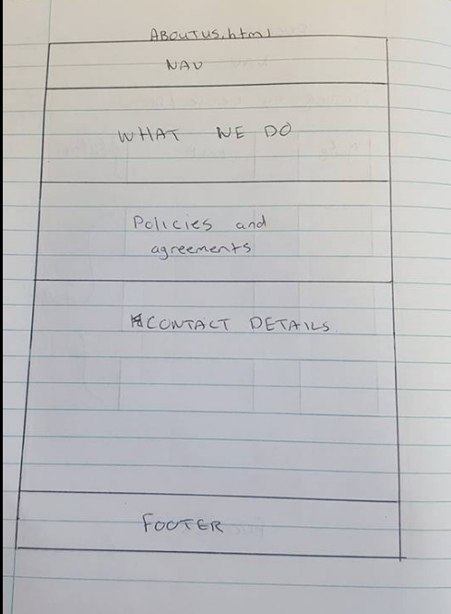

Events.html

Aboutus.html

M5 (Contributions):

Ronan Doran X00136708: Did the drawings and co-operated with the design.

Nathan Brunel: X00139550: Decided which page should be linked to which design to improve clarity.

Brandon Dowling: X00130274: Came up with the page layout mostly. Thought of the filtering process.