D1 (User types):

Normal: This user will be the common customer who can browse the website, buy tickets, look up locations/prices, login and add money to their account.

Moderator: This user will be looking after the feedback given by the customers. They’ll moderate the comments to filter out any inappropriate or irrelevant comments. The will also appoint the positive comments or suggestions to the administrators so the website can be improved.

Admin: This is the account that can access the data behind the website, update and change sections. They can also control customer traffic and ban certain users depending on exploits or other services.

D2 (Functional requirements):

Browse: The user will be able to reach every visual aspect of the website, allowing them to understand the navigation system. This can be used to locate which concert is at what location as they can browse the Location navigation and it will give them a list of current/upcoming converts and they’re County->Town.

Purchase: The user will be able to purchase tickets for a concert (1..n) This can be done through credit cards or paypal accounts. If discounts apply, they will be given out accordingly to every user.

Contact: The user should be able to contact the administrators or help services on another navigation, this is where an email and/or phone address will be located and the user can easily contact the administrator for assistance regarding the website not being fully comprehensive or a personal purchase glitch, etc.

Comments: A user will be able to write feedback about an event or venue on our website, These comments will be moderated by a separate user group mentioned above, “Moderators”. They can be used like a review website where a user can find positive or negative feedback about the venue/event, including its location or the prices that competitors had. These can be useful to branch out and show better qualities than other competing services.

D3 (Visio representation):

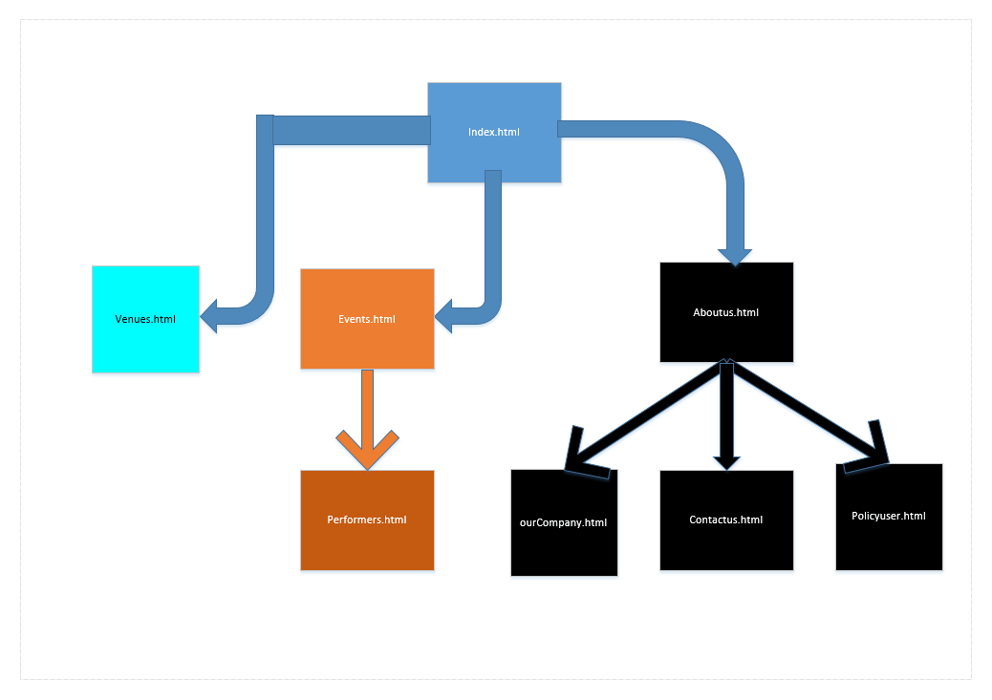

D4 (Navigation Table):

|  |  |  |
| --- | --- | --- |
| Name of element | Description and links | Included pages |
| Main navigation Bar | Home (target: index.html)  Countries (target: countries.html)  Events (target: events.html)  About us (target: about/html) | all |
| Media link list | Venues (target: venues.html)  Performers (target: performers.html)  Our company (target: ourcompany.html)  Contact us (target: contactus.html)  Policy (target: policyuser.html) | Countries.html  Events.html  Aboutus.html |

M4

Contributions:

X00136708 Ronan Doran: Navigation image and table. Types of users.

X00130274 Brandon Dowling: git repository, adding all the files and users.

X00139550 Nathan Brunel: Functional requirements.