Final iteration Report
ReelMovies Web Application
By x00222712 (Glen Johnston), x00227300 (Alex Daly) and x00226482 (Lauren Farrell)
Supervisor – Mary Hendrick

Table of Contents
Final iteration Report 1
Table of Contents 1
Introduction 2
Team Responsibilities 2
User Requirements 3
Iteration 1 Report 5
Introduction 5
Methodology 5
Testing Approach 6
Issues faced 7
Test Cases and Results 8
Conclusion 9
Assigned Parts 9
Iteration 2 Report 10
Introduction 10
Methodology 10
Testing Approach 11
Issues Faced 11
Test Cases and Results 12
Conclusion 13
Assigned Parts 13
Iteration 3 Report 14
Introduction 15
Methodology 15
Testing Approach 16
Issues Faced 16
Test Cases and Results 17
Conclusion 18
Assigned Parts 18
Concluding Conclusions 19
References 19
Project Links 20
Student affirmation of Academic Integrity for assessment in TU Dublin Programmes 21

Introduction
ReelMovies is a modern web-based cinema booking system developed as part of our second-year software project. The application allows users to browse movies, search and filter content, book tickets, and manage their accounts through a user-friendly interface.
The project was developed over three iterations. Each iteration focused on different aspects of software development, including user interface design, feature implementation, and final testing and refinement. This report outlines the development process, key achievements, challenges encountered, and the final outcome of the project.

Team Responsibilities
Glen:

Alex:
- Footer and header for the web application
- Movies, Screens/Seats, Booking, and Loyalty Databases
- Movies, Booking, Payment, Loyalty Contact us, About Us and Feedback pages
- Booking and payment system
- APIs
- Resend (emails)
- Overall UI and styling
- Movie Screenings and Genre CRUD

Lauren:
- Food page and database

User Requirements

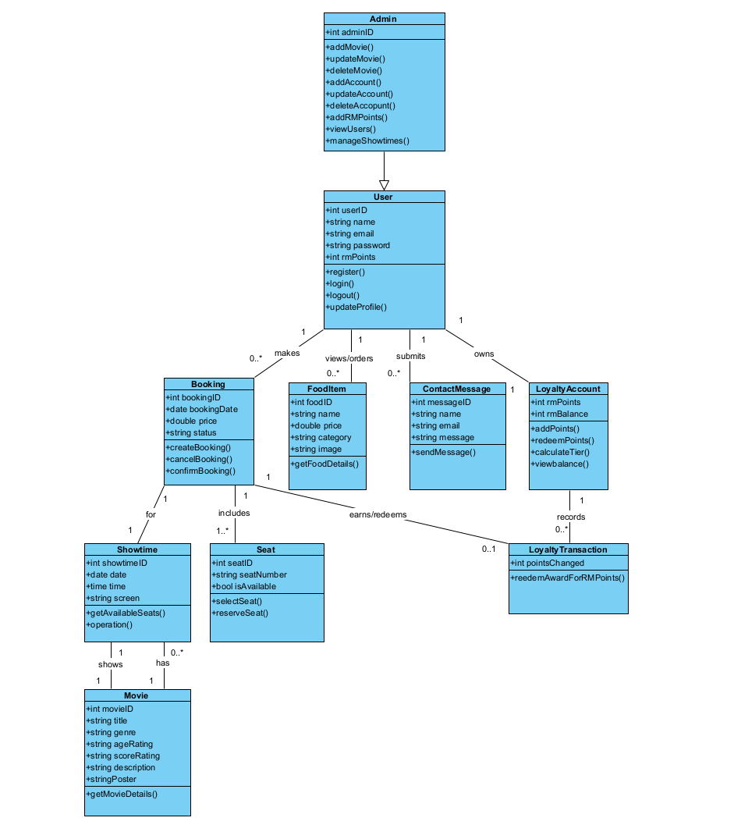
This updated class diagram is a clear improvement on our first one as at the time we didn’t have a clear vision on what our project would end up like, but as time went by, we had fully planned it out and this is the result. There are a lot more classes, attributes, operations, and logic in this diagram.
One of the main improvements in this new diagram is the Loyalty Account and transaction classes, which allows users to gain a digital currency for their loyalty to the cinema and gain rewards doing it, we made this change as we thought rewards would give me user interest into the business.
All previous classes were either removed, improved, or completely changed. These changes were necessary to improve scalability and maintainability while also helping to accurately represent real-world interactions.
Overall, the updated diagram provides a more modular, maintainable, and realistic representation of the ReelMovies application.

Iteration 1 Report
ReelMovies Web Application
By x00222712 (Glen Johnston), x00227300 (Alex Daly) and x00226482 (Lauren Farrell)

Introduction
This is the iteration 1 report for our group project, which is us creating a web application. We have gone with a cinema booking system. We named the project “ReelMovies”.

ReelMovies is a web application designed as a modern cinema booking interface allowing customers to browse movies, food, search and filter, book tickets, have an account, etc. It will also have multiple informational pages such as the about us page and the feedback page.

The main objective of this iteration was to design and develop the UI, so that we could provide a clean modern user-friendly interface that will allow users to visit the website and easily navigate it while maintaining a consistent visual interface across the whole website. This report will outline the methodologies used to design and develop the UI, along with the test cases used to evaluate its functionality and usability.

Methodology
Our development of the UI for our project ReelMovies followed a very structured approach to designing and implementing processes which consisted of three stages: Planning and design, Development and testing.

During our planning stage, the main user requirements were identified and given to us by our supervisor, we needed a home page which has at least three key pages, working navigation between these pages, three forms of user input and layout and styling.

We identified that the navigation was going to be a big part of this iteration, so one of our first steps was to design a modern, clean, and functional navigation bar that would allow users to change pages with ease. The layout structure was created using a consistent header, main content area, and footer across all our pages.
We used Sveltekit, which is a JavaScript framework, it allowed to develop and build the web interfaces way easier as its component-based architecture which allowed us to put the navigation and footer into a reusable component. This makes it also a lot easier to change and update the navigation and footer in the future.
For styling and layout, we used Bootstrap, it allowed us to make sure the interface would adapt to all different screen sizes, making sure that usability will be perfectly fine on all different devices such as laptops, phones, tablets, etc. Custom CSS was also added on top of the bootstrap to ensure a modern aesthetic, based off other cinema sites we decided to go with a clean dark-cinema style.

We also implanted several interactive elements to improve user engagement, such as a search bar and filters that will allow users to search for movies by genre and titles and also allowing users to search for different food in our food menu. Our contact and feedback page also allows users to input text to either get in contact with us or leave us a review which displays below the form instantly demonstrating real time UI updates.

Testing Approach
Our testing was conducted throughout the whole development phase so that we could ensure at all times the UI and pages worked and provided a user-friendly experience at all times. Our functional testing focused on making sure that each interactive component behaved as intended. For example, search and filter bar functionality on the Movies and food pages was tested with the different filters and titles/food names to confirm that only the relevant results were displayed. Our form elements were also tested on the contact and feedback pages to confirm input fields were accepting user's inputs correctly and displaying information correctly.

Usability testing involved making sure that the layout was visually consistent, the text was readable on the dark background, and that navigation was user-friendly. We tested different screen sizes as well to ensure our bootstrap responsive layout was adjusted properly on different size screens.

Issues faced
Issue | Description | Solved
Merge issue | Alex had an issue with his code where it wouldn't work in main | Alex solved the issue by going into main and manually fixing it
Search bar/filtering | Alex had issues getting his search bar to work perfectly | Alex solved his issue by researching and tinkering around with it
Recommended movies | Glen had an issue with the recommendation component where the elements overlapped eachother. | Glen solved the issue by removing “d-flex” from the carousel and moving “d-flex” to a div inside the carousel.
User sign in | Glen had an issue with the sign in of users, whenever the user signed in and out, the user could not sign back in. | Glen solved this by deleting any sign ins of a user when a valid sign in is requested.
Movies data layers | Glen had an issue with the movie data layers where some things already made where broken when updated. | Glen solved this by going in and changing the value’s read from “.rating” to “.ageRating”.
Account icon | Glen had an issue with the account icon that it would movie below the nav menu on mobile devices. | Glen solved this by making the account icon show only when the nav was fully extended.
Seat Selection | Glen had an issue when selecting a seat it would also return "false” even when the HTML elements value was “1,1” (should be true) | Glen solved this by reading the values separately because the function wanted them separately.

Test Cases and Results
Test Case | Description | Expected Results | Result
Navigation Links | Click each navbar link and ensure it works | Correct page loads | Passed
Movie Search | Enter as movie title in search bar | Matching movie(s) display | Passed
Menu Search | Enter menu item name in search bar | Matching item(s) displayed | Passed
Genre Filter | Select a genre filter | Matching movies with only the genre selected display | Passed
Rating Filter | Select a rating | Matching movies with only the age rating selected display | Passed
Sign in | Enter username and password | To be signed in or display incorrect username/password | Passed
Sign up | Enter username and password | Created and signed into an account if available | Passed
Seat selection | Selecting seats for screenings | Selected seat highlighted | Passed
Feedback form | Submit a review | Review appears in review list | Passed
Team members click | Click a team member name | Description Appears | Passed
Responsive layout | Resize browser window | Layout adjusts for smaller screen sizes | Passed

Conclusion
Overall, we personally feel that the UI was successfully designed and developed using both Sveltkit and Bootstrap to create our modern and responsive web interface. Testing confirmed that everything was working as intended. Future improvements will also be easy to implement due to how we have been building the web application.

Assigned Parts
Glen
- Account sign in
- Account signup
- Signing out
- Home page content
- Book tickets page
- Database service
- Data access layers
- Server APIs
Alex
- Navigation bar
- Footer
- Movies page
- About us page
- Contact us page
- Feedback page
- Overall styling
- Layout

Lauren
- Food and drinks page.

Iteration 2 Report
ReelMovies Web Application
By x00222712 (Glen Johnston), x00227300 (Alex Daly) and x00226482 (Lauren Farrell)

Introduction
This is the iteration 2 report for our group project, which involves developing a web application. As outlined in the previous iteration, our project is a cinema booking system called “ReelMovies”.
ReelMovies is a web application designed to provide a modern cinema booking experience. It allows users to browse movies and food items, search and filter content, book tickets, and manage their accounts. The system also includes additional pages such as About Us and Feedback to enhance user interaction and provide more information.
The main objective of this iteration was to build upon the user interface developed in iteration 1 by implementing core functionality such as a seat booking system, authentication, and CRUD functionality. This report outlines the development process, testing methods, issues encountered, and results achieved during this phase.

Methodology
The development process for iteration 2 followed a structured approach consisting of three main stages: bug fixing, feature implementation, and testing.
Firstly, we revisited the issues identified in iteration 1 and ensured that all remaining bugs and issues were resolved. This included fixing UI inconsistencies, improving navigation, and refining search and filtering functions. These improvements allowed us to ensure that we had great functionality before starting to implement new features.
Secondly, we implemented several new features to enhance the system. A seat booking system was developed, allowing users to select movies, choose showtimes, and reserve seats. This feature integrates with the existing UI and provides real-time feedback when seats are selected.
We also implemented a movie database which has all the movies we will be showing along with their respective genres, age rating, poster, etc. Using this we made APIs that would allow adding and deleting movies.
Contact us was made to use Resend to allow us to send emails to customers looking to get in contact with us, we also made a database for contact us.
User authentication was further improved by refining the sign-up and login system. Session handling was enhanced to ensure users remain logged in securely, and logout functionality was improved for reliability. We also made an admin account which would allow ReelMovies admins to update and change the movies and showtimes whenever they want through a dashboard.

Testing Approach
Testing was carried out continuously throughout the development process to ensure all features functioned correctly and efficiently.
Functional testing was used to verify that all newly implemented features worked as expected. For example, booking tests ensured that users could select seats. We ensured that the movie database was implemented properly and had full functionality as well as the contact us page with Resend.
Authentication testing ensured that users could register, log in, and log out without issues. Edge cases such as incorrect login details were also tested.
We also tested the application on different screen sizes to ensure that the responsive design from iteration 1 remained effective after adding new features. As well as testing accessibility and following the practice we learned to make sure it was accessible.

Issues Faced
Issue | Description | Solved
Movie Database not working | The movie database wouldn’t work for Alex the way he intended | Alex and Glen identified the tiny issue which was the cause of the whole problem and debugged it
Resend not working | The Resend API wasn’t working at all | Glen helped Alex find the issue where the API key was not correctly received and fixed it.
Search bar issue | After implementing the movie database, the search bar broke | Alex debugged and fixed it after fixing the issue that was causing it.
RM points not displaying | When in the admin panel, no users RM points data was showing except admins. | Glen found in the data access layer where the data was coming from, the admin ID was used to get RM points instead of the user ID, making user’s RM points not grabbed unless they were in the admins table.
Paging not working on admin panel | When the user would select the back button, nothing would happen if the amount of content to go back was under the page size. | To fix this, the paging checked if you were able to see the first account, if so, it would loop to the end, otherwise pressing back would take you to the first, give N < page size.

Test Cases and Results
Test Case | Description | Expected Results | Result
Movie search | To make sure after implementing all the new movies that the search bar still worked | For the search bar to fully work and show the expected search results | Passed
New UI interface | To ensure the new small tweaks to the UI were implemented correctly. | For the UI to be fully implemented correctly while still being user-friendly and modern. | Passed
Resend Emails | For customers to be able to receive emails from us through the Contact us page. | For the user to get sent an email from ReelMovies after filling in a form on the contact us page. | Passed
User signin, no account | Ensure that better auth signin worked correctly, not allowing for an email to be used more than once | email / password incorrect | Passed
User signup reused email | Ensure that better auth signup would not allow the reuse of an email already in use. | User already exists. Use another email. | Passed
Admin panel integrity | Enter the URL of the admin panel while signed out to ensure only admin can access the sensitive functions. | Redirected to signin | Passed
Admin Panel Movie CRUD | Ensure that an admin can easily add, delete and update a movie to or from the web application | Admins could succesfully add, delete and update movies | Passed

Conclusion
Overall, this iteration was successful in transforming the ReelMovies application from a static UI into a functional web system. All major bugs from the previous iteration were resolved, and significant new features such as booking seats, databases, CRUD functionality, admin accounts and dashboard and improved authentication were implemented.
Testing confirmed that the system performs reliably and meets the core functional requirements. While minor issues were encountered, they were resolved effectively, resulting in a stable and user-friendly application.
The project is now in a strong position for demonstration, showcasing both its functionality and usability. Future improvements may focus on performance optimization, repayment integration, and further UI enhancements.

Assigned Parts
Glen
- Better Auth Authentication (login/logout improvements)
- User account information
- Admin access DB
- Test page
- Account test API
- Setup DB page
- Help debug and test PR

Alex
- Create Movie Databases
- Movie Test API
- Create Movie APIs
- UI improvements and responsiveness
- Navigation updates
- Contact us Database
- Resend API (emails)
- CRUD Movies
Lauren
- Create the menu DB

Iteration 3 Report
ReelMovies Web Application
By x00222712 (Glen Johnston), x00227300 (Alex Daly) and x00226482 (Lauren Farrell)

Introduction
This is the iteration 3 report for our group project, which involves developing a web application. As outlined in the previous iteration, our project is a cinema booking system called “ReelMovies”.
ReelMovies is a web application designed to provide a modern cinema booking experience. It allows users to browse movies and food items, search and filter content, book tickets, make payments, and manage their accounts. The system also includes additional pages such as About Us and Feedback to enhance user interaction and provide more information.
The main objective of this iteration was to refine the application, fix remaining issues, and to perform comprehensive testing to ensure a stable and functional final prototype, but due to being behind schedule, we also had to add the booking, payment and loyalty system in this iteration.

Methodology
The development process for iteration 3 followed a structured approach consisting of three main stages: bug fixing, feature implementation, and testing.
Firstly, we revisited the issues identified in iteration 2 and ensured that all remaining bugs and issues were resolved. This included fixing minor issues with our CRUD and styling.
We then implemented several new features to enhance the system. The booking system was finished, by making a database for screenings and seatings we were able to implement a fully functional booking system, allowing users to choose a movie, a screen, date and time for the movie, book and reserve seats and then finally pay for their movie tickets.
A Screenings CRUD was also added to help the admins and management add, edit or remove screenings, this will help them manage the system more efficiently.

Testing Approach
Testing was carried out continuously throughout the development process to ensure all features functioned correctly and efficiently.
Functional testing was used to verify that all newly implemented features worked as expected. For example, booking tests ensure that a user can select a movie, date, time, and screen, then book and reserve their seats and pay for their movie tickets.
Testing was also done on the Screenings CRUD to ensure that admins and management can easily and efficiently add, edit or remove screenings from the admin panel.
Finally testing was done on the whole web application, making sure everything still works as intended and is functional after finishing everything.

Issues Faced
Issue | Description | Solved
Screenings Database | The screening database wouldn’t work the way it was intended to. | Alex identified the issue which was the cause of the whole problem and debugged it
Screenings CRUD | The screenings CRUD was not working as intended. | Alex had an issue where the CRUD for screenings wasn't working as intended. It was a small issue where he forgot to import all the correct database tables.
Seats not reserving | After implementing the screening databases, we had an issue where the seats weren't being reserved properly. | Alex debugged and fixed it after fixing the issue that was causing it.
Loyalty Points deduction | The loyalty points were not being taken away from accounts after they redeemed rewards. | Alex found the issue and debugged it.
Seat bookings URL overflow | When booking a lot of seats, the website would not load when going to pay for it. | Glen found the bug and changed the parameters from the URL to cookies that would be set and removed when paid for.
Seats not displaying right | When viewing a screening either in /movies/viewscreening or purchase/tickets the seats already booked would not show, allowing multiple people to book those seats | Glen found and fixed the bug by understanding how the code works and making sure all bookings are made using strings with a space after the comma.
Wrong RM points on home page | When the user logs in, they are shown some rewards that some RM points value, and when redeeming would have a different number | Glen found the bug and made it so whenever the recommended rewards were got, it would get the reward’s DB.
Booking CRUD | When interating with the form’s for the booking crud, it would reload the page forcing the user to reenter the email. | Glen solved this by passing the email to the server so that the email could be passed back when reloading.
Seating index at 0 | Seats index at zero, so to sit top left would be seat 0,0 which is not user-friendly. | Glen noticed this and changed the code everywhere to be (i+1, j+1) so the seat 0,0 would become 1, 1

Test Cases and Results
Test Case | Description | Expected Results | Result
Full Booking System | To make sure users can easily select a movie, date, time and screen, book a seat, reserve the seat and pay for the tickets | For the users to be able to easily select a movie, date, time and screen, book a seat, reserve the seat and pay for the tickets | Passed
Select and deselect Seat | To make sure that when a user clicks on a seat, it changes color. | Seat to change to green when selected, and back to normal when unselected. | Passed
Taken seat cannot be selected | To make sure when a user clicks on a seat it doesn't select | Seat not to be selected and remain reserved. | Passed
Continue without seat | To make sure the user can't continue without selecting a seat | User cannot proceed further without a seat selected | Passed
Proceed to payment | To allow the user to proceed to payment page after selecting seats | The payment page to load after user clicks proceed to payment button | Passed
Redeem with enough points | To allow users to redeem rewards with their loyalty points | Points decrease and redemption is saved | Passed
Create screening | To allow an admin to select a movie, screen, date, time and submit a new screening | New screening is created | Passed
Edit screening | To allow an admin to edit a screening | Screening updates
Delete screening | To allow an admin to delete a screening | Screening is deleted

Conclusion
Overall, iteration 3 successfully delivered a polished and fully functional prototype. The system met all core user requirements and demonstrated strong integration between frontend and backend components. The testing process confirmed that the application performs reliably under normal usage conditions.
The project is now in a strong position for our final demonstration, showcasing both its functionality and usability. Future improvements may focus on performance optimization and real payment integration.

Assigned Parts

Alex:
- Screens/Seats, Booking, and Loyalty Databases
- Booking and payment system
- Booking, Payment and Loyalty pages
- Screenings CRUD
Glen:
- View bookings page
- View screening page
- Booking CRUD
- Loyalty integration with other systems
- Feedback on home page + Changed Feedback page

Concluding Conclusions
The ReelMovies project successfully delivered a fully functional cinema booking web application. Over the course of three iterations, the system evolved from a user interface prototype into a complete application with authentication, booking, and administrative functionality.
While the system meets its core objectives, there are some limitations, including scalability and advanced features such as real payment integration. Future improvements could include enhancing security, performance optimization, and expanding the system to support mobile applications.

References
Bootstrap references for styling:
https://getbootstrap.com/docs/5.3/getting-started/introduction/
https://getbootstrap.com/docs/5.0/getting-started/introduction/
Used to help with:
Carousel, buttons, text, flex, nav, icons, forms

SvelteKit Form Handling:
- Form Actions Made Simple by Huntabyte - https://www.youtube.com/watch?v=52nXUwQWeKI
- https://svelte.dev/tutorial/kit/post-handlers
- https://svelte.dev/tutorial/kit/cookies

Cinema Booking System design help:
- Movie Ticket Booking Database Design - https://www.inettutor.com/mysql/movie-ticket-booking-database-design/

References of cinema booking systems:
- https://www.myvue.com/
- https://www.movies-at.ie/
Main help
Inspiring changing seat colours
Inspiring a sleek booking seats system

Debugging and understanding code:
https://stackoverflow.com/questions/4816099/chrome-sendrequest-error-typeerror-converting-circular-structure-to-json
https://stackoverflow.com/questions/37576685/using-async-await-with-a-foreach-loop
Web development’s Brightspace

Project Links
Azure DevOps - https://dev.azure.com/X00222712/Reel%20Movies
GitHub Project - https://github.com/X00222712/ReelMovies

Student affirmation of Academic Integrity for assessment in TU Dublin Programmes
Each student is responsible for knowing and abiding by TU Dublin Academic Regulations and Policies. Any student in breach of these regulation/policies will be subject to action in accordance with the University’s procedures for breaches of assessment regulations. Some guidelines towards compliance with Academic Integrity are outlined overleaf.

By signing this form, I indicate that I understand and that I agree to abide by the University Regulations and Policies covering Academic Integrity, a summary of which is provided at https://www.tudublin.ie/explore/about-the-university/academic-affairs/academic-quality-assurance-and-enhancement/academic-integrity/
Therefore, I declare that any individual work being submitted for assessment is entirely the product my own effort. For all group assignments, I accept that each member of the group is responsible for the academic integrity of the entire submission. I will retain a copy of this agreement for future reference.
N.B to be filled out by each member of the team.
Student Name (1): | Alex Daly | Student No.: | x00227300
Student Name (2): | Glen Johnston | Student No.: | x00222712
Student Name (3): |  | Student No.:
Student Name (4): |  | Student No.:
Module title: | Project
Programme Title: | TU859
Date: DD/MM/YYYY | 28/04/2026

Guidelines towards Student Compliance with Academic Integrity
These guidelines should be read in conjunction with the Academic Policy and Regulations applying to each programme and which are provided for in the Student Handbook. Students may need to consult the coordinator or chair of the programme.
All students are expected to complete their courses/programmes in compliance with University regulations. No student shall engage in any activity that involves attempting to receive a grade by means other than honest effort, for example:
- No student shall complete, in part or in total, any examination or assessment for another person.

- No student shall knowingly allow any examination or assessment to be completed, in part or in total, for themselves by another person.

- No student shall plagiarise or copy the work of another and submit it as their own work.

- No student shall falsify any data. Falsification is the invention of data, its alteration, its copying from any other source, or otherwise obtaining it by unfair means, or inventing quotations and/or references.

- No student shall use aids or devices excluded by the lecturer in undertaking course work or assessments/ examinations.

- No student shall knowingly procure, provide, or accept any materials that contain questions or answers to any examination or assessment to be given at a subsequent time.

- No student shall provide their assignments, in part or in total, to any other student in current or future classes of this module/ programme unless authorised to do so by the lecturer.

- No student shall submit substantially the same material in more than one module/programme without prior authorization.

- No student shall alter graded assignments or examinations and then resubmit them for regrading, unless specifically authorised to do so by the lecturer.

- All programming code and documentation, unless correctly referenced, submitted for assessment or existing in the student’s computer accounts must be the students’ original work or material specifically authorized by the lecturer.

- Collaborating with other students to develop, complete or correct course work is limited to activities explicitly authorized by the lecturer.

- For all group assignments, each member of the group is responsible for the academic integrity of the entire submission. Consequently, all group members must satisfy themselves that all elements of their submission adhere to the academic integrity statement points above.

- In accordance with current regulations, TU Dublin may invite any student to discuss their coursework or required assessment. This is intended to support students and to ensure that academic standards and academic integrity are maintained.
- Where the use of artificial intelligence is not an explicit element of the assessment brief students are required to declare their use of same, to what purpose it was used, and list the large language model (LLM)/artificial intelligence resources used in the design, development and production of material and content to be submitted for assessment as part of their programme of study.

