Experiment No. 6

Student Name: Shubham Agarwal UID: 25MCI10091
Branch: MCA (AI & ML) Section/Group: 25MAM-1/A
Semester: 2nd Date of Performance:24/02/2026 Subject Name: Technical Training Lab Subject Code: 25CAH-653

Aim of the Session:
Learn how to create, query, and manage views in SQL to simplify database queries and provide a layer of abstraction for end-users. (Company Tags: Amazon, Zoho, ServiceNow)

Software Requirements:
- PostgreSQL Database Server
- pgAdmin 4
- Windows Operating System

Objective of the Session:
- Data Abstraction: To understand how to hide complex table joins and calculations behind a simple virtual table interface.
- Enhanced Security: To learn how to restrict user access to sensitive columns by providing views instead of direct table access.
- Query Simplification: To master the creation of views that pre-join multiple tables, making reporting easier for non-technical users.
- View Management: To understand the syntax for creating, altering, and dropping views, as well as the naming conventions required for efficient data access.
Practical Experiment Steps:

Table Creation :

CREATE TABLE Departments (
DeptID INT PRIMARY KEY,
DeptName VARCHAR(50)
);

CREATE TABLE Employees (
EmpID INT PRIMARY KEY,
EmpName VARCHAR(50),
DeptID INT,
Salary NUMERIC(10,2),
Status VARCHAR(10),
FOREIGN KEY (DeptID) REFERENCES Departments(DeptID)
);

INSERT INTO Departments VALUES
(1,'IT'),
(2,'HR'),
(3,'Finance');

INSERT INTO Employees VALUES
(101,'Amit',1,50000,'Active'),
(102,'Neha',2,45000,'Inactive'),
(103,'Rahul',1,60000,'Active'),
(104,'Pooja',3,70000,'Active');

Select * from Departments;

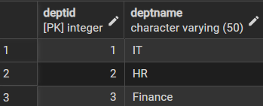

Select * from Employees;

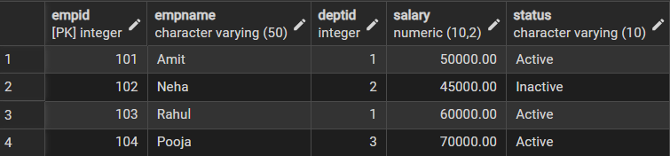

Step 1: Creating a Simple View for Data Filtering
Implementing a view to provide a quick list of active employees without exposing the entire table structure.

CREATE VIEW ActiveEmployees AS
SELECT EmpID, EmpName, DeptID, Salary
FROM Employees
WHERE Status = 'Active';

select * from ActiveEmployees;

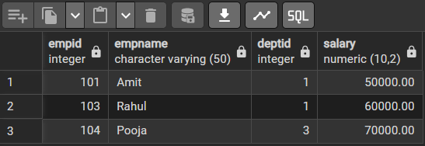

Step 2: Creating a View for Joining Multiple Tables
Simplifying the retrieval of data distributed across Employees and Departments tables.

CREATE VIEW EmpDeptView AS
SELECT
e.EmpID,
e.EmpName,
d.DeptName,
e.Salary
FROM Employees e
JOIN Departments d ON e.DeptID = d.DeptID;

SELECT * FROM EmpDeptView;

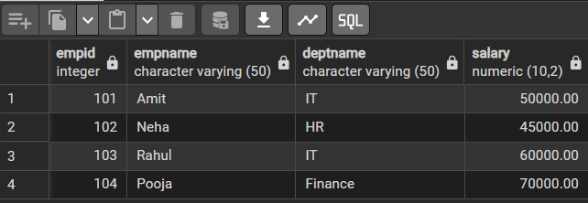

Step 3: Advanced Summarization
View Creating a view to provide department-level statistics automatically

CREATE VIEW DeptSalaryStats AS
SELECT
d.DeptName,
COUNT(e.EmpID) AS TotalEmployees,
SUM(e.Salary) AS TotalSalary,
AVG(e.Salary) AS AvgSalary
FROM Employees e
JOIN Departments d ON e.DeptID = d.DeptID
GROUP BY d.DeptName;

SELECT * FROM DeptSalaryStats;
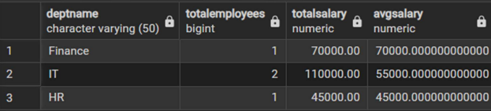
I/O Analysis

Input:
- Employee Data
- Department Data

Output:

- Data Filtering:
The ActiveEmployees view filtered and displayed only those employees whose status is ‘Active’, hiding unnecessary records. The EmpDeptView combined data from multiple tables, allowing easy access to employee and department details in a single query.
- Data Abstraction:
Views acted as virtual tables, hiding complex SQL queries and joins from the user.
- Aggregated Reporting:
The DeptSalaryStats view generated department-wise summaries including total employees, total salary, and average salary.
- Improved Security:
Sensitive data access was controlled by exposing only required columns through views instead of full tables.
- Reusability:
Views can be reused multiple times without rewriting complex queries, improving efficiency.

Learning Outcomes
- Abstraction Proficiency: Students will be able to create and query views to simplify efficient data access and abstraction.
- Security Implementation: Students will understand how to use views for data masking and providing restricted access to sensitive information.
- Syntactic Accuracy: Students will demonstrate the correct syntax for creating and querying views, ensuring logical clarity in naming conventions.
- Real-world Application: Students will be able to design views for practical domains like Library Management Systems or Payroll Systems to demonstrate functionality.

