Experiment No. 7

Student Name: Shubham Agarwal UID: 25MCI10091
Branch: MCA (AI & ML) Section/Group: 25MAM-1/A
Semester: 2nd Date of Performance:31/03/2026 Subject Name: Technical Training Lab Subject Code: 25CAH-653

Aim of the Session:
To implement and understand different types of JOIN operations in PostgreSQL for combining data from multiple tables.

Software Requirements:
- PostgreSQL Database Server
- pgAdmin 4
- Windows Operating System

Objective of the Session:
- To apply different types of JOIN operations on four related tables—Students, Courses, Enrollments, and Departments.
- To understand the relationships between these tables using primary and foreign keys.
- To combine data from multiple tables to retrieve meaningful and structured information.
- To enhance query writing skills for real-world database analysis and reporting.

Practical Experiment Steps:

Table Creation & Record Insertion:

CREATE TABLE DEPARTMENTS (
dept_id VARCHAR(10) PRIMARY KEY, dept_name VARCHAR(50)
);

CREATE TABLE STUDENTS (
student_id VARCHAR(15) PRIMARY KEY, student_name VARCHAR(50), dept_id VARCHAR(10),
FOREIGN KEY (dept_id) REFERENCES Departments(dept_id)
);

CREATE TABLE Courses (
course_id VARCHAR(15) PRIMARY KEY, course_name VARCHAR(50)
);

CREATE TABLE Enrollments (
enroll_id VARCHAR(20) PRIMARY KEY,student_id VARCHAR(15),course_id VARCHAR(15),
FOREIGN KEY (student_id) REFERENCES Students(student_id),
FOREIGN KEY (course_id) REFERENCES Courses(course_id)
);

--DEPARTMENTS TABLE
INSERT INTO Departments VALUES ('D01', 'Computer Science');
INSERT INTO Departments VALUES ('D02', 'Mechanical');
INSERT INTO Departments VALUES ('D03', 'Electrical');

--STUDENTS TABLE
INSERT INTO Students VALUES ('STU101A', 'Shubham Agarwal', 'D01');
INSERT INTO Students VALUES ('STU102B', 'Rahul Sharma', 'D02');
INSERT INTO Students VALUES ('STU103C', 'Amit Verma', 'D01');
INSERT INTO Students VALUES ('STU104D', 'Neha Kapoor', 'D03');
INSERT INTO Students VALUES ('STU105E', 'Priya Singh', 'D02');
INSERT INTO Students VALUES ('STU106F', 'Karan Mehta', 'D01');

--COURSES TABLE
INSERT INTO Courses VALUES ('CSE201', 'Database Management System');
INSERT INTO Courses VALUES ('CSE202', 'Operating System');
INSERT INTO Courses VALUES ('MTH101', 'Engineering Mathematics');
INSERT INTO Courses VALUES ('PHY110', 'Applied Physics');

--ENROLLMENTS TABLE
INSERT INTO Enrollments VALUES ('ENR001', 'STU101A', 'CSE201');
INSERT INTO Enrollments VALUES ('ENR002', 'STU101A', 'CSE202');
INSERT INTO Enrollments VALUES ('ENR003', 'STU101A', 'MTH101');
INSERT INTO Enrollments VALUES ('ENR004', 'STU102B', 'MTH101');
INSERT INTO Enrollments VALUES ('ENR005', 'STU103C', 'CSE201');
INSERT INTO Enrollments VALUES ('ENR006', 'STU103C', 'PHY110');
INSERT INTO Enrollments VALUES ('ENR007', 'STU106F', 'CSE201');
INSERT INTO Enrollments VALUES ('ENR008', 'STU106F', 'CSE202');
INSERT INTO Enrollments VALUES ('ENR009', 'STU106F', 'PHY110');

--VIEWING RECORDS OF DIFFERENT TABLES

SELECT * FROM DEPARTMENTS;
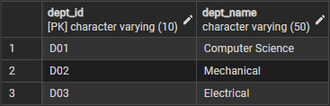

SELECT * FROM STUDENTS;
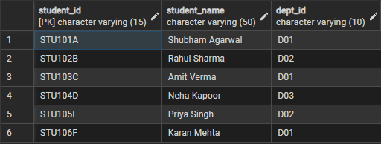

SELECT * FROM ENROLLMENTS;
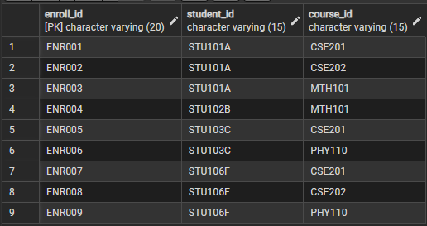

SELECT * FROM COURSES;
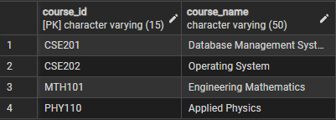

Step 1: Write queries to list students with their enrolled courses (INNER JOIN).
SELECT * FROM Students S INNER JOIN Enrollments E
ON S.student_id = E.student_id INNER JOIN Courses C
ON E.course_id = C.course_id;

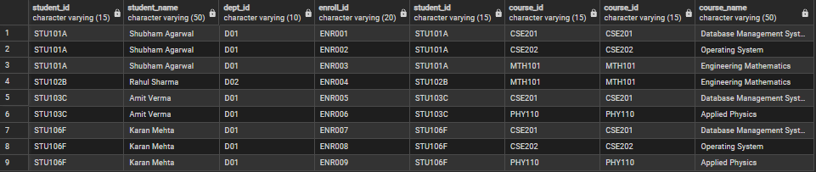

STEP 2: Find students not enrolled in any course (LEFT JOIN).
SELECT s.student_id, s.student_name
FROM STUDENTS s
LEFT JOIN ENROLLMENTS e ON s.student_id = e.student_id
WHERE e.student_id IS NULL;
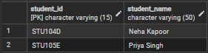

STEP 3: Display all courses with or without enrolled students (RIGHT JOIN).
SELECT c.course_id, c.course_name, s.student_name
FROM STUDENTS s
RIGHT JOIN ENROLLMENTS e ON s.student_id = e.student_id
RIGHT JOIN COURSES c ON e.course_id = c.course_id;
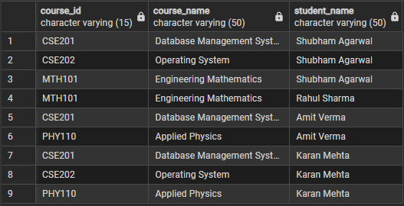

STEP 4: Show students with department info using SELF JOIN or MULTIPLE JOINS.
SELECT s.student_id, s.student_name, d.dept_name
FROM STUDENTS s
INNER JOIN DEPARTMENTS d ON s.dept_id = d.dept_id;
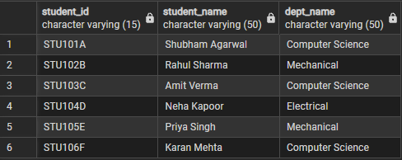

STEP 5: Display all possible student-course combinations (CROSS JOIN).
SELECT s.student_name, c.course_name
FROM STUDENTS sCROSS JOIN COURSES c;
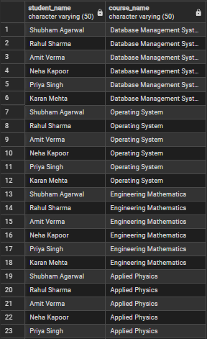

I/O Analysis
Input:
The input consists of data stored in four relational tables:

Departments Table
dept_id | dept_name
--------------------------
D01 | Computer Science
D02 | Mechanical
D03 | Electrical

Students Table
student_id | student_name | dept_id
----------------------------------------
STU101A | Shubham Agarwal | D01
STU102B | Rahul Sharma | D02
STU103C | Amit Verma | D01
STU104D | Neha Kapoor | D03
STU105E | Priya Singh | D02
STU106F | Karan Mehta | D01

Courses Table
course_id | course_name
--------------------------------------
CSE201 | Database Management System
CSE202 | Operating System
MTH101 | Engineering Mathematics
PHY110 | Applied Physics

Enrollments Table
enroll_id | student_id | course_id
----------------------------------
ENR001 | STU101A | CSE201
ENR002 | STU101A | CSE202
ENR003 | STU101A | MTH101
ENR004 | STU102B | MTH101
ENR005 | STU103C | CSE201
ENR006 | STU103C | PHY110
ENR007 | STU106F | CSE201
ENR008 | STU106F | CSE202
ENR009 | STU106F | PHY110

Output:
- Step 1 – Inner Join Operation:
Displayed only those students who are enrolled in courses, ensuring matching records from all related tables.

- Step 2 – Left Join Operation:
Identified students who are not enrolled in any course by showing unmatched records from the Students table.

- Step 3 – Right Join Operation:
Displayed all courses along with enrolled students, ensuring that even courses without students would be included.

- Step 4 – Multiple Join Operation:
Combined Students and Departments tables to provide complete student details along with their department information.

- Step 5 – Cross Join Operation:
Generated all possible combinations of students and courses, demonstrating the concept of Cartesian product.

Learning Outcomes
- Understanding of JOIN Operations:
Gained knowledge of different types of SQL joins such as INNER JOIN, LEFT JOIN, RIGHT JOIN, and CROSS JOIN and their practical applications.

- Data Integration Skills:
Learned how to combine data from multiple related tables (Students, Courses, Enrollments, Departments) to extract meaningful information.

- Handling Matched and Unmatched Records:
Developed the ability to identify both matching and non-matching records using INNER and OUTER joins.

- Query Writing and Optimization:
Improved skills in writing efficient SQL queries to retrieve structured and relevant data from relational databases.

