Experiment No. 9

Student Name: Shubham Agarwal UID: 25MCI10091
Branch: MCA (AI & ML) Section/Group: 25MAM-1/A
Semester: 2nd Date of Performance:12/03/2026 Subject Name: Technical Training Lab Subject Code: 25CAH-653

Aim of the Session:
To apply the concept of Stored Procedures in database operations in order to perform tasks like insertion, updating, deletion, and retrieval of data efficiently, securely, and in a reusable manner within the database system.
Software Requirements:
- PostgreSQL Database Server
- pgAdmin 4
- Windows Operating System

Objective of the Session:
- To understand the concept and usage of stored procedures in database systems.
- To implement stored procedures for performing CRUD operations efficiently.
- To enhance data security by restricting direct access through stored procedures.
- To reduce code redundancy by using reusable database procedures.
- To improve performance of database operations using precompiled stored procedures
Practical Experiment Steps:

Table Creation:

CREATE TABLE employees (
emp_id INT PRIMARY KEY,
emp_name VARCHAR(50),
department VARCHAR(50),
designation VARCHAR(50),
salary NUMERIC(20,3),
joining_date DATE
);

Record Insertion:

INSERT INTO employees (emp_id, emp_name, department, designation, salary, joining_date) VALUES
(1, 'Rahul Sharma', 'IT', 'Software Engineer', 45000.000, '2022-03-15'),
(2, 'Priya Verma', 'HR', 'HR Manager', 55000.000, '2021-07-10'),
(3, 'Amit Gupta', 'Finance', 'Accountant', 40000.000, '2020-11-05'),
(4, 'Sneha Kapoor', 'IT', 'Frontend Developer', 42000.000, '2023-01-20'),
(5, 'Vikas Singh', 'Sales', 'Sales Executive', 38000.000, '2022-06-25'),
(6, 'Neha Joshi', 'Marketing', 'Marketing Manager', 60000.000, '2019-09-12'),
(7, 'Arjun Mehta', 'IT', 'Backend Developer', 47000.000, '2021-12-01');

SELECT * FROM employees;

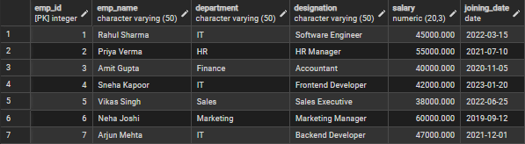

Step 1: Creating a Stored Procedure:

CREATE OR REPLACE procedure update_salary_proc(IN P_EMP_ID INT,INOUT P_SALARY NUMERIC(20,3),OUT STATUS VARCHAR(20))
AS
$$
DECLARE
CURR_SAL NUMERIC(20,3);
BEGIN

SELECT SALARY+P_SALARY INTO CURR_SAL FROM employees WHERE EMP_ID=P_EMP_ID;
IF NOT FOUND THEN
RAISE EXCEPTION 'EMPLOYEE NOT FOUND';
END IF;

UPDATE employees
SET salary= curr_sal
where emp_id=p_emp_id;

P_salary:=curr_sal;
status:='SUCCESS';

EXCEPTION
WHEN OTHERS THEN
IF SQLERRM LIKE '%EMPLOYEE NOT FOUND%' THEN
STATUS:= 'EMPLOYEE NOT FOUND';
END IF;

END;
$$ LANGUAGE PLPGSQL;

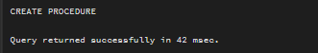

Step 2: Calling Stored Procedure
DO
$$
DECLARE
EMP_ID INT:=1;
STATUS VARCHAR(20);
SALARY NUMERIC(20,3):=500;
BEGIN
CALL update_salary_proc(Emp_id,salary,status);
RAISE NOTICE 'YOUR STATUS IS % AND YOUR UPDATED SALARY IS %',STATUS,salary;
END;
$$
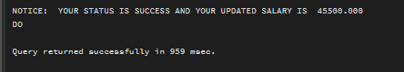

I/O Analysis
Input:
- Employee Data
Output:
- Salary Update: Adds increment to existing salary and updates database
- Validation: Checks if employee exists
- Updated Salary: Returned using INOUT parameter
- Status Message: Returns SUCCESS or EMPLOYEE NOT FOUND
- Error Handling: Handles exceptions properly

Learning Outcomes
- Stored Procedure Implementation:Students will be able to create and execute stored procedures using IN, OUT, and INOUT parameters for real-world database operations.
- Error Handling & Validation:Students will understand how to implement exception handling in PL/pgSQL to manage invalid inputs and unexpected conditions.
- Logical Flow Understanding:Students will gain knowledge of control structures like variable declaration, conditional statements, and query execution inside procedures.
- Real-world Application:Students will be able to design systems such as payroll management, employee management, or banking systems where automated updates and validations are required.

