

National College of Ireland

Project Submission Sheet

Student Name: | Emre Cholakoglu
Student ID: | 24775049
Programme: | BSc (Honours) in Computing | Year: | 2nd
Module: | Object Oriented Programming
Lecturer: | Julie Power
Submission Due Date: | 25/10/2026
Project Title: | CA Group Project / Home Energy Manager App
Word Count: | ………………………………………………………………………………………………………………

Academic Integrity Certificate Verification Code: scD7OLv4aF

I hereby certify that the information contained in this (my submission) is information pertaining to research I conducted for this project. All information other than my own contribution will be fully referenced and listed in the relevant bibliography section at the rear of the project.
ALL internet material must be referenced in the references section. Students are encouraged to use the Harvard Referencing Standard or appropriate referencing style supplied by the Library. To use other author's written or electronic work is illegal (plagiarism) and may result in disciplinary action. Students may be required to undergo a viva (oral examination) if there is suspicion about the validity of their submitted work.

Note: Academic Integrity Course Requirement – Starting Monday, 19th January 2026, all students are required to successfully complete the Epigeum Academic Integrity Course, which is available on Moodle. This is a self-paced online course consisting of 4 modules and will take approximately 2 hours to complete. Once you have successfully completed the course, you will receive a Certificate & Verification Code. This code must be included on the Project Cover Sheet when submitting your work. For full details and guidance, please visit: 🔗 ttps://libguides.ncirl.ie/academicintegrity/epigeumforstudents

Signature: | Emre Cholakoglu
Date: | 23/10/2026

PLEASE READ THE FOLLOWING INSTRUCTIONS:

1. Please attach a completed copy of this sheet to each project (including multiple copies).
2. Projects should be submitted to your Programme Coordinator.
3. You must ensure that you retain a HARD COPY of ALL projects, both for your own reference and in case a project is lost or mislaid. It is not sufficient to keep a copy on computer. Please do not bind projects or place in covers unless specifically requested.
4. You must ensure that all projects are submitted to your Programme Coordinator on or before the required submission date. Late submissions will incur penalties.
5. All projects must be submitted and passed in order to successfully complete the year. Any project/assignment not submitted will be marked as a fail.
6. Please check that you read AI and Academic Integrity Acknowledgement Supplments in this document

Office Use Only
Signature:
Date:
Penalty Applied (if applicable):

AI Acknowledgement Supplement

[Object Oriented Programming]

[Home Energy Manager App]

Your Name/Student Number | Course | Date
Emre Cholakoglu/24775049 | BSc Computing | 23/10/2026

This section is a supplement to the main assignment, to be used if AI was used in any capacity in the creation of your assignment; if you have queries about how to do this, please contact your lecturer. For an example of how to fill these sections out, please click here.

AI Acknowledgment
This section acknowledges the AI tools that were utilized in the process of completing this assignment.
Tool Name | Brief Description | Link to tool

Description of AI Usage
This section provides a more detailed description of how the AI tools were used in the assignment. It includes information about the prompts given to the AI tool, the responses received, and how these responses were utilized or modified in the assignment. One table should be used for each tool used.
[Insert Tool Name]
[Insert Description of use]
[Insert Sample prompt] | [Insert Sample response]
Evidence of AI Usage
This section includes evidence of significant prompts and responses used or generated through the AI tool. It should provide a clear understanding of the extent to which the AI tool was used in the assignment. Evidence may be attached via screenshots or text.

Additional Evidence:
[Place evidence here]

National College of Ireland

Project Submission Sheet

Student Name: | Ly Nam Anh
Student ID: | 24216577
Programme: | BSc (Honours) in Computing | Year: | Second year
Module: | Object Oriented Programming
Lecturer: | Julie Power
Submission Due Date: | 25/10/2026
Project Title: | CA Group Project / Home Energy Manager App
Word Count:

Academic Integrity Certificate Verification Code: d54JisMbeR

I hereby certify that the information contained in this (my submission) is information pertaining to research I conducted for this project. All information other than my own contribution will be fully referenced and listed in the relevant bibliography section at the rear of the project.
ALL internet material must be referenced in the references section. Students are encouraged to use the Harvard Referencing Standard or appropriate referencing style supplied by the Library. To use other author's written or electronic work is illegal (plagiarism) and may result in disciplinary action. Students may be required to undergo a viva (oral examination) if there is suspicion about the validity of their submitted work.

Note: Academic Integrity Course Requirement – Starting Monday, 19th January 2026, all students are required to successfully complete the Epigeum Academic Integrity Course, which is available on Moodle. This is a self-paced online course consisting of 4 modules and will take approximately 2 hours to complete. Once you have successfully completed the course, you will receive a Certificate & Verification Code. This code must be included on the Project Cover Sheet when submitting your work. For full details and guidance, please visit: 🔗 ttps://libguides.ncirl.ie/academicintegrity/epigeumforstudents

Signature: | 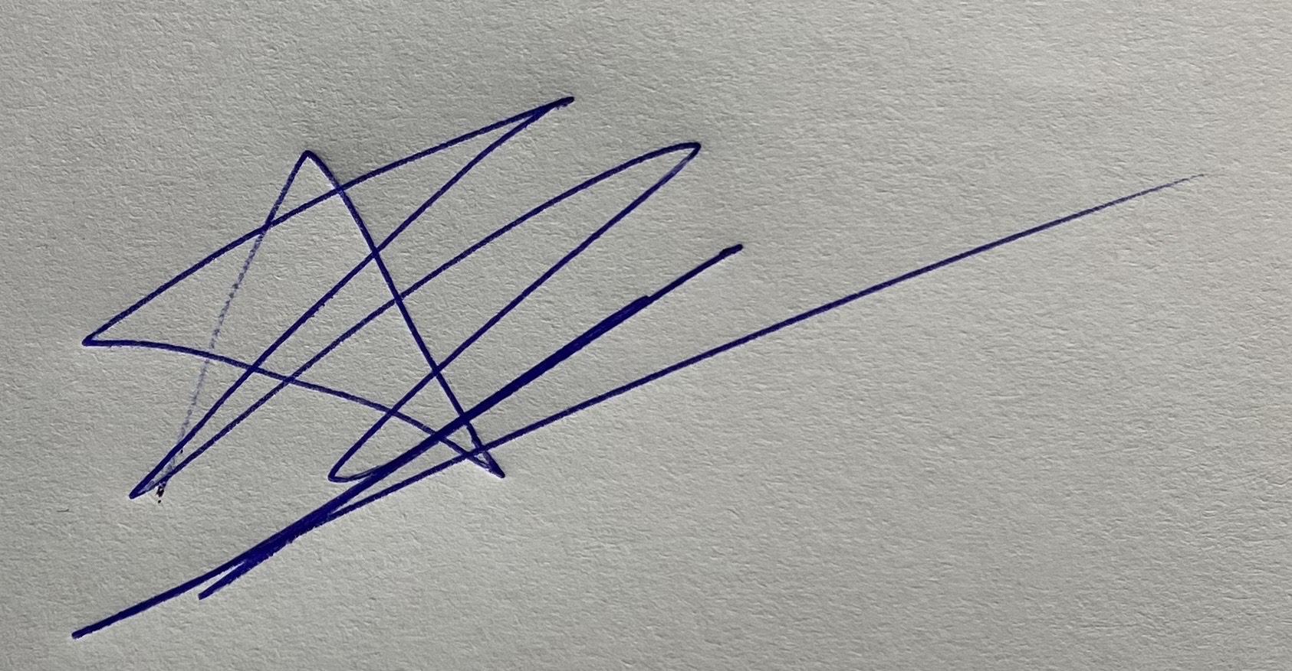
Date: | 21/10/2026

PLEASE READ THE FOLLOWING INSTRUCTIONS:

1. Please attach a completed copy of this sheet to each project (including multiple copies).
2. Projects should be submitted to your Programme Coordinator.
3. You must ensure that you retain a HARD COPY of ALL projects, both for your own reference and in case a project is lost or mislaid. It is not sufficient to keep a copy on computer. Please do not bind projects or place in covers unless specifically requested.
4. You must ensure that all projects are submitted to your Programme Coordinator on or before the required submission date. Late submissions will incur penalties.
5. All projects must be submitted and passed in order to successfully complete the year. Any project/assignment not submitted will be marked as a fail.
6. Please check that you read AI and Academic Integrity Acknowledgement Supplments in this document

Office Use Only
Signature:
Date:
Penalty Applied (if applicable):

AI Acknowledgement Supplement

Object Oriented Programming

HomeEnergyManagerApp

Your Name/Student Number | Course | Date
Ly Nam Anh | BSc (Honours) in Computing | 21/10/2026

This section is a supplement to the main assignment, to be used if AI was used in any capacity in the creation of your assignment; if you have queries about how to do this, please contact your lecturer. For an example of how to fill these sections out, please click here.

AI Acknowledgment
This section acknowledges the AI tools that were utilized in the process of completing this assignment.
Tool Name | Brief Description | Link to tool
None

Description of AI Usage
This section provides a more detailed description of how the AI tools were used in the assignment. It includes information about the prompts given to the AI tool, the responses received, and how these responses were utilized or modified in the assignment. One table should be used for each tool used.
None

Evidence of AI Usage
This section includes evidence of significant prompts and responses used or generated through the AI tool. It should provide a clear understanding of the extent to which the AI tool was used in the assignment. Evidence may be attached via screenshots or text.

Additional Evidence:

National College of Ireland

Project Submission Sheet

Student Name: | Alpsan Karademir
Student ID: | 24338729
Programme: | BSc (Honours) in Computing | Year: | 2nd
Module: | Object Oriented Programming
Lecturer: | Julie Power
Submission Due Date: | 25/10/2026
Project Title: | CA Group Project / Home Energy Manager App
Word Count: | ………………………………………………………………………………………………………………

Academic Integrity Certificate Verification Code: Mo6YCZeF2c

I hereby certify that the information contained in this (my submission) is information pertaining to research I conducted for this project. All information other than my own contribution will be fully referenced and listed in the relevant bibliography section at the rear of the project.
ALL internet material must be referenced in the references section. Students are encouraged to use the Harvard Referencing Standard or appropriate referencing style supplied by the Library. To use other author's written or electronic work is illegal (plagiarism) and may result in disciplinary action. Students may be required to undergo a viva (oral examination) if there is suspicion about the validity of their submitted work.

Note: Academic Integrity Course Requirement – Starting Monday, 19th January 2026, all students are required to successfully complete the Epigeum Academic Integrity Course, which is available on Moodle. This is a self-paced online course consisting of 4 modules and will take approximately 2 hours to complete. Once you have successfully completed the course, you will receive a Certificate & Verification Code. This code must be included on the Project Cover Sheet when submitting your work. For full details and guidance, please visit: 🔗 ttps://libguides.ncirl.ie/academicintegrity/epigeumforstudents

Signature: | Alpsan Karademir
Date: | 23/10/2026

PLEASE READ THE FOLLOWING INSTRUCTIONS:

1. Please attach a completed copy of this sheet to each project (including multiple copies).
2. Projects should be submitted to your Programme Coordinator.
3. You must ensure that you retain a HARD COPY of ALL projects, both for your own reference and in case a project is lost or mislaid. It is not sufficient to keep a copy on computer. Please do not bind projects or place in covers unless specifically requested.
4. You must ensure that all projects are submitted to your Programme Coordinator on or before the required submission date. Late submissions will incur penalties.
5. All projects must be submitted and passed in order to successfully complete the year. Any project/assignment not submitted will be marked as a fail.
6. Please check that you read AI and Academic Integrity Acknowledgement Supplments in this document

Office Use Only
Signature:
Date:
Penalty Applied (if applicable):

AI Acknowledgement Supplement

[Object Oriented Programming]

[Home Energy Manager App]

Your Name/Student Number | Course | Date
Alpsan Karademir/24338729 | BSc Computing | 23/10/2026

This section is a supplement to the main assignment, to be used if AI was used in any capacity in the creation of your assignment; if you have queries about how to do this, please contact your lecturer. For an example of how to fill these sections out, please click here.

AI Acknowledgment
This section acknowledges the AI tools that were utilized in the process of completing this assignment.
Tool Name | Brief Description | Link to tool

Description of AI Usage
This section provides a more detailed description of how the AI tools were used in the assignment. It includes information about the prompts given to the AI tool, the responses received, and how these responses were utilized or modified in the assignment. One table should be used for each tool used.
[Insert Tool Name]
[Insert Description of use]
[Insert Sample prompt] | [Insert Sample response]
Evidence of AI Usage
This section includes evidence of significant prompts and responses used or generated through the AI tool. It should provide a clear understanding of the extent to which the AI tool was used in the assignment. Evidence may be attached via screenshots or text.

Additional Evidence:
[Place evidence here]

Project Overview

Home Energy Manager is a Java application that supports UN Sustainable Development Goal 7 (Affordable and Clean Energy). It helps households understand how much energy they use, find where they can save, and explore clean energy options for their home. The app has three sections, and a main class (HomeEnergyApp) links them together. Each section is developed by one team member.

Section 1: Energy Consumption Tracker by Ly Nam Anh

The Energy Consumption Tracker is an application that allows users to manage and monitor their energy consumption records. Users can add meter readings by entering the date, energy type, and units consumed, view all recorded readings with the calculated cost, search for records by month or energy type, and delete incorrect entries. This application helps users track their energy usage and better understand their energy expenses.

Section 2: Appliance Manager & Savings Tips by Emre Cholakoglu
In this section it will show to households where their electricity goes. Users will be able to record power in watts and daily hours of use. Then the app works out daily energy use and monthly cost, highlights the biggest consumers, and gives saving tips.
Initial Functionality:
1- Add, display, search (by name or room) and delete appliances, stored in ArrayList
2- Calculate daily kWh and monthly cost from user’s electricity rate
3- Saving report which will include the highest consuming appliance, the total monthly cost and a tip for each appliance type, and an appliance list saved to and loaded from a file.
As a homeowner, I would like to record my appliances’ usage and see which ones cost me the most, so that I can start saving energy by following the saving tips generated by the application. Costs are calculated from the electricity rate entered by the user.

Section 3: Clean Energy Guide by Alpsan Karademir

This section helps users explore clean energy options for their home (solar panels, wind turbines and heat pumps) and compare their cost/efficient.

- Browse clean energy options with their details
- Enter home details to calculate installation cost, yearly savings
- Add a new energy option or delete an existing one
- Recommend the option with the shortest payback period

I want to compare clean energy options for my home so that I can see how much each one costs and how many years it takes to pay for itself.

Class Diagrams
From: Ly Nam Anh

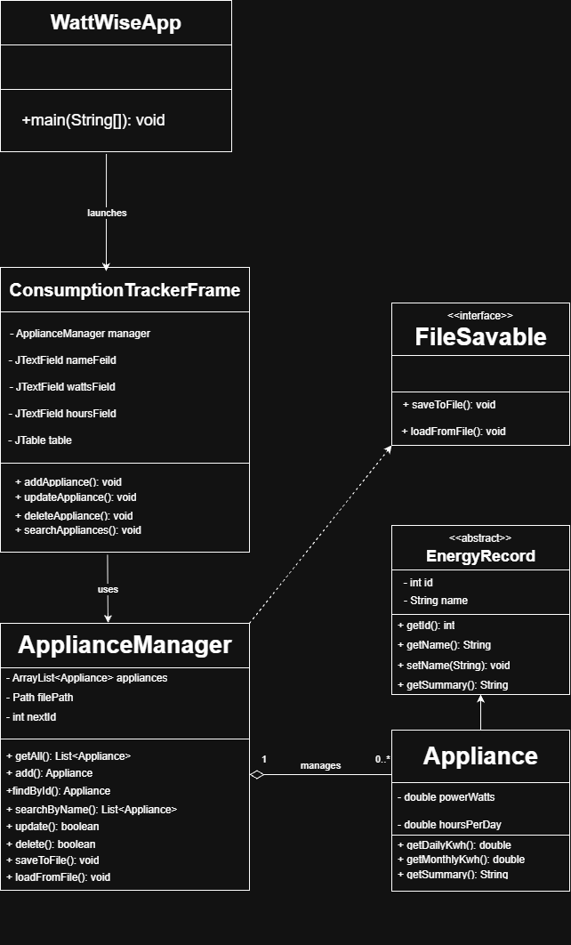

From: Emre Cholakoglu

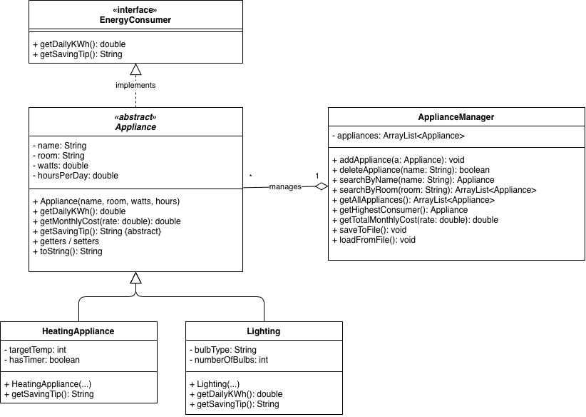

From: Alpsan Karademir

