User Guide

1. Overview

There are total **5** parts of the **UI** of this system**:**

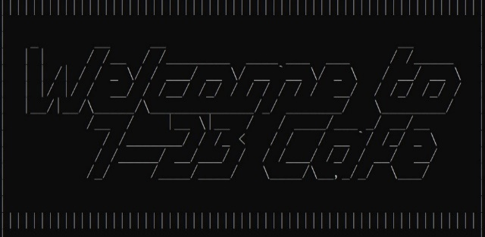

1. **Welcome image**
2. **Menu**  (too long so I cut it into two parts)

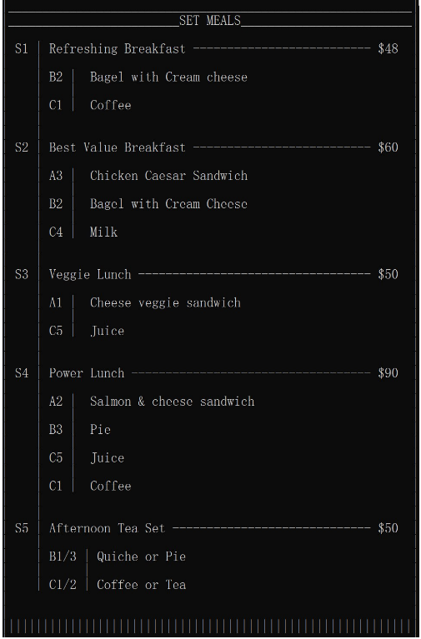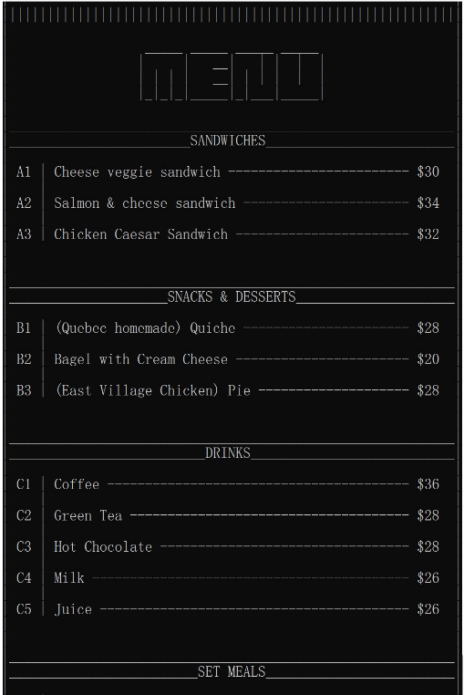

**Item price**

**Item name**

**Food included in the set meal**

**Item code**

**(Item ID)**

1. 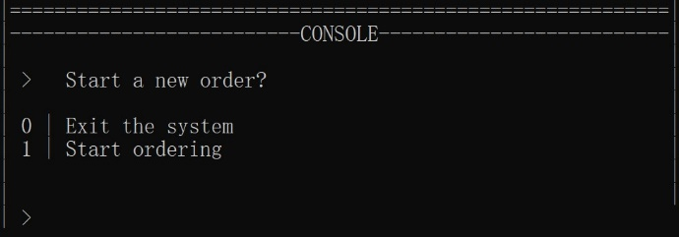**Console**

(imitating the command line, show avaliable commands and wait for user to input)

**User’s ID (OIS)**

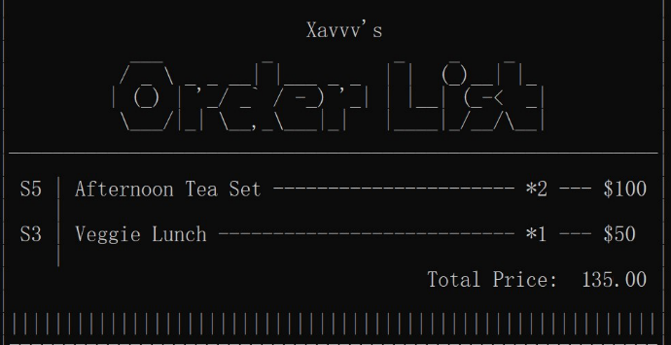

1. **Order list**

**Item number**

(show your ID, foods, their numbers and prices)

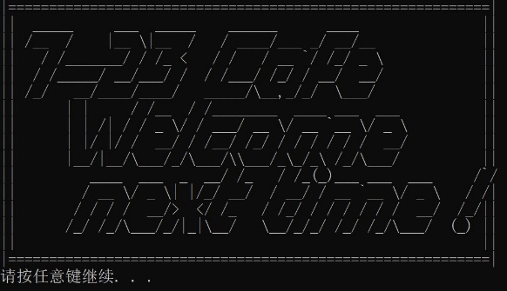

1. **Goodbye image**
2. **Guide to the system step by step**
3. 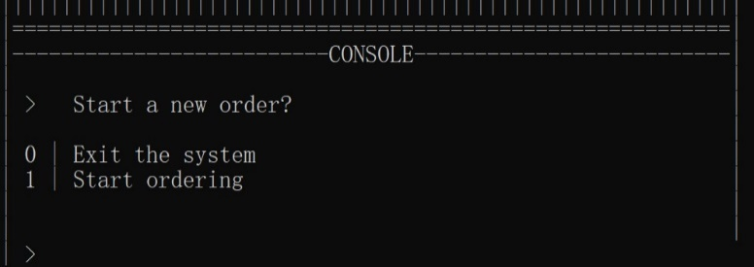(You will see **Welcome image + Menu + console**) You can choose to start a new order or exit the system.

This is the screenshot of the Console. The console will always at the bottom of the screen, under Menu and your Order List.

(Enter 1: go to **Step 2.**

Enter 0: go to **Step 6.**)

**Tips:** After you enter a legal system command, the screen will be refreshed and updated, which may cause a certain delay.

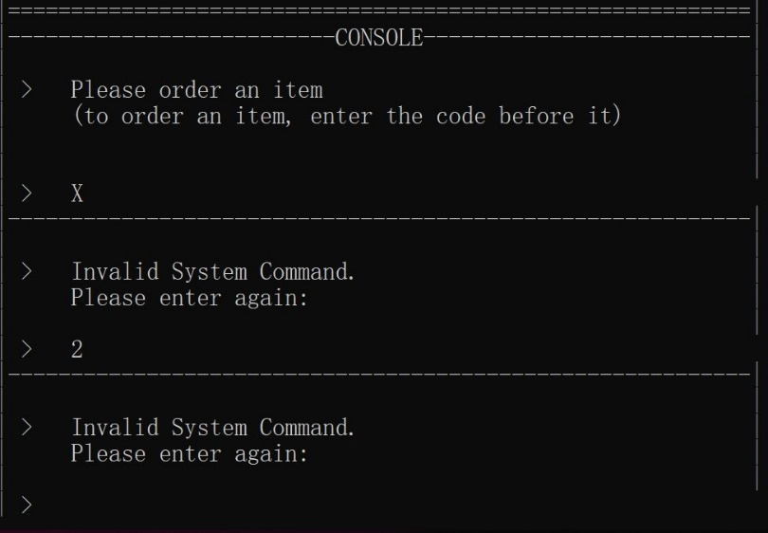**Tips:** If you enter illegal commands, you’ll be asked to enter again.

1. (**Menu + Console**) Once start order, you should enter an **Order Identification String**

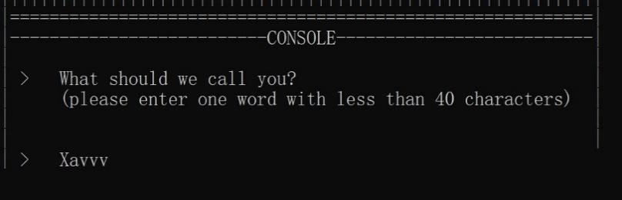(e.g. Xavvv)

1. **(Menu + Order List + Console**) Now you can choose an item from the menu (above the console). (e.g. S5)

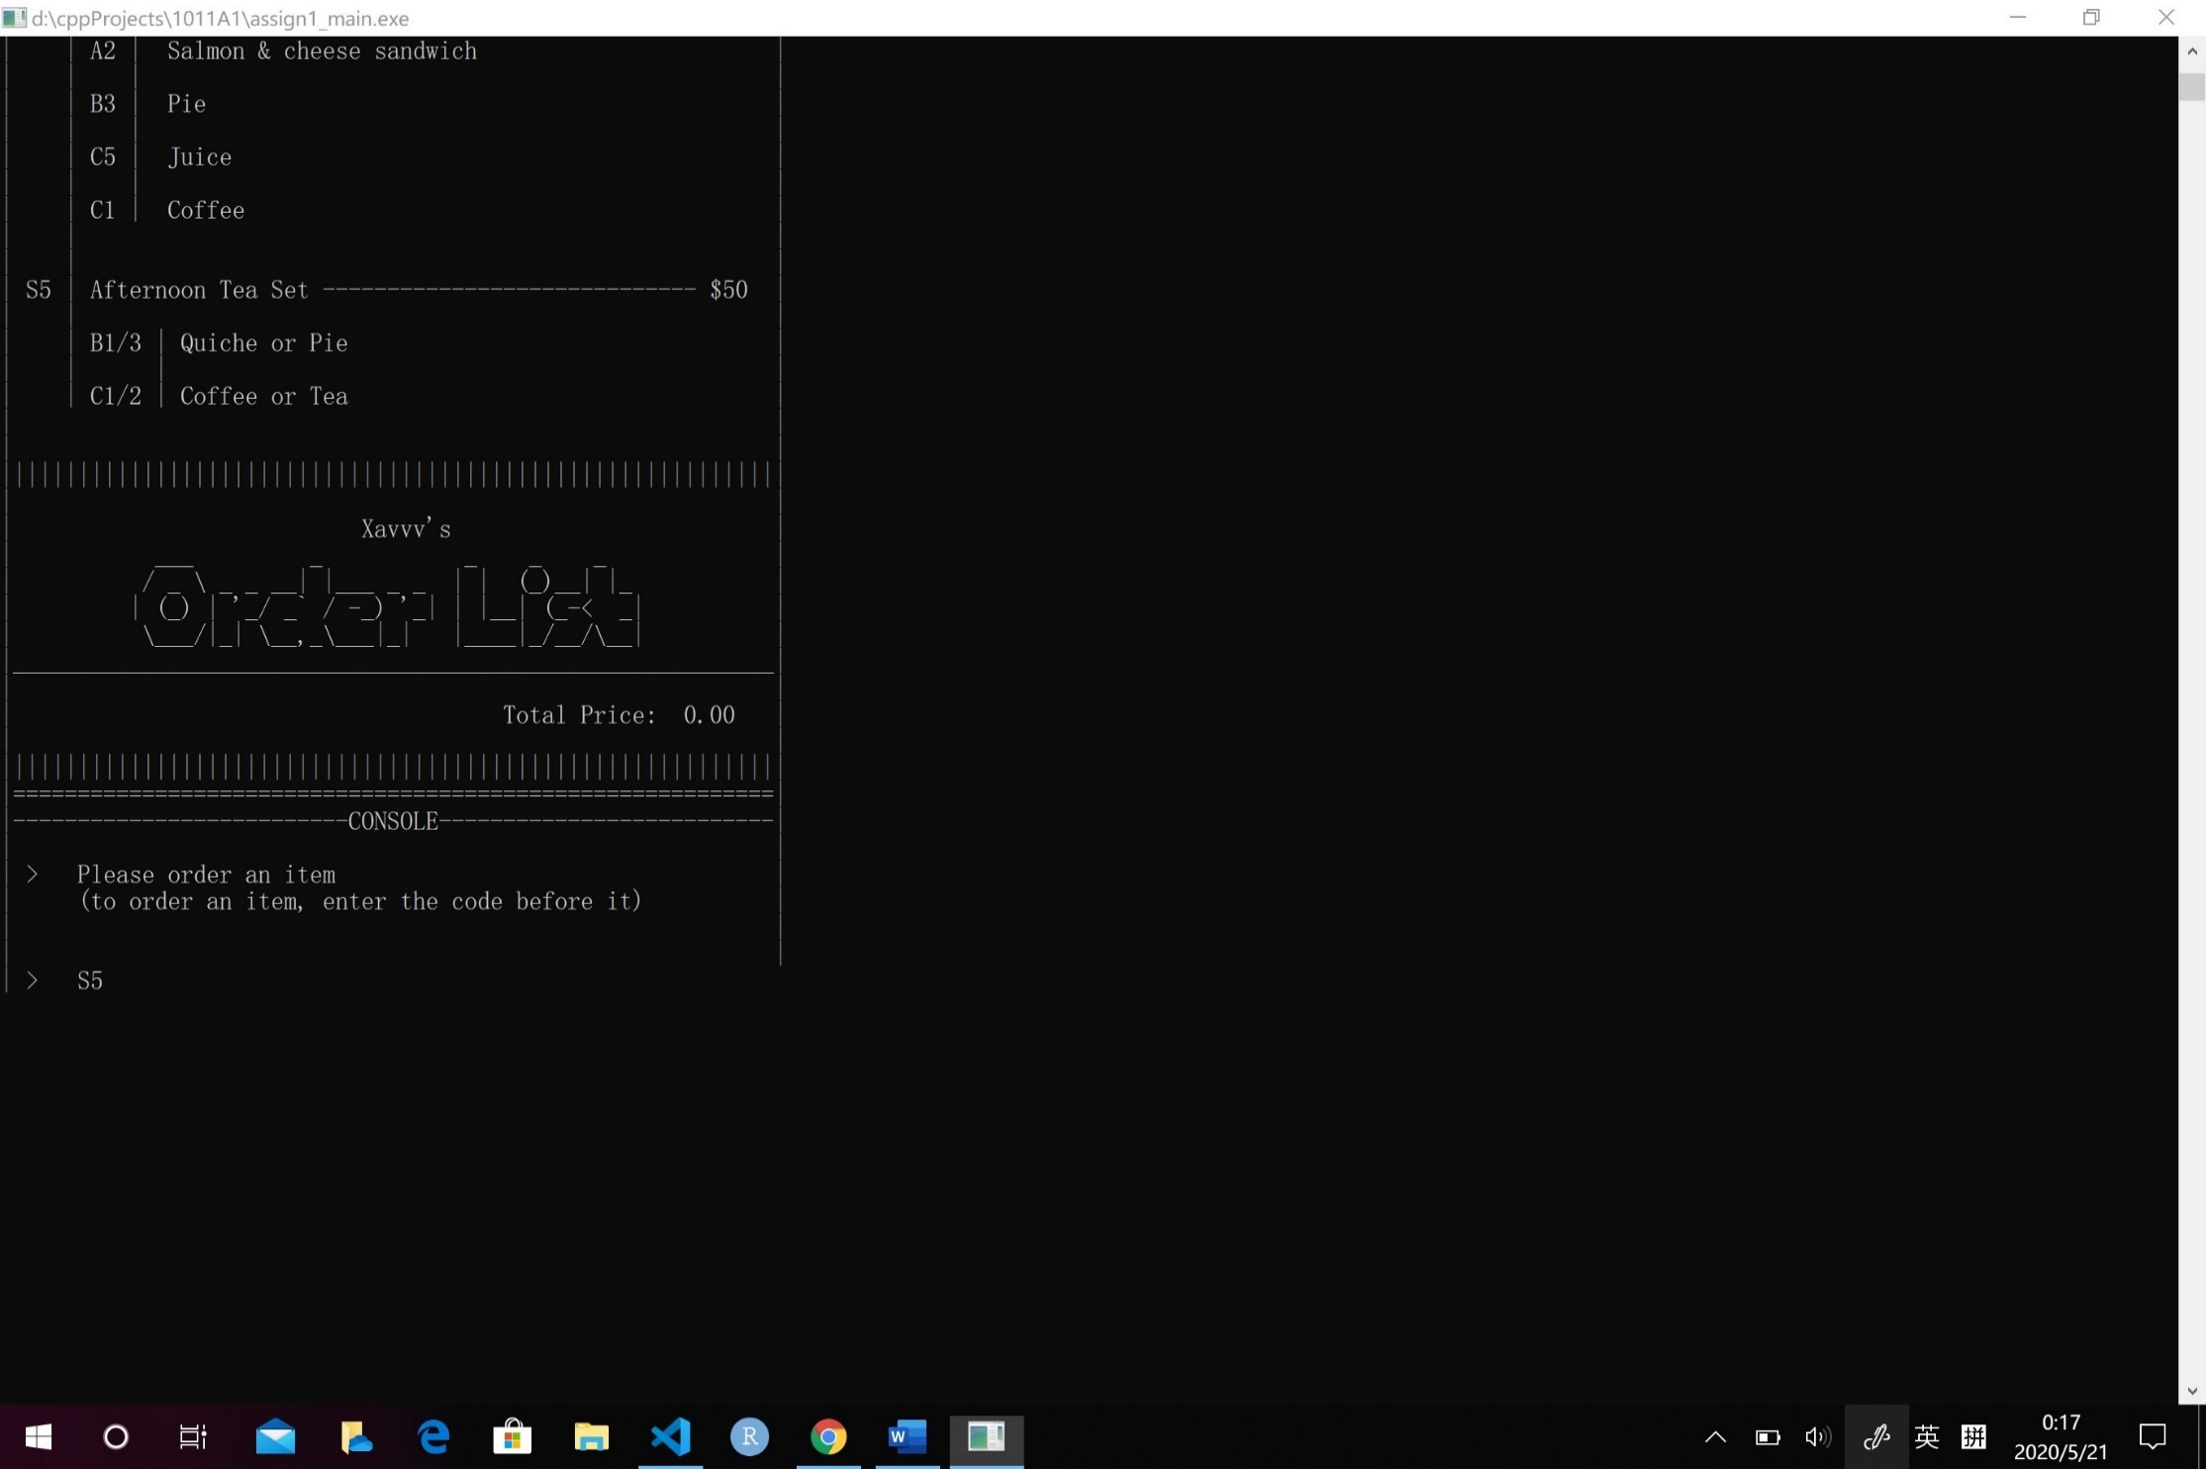

1. 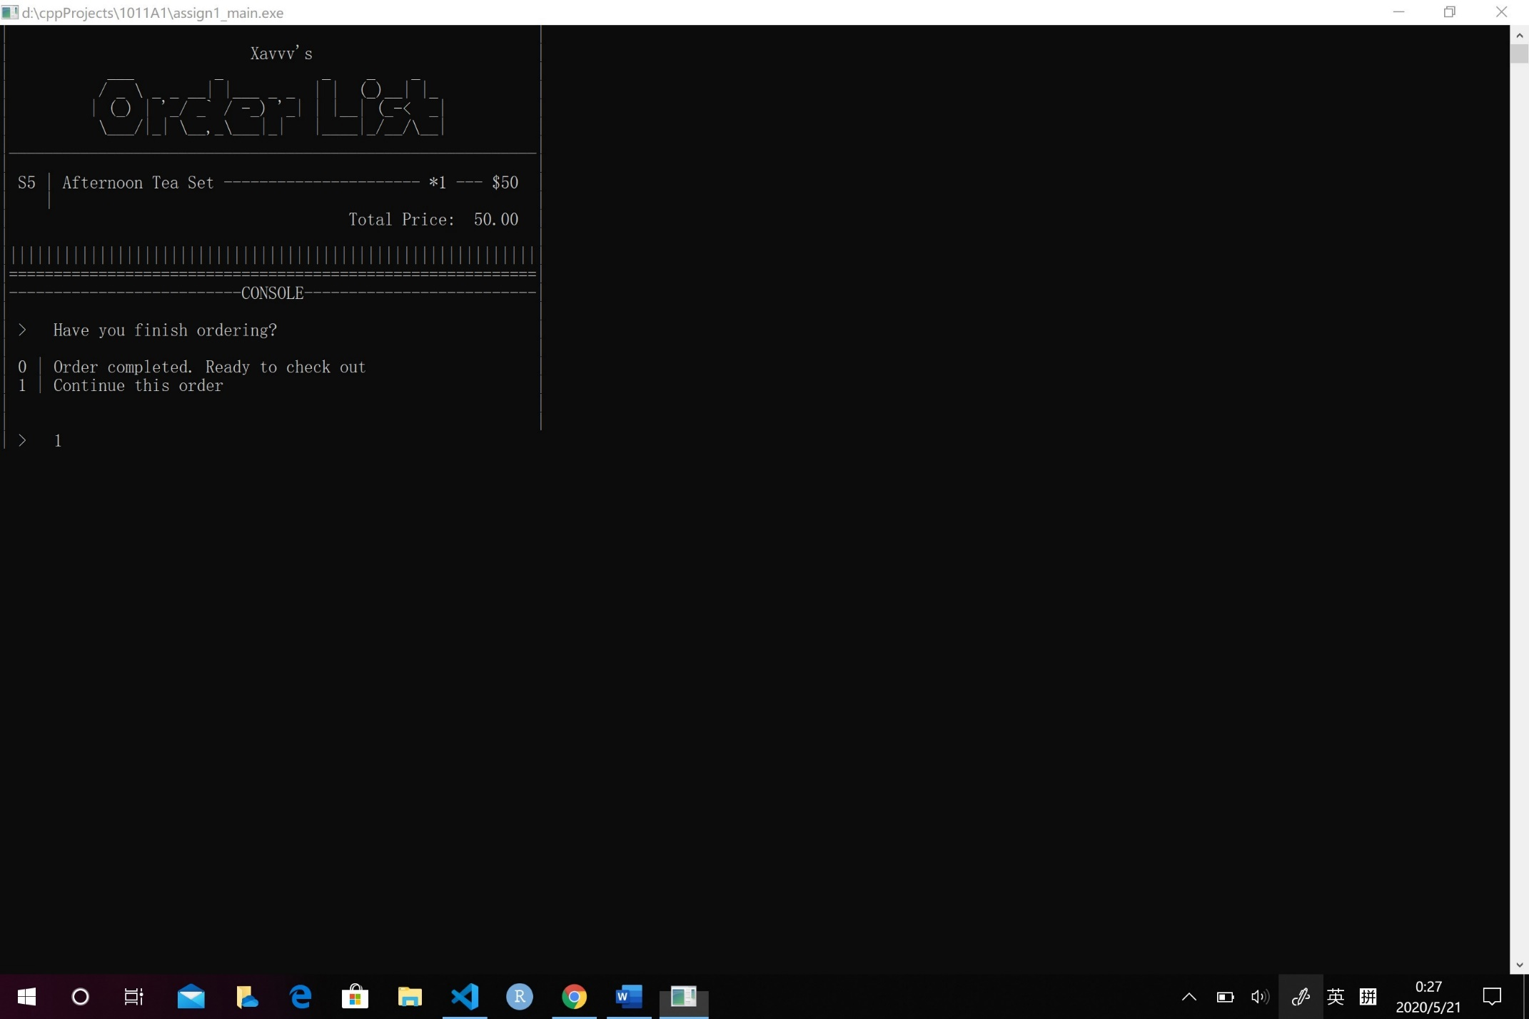 (**Menu + Order List + Console**) After order an item, you can choose to continue ordering or check out.

(Enter 1: go to **Step 3.**

Enter 0: go to **Step 5.**)

**Tips:** Your items will be **packaged** into **set meals** automatically once you order them.

(e.g. if you have **A1** in your list, after you order a **C5**, you’ll automatically have a **S3** to take the place of **A1** and **C5** in your Order List. See images below.)

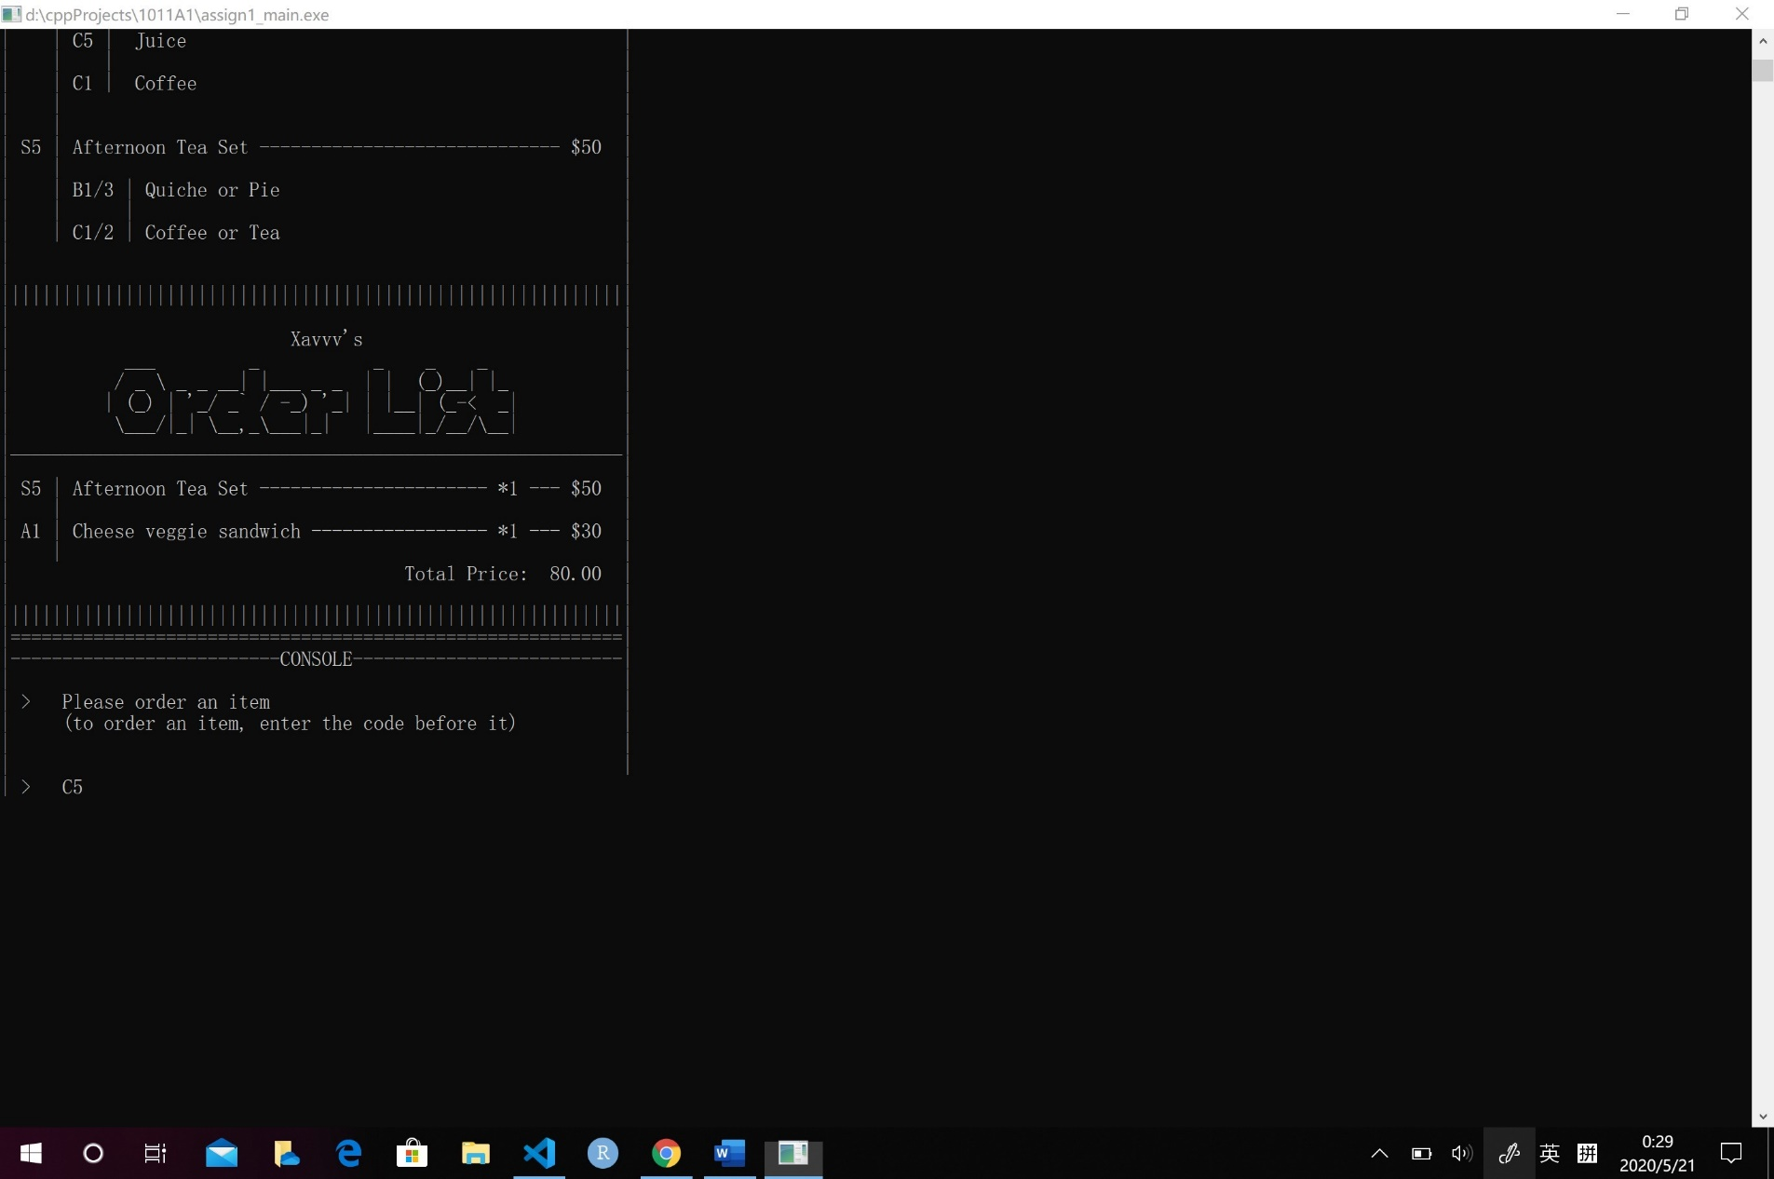

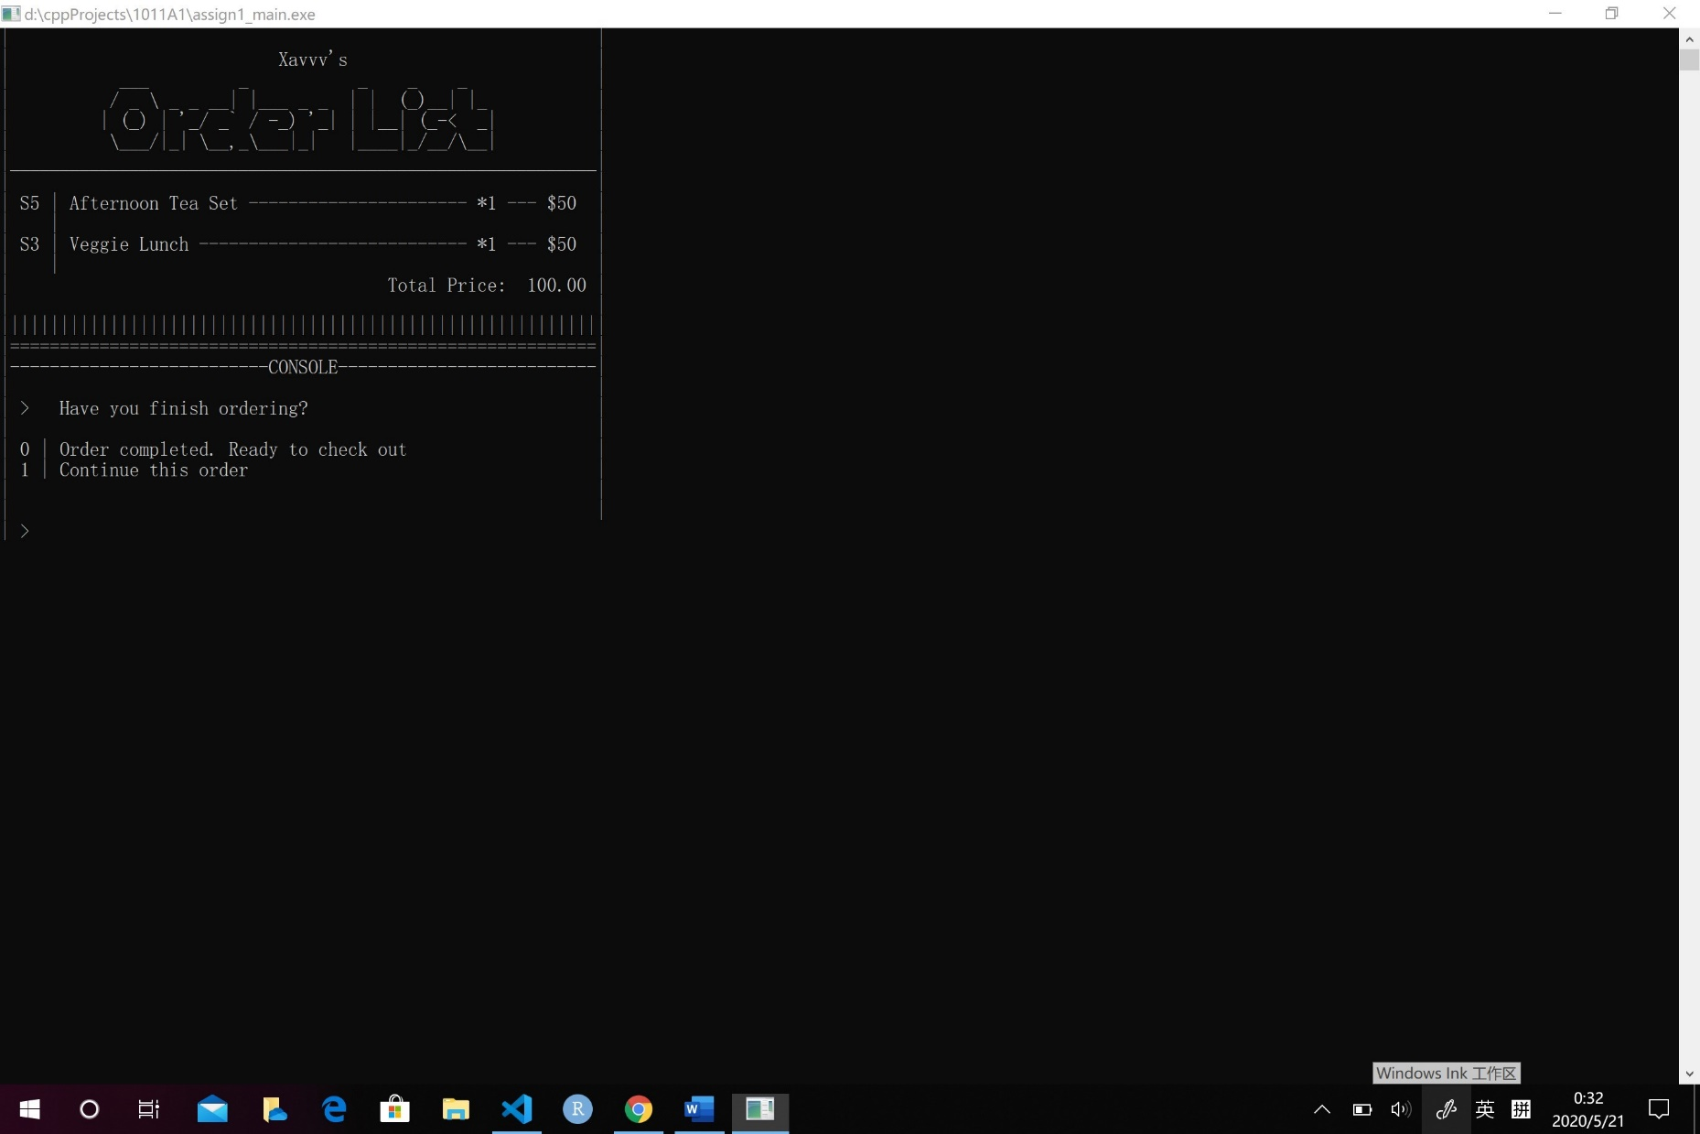

1. 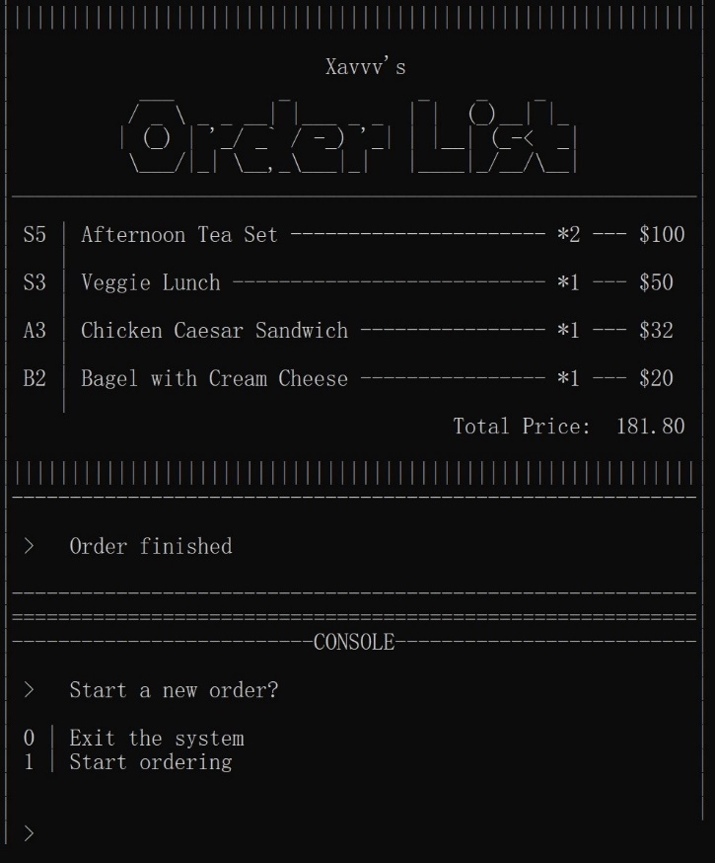(**Order List + Console**) In check out session, you can check **all the items ordered**, **their numbers and prices**,and **the total price**. You can choose to start a new order or exit the system (same as step 1.).

(Enter 1: go to **Step 2.**

Enter 0: go to **Step 6.**)

1. (**Goodbye image**) You have exit the system successfully. Welcome next time.

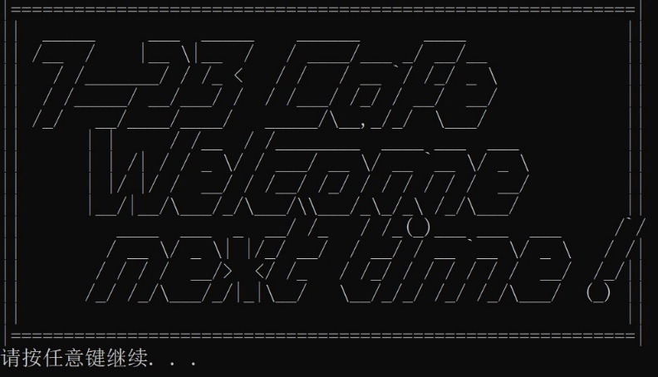(press any button to quit the program)