EDMECA ACADEMY WEBSITE

Accessibility Design Guidelines
Document Version: 1.0
Date: February 16, 2026
Phase: 2 - Design & Prototyping
Compliance: WCAG 2.1 Level AA

1. OVERVIEW
This document outlines the accessibility design guidelines ensuring the EDMECA Academy Website is usable by all people, including those with disabilities. We comply with WCAG 2.1 Level AA standards.

2. COLOR CONTRAST
All text and interactive elements meet WCAG 2.1 AA minimum contrast ratios:
- Normal text: 4.5:1 minimum contrast ratio
- Large text (18pt+): 3:1 minimum contrast ratio
- UI components: 3:1 minimum contrast ratio
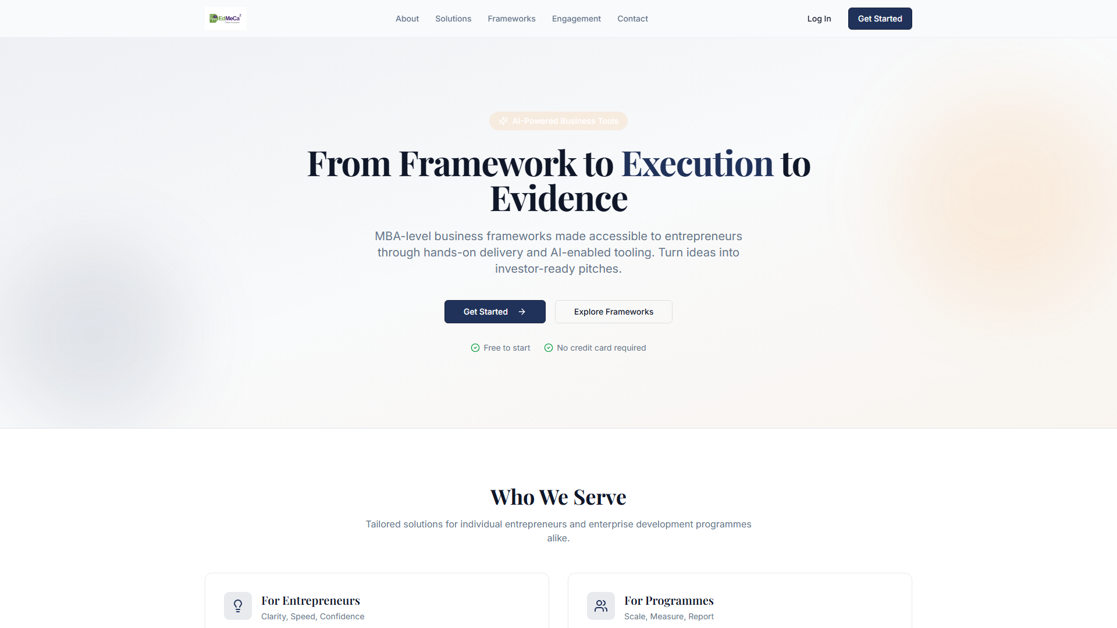
Figure 1: Color contrast examples

3. FOCUS STATES
All interactive elements have clearly visible focus indicators for keyboard navigation.
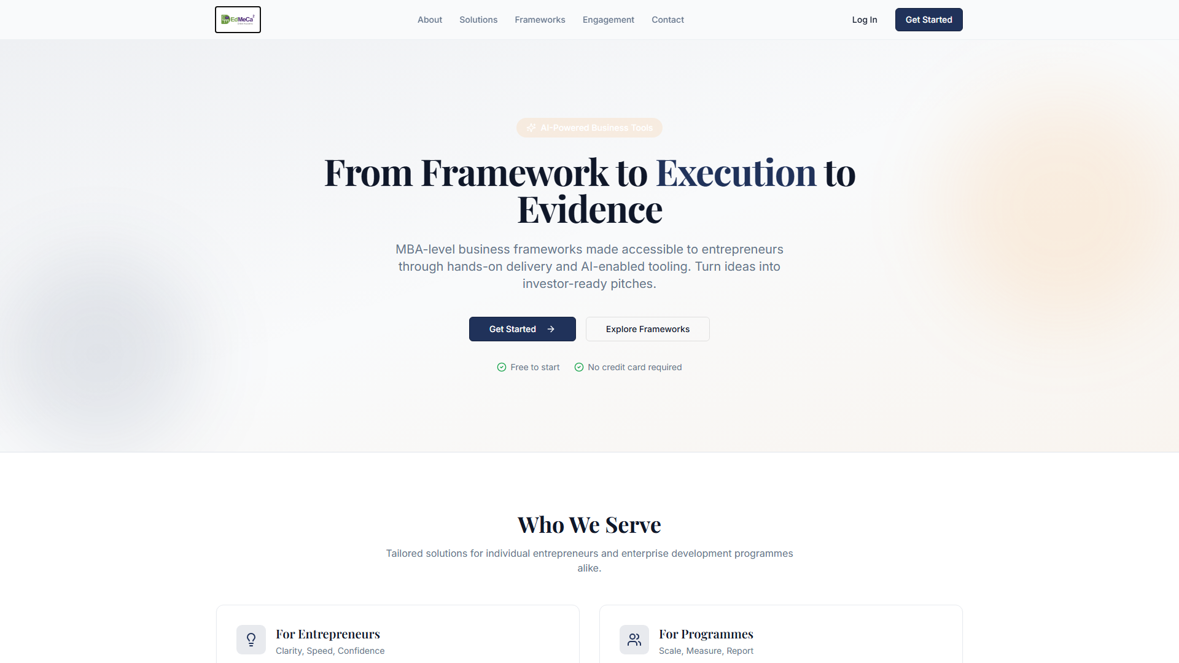
Figure 2: Focus state examples

4. TEXT READABILITY
- Font size: minimum 16px for body text
- Line height: 1.5 for body text
- Paragraph width: maximum 80 characters
- Clear typography hierarchy
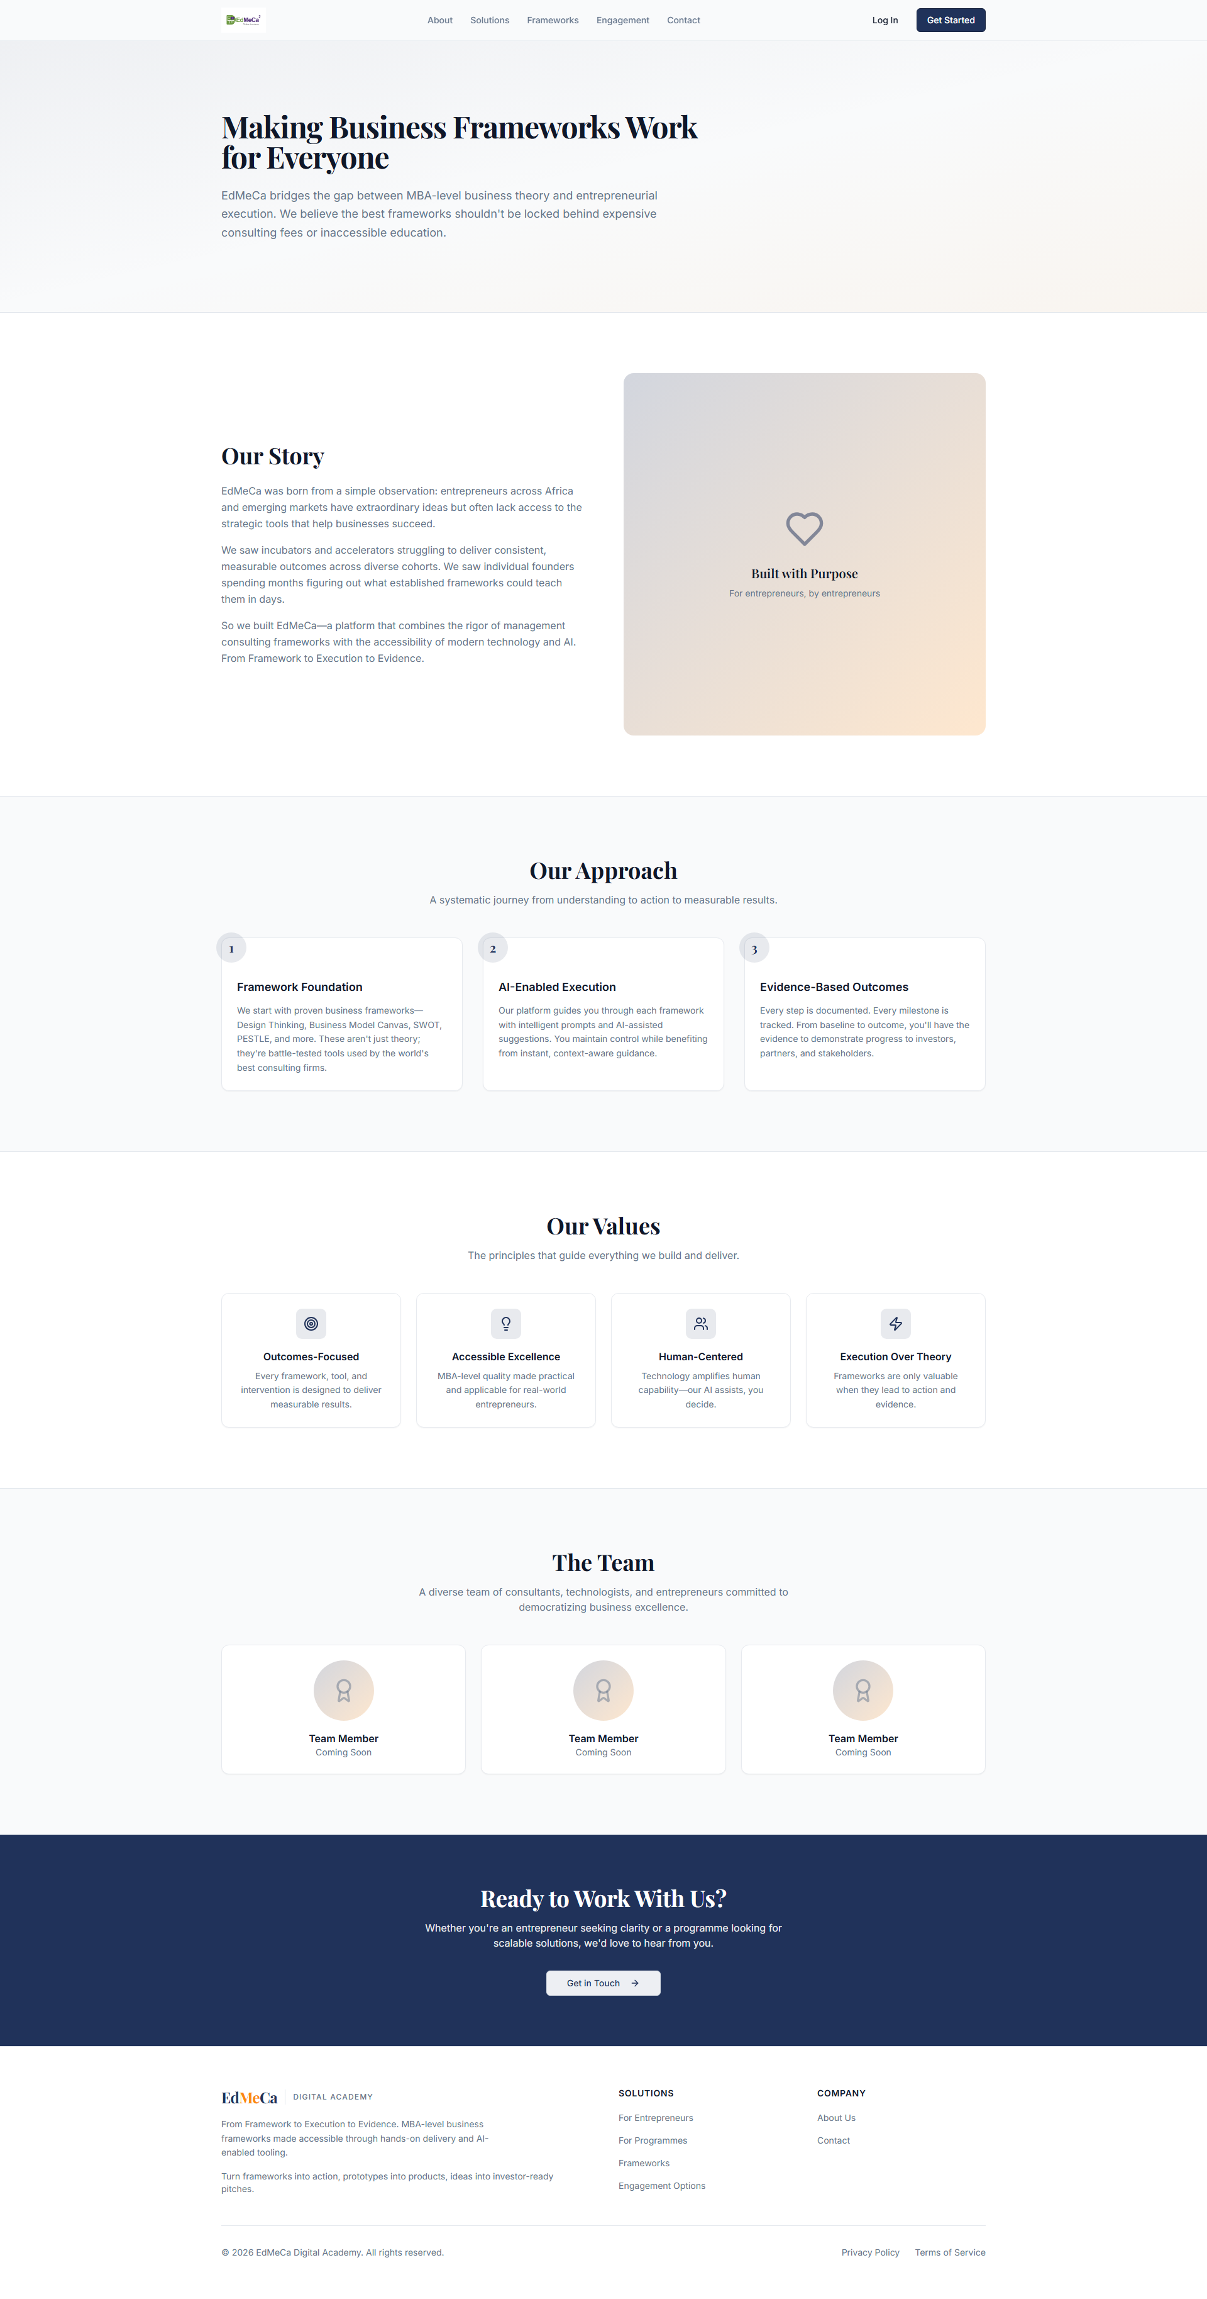
Figure 3: Text readability and hierarchy

5. KEYBOARD NAVIGATION
- All functionality available via keyboard
- Logical tab order throughout pages
- Skip navigation links provided
- No keyboard traps

6. SCREEN READER SUPPORT
- Semantic HTML elements used throughout
- ARIA labels for complex interactions
- Alternative text for all images
- Meaningful link text (no "click here")
- Form field labels properly associated

7. TOUCH TARGET SIZE
- Minimum 44x44px for all interactive elements
- Adequate spacing between touch targets
- Mobile-optimized button sizes

8. WCAG 2.1 AA COMPLIANCE CHECKLIST
- ✅ Perceivable: Information presented in multiple ways
- ✅ Operable: All functionality available via keyboard
- ✅ Understandable: Clear navigation and content structure
- ✅ Robust: Compatible with assistive technologies

9. ACCEPTANCE CRITERIA
- ✅ WCAG 2.1 AA compliance checklist
- ✅ Color contrast ratios verified (4.5:1 min)
- ✅ Focus states designed for all interactive elements
- ✅ Screen reader friendly content structure
- ✅ Keyboard navigation patterns defined
- ✅ Alternative text guidelines created

