EDMECA ACADEMY WEBSITE

Design System & Brand Guidelines
Document Version: 1.0
Date: February 16, 2026
Phase: 2 - Design & Prototyping

1. INTRODUCTION
This document outlines the comprehensive design system and brand guidelines for the EDMECA Academy Website. It establishes the visual identity, design principles, and reusable components that ensure consistency across all pages and features.
The design system serves as the foundation for all UI/UX decisions and provides developers with clear specifications for implementation.

2. BRAND COLORS & COLOR PALETTE
Our color system is built on a carefully selected palette that ensures accessibility, visual harmony, and brand consistency.

2.1 Primary Color Scheme
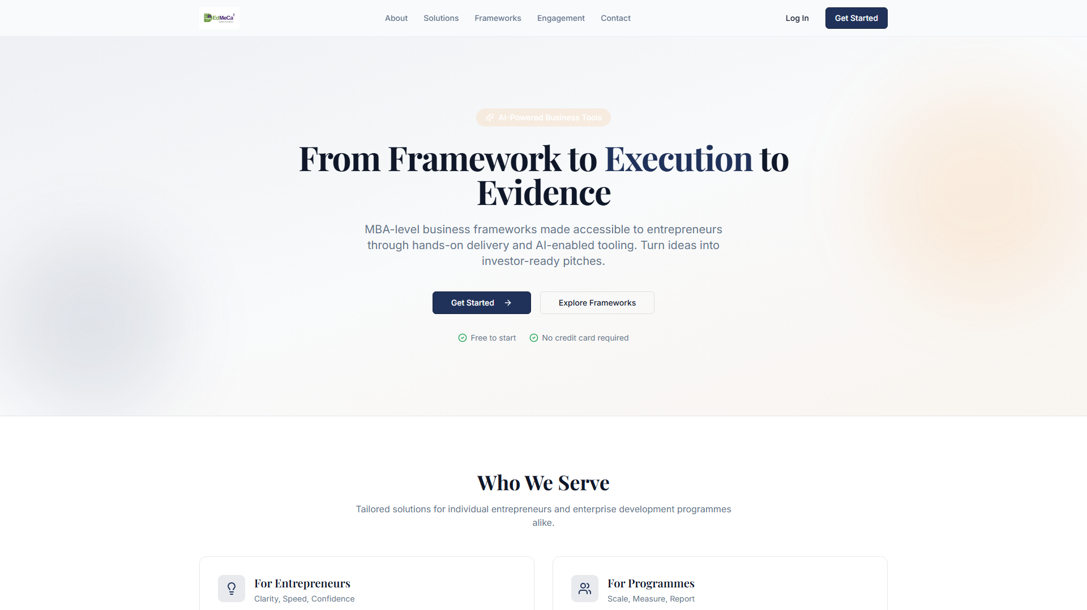
Figure 1: Primary color palette as shown in the website

2.2 Dark Mode Support
The website includes comprehensive dark mode support with optimized color contrast ratios for enhanced readability in low-light conditions.

3. TYPOGRAPHY SYSTEM
Typography plays a crucial role in establishing hierarchy, readability, and brand personality.

3.1 Font Families
- Primary Font: System font stack for optimal performance
- Headings: Bold weight with tighter letter spacing
- Body Text: Regular weight optimized for readability
- Code/Monospace: Used for technical content
Figure 2: Typography hierarchy and styles

4. UI COMPONENTS
The component library includes all reusable UI elements built with shadcn/ui and Tailwind CSS.

4.1 Component Overview
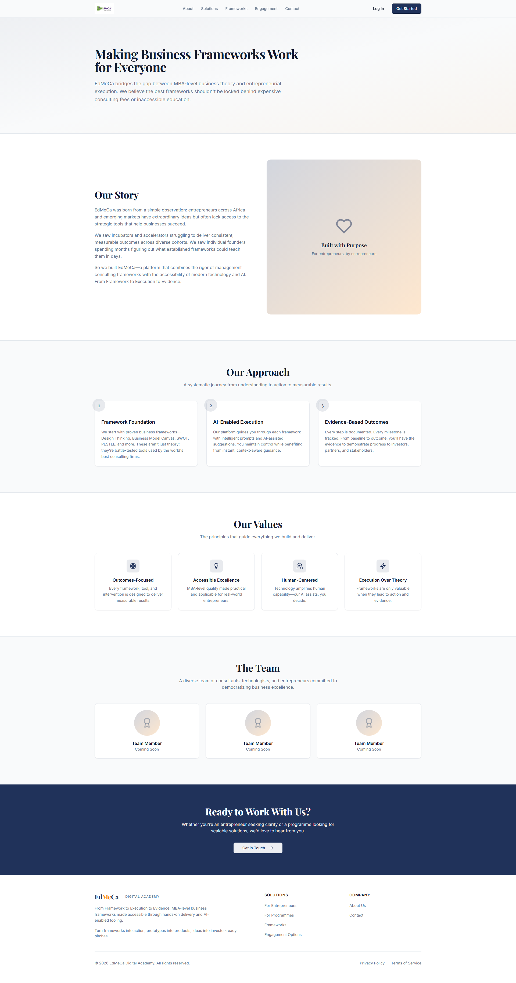
Figure 3: Sample UI components in use

4.2 Buttons & Interactive Elements
- Primary buttons for main actions
- Secondary buttons for alternative actions
- Ghost buttons for tertiary actions
- Icon buttons for compact interfaces

Figure 4: Button states and variants

5. DESIGN TOKENS
Design tokens are the atomic values that power our design system, ensuring consistency across all platforms.

5.1 Spacing System
- Base unit: 4px (0.25rem)
- Spacing scale: 0, 1, 2, 3, 4, 6, 8, 12, 16, 24, 32
- Consistent padding and margins throughout

5.2 Border Radius
- Small: 4px - for buttons, inputs
- Medium: 8px - for cards, panels
- Large: 12px - for modals, dialogs

5.3 Shadows
- Subtle elevation for cards
- Medium elevation for dropdowns
- High elevation for modals

6. IMPLEMENTATION GUIDELINES
Best practices for designers and developers working with this design system:
- Always use design tokens instead of hard-coded values
- Maintain WCAG 2.1 AA color contrast ratios
- Test components in both light and dark modes
- Ensure all interactive elements meet 44px minimum touch target size
- Use semantic HTML elements for better accessibility

7. ACCEPTANCE CRITERIA
- ✅ Brand color palette defined with accessibility ratios
- ✅ Typography system established (headings, body, code)
- ✅ Spacing and layout grid system defined
- ✅ Component design tokens created
- ✅ Design system documentation completed
- ✅ Style guide created for developers

